Import an SQL file into different database in PostgreSQL

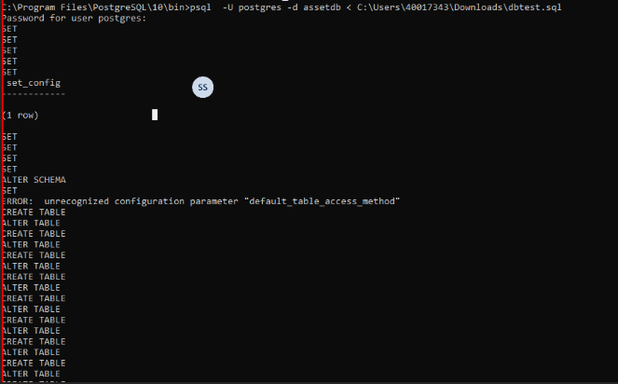

Export Database from PostgreSQL

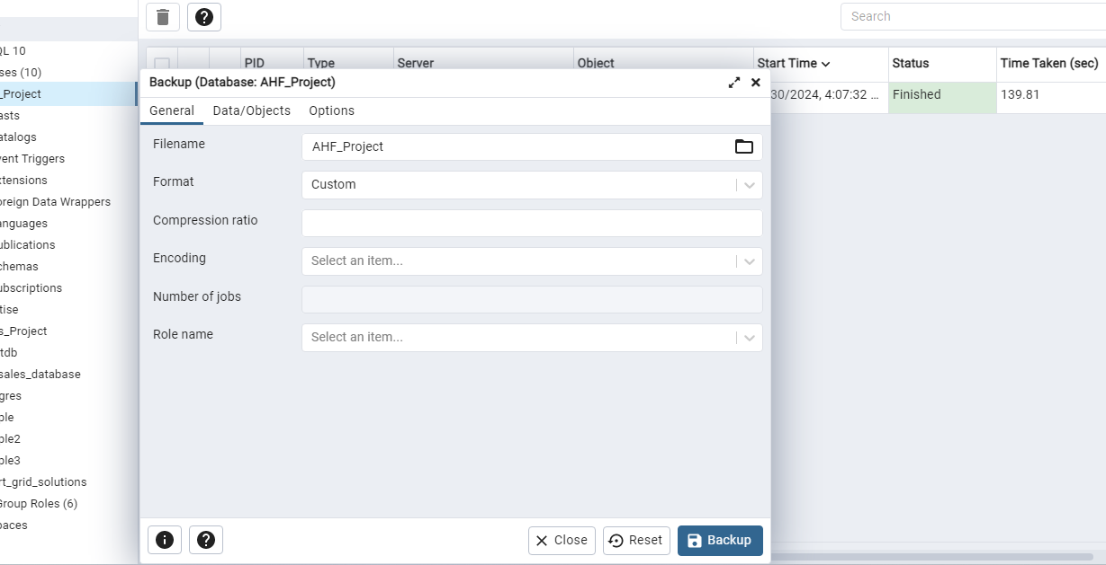

Flask-RESTful (API’S)

->These packages need to be installed

pip install Flask==2.3.2 Flask-Cors==3.0.10 cors==1.0.1 psycopg2==2.9.6



