Improving Automatic Speech Recognition Accuracy Across Language Dialects for Fair and Inclusive Subtitle Generation

Haniruth Muthuselvam, Subhan Ahmed Haris, Anusha Undamatla, Nakul Arora, Zain Shahid, Vasavi Atkuri

1. Introduction
1.1 Background
Automatic Speech Recognition (ASR) now sits behind voice assistants, transcription tools, and subtitle systems across media, education, and public services. Tools such as Whisper [1], Google Cloud Speech-to-Text, and automatic captioning on video platforms have made speech-to-text widely available. However, this progress has not been shared equally. ASR systems still tend to perform best on standard or high-resource speech varieties and less well on regional, social, or under-represented dialects. In practice, this means subtitle quality can vary depending on how closely a speaker’s speech matches the data used to train the model.
1.2 Motivation and Problem Statement
Poor subtitles do more than introduce minor transcription errors. They can change meaning, interrupt comprehension, and create access barriers for users who rely on captions, especially deaf and hard-of-hearing viewers. Studies have already shown that commercial ASR systems can produce different error rates across race, accent, and dialect [1], [2], yet many deployed captioning systems are still judged mainly by average accuracy. That hides who the systems work well for and who they fail. The problem is therefore both technical and social: uneven subtitle quality can reinforce linguistic inequality and reduce trust in AI-supported communication.
1.3 Research Hypothesis
We hypothesize that a combination of better dialect-balanced benchmarking, fairness-aware evaluation, and targeted model adaptation can reduce transcription gaps across dialect groups without harming overall subtitle quality.
2. Research Objectives
Objective 1: Construct a balanced multi-dialect benchmark for subtitle-oriented ASR evaluation covering five English dialect groups with clear metadata, subtitle-style transcripts, and documented dataset limitations.
Objective 2: Audit representative ASR systems — Whisper [11], wav2vec 2.0 [13], and one commercial captioning/ASR service — using disaggregated transcription and fairness metrics across the selected dialect groups.
Objective 3: Develop dialect-aware ASR improvement strategies using data balancing, augmentation, and parameter-efficient fine-tuning to reduce worst-group error without sacrificing overall subtitle quality.
Objective 4: Build a fair subtitle generation pipeline with punctuation restoration, readable subtitle segmentation, timestamp alignment, and transparent handling of uncertain outputs.
Objective 5: Conduct a focused people-centred evaluation with a manageable set of subtitle users, including speakers from the target dialect groups and users with accessibility needs, to assess readability, trust, and inclusivity.

3. Societal Importance and Relevance
This research addresses a practical fairness problem in a setting that matters to everyday life. Subtitles are now widely used in education, public communication, entertainment, and online media. If they work well only for speakers of dominant dialects, then access to information is not equal. Improving dialect robustness in subtitle generation would support more inclusive access to spoken content, while also encouraging speech AI systems to be evaluated in a more responsible way from the start rather than only after deployment.
4. Literature Review
ASR has moved a long way from earlier Hidden Markov Model pipelines and toolkit-based systems such as Kaldi [17]. Newer approaches based on self-supervised learning and large pretrained models, including wav2vec 2.0 [13] and Whisper [11], have improved general transcription accuracy and transfer performance. Even so, better average accuracy does not automatically mean fairer performance. Koenecke et al. [1] and Tatman and Kasten [2] show that commercial systems can still produce substantial differences in error rates across racial and dialect groups. At the same time, resources such as Common Voice [4], FLEURS [7], VoxPopuli [8], and CORAAL [6] have made broader evaluation more possible, while frameworks such as Datasheets for Datasets [5] and Model Cards [12] have pushed the field toward better documentation and transparency.
The main gap is that much of the existing work stops at showing that disparities exist. Fewer studies connect dialect-aware ASR improvement to the actual quality of subtitles seen by users. Our proposal addresses that gap by linking three things that are often treated separately: fairness-aware ASR evaluation, targeted dialect adaptation, and subtitle-specific quality assessment.
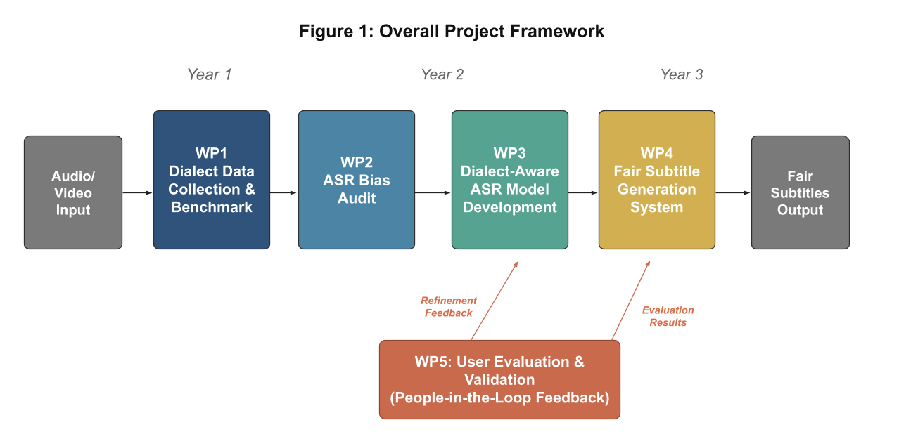
5. Methodology
Figure 1: Overall project framework showing the end-to-end pipeline from WP1 through WP5.
5.1 WP1: Dialect Speech Data Collection and Benchmark Development
Current evaluation still relies heavily on standard benchmarks such as LibriSpeech [3]. These are useful, but they are limited for dialect fairness analysis because they contain little dialect metadata and mostly standardized speech. WP1 therefore establishes a more suitable foundation for this project by defining a focused benchmark for subtitle-oriented evaluation across dialect groups.
Task 1.1: Dialect Identification and Selection
To keep the project both meaningful and realistic, five dialect groups are proposed: Standard American English and Southern Standard British English as reference varieties, together with African American English, Indian English, and Nigerian English as under-represented but socially important varieties. This gives enough diversity to study fairness without making the project unmanageably broad.
Task 1.2: Data Collection and Curation
Existing corpora will be curated and harmonized into a common benchmark with subtitle-style transcripts, speaker metadata where available, and consistent train/development/test splits. Instead of promising large-scale new data collection, the project prioritizes careful reuse and documentation of public resources such as Common Voice [4], CORAAL [6], FLEURS [7], VoxPopuli [8], and the Speech Accent Archive [10].
Task 1.3: Benchmark Dataset Creation and Annotation
Transcription conventions will preserve dialect-relevant lexical and grammatical features so that the evaluation does not wrongly treat dialect identity as noise. Annotation guidance, quality checks, and a datasheet [5] will be produced as part of the benchmark deliverable.

5.2 WP2: Auditing ASR Models for Dialect Bias
WP2 extends earlier ASR fairness studies by running a focused comparative audit across the selected dialect groups. The aim is to show where current systems fail, which error patterns matter most for subtitles, and which baselines are most worth improving.
Task 2.1: ASR Model Selection
The evaluation will compare two strong open-source baselines — Whisper [11] and wav2vec 2.0 [13] together with one widely used commercial or platform captioning system where access is possible. This keeps the comparison meaningful without making the project too diffuse.
Task 2.2: Dialect-Specific Performance Evaluation
WER, CER, and subtitle-relevant error patterns will be reported for each dialect group. Qualitative analysis will focus on mistranscribed named entities, subtitle segmentation failures, deletions of dialect markers, and substitutions that change meaning.
Task 2.3: Bias Metric Development
Fairness will be assessed using a small, justified set of metrics: WER disparity, worst-group WER, the ratio between worst- and best-group WER, and a simple aggregate inequality measure. This keeps the evaluation interpretable and proportionate to the proposal scope.

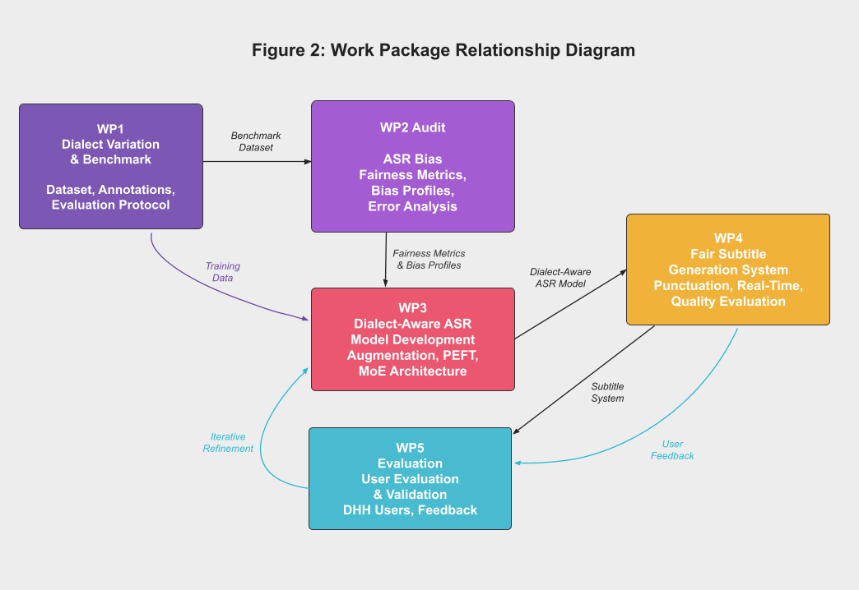
Figure 2: Work package relationship diagram showing data flows and iterative feedback loop.

5.3 WP3: Dialect-Aware ASR Model Development
WP3 develops a dialect-aware ASR improvement pipeline built around methods that are both effective and realistic for the project scope.
Task 3.1: Data Augmentation for Underrepresented Dialects
The project will use targeted rebalancing of training subsets and established augmentation methods such as SpecAugment [20] and controlled noise addition [18], [19] to improve robustness for under-represented dialect segments.
Task 3.2: Transfer Learning and Fine-Tuning
Parameter-efficient adaptation of pretrained models will be explored using lightweight methods such as LoRA [21] or adapters [22], with comparison against standard fine-tuning where feasible. The aim is to improve under-served dialect performance without assuming unrealistic compute budgets.
Task 3.3: Multi-Dialect Architecture Design
If time and resources allow, worst-group-aware optimization inspired by distributionally robust learning [16] will be explored as a secondary strategy. The main deliverable, however, is a realistic dialect-aware adaptation pipeline rather than an overextended package of advanced experiments.

5.4 WP4: Fair Subtitle Generation System
WP4 integrates the improved ASR output into a subtitle generation system designed to make those technical gains visible to users.
Task 4.1: Subtitle Pipeline Integration
The subtitle pipeline will include audio preprocessing, ASR inference, punctuation restoration, readable segmentation, and timestamp alignment to SRT or WebVTT output. Subtitle formatting will be informed by practical accessibility guidance such as the BBC subtitle guidelines [25].
Task 4.2: Real-Time Framework
For live or near-real-time use cases, the project will consider lightweight streaming behavior and low-latency design principles, drawing on work such as Emformer [26], without overcommitting to a full production-grade streaming deployment.
Task 4.3: Subtitle Quality Evaluation
Subtitle quality will be measured using a combination of transcription accuracy, segmentation quality, timing coherence, and user readability. This keeps the project grounded in the actual subtitle experience rather than transcription alone.

5.5 WP5: User Evaluation and Validation
WP5 brings users into the validation process by assessing whether the proposed system genuinely improves subtitle usability and perceived fairness.
Task 5.1: User Study with Dialect Speakers
A focused user evaluation will involve a manageable sample of viewers drawn from the target dialect communities. Participants will compare subtitles generated by the baseline and improved systems and comment on clarity, trustworthiness, subtitle lag, and perceived fairness.
Task 5.2: DHH Accessibility Evaluation
A smaller accessibility-focused subgroup, including users who rely heavily on captions, will assess subtitle readability, lag tolerance, and formatting quality. This provides meaningful user-centred evaluation without making unrealistic sampling claims.
Task 5.3: Iterative Refinement
The evaluation will be used to refine the system once or twice in an iterative improvement loop. The goal is practical validation of fairness and inclusivity rather than an excessively large behavioral study.

6. Expected Outcomes and Impact
Expected outputs include a documented multi-dialect benchmark for subtitle-oriented ASR evaluation, a comparative fairness audit of representative ASR systems, a dialect-aware adaptation pipeline built on strong pretrained ASR models, a subtitle generation prototype, and user-informed evidence about subtitle readability and inclusivity across dialect groups.

7. Risk Assessment and Mitigation

Technical risks:
ASR performance may not improve equally for all dialects (medium likelihood / high impact). Mitigation: use strong baselines, monitor worst-group performance early, and keep improvement goals focused on disparity reduction rather than headline average gains.
Data-related risks:
Public datasets may have uneven metadata quality or insufficient dialect coverage (medium / high). Mitigation: prioritize careful curation, explicit documentation of dataset limitations, and realistic benchmark design rather than forcing false balance.
Ethical risks:
Speech data may raise privacy and representational concerns (medium / high). Mitigation: use appropriately licensed data, minimize personal data exposure, and avoid framing dialect difference as deficiency.
Management:
Progress will be reviewed regularly against the Gantt chart, with each work package assigned to named group members. Scope control will be treated as an active management task so that the proposal remains credible and deliverable.

Work Plan
Task | Q1 | Q2 | Q3 | Q4 | Q5 | Q6 | Q7 | Q8 | Q9 | Q10 | Q11 | Q12
WP1: Dialect Data Collection & Benchmark
T1.1 Dialect identification & selection
T1.2 Data collection & curation
T1.3 Benchmark creation & annotation
WP2: Auditing ASR for Dialect Bias
T2.1 ASR model selection
T2.2 Dialect-specific evaluation
T2.3 Bias metric development & analysis
WP3: Dialect-Aware ASR Development
T3.1 Data augmentation techniques
T3.2 Transfer learning & fine-tuning
T3.3 Multi-dialect architecture design
WP4: Fair Subtitle Generation
T4.1 ASR-subtitle pipeline integration
T4.2 Real-time framework
T4.3 Subtitle quality evaluation
WP5: User Evaluation & Validation
T5.1 User study with dialect speakers
T5.2 DHH accessibility evaluation
T5.3 Iterative refinement

Milestones
- M1: Dialect groups selected and benchmark design agreed (Q2)
- M2: Benchmark dataset curated and documented (Q5)
- M3: Baseline fairness audit completed (Q7)
- M4: Dialect-aware ASR adaptation completed (Q9)
- M5: Subtitle generation prototype integrated (Q10)
- M6: User-centred validation completed (Q11)
- M7: Final recommendations and dissemination outputs completed (Q12).

Deliverables
- D1: Subtitle-oriented multi-dialect benchmark specification and dataset documentation (Q5)
- D2: ASR fairness audit report and evaluation toolkit (Q7)
- D3: Dialect-aware adapted ASR model and error analysis (Q9)
- D4: Fair subtitle generation prototype (Q10)
- D5: User evaluation and accessibility findings (Q11)
- D6: Final project report and deployment recommendations (Q12).
References
[1] A. Koenecke et al., “Racial disparities in automated speech recognition,” Proc. Natl. Acad. Sci., vol. 117, no. 14, pp. 7684–7689, 2020.
[2] R. Tatman and C. Kasten, “Effects of talker dialect, gender & race on accuracy of Bing speech and YouTube automatic captions,” in Proc. Interspeech, 2017, pp. 934–938.
[3] V. Panayotov et al., “LibriSpeech: An ASR corpus based on public domain audio books,” in Proc. IEEE ICASSP, 2015, pp. 5206–5210.
[4] R. Ardila et al., “Common Voice: A massively-multilingual speech corpus,” in Proc. LREC, 2020, pp. 4218–4222.
[5] T. Gebru et al., “Datasheets for datasets,” Commun. ACM, vol. 64, no. 12, pp. 86–92, 2021.
[6] T. Kendall and C. Farrington, “The Corpus of Regional African American Language,” Version 2023.06, 2023.
[7] A. Conneau et al., “FLEURS: Few-shot Learning Evaluation of Universal Representations of Speech,” in Proc. IEEE SLT, 2023, pp. 798–805.
[8] C. Wang et al., “VoxPopuli: A large-scale multilingual speech corpus,” in Proc. ACL-IJCNLP, 2021, pp. 993–1003.
[9] G. Zhao et al., “L2-ARCTIC: A non-native English speech corpus,” in Proc. Interspeech, 2018, pp. 2783–2787.
[10] S. H. Weinberger, “Speech Accent Archive,” George Mason University, 2015.
[11] A. Radford et al., “Robust speech recognition via large-scale weak supervision,” in Proc. ICML, 2023, pp. 28492–28518.
[12] M. Mitchell et al., “Model cards for model reporting,” in Proc. FAT*, 2019, pp. 220–229.
[13] A. Baevski et al., “wav2vec 2.0: A framework for self-supervised learning of speech representations,” in NeurIPS, vol. 33, 2020, pp. 12449–12460.
[14] N. Mehrabi et al., “A survey on bias and fairness in machine learning,” ACM Comput. Surv., vol. 54, no. 6, pp. 1–35, 2021.
[15] V. Pratap et al., “Scaling speech technology to 1,000+ languages,” arXiv:2305.13516, 2023.
[16] S. Sagawa et al., “Distributionally robust neural networks for group shifts,” in Proc. ICLR, 2020.
[17] D. Povey et al., “The Kaldi speech recognition toolkit,” in Proc. IEEE ASRU, 2011.
[18] D. Snyder et al., “MUSAN: A music, speech, and noise corpus,” arXiv:1510.08484, 2015.
[19] J. Thiemann et al., “The DEMAND database,” in Proc. Meetings Acoust., vol. 19, 2013, p. 035081.
[20] D. S. Park et al., “SpecAugment: A simple data augmentation method for automatic speech recognition,” in Proc. Interspeech, 2019, pp. 2613–2617.
[21] E. J. Hu et al., “LoRA: Low-rank adaptation of large language models,” in Proc. ICLR, 2022.
[22] N. Houlsby et al., “Parameter-efficient transfer learning for NLP,” in Proc. ICML, 2019, pp. 2790–2799.
[23] B. H. Zhang, B. Lemoine, and M. Mitchell, “Mitigating unwanted biases with adversarial learning,” in Proc. AIES, 2018, pp. 335–340.
[24] X. L. Li and P. Liang, “Prefix-tuning: Optimizing continuous prompts for generation,” in Proc. ACL-IJCNLP, 2021, pp. 4582–4597.
[25] BBC, “BBC subtitle guidelines,” 2023. Available: https://www.bbc.co.uk/accessibility/
[26] Y. Shi et al., “Emformer,” in Proc. IEEE ICASSP, 2021, pp. 6783–6787.
[27] A. Gulati et al., “Conformer,” in Proc. Interspeech, 2020, pp. 5036–5040.
[28] P. Romero-Fresco and J. Martínez, “The NER model,” in Audiovisual Translation in a Global Context, Palgrave, 2015.
Group Member Contributions

Group Member Name | Main Contributions and Collective Work Done
Haniruth Muthuselvam | Sections 1.1–1.2 (Background, Motivation), Literature Review (Section 4), IEEE reference list. Reviewed all sections for consistency.
Subhan Ahmed Haris | Section 1.3 (Hypothesis), Section 2 (Objectives 1–5), Section 3 (National Importance). Ensured objective-WP alignment and AI Track compliance.
Anusha Undamatla | WP1 and WP2 (Tasks 1.1–1.3, 2.1–2.3). Defined five target dialect groups, supported benchmark design, data methodology, and fairness evaluation criteria. Collaborated with Member 4 on work package alignment.
Nakul Arora | WP3 and WP4 (Tasks 3.1–3.3, 4.1–4.3). Developed the dialect-aware adaptation and subtitle pipeline methodology, including augmentation, parameter-efficient fine-tuning, and subtitle quality design. Coordinated with Member 3 for consistency.
Vasavi Atkuri | WP5 (Tasks 5.1–5.3), Section 7 (Risk Assessment). Designed Gantt chart with milestones and deliverables. Reviewed methodology for timeline feasibility.
Zain Shahid | Section 6 (Expected Outcomes). Created Figures 1–2. Quality control: formatting, style, figures, referencing. Compiled contributions table.

Assessment and Feedback Form
This is to be completed by the marker and not the group.
Assessment component | Mark
Vision of proposed work
- is of excellent quality and importance within or beyond the field(s) | /20
- has the potential to advance current understanding, generates new knowledge | /10
- is timely given current trends, context and needs | /10
The approach to deliver the work
- is effective and appropriate to achieve your objectives | /15
- summarises previous work and describes how it will be built upon | /10
- will maximise research outputs and impacts | /10
The work plan
- provides a clear, realistic, and well-structured timeline | /5
- includes key milestones, tasks, and deliverables aligned with objectives | /5
Quality of proposal writing
- Quality of writing in clear level of English | /5
- Neat presentation of the proposal including figures | /5
- Correct referencing done as required | /5
TOTAL | /100

What has been done well in the proposal:
What could have been done better in the proposal:
General comments:

