**Docker Experiment using Gitbash**

**Download the Gitbash software and give the access for the further uses**

**Gitbash download link:**

[**https://github.com/git-for-windows/git/releases/download/v2.47.1.windows.1/Git-2.47.1-64-bit.exe**](https://github.com/git-for-windows/git/releases/download/v2.47.1.windows.1/Git-2.47.1-64-bit.exe)

**Open the Gitbash software :**

**Step-by-step process: Type the commands one by one**

**Note: instead of Sunday type any name**

**Step 1: Type mkdir sunday**

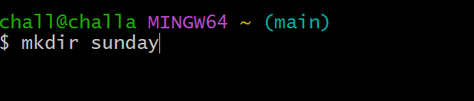

**Step 2: Type cd sunday**

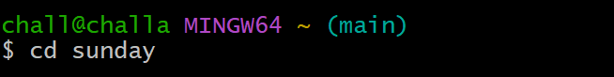

**Step 3: Type touch index.html**

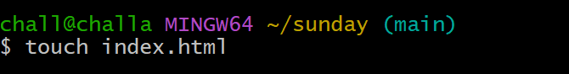

**Step 4: Type notepad index.html**

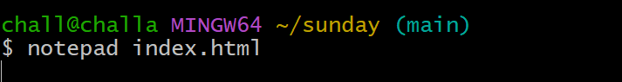

**Step 5: After this command notepad will be open then paste this html code into the notepad**

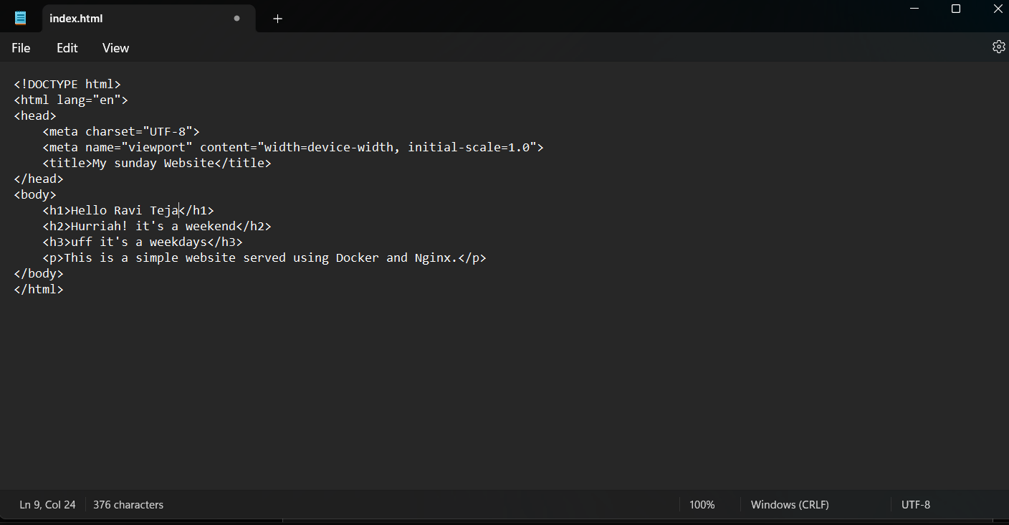

**HTML CODE:**

**<!DOCTYPE html>**

**<html lang="en">**

**<head>**

**<meta charset="UTF-8">**

**<meta name="viewport" content="width=device-width, initial-scale=1.0">**

**<title>My sunday Website</title>**

**</head>**

**<body>**

**<h1>Hello Ravi Teja</h1>**

**<h2>Hurriah! it's a weekend</h2>**

**<h3>uff it's a weekdays</h3>**

**<p>This is a simple website served using Docker and Nginx.</p>**

**</body>**

**</html>**

**Step 6: save the file in notepad as “index.html” and close the notepad window**

**Step 7: Type touch dockerfile**

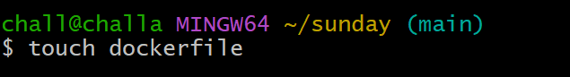

**Step 8: Type notepad dockerfile**

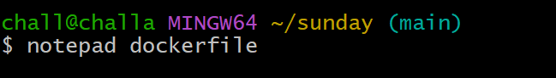

**Step 9: After this command notepad will be open then paste this html code into the notepad**

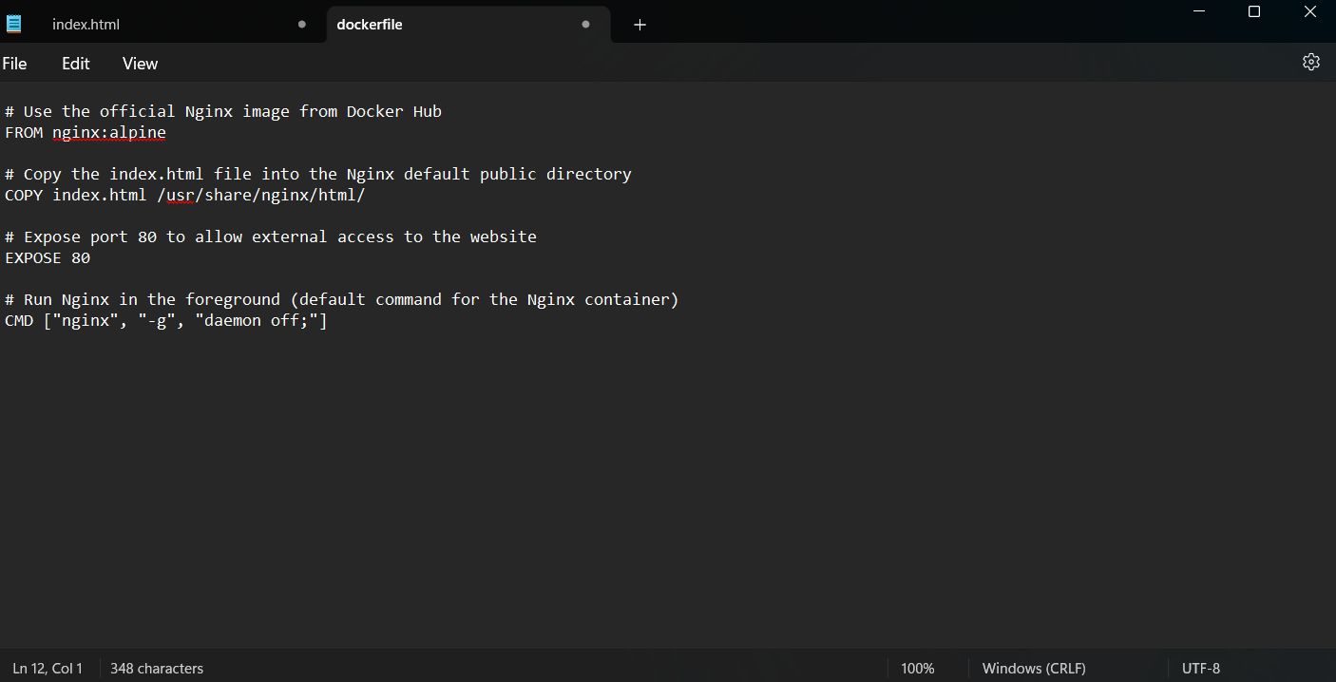

**DOCKERFILE:**

# Use the official Nginx image from Docker Hub

FROM nginx:alpine

# Copy the index.html file into the Nginx default public directory

COPY index.html /usr/share/nginx/html/

# Expose port 80 to allow external access to the website

EXPOSE 80

# Run Nginx in the foreground (default command for the Nginx container)

CMD ["nginx", "-g", "daemon off;"]

**Step 9: save the file in notepad as “dockerfile” and close the notepad window**

**Step 10: Type docker build -t Sunday .**

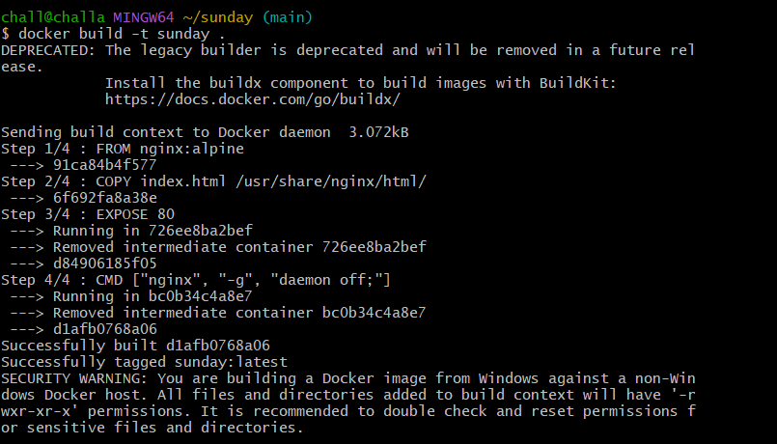

**Step 11: Type docker run -d -p 8080:80 sunday**



**Step 12: Type docker ps**

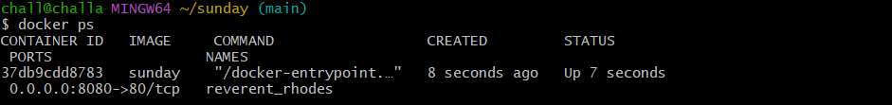

**Step 13: After completing these 12 steps open the docker software.**

**The docker frontpage be like this**

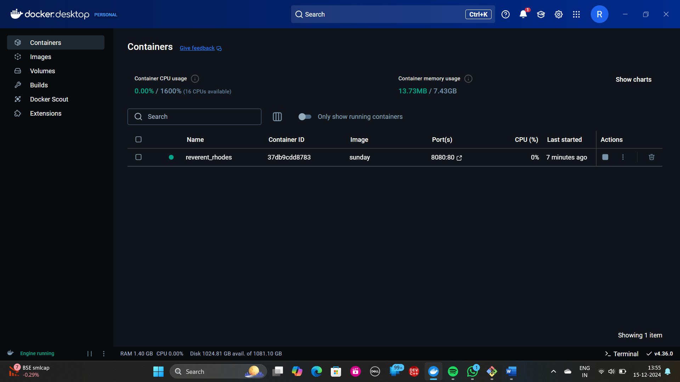

**Step 14: “** [**http://localhost:8080**](http://localhost:8080) **“ copy this ipe address and paste in the google chrome**

**Step 15: The output will be shown like this**

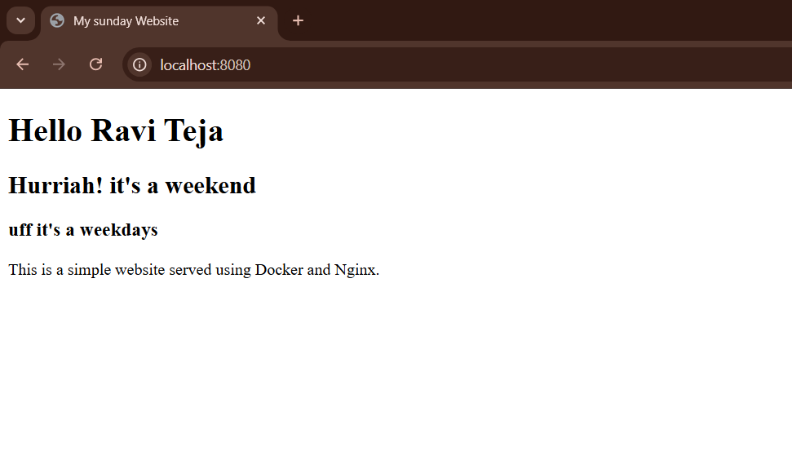

**Therefore, The docker experiment done sucessfully**