Sales Dashboard :

Sales Dashboard Analysis
Project Overview:
The project analysis the sales trend analysis using data from 700 purchases across various products. The goal is to uncover insights into selling patterns, top customers top selling region, product preferences and enterprise & small business segments to guide strategic business decisions.

2. Dataset Summary & EDA
Rows: 700
Columns: 10
Key Features:
Customer : Segments, customer ID, Country
Sales details: Sales, Profit, unit sold, Product name
Date: Date, Year
Missing Data: 6 profit values for -. Calculated the Profit columns using
- Profit columns of few records are – changed to 0. Based on the below calculation
- • Gross Sales = $\text{Units Sold} \times \text{Sale Price}$
- • Sales (Net Sales) = $\text{Gross Sales} - \text{Discounts}$
- • COGS = $\text{Units Sold} \times \text{Manufacturing Price}$
- • Profit = $\text{Sales} - \text{COGS}$

- M lang- try #"Reordered Columns"{0}[Profit] otherwise 0
- Transforming data: Looking for any errors – Replaced errors with 0.
- If we have date column, month & monthname columns were generated using Add column option.
Reports:
KPIs:
Total Sales
Total Units Sold
Total Profit
Total Profit %
Top selling product
Higest Number of units sold.
Donut Charts:
Sales % based on Products
Profit % based on Products.

Line/Bar charts
Month over Month Sales Tren analysis.
Region wise sales
Top customers
Tree Map:
Sales breakup by segments like Government, small business, etc.

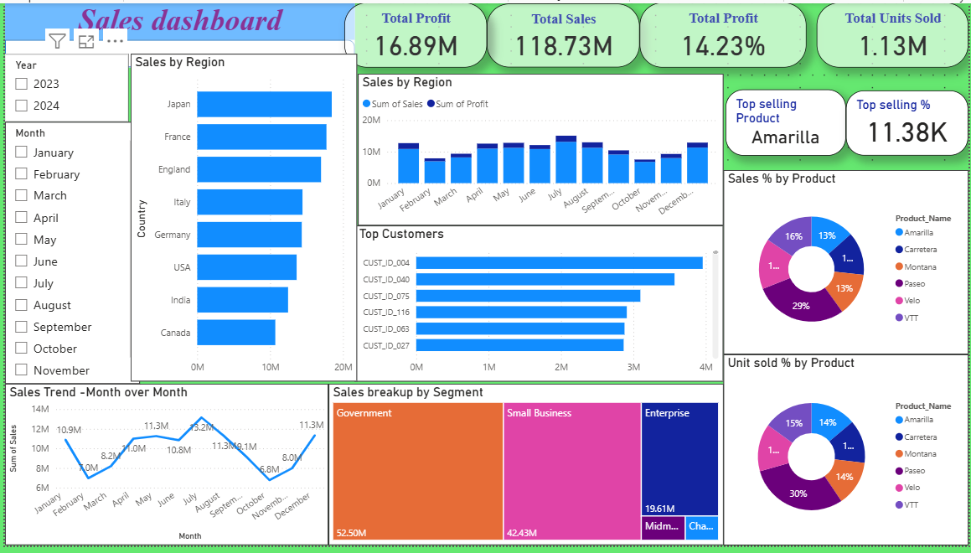

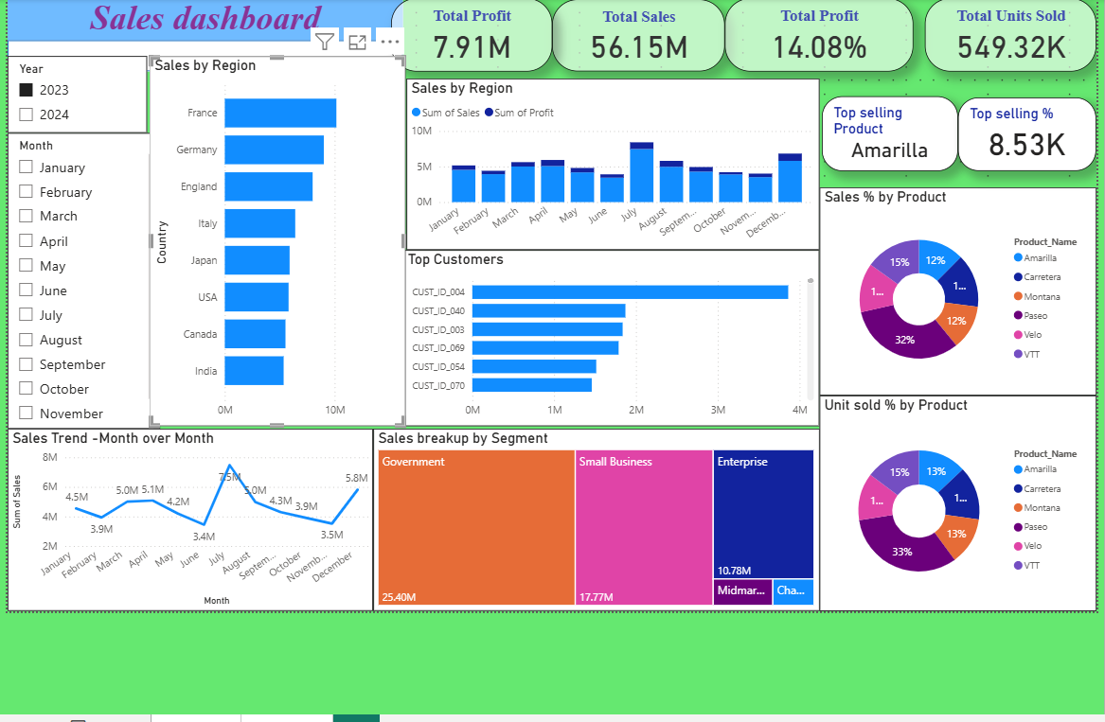

Slicers required to analyze the sales changes by period.

Key Business Recommendations
- Stop heavy year-end discounting to avoid the trap of high sales volume with low profitability.
- Reinstate strict pricing controls for high-volume Government and Enterprise customer segments.
- Prioritize marketing and sales pushes for high-margin product lines like Velo to protect premium revenue.
- Focus organizational KPIs on profit margins and overall value rather than unit volume targets.
- Analyze and replicate Canada's surprising Q4 growth model across other regional markets.
- Set up early-warning alerts for monthly sales to catch October and November slumps before they escalate.

