TDC mezzanines on SVEC carriers Long Runs

egousiou@cern.ch | 13.01.2014

The purpose of the tests is the confirmation of the performance of the TDC mezzanine board with SVEC as carrier. Similar tests with the SPEC carrier board are available in [1,2].

**Test Setup 1 | Pulse Pairs**

Figure 1 shows the test setup. We use four calibrated TDC v3 boards housed on two SVEC boards. Both SVEC boards are plugged in the same ELMA crate.

As pulse generator we use a Fine Delay mezzanine board housed on a third SVEC board, inside the same ELMA crate. The Fine Delay pulses enter the pulse distributor from where they arrive properly terminated to the four different TDC channels.

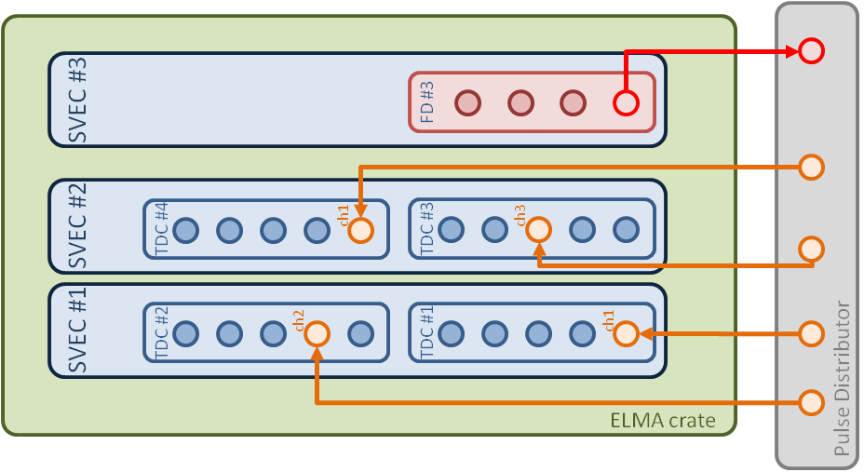

Figure : Test Setup 1

The Fine Delay is providing pulse pairs of 500 ns. The pairs are separated between them by a random amount of time.

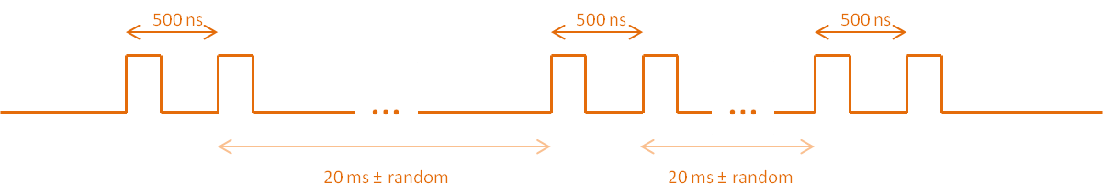

Figure : Pulses fed to the TDC boards

The test extended over around three days and. We retrieved the timestamps of each channel and subtracted consecutive timestamps by pairs. The SVEC driver developed by Tomasz Wlostowski is used for the retrieval of the TDC timestamps.

Figure 3 shows the results from 10M data from each channel and Table 1 presents the main statistics.

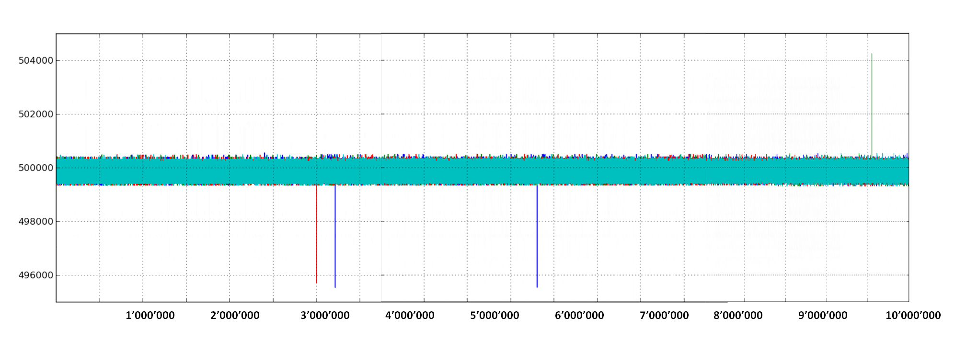

Figure : 10M data per channel

The graph, as well as the average of Table 1, confirms the consistency of the measurements from the different channels.

As expected, from previous measurements, spikes of ±4ns appear. In total four spikes appear in 40 M data, which agrees with the 1 spike/10M that has been previously observed [1].

|  |  |  |  |  |  |
| --- | --- | --- | --- | --- | --- |
|  | number of pulse pairs | average (ps) | max (ps) | min (ps) | span (ps) |
| TDC #1 Channel #1 | 10'000'000 | 499'956 | 500'576 | 495'552 | 5'024 |
| TDC #2 Channel #2 | 10'000'000 | 499'958 | 504'256 | 499'328 | 4'928 |
| TDC #3 Channel #3 | 10'000'000 | 499'952 | 500'512 | 495'712 | 4'800 |
| TDC #4 Channel #1 | 10'000'000 | 499'957 | 500'544 | 499'328 | 1'216 |

Table : Statistics from the measurements from the four channels

Removing the four spikes gives the statistics of Table 2 and the histogram of Figure 4. The spanning of the measurements is within the ±700 ps of the TDC specifications.

|  |  |  |  |  |  |
| --- | --- | --- | --- | --- | --- |
|  | number of pulse pairs | average (ps) | max (ps) | min (ps) | span (ps) |
| TDC #1 Channel #1 | 9'999'998 | 499'956 | 500'576 | 499'328 | 1'248 |
| TDC #2 Channel #2 | 9'999'999 | 499'958 | 500'544 | 499'328 | 1'216 |
| TDC #3 Channel #3 | 9'999'999 | 499'952 | 500'512 | 499'328 | 1'184 |
| TDC #4 Channel #1 | 10'000'000 | 499'957 | 500'544 | 499'328 | 1'216 |

Table : Statistics from the measurements from the four channels, without the ±4ns spikes

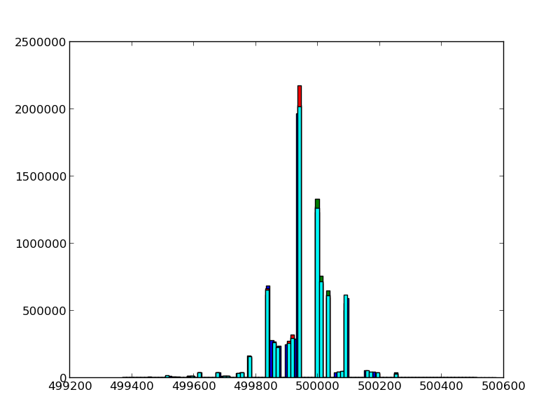

Figure : Histograms of the measurements from the four channels.

Note that because of computation resources issues the graph contains 6M data per channel, rather than 10M.

**Test Setup 2 | Pulses of constant period**

The setup is very similar to the one of Figure 1. We used the same four calibrated TDC v3 boards.

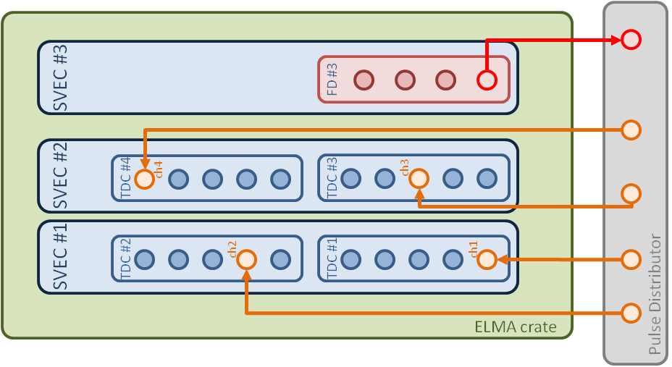

Figure : Test Setup 2

The pulses sent by the Fine Delay are of constant period of 20 ms.



Figure : Pulses fed to the TDC boards

Figure 7 shows 20M data per channel. The test extended over around five days. The jump on all the channels after around 11M data is because the acquisition was stopped and then restarted. Note the seven ±4ns spikes throughout the 80M data that are again in accordance with previous observations. The spikes in this graph appear both as +4ns and -4 ns; here we calculate the difference between consecutive pulses (rather than pulse pairs) and one wrong timestamp gives two wrong measurements.

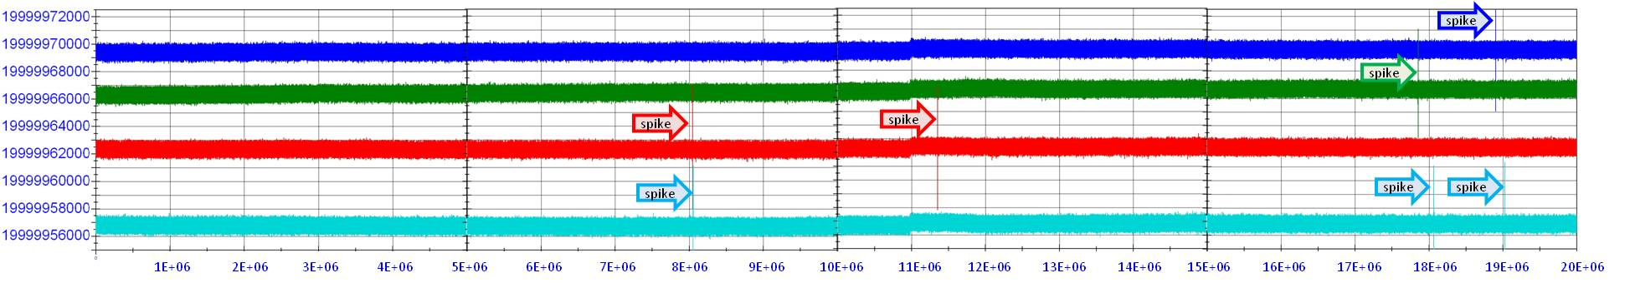

Figure : 20M data per channel

Table 3 presents the main statistics.

|  |  |  |  |  |  |
| --- | --- | --- | --- | --- | --- |
|  | number of pulse pairs | average (ps) | max (ps) | min (ps) | span (ps) |
| TDC #1 Channel #1 | 20'000'000 | 19'999'969'497 | 19'999'974'144 | 19'999'965'056 | 9'088 |
| TDC #2 Channel #2 | 20'000'000 | 19'999'966'548 | 19'999'971'072 | 19'999'962'176 | 8'896 |
| TDC #3 Channel #3 | 20'000'000 | 19'999'962'385 | 19'999'967'008 | 19'999'957'824 | 9'184 |
| TDC #4 Channel #1 | 20'000'000 | 19'999'956'801 | 19'999'961'344 | 19'999'952'256 | 9'088 |

Table : Statistics from the measurements from the four channels

Figure 8 zooms into one of the spikes.

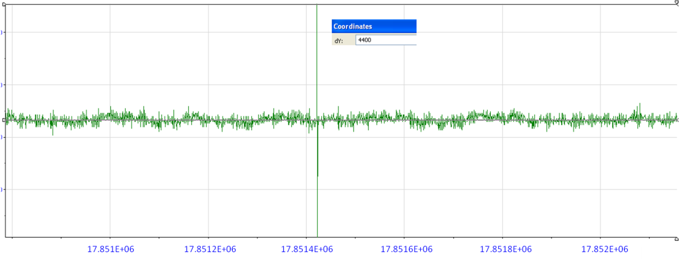

Figure : Zoom into a spike on TDC #2 Channel #2 after around 17M measurements

Removing the seven spikes gives the statistics of Table 4 and the histogram of Figure 9.

Note that the measurements of each channel are consistent, but between channels the measurements have clear offsets. The maximum offset (between the average of the blue and the average of the cyan measurements of Figure 9) is 12’696 ps, which for a 20 ms measurement translates to < 1ppm. The offsets come from the fact that for a measurement of 20 ms, a board heavily depends on its local oscillator; despite the fact that the boards are calibrated, differences in temperature and on the oscillators’ quality cause these offsets. Remark here that both the TDC as well as the Fine Delay oscillators contribute to the offsets.

|  |  |  |  |  |  |
| --- | --- | --- | --- | --- | --- |
|  | number of pulse pairs | average (ps) | max (ps) | min (ps) | span (ps) |
| TDC #1 Channel #1 | 19'999'998 | 19'999'969'497 | 19'999'974'144 | 19'999'968'608 | 1'824 |
| TDC #2 Channel #2 | 19'999'998 | 19'999'966'548 | 19'999'967'552 | 199'99'965'535 | 2'017 |
| TDC #3 Channel #3 | 19'999'996 | 19'999'962'385 | 19'999'963'296 | 19'999'961'472 | 1'824 |
| TDC #4 Channel #1 | 19'999'994 | 19'999'956'801 | 19'999'957'760 | 19'999'955'872 | 1'888 |

Table : Statistics from the measurements from the four channels, without the ±4ns spikes

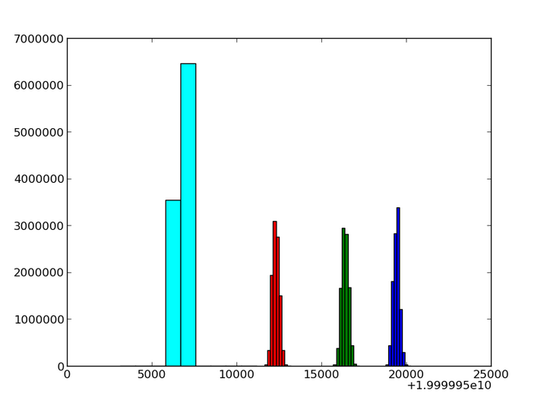

Figure : Histograms of the measurements from the four channels without spikes. The same number of bins has been used; cyan measurements are concentrated into fewer bins. Note that because of computation resources issues the graph contains 6M data per channel, rather than 20M.

Figure 10 focuses on the first 5M data from each channel and Figure 11 shows the corresponding rough temperature measurements from the One-Wire thermometers on the boards. The figures clarify that the dependence on the temperature is not the only parameter for the offsets (otherwise we would be expecting the red temperature graph to be at lower temperature than the green one).

Note also that the calibration of a TDC board takes place on a SPEC board at a temperature of ~50oC.

Extension of the TDC core with White Rabbit will provide sub-ns timebase accuracy and eliminate the offsets appearing on these long measurements.

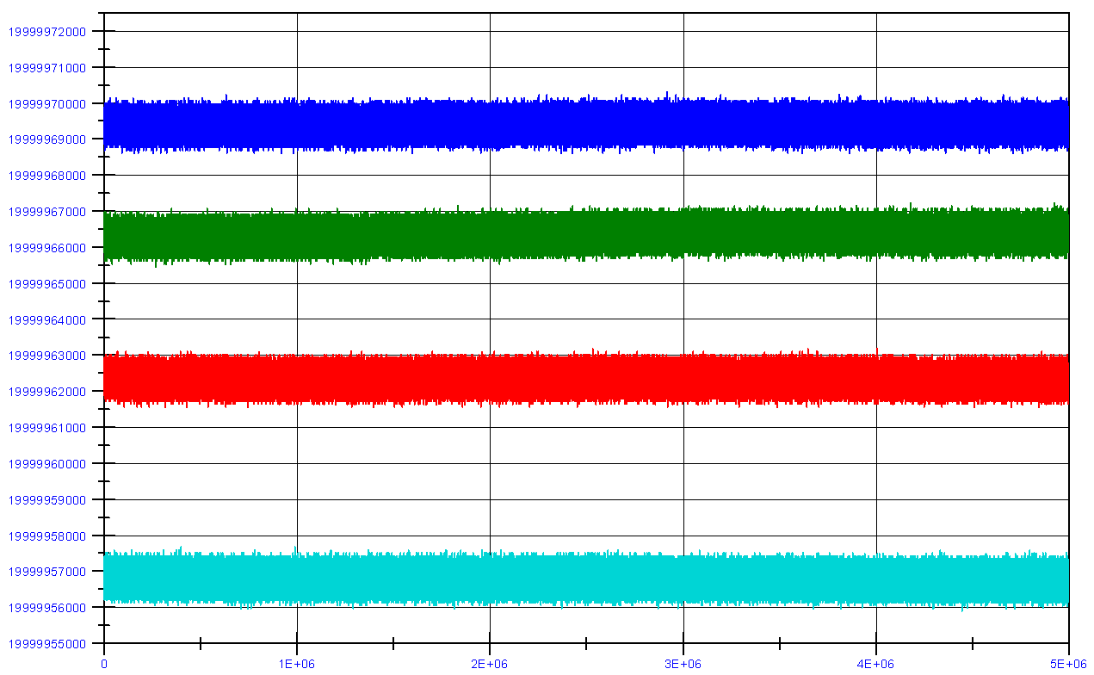

Figure : Focus on only 5M data per channel

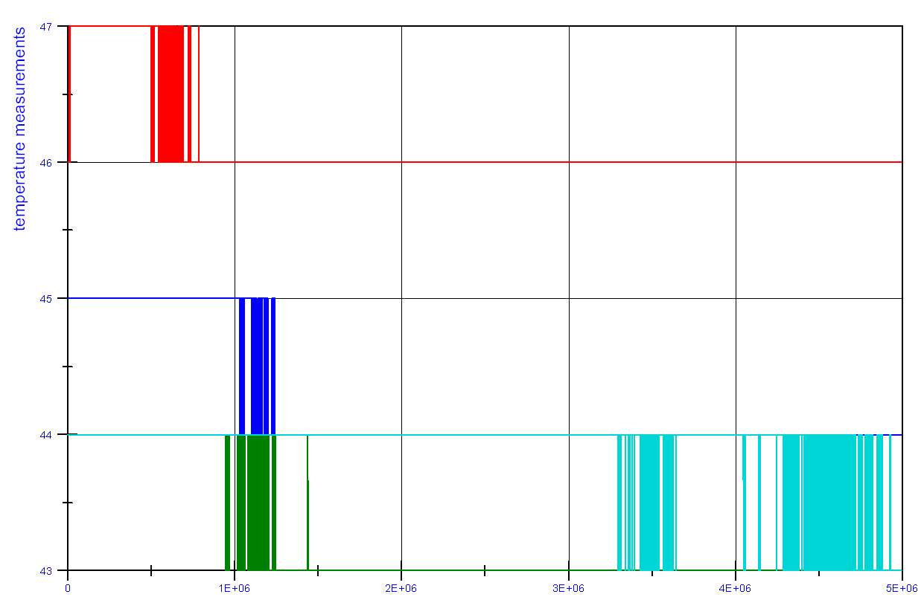

Figure : Rough temperature measurements from the One Wire thermometer on each board

[1]: TDC mezzanine board Performance testing: [ohwr.org/projects/fmc-tdc/repository/changes/board_testing/TDCperformance.pdf](http://www.ohwr.org/projects/fmc-tdc/repository/changes/board_testing/TDCperformance.pdf)

[2]: Precision tests on the TDC mezzanine board: [ohwr.org/projects/fmc-tdc/repository/changes/board_testing/TDCprecision.pdf](http://www.ohwr.org/projects/fmc-tdc/repository/changes/board_testing/TDCprecision.pdf)