TDC channels calibration study

egousiou@cern.ch | 28.05.2013

We use the PCIE_FMC_TESTBENCH7 front end in the 864-1-A19 lab where we plug one SPEC carrier in the setup of Figure 1. We use the V3 pre-series TDC HCCFFIC___-CR000001. The [Symmetricom Cesium](http://www.symmetricom.com/products/frequency-references/cesium-frequency-standard/Cs4000/) clock is used as external time reference for the [CNT 91 pendulum](http://www.spectracomcorp.com/ProductsServices/TestandMeasurement/FrequencyAnalyzersCounters/CNT9191RTimerCounterAnalyzerCalibrator/tabid/1283/Default.aspx). The pendulum is providing pulses of 1 ms period. The [Timetech pulse distributor](http://wikis/display/HT/Pulse+Distribution+Unit+10535+-+1+PPS+to+200MHz%2C+1+input%2C+16+outputs%2C+SMA) is used for the fanout of the input. Cable “a” is 8 ns long and cable “a’” is 2 ns. On the TDC side we enable the channels terminations. From the TDC we acquire 6’400 rising edge timestamps per channel (this translates to 100 fills of the TDC memory); we subtract them by pairs as Figure 2 shows and then we average.

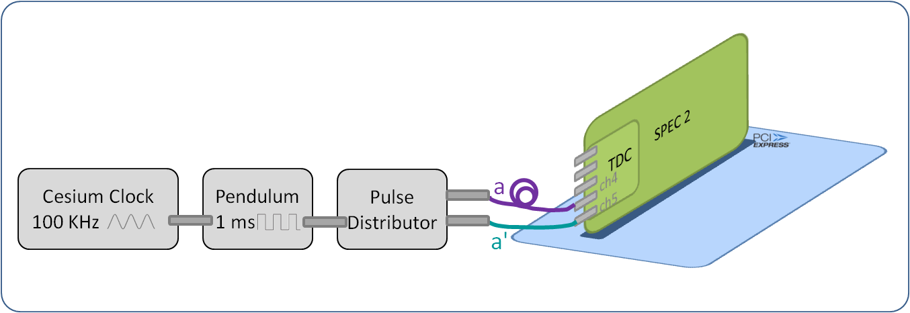

Figure : General setup. Note that the Cesium could be skipped.

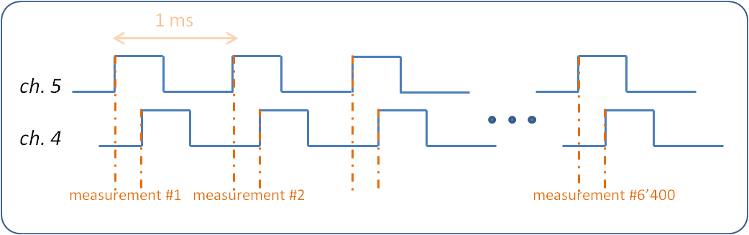

Figure : Pulses arriving to the TDC board

Figure 3 shows in detail how the pulses are arriving to the different locations of the setup. Lch4 represents the path to be traversed by a pulse arriving to the TDC channel 4 until it gets timestamped by the ACAM chip; it also includes the path inside the [CDCLVC clock buffer](http://www.ti.com/lit/ds/symlink/cdclvc1102.pdf), which according to the documentation may vary from chip to chip as much as 2ns. Similarly Lch5 represents the path a pulse arriving to TDC channel 5 needs to traverse until it gets timestamped by the ACAM chip. In the experiment of Figure 3 the average of the 6’400 measurements gave 6124.00 ps.

We can write the equation [1]: (*a + Lch4) – (a’ + Lch5) = 6124.00 ps*

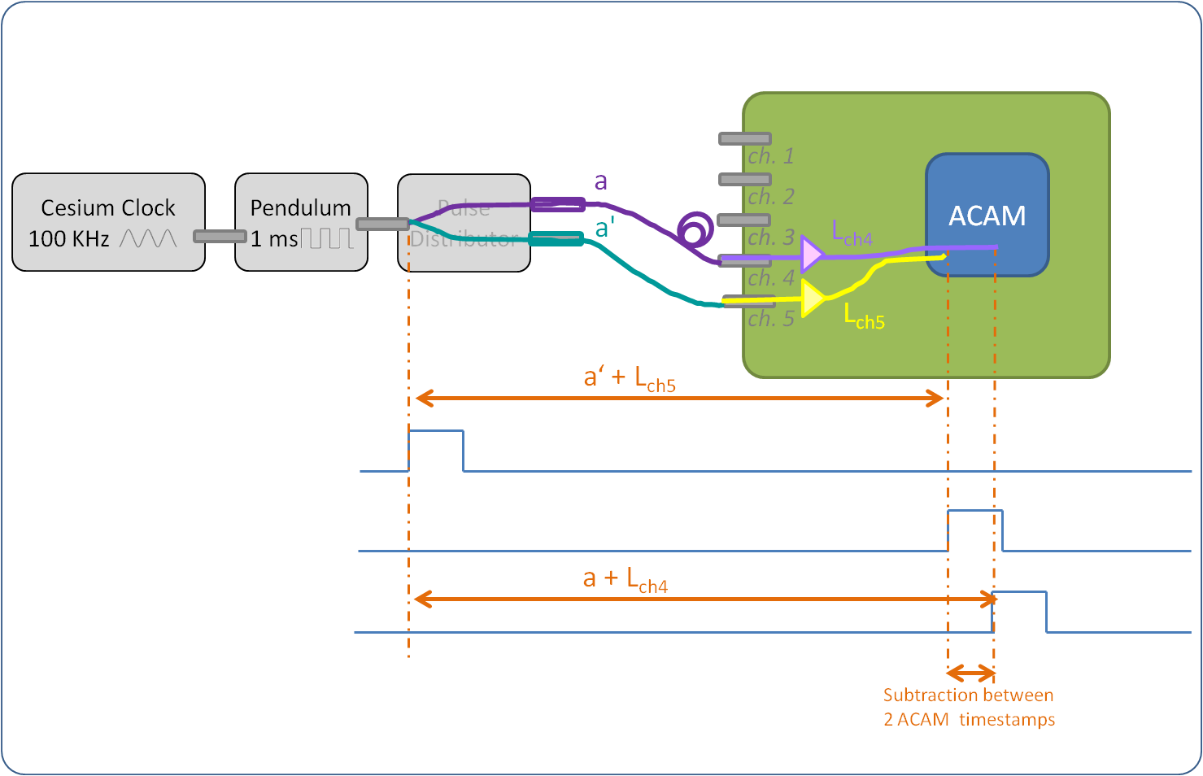

Figure : Pulses as they arrive to different locations of the setup. Lch4 / Lch5 represents the path to be traversed by a pulse arriving to TDC channel 4/5 until it gets timestamped by the ACAM chip.

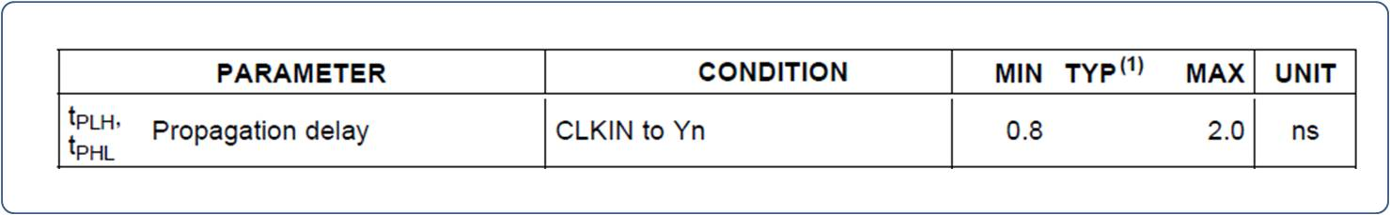

Figure : CDCLV clock buffer propagation delay characteristics

We then swap the cables “a”, “a’” along with the pulse distributor channels and take another 6’400 measurements. Figure 4 shows the new setup. The average of the 6’400 measurements in this setup gave -6280.83 ps (the “-“sign shows that Lch5 is longer than Lch4).

We form the equation [2]: (*a’ + Lch4) – (a + Lch5) = -6280.83 ps*

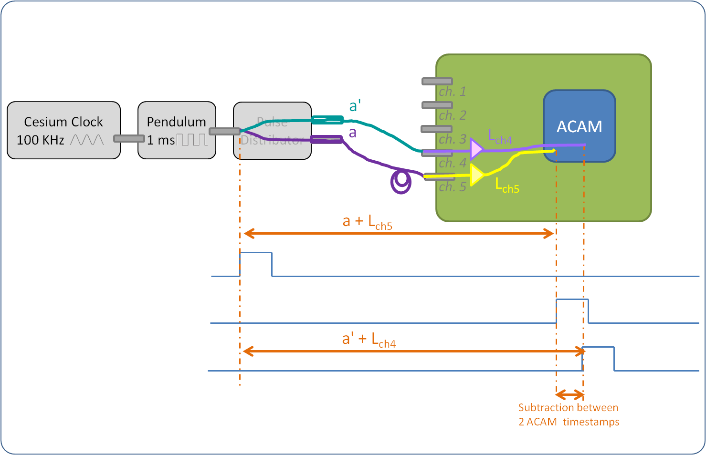

Figure : Pulses as they arrive to different locations of the setup with inverted cables

Adding equations [1] and [2] gives: *Lch4 – Lch5 = -78.415 ps*

Subtracting equations [1] and [2] gives:  *a – a’ = 6202.415 ps*

We performed the same set of experiments for the 10 different TDC channel pairs. Table 1 summarizes the results. The Annex at the end of the document provides the details of the measurements.

|  |  |  |
| --- | --- | --- |
| Channel pair | a - a' (ps) | Path difference (ps) |
| (1,2) | 6211.82 | Lch1 – Lch2  = -146.29 |
| (1,3) | 6203.31 | Lch1 – Lch3  = 379.38 |
| (1,4) | 6193.92 | Lch1 – Lch4  = 356.69 |
| (1,5) | 6192.30 | Lch1 – Lch5  = 280.73 |
| (2,3) | 6206.05 | Lch2 – Lch3  = 536.46 |
| (2,4) | 6195.79 | Lch2 – Lch4  = 510.09 |
| (2,5) | 6206.90 | Lch2 – Lch5  = 432.33 |
| (3,4) | 6202.27 | Lch3 – Lch4  = -24.33 |
| (3,5) | 6208.65 | Lch2 – Lch5  = -101.01 |
| (4,5) | 6202.42 | Lch2 – Lch5  = -78.42 |

Table : Board HCCFFIC___-CR000001 measurements between all pairs of channels

From Table 1, column “a-a’” notice the good precision between different channels; the span is restricted to 19.51 ps.

Table 1, column “Path difference” gives the calibration values for this TDC board.

However, instead of providing all the ten values from Table 1, we could associate each channel to a reference channel, let’s say channel 1. Like this we will only need to provide the four calibration values of Table 2. Remember also that in this application we are only interested in differences between pulses, so the definition of the exact Lch1 length is not in our scope.

The calculation of Lch2 – Lch3 for example can be replaced by (Lch2 – Lch1) - (Lch3 – Lch1) = 146.29 + 379.38 = 525.67 ps which coincides with the 536.46 ps of the direct measurement from Table 1.

|  |  |
| --- | --- |
| Channel pair | Path difference (ps) |
| (1,2) | Lch1 – Lch2  = 146.29 |
| (1,3) | Lch1 – Lch3  = 379.38 |
| (1,4) | Lch1 – Lch4  = 356.69 |
| (1,5) | Lch1 – Lch5  = 280.73 |

Table : Board HCCFFIC___-CR000001 calibration values with respect to channel 1

We did the same tests on TDC board HCCFFIC___-CR000004, coming from the same batch as HCCFFIC___-CR000001. Table 3 shows the results that are very close to the ones of Table 2. Remember also that the TDC resolution is 81.03 ps. More tests will be done on boards from different batches.

|  |  |
| --- | --- |
| Channel pair | Path difference (ps) |
| (1,2) | Lch1 – Lch2  = 156.11 |
| (1,3) | Lch1 – Lch3  = 433.49 |
| (1,4) | Lch1 – Lch4  = 348.75 |
| (1,5) | Lch1 – Lch5  = 265.18 |

Table : Board HCCFFIC___-CR000004 calibration values with respect to channel 1

## Automated Calibration

For the automation of the procedure, the USB calibration box (aka Mathieu’s) will be used as the following figures show. The short “1ns” cables between the USB box and the board are coming from the same lot and we suppose they are identical in length, regardless of their real value. In order to stay as much as possible intact from the other cable length uncertainties and the delays of the pulse distributor, the idea is that the operator, when asked, swaps the USB box input cables. Essential is also the calibration of the USB box.; this will be done only once.

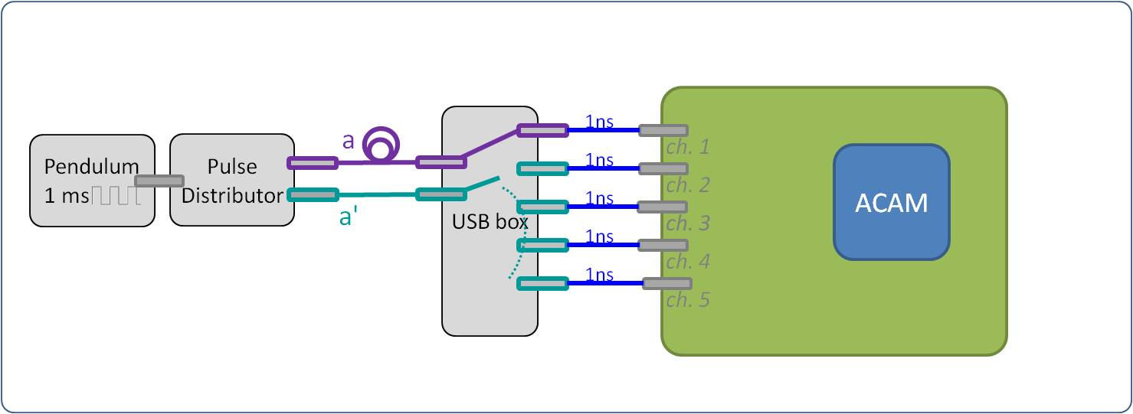

Figure : Automated Calibration Setup (cables straight)

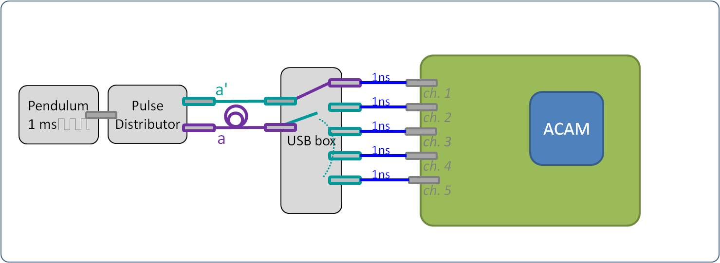

Figure : Automated Calibration Setup (cables swapped)

For the calibration of the box, we tested board HCCFFIC___-CR000001. Table summarizes the tests done with the setup of Fugure 6 and Table.. the ones with the setup of Figure7.

|  |  |
| --- | --- |
| Channel pair | Path difference (ps) |
| (1,2) | Pathch1 – Pathch2  = 5637.12 |
| (1,3) | Pathch1 – Pathch3  = 6192.92 |
| (1,4) | Pathch1 – Pathch4  = 6166.04 |
| (1,5) | Pathch1 – Pathch5  = 6021.23 |

|  |  |
| --- | --- |
| Channel pair | Path difference (ps) |
| (1,2) | Pathch1 – Pathch2  = -6346.40 |
| (1,3) | Pathch1 – Pathch3  = -5781.48 |
| (1,4) | Pathch1 – Pathch4  = -5778.94 |
| (1,5) | Pathch1 – Pathch5  = -5925.48 |

|  |  |
| --- | --- |
| Channel pair | Path difference (ps) |
| (1,2) | Lch1 – Lch2  = -354.64 |
| (1,3) | Lch1 – Lch3  = 205.72 |
| (1,4) | Lch1 – Lch4  = 193.55 |
| (1,5) | Lch1 – Lch5  = -47.88 |

Using the values of Table we manage to establish the calibration of the USB box.

|  |  |
| --- | --- |
| Channel pair | Path difference (ps) |
| (1,2) | BoxLengthch1 – BoxLengthch2  = 208.35 |
| (1,3) | BoxLengthch1 – BoxLengthch3  = 173.66 |
| (1,4) | BoxLengthch1 – BoxLengthch4  = 163.14 |
| (1,5) | BoxLengthch1 – BoxLengthch5  = 232.85 |

With the calibrated values we now retested with the setup of Figures 6 and 7 the board HCCFFIC___-CR000004. Table shows the results that are very similar to the ones of Table 3.

|  |  |
| --- | --- |
| Channel pair | Path difference (ps) |
| (1,2) | Lch1 – Lch2  = -159.10 |
| (1,3) | Lch1 – Lch3  = 440.62 |
| (1,4) | Lch1 – Lch4  = 343.99 |
| (1,5) | Lch1 – Lch5  = 267.61 |

|  |  |
| --- | --- |
| Channel pair | Path difference (ps) |
| (1,2) | Lch1 – Lch2  = -153.73 |
| (1,3) | Lch1 – Lch3  = 433.66 |
| (1,4) | Lch1 – Lch4  = 340.65 |
| (1,5) | Lch1 – Lch5  = 260.80 |

# Annex

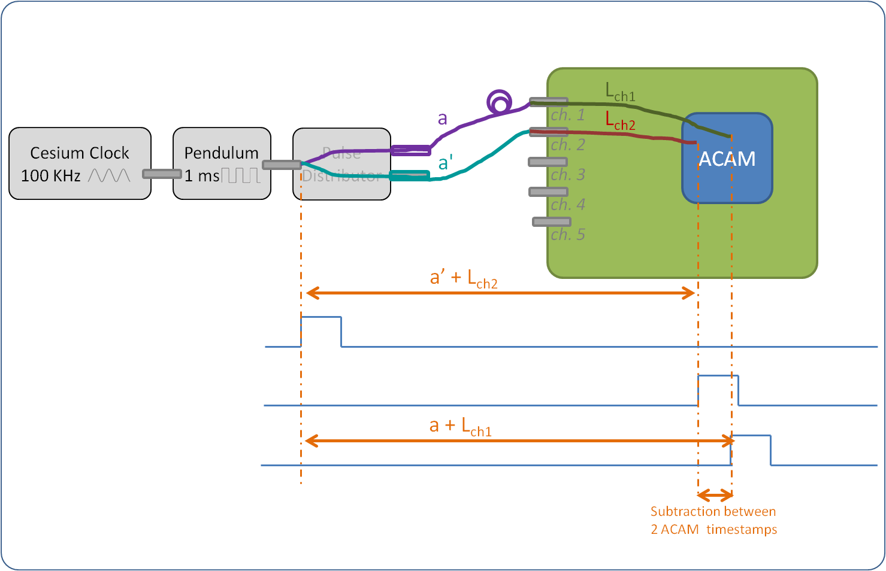

*[1]: a + Lch1 – (a’ + Lch2) = 6065.53 ps*

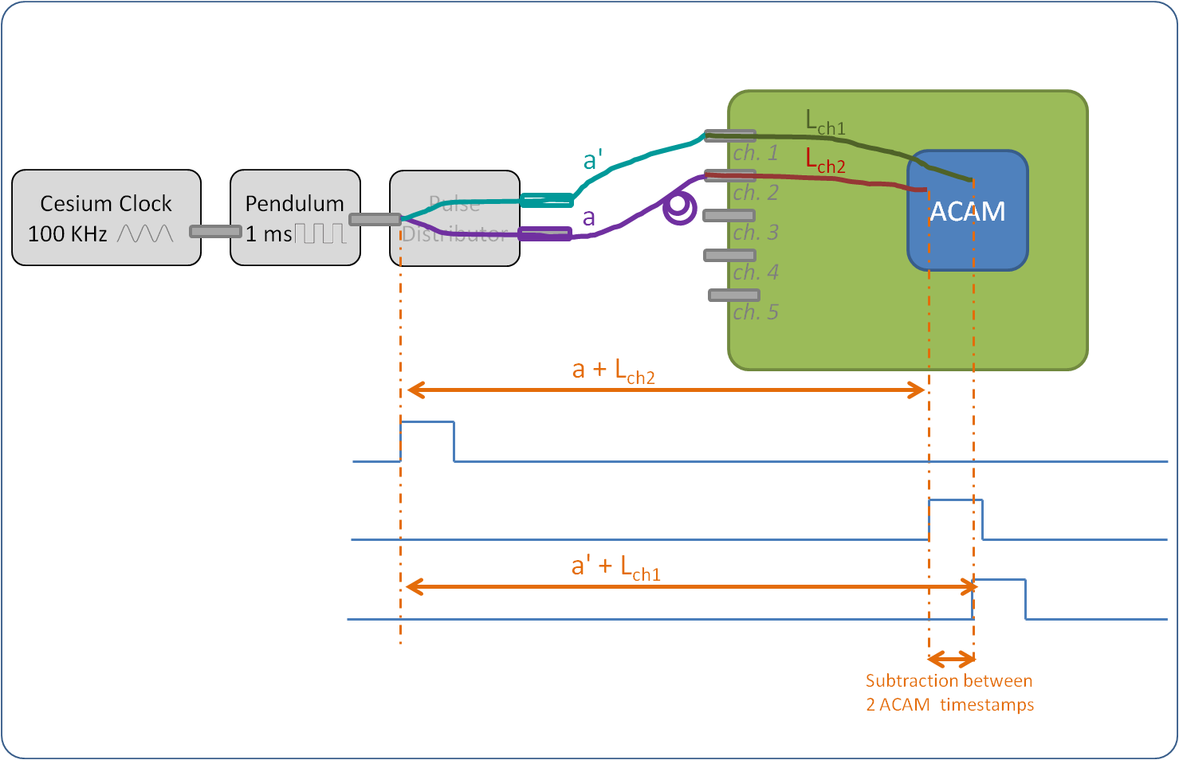

*[2]: a' + Lch1 – (a + Lch2) = -6358.10 ps*

*[1+2]: Lch1 – Lch2 = -146.285 ps*

*[1-2]: a – a’ = 6211.815 ps*

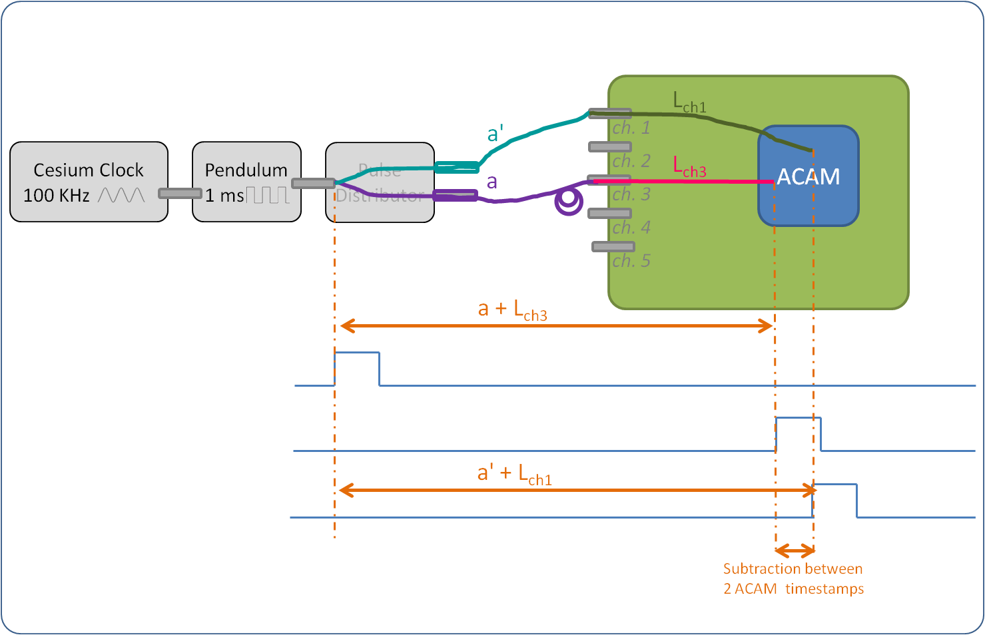

*[1]: a + Lch1 – (a’ + Lch3) = 6582.69 ps*

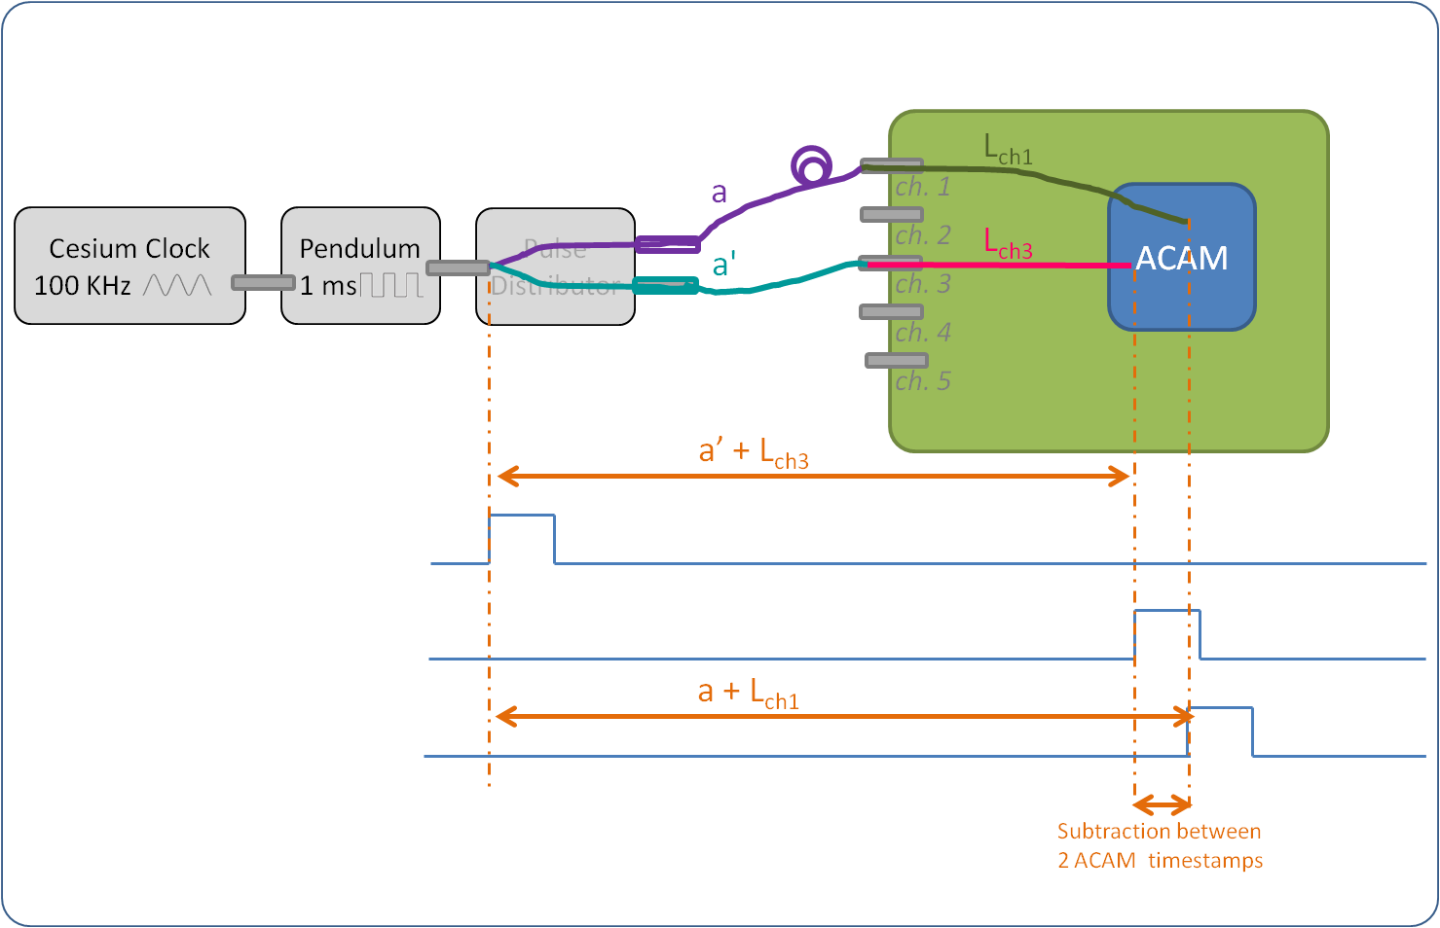

*[2]: a' + Lch1 – (a + Lch3) = - 5823.93 ps*

*[1+2]: Lch1 – Lch3 = 379.38 ps*

*[1-2]: a – a’ = 6203.31 ps*

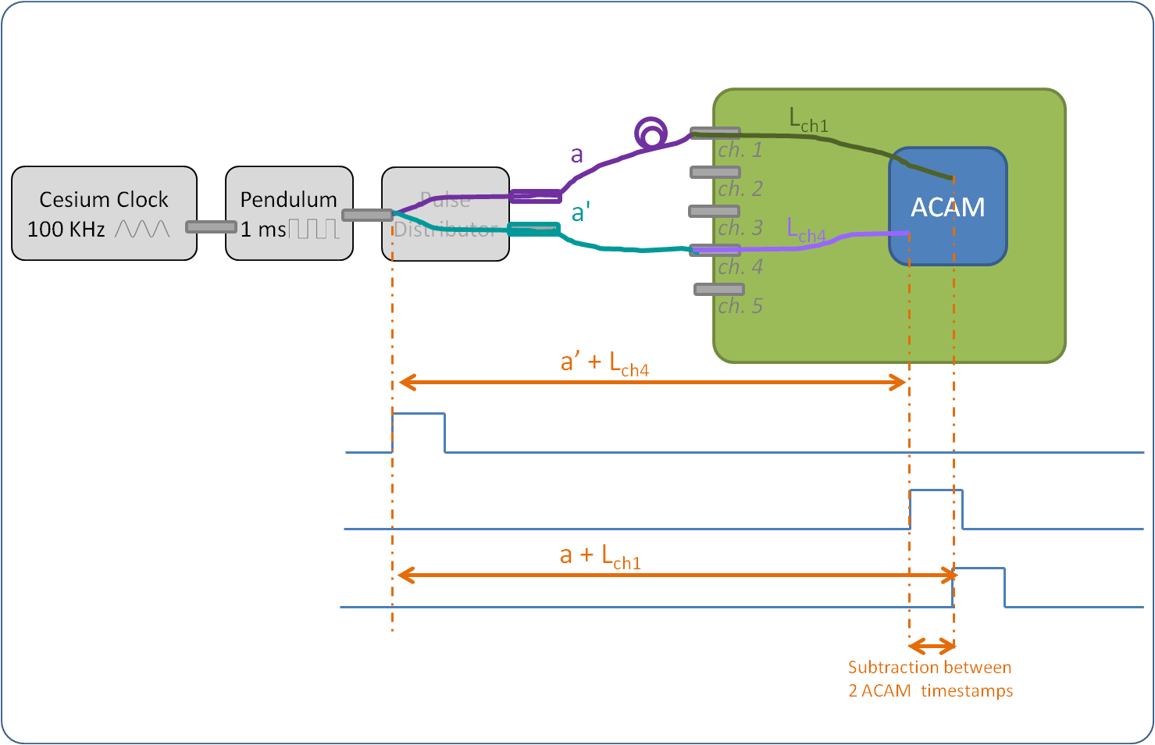

*[1]: a + Lch1 – (a’ + Lch4) = 6550.60 ps*

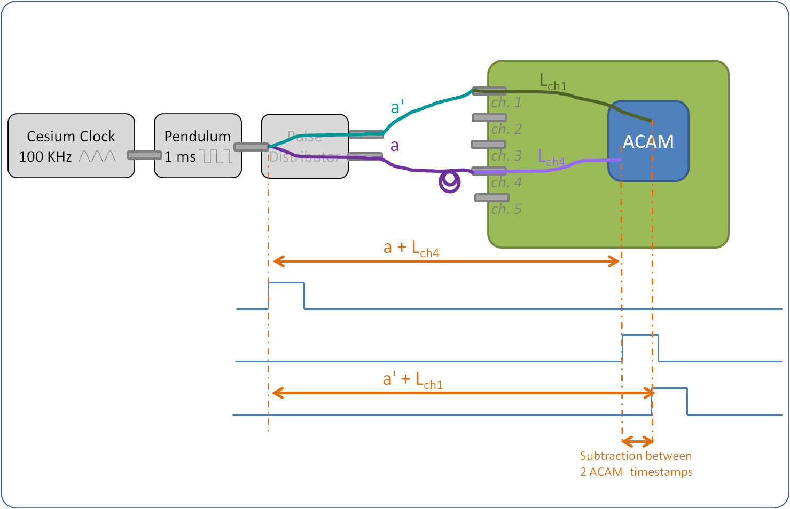

*[2]: a' + Lch1 – (a + Lch4) = -5837.23 ps*

*[1+2]: Lch1 – Lch4 = 356.685 ps*

*[1-2]: a – a’ = 6193.915 ps*

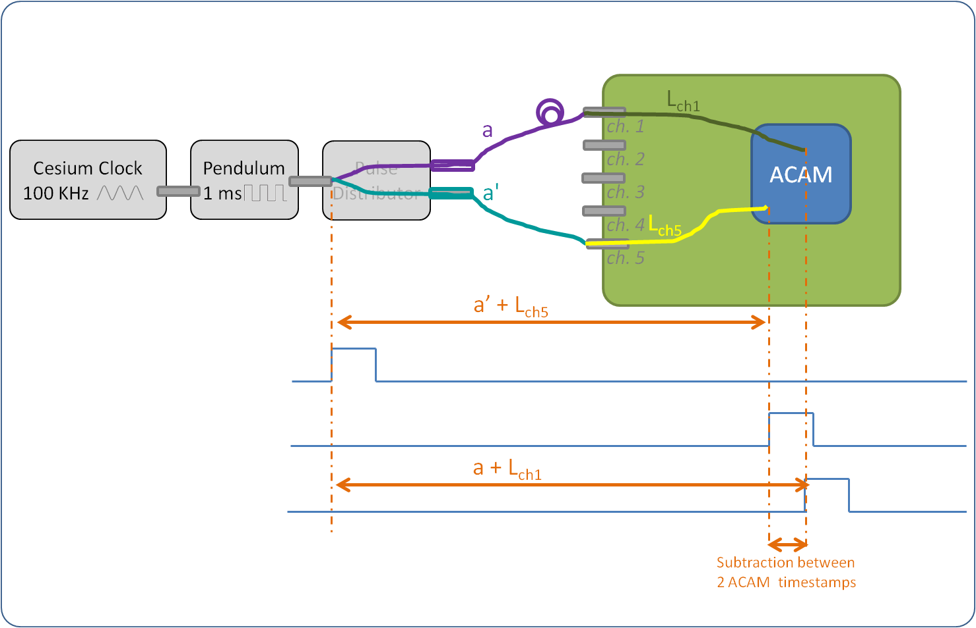

*[1]: a + Lch1 – (a’ + Lch5) = 6473.03 ps*

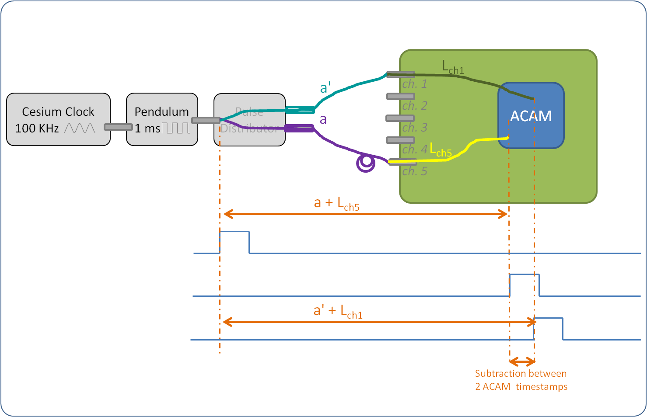

*[2]: a' + Lch1 – (a + Lch5) = -5911.58 ps*

*[1+2]: Lch1 – Lch5 = 280.725 ps*

*[1-2]: a – a’ = 6192.305 ps*

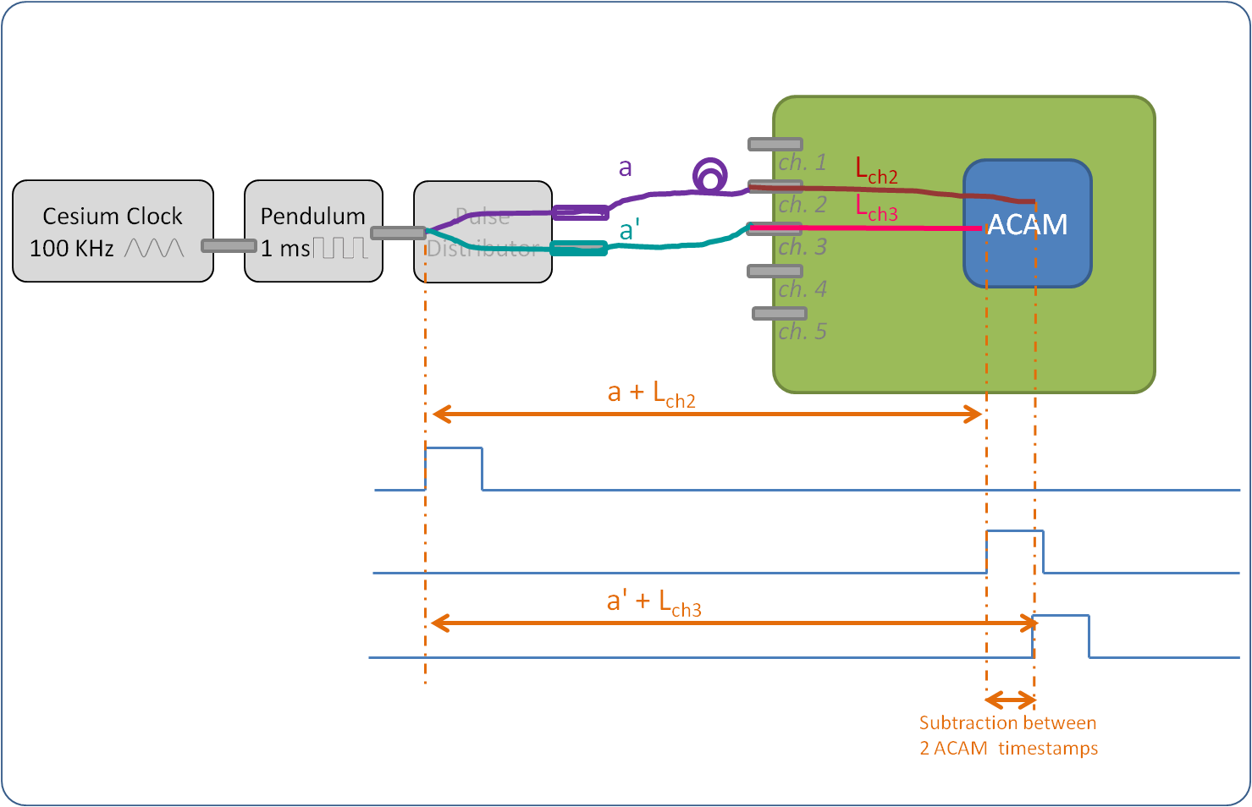

*[1]: a + Lch2 – (a’ + Lch3) = 6742.50 ps*

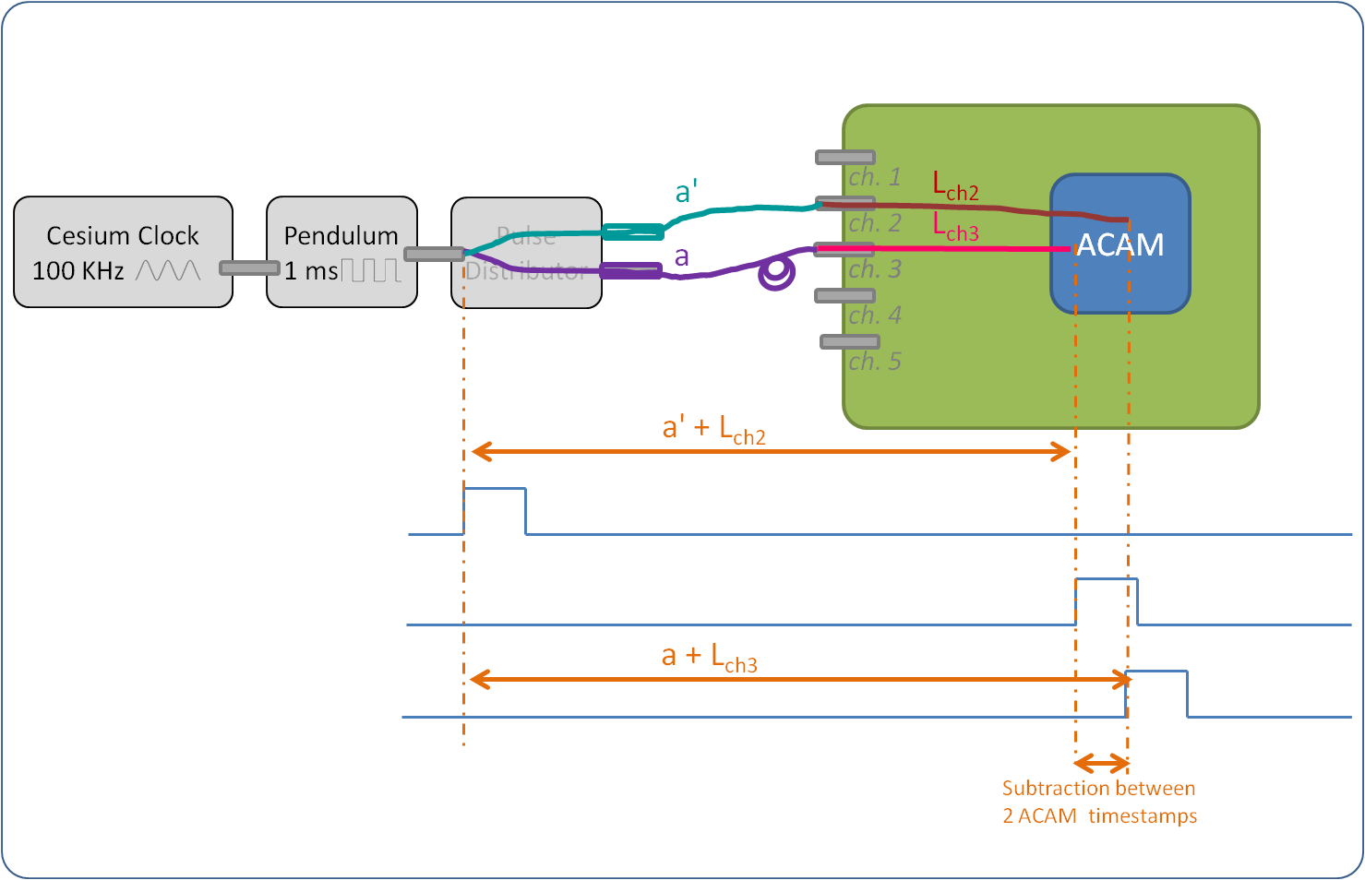

*[2]: a' + Lch2 – (a + Lch3) = -5669.59 ps*

*[1+2]: Lch2 – Lch3 = 536.455 ps*

*[1-2]: a – a’ = 6206.045 ps*

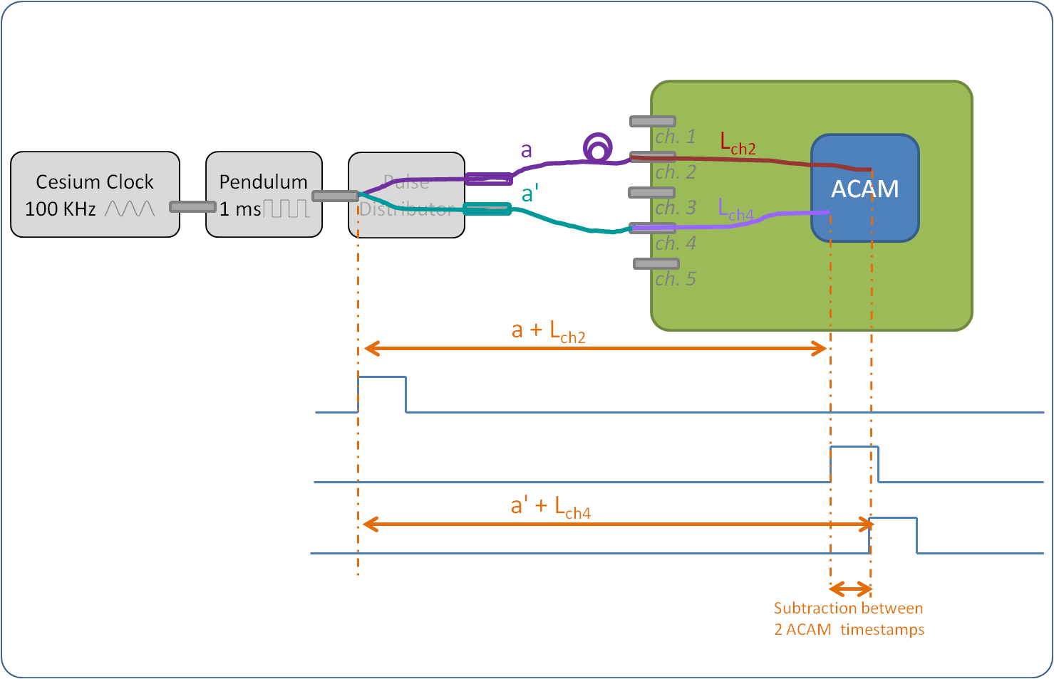

*[1]: a + Lch2 – (a’ + Lch4) = 6705.88 ps*

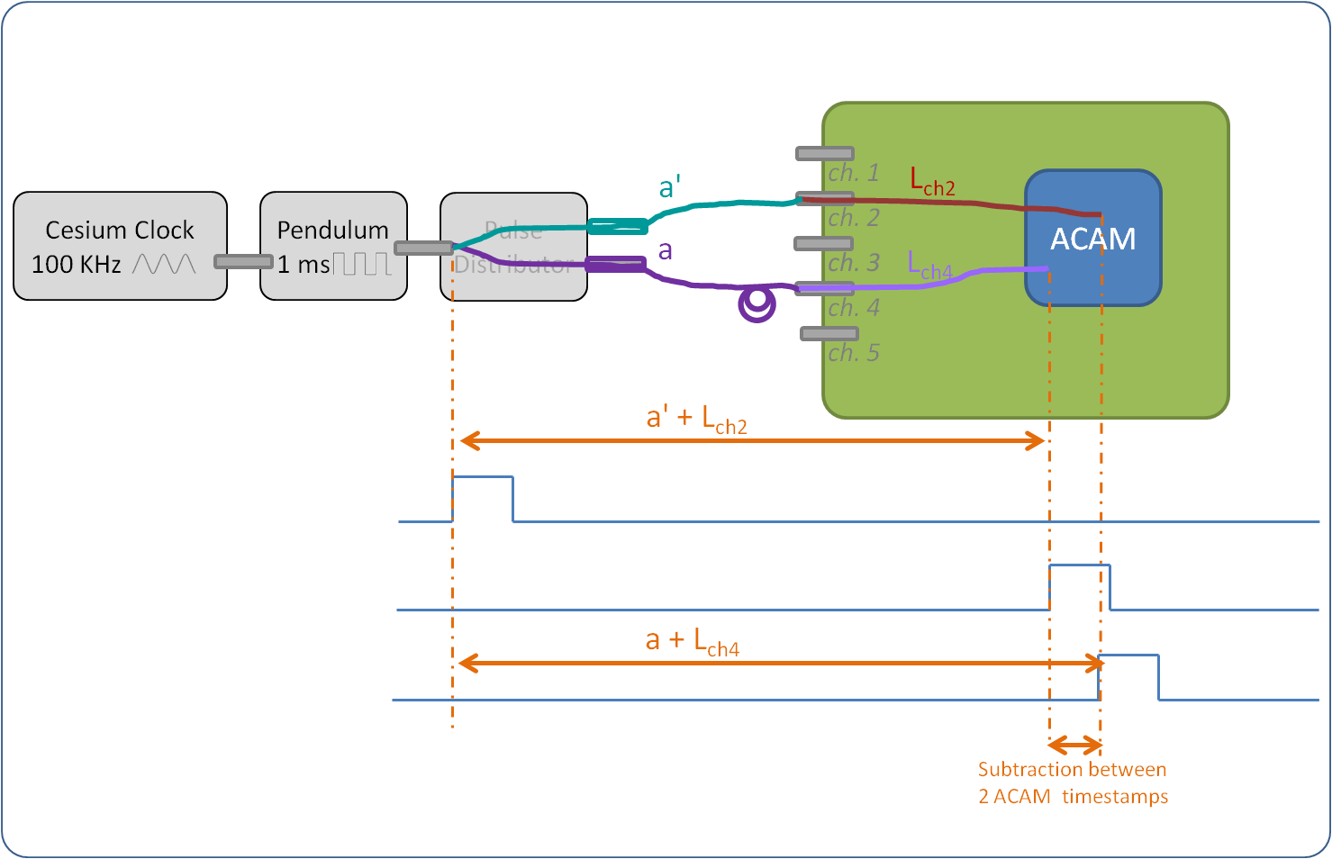

*[2]: a' + Lch2 – (a + Lch4) = -5685.70 ps*

*[1+2]: Lch2 – Lch4 = 510.09 ps*

*[1-2]: a – a’ = 6195.79 ps*

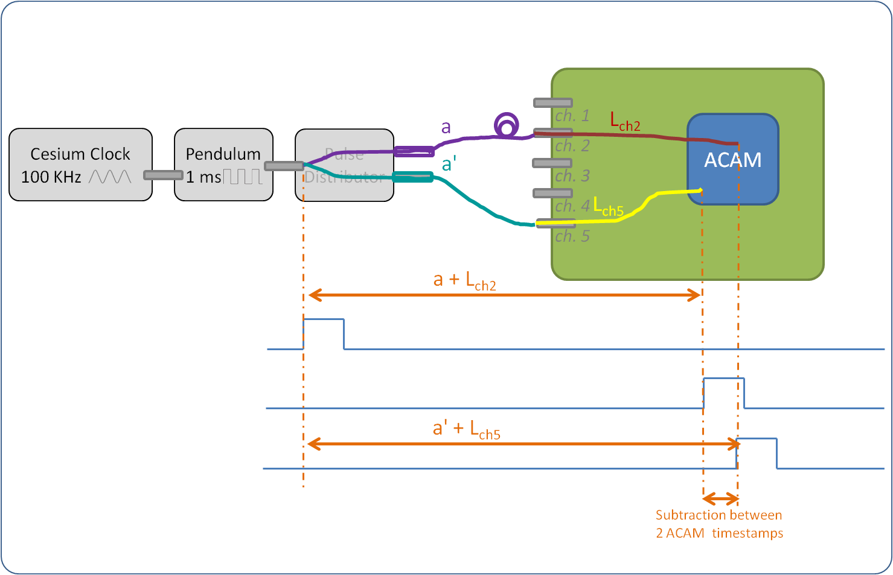

*[1]: a + Lch2 – (a’ + Lch5) = 6639.22 ps*

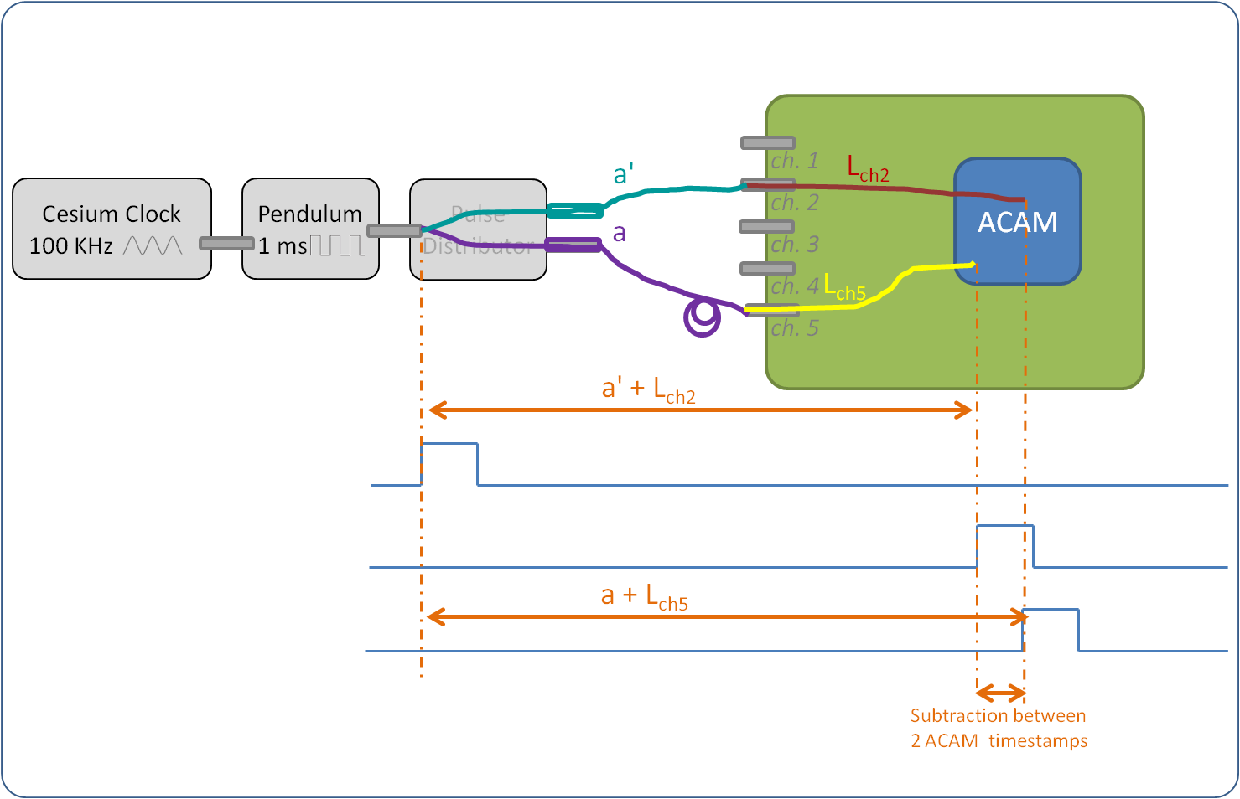

*[2]: a' + Lch2 – (a + Lch5) = -5774.57 ps*

*[1+2]: Lch2 – Lch4 = 432.325 ps*

*[1-2]: a – a’ = 6206.895 ps*

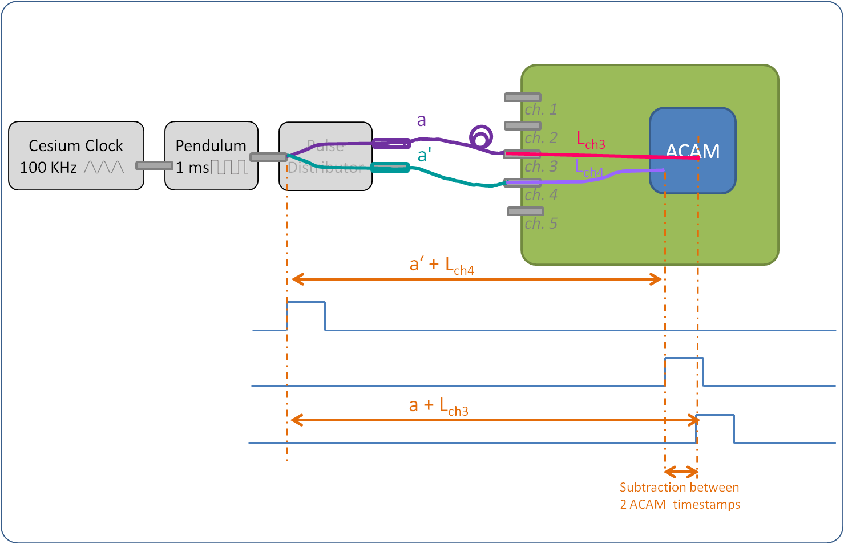

*[1]: a + Lch3 – (a’ + Lch4) = 6177.94 ps*

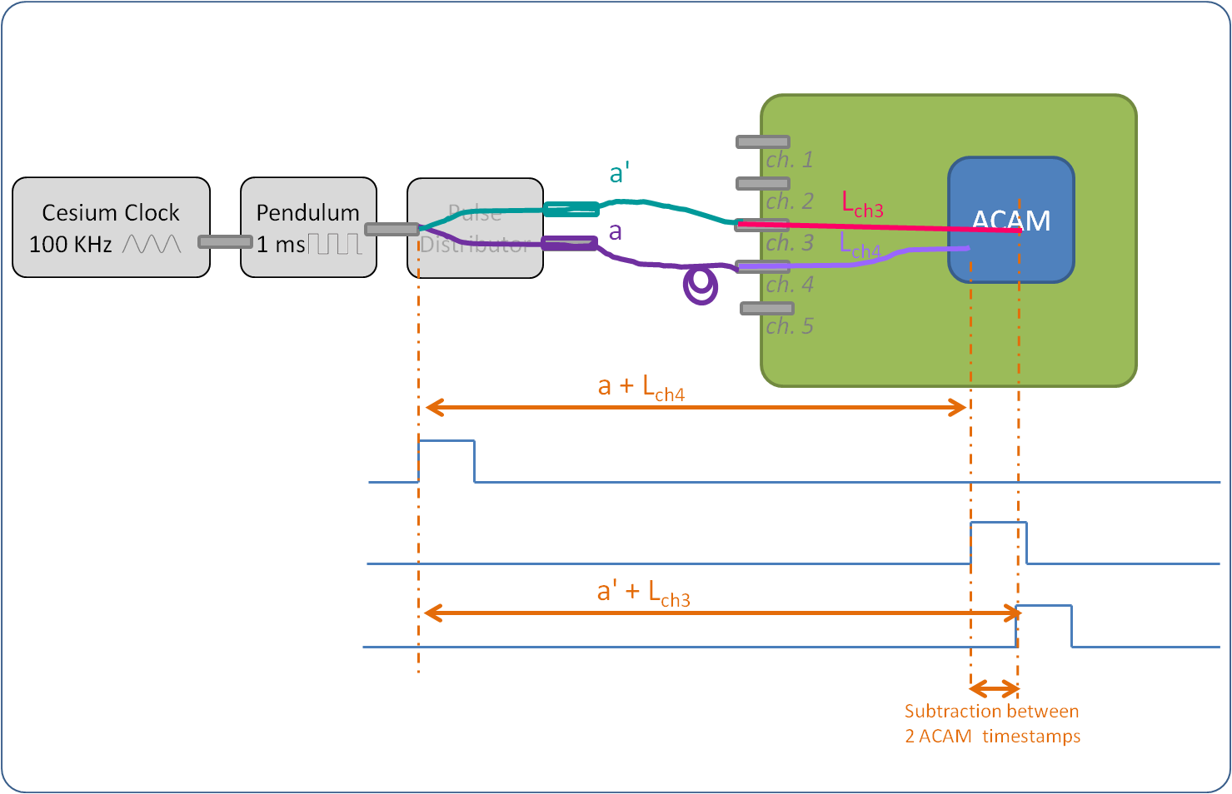

*[2]: a' + Lch3 – (a + Lch4) = -6226.60 ps*

*[1+2]: Lch3 – Lch4 = -24.33 ps*

*[1-2]: a – a’ = 6202.27 ps*

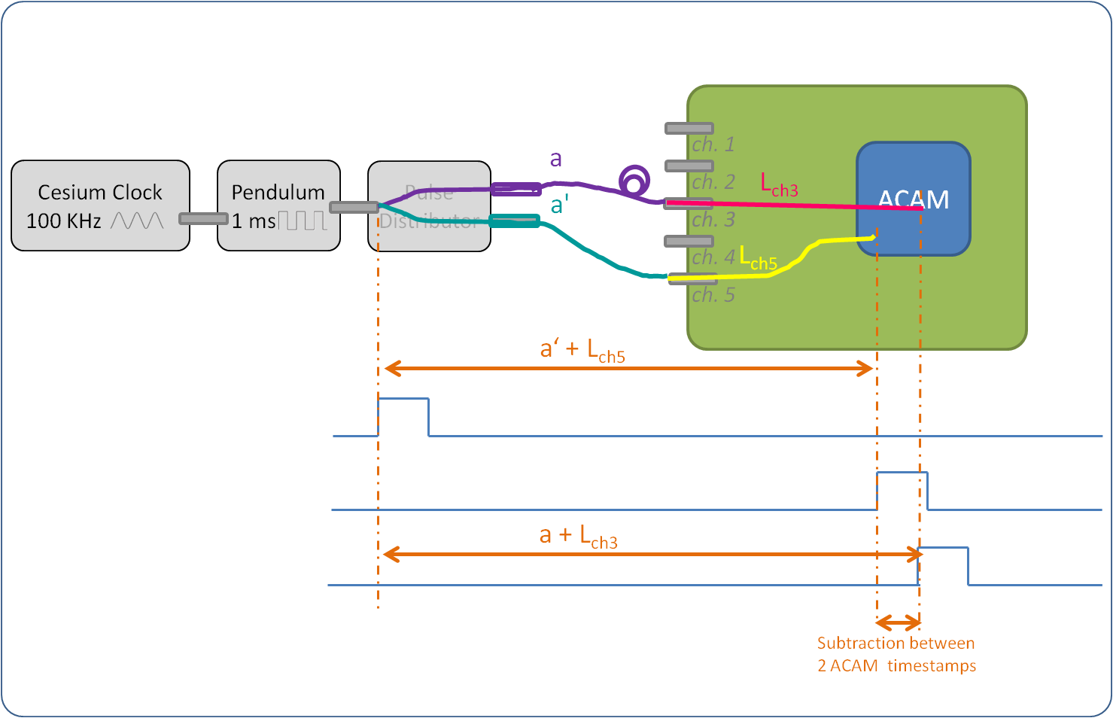

*[1]: a + Lch3 – (a’ + Lch5) = 6107.64 ps*

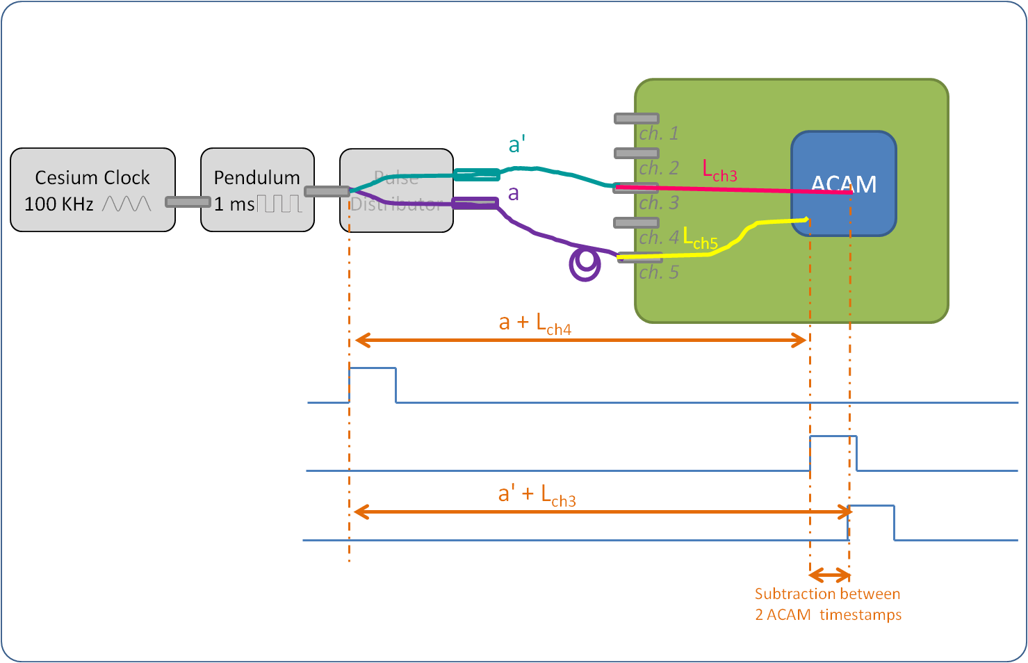

*[2]: a' + Lch3 – (a + Lch5) = -6309.66 ps*

*[1+2]: Lch3 – Lch5 = -101.01 ps*

*[1-2]: a – a’ = 6208.65 ps*

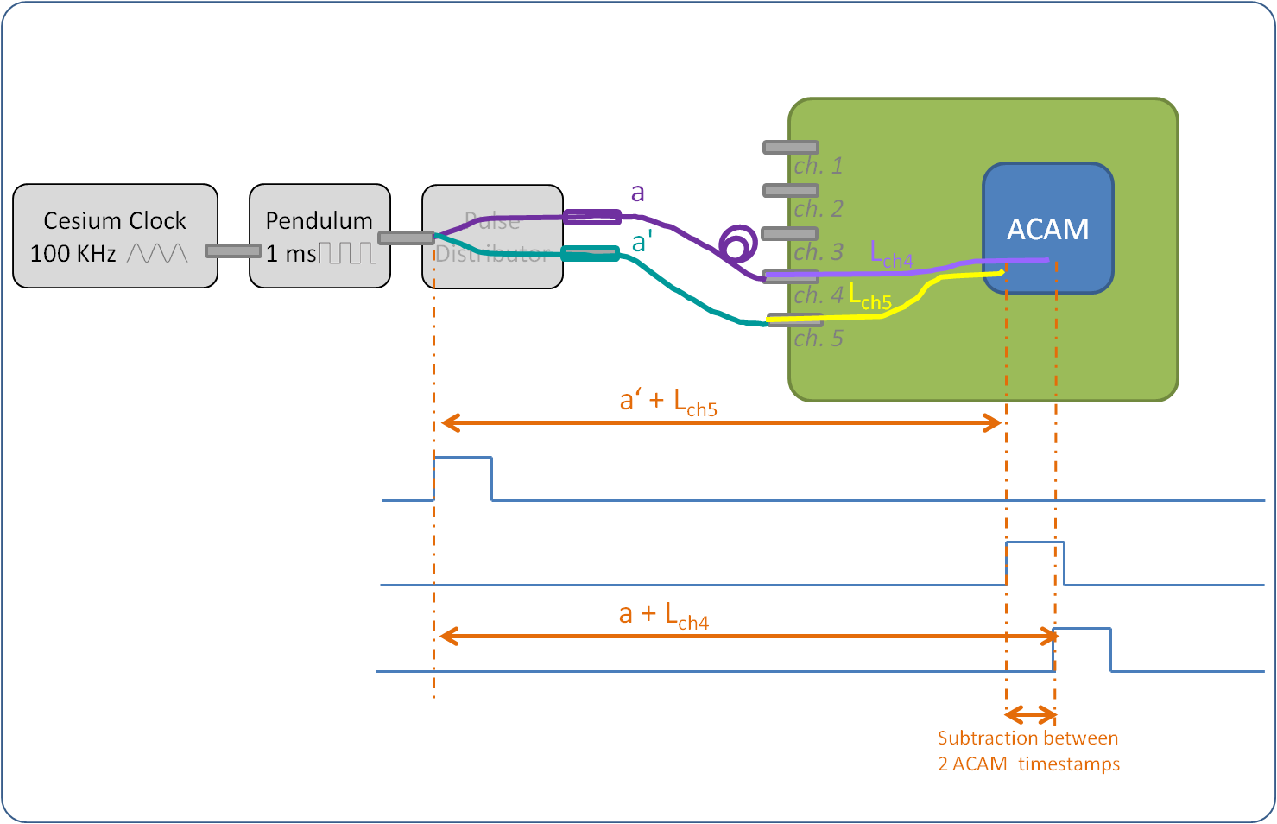

*[1]: a + Lch4 – (a’ + Lch5) = 6124.00 ps*

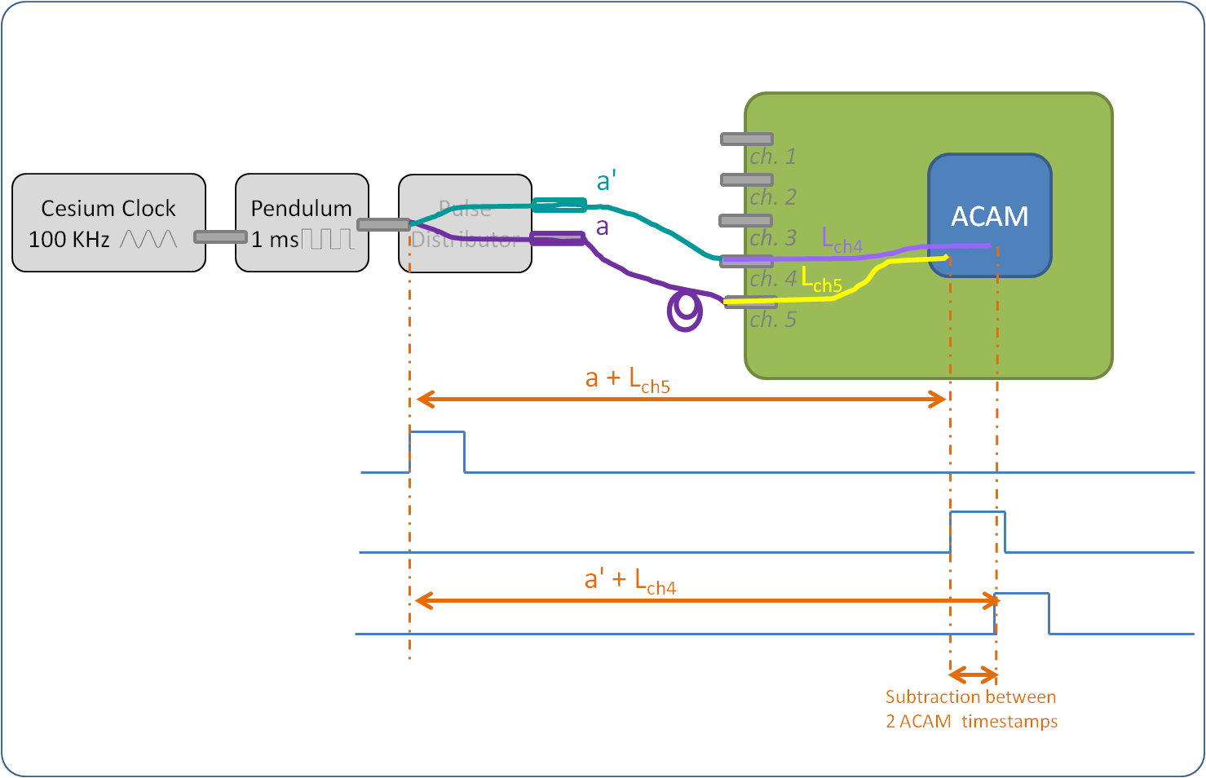

*[2]: a' + Lch4 – (a + Lch5) = -6280.83 ps*

*[1+2]: Lch4 – Lch5 = -78.415 ps*

*[1-2]: a – a’ = 6202.415 ps*