Results of the Precision tests on the TDC mezzanine board (draft)

The aim of the test is to determine the precision of the [Time to Digital Converter mezzanine board](http://www.ohwr.org/projects/fmc-tdc/wiki) (TDC).

The TDC board makes use of the [ACAM TDC-GPX](http://www.acam.de/fileadmin/Download/pdf/English/DB_GPX_e.pdf) chip and can measure time difference between the rising edges of pulses arriving to its stop channels.

The testing plan is to acquire and analyze a significant amount of measurements of a constant value.

## ACAM TDC-GPX precision

After a conversation with ACAM Engineer N.Breyer it has been clarified that the measurements of a TDC-GPX channel show a typical Gaussian distribution. What is called resolution in the ACAM documentation, which is specified as 81 ps for the I-mode, can be understood as 1 standard deviation of a Gaussian distribution.

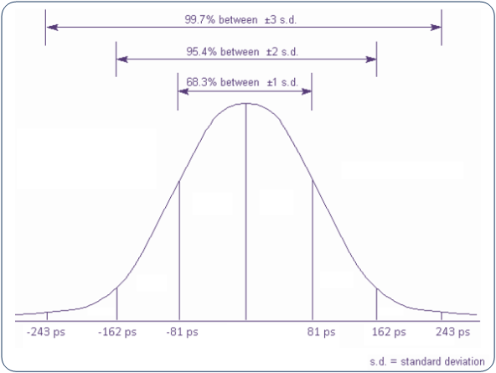

Figure : TDC-GPX channel precision

In this TDC testing we are making use of 2 TDC channels. If we assume a Gaussian distribution with standard deviation = 81ps for each channel, the result of the [subtraction](http://mathworld.wolfram.com/NormalDifferenceDistribution.html) of two channels would also be a Gaussian distribution with standard deviation = 81√2 = 115 ps.

The initial specification for the precision of the TDC board is +/- 500 ps. This translates to ~+/-4 standard deviations. Note that in a Gaussian distribution ~0.006% of data is outside +/-4 standard deviations.

**Test Setup #1**

We used the PCIE_FMC_TESTBENCH3 front end in the 864-1-A17 lab where we plugged two SPEC carrier boards as Figure 2 indicates.

SPEC 1 carries a Fine Delay (FD) mezzanine, used as pulse generator.

SPEC 2 carries the TDC mezzanine under test. One TDC channel is connected to one FD channel and a second TDC channel is connected to the first one through a 16 ns coaxial LEMO cable.

Figure 2 shows how pulses should be arriving to each one of the TDC channels.

A temperature measurement on the TDC mezzanine is being acquired every second.

A dedicated python testing program is responsible for the continuous retrieval of the timestamps and their manipulation: only timestamps corresponding to rising edges are kept and they are subtracted by pairs. This way the delay introduced by the coaxial cable is the constant value on which the precision testing is based.

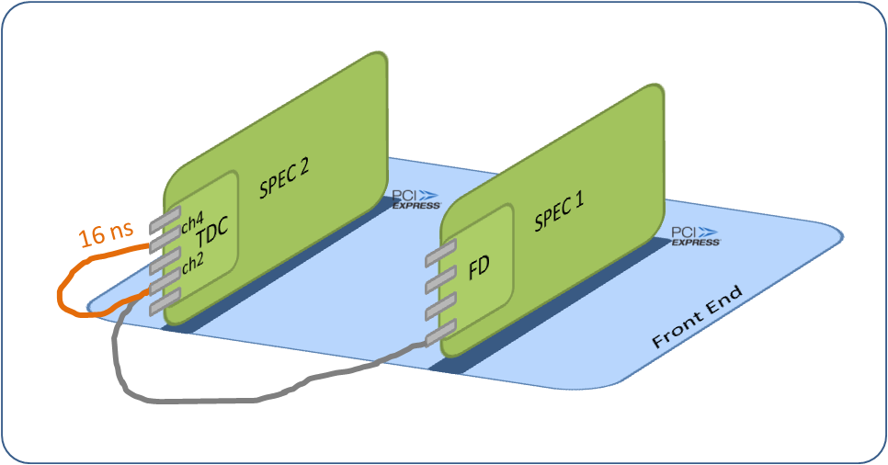

Figure : Test setup

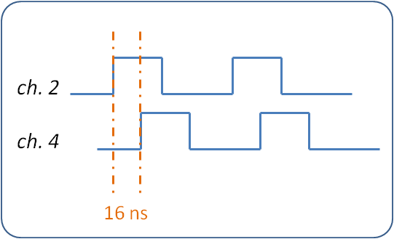

Figure : Pulses arriving to the two TDC stop channels

Note that with this setup the channels are not correctly terminated, as from one FD channel we have to arrive to two TDC ones. We assume that it is because of reflections that the tested boards indeed measured the 16 ns cable delay as ~20 ns when the termination of channel 2 was enabled and as ~23 ns when the termination of channel 4 was enabled.

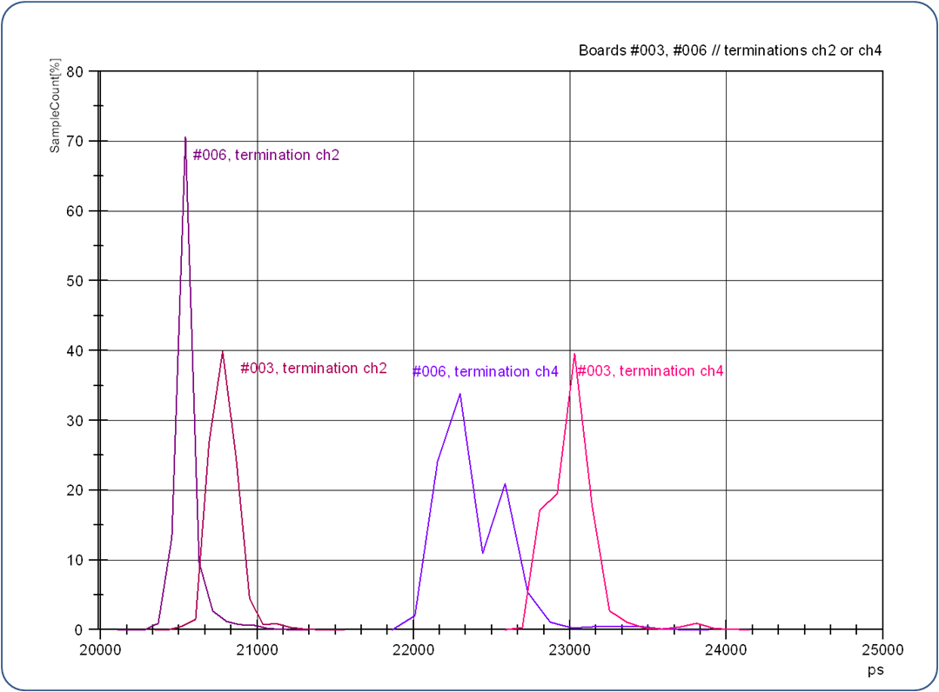

Figure : Histograms of the measurements on different boards with different terminations, under Setup #1

|  |  |  |
| --- | --- | --- |
| Board | Termination | Mean (ps) |
| #006 | ch2 | 20568 |
| #003 | ch2 | 20780 |
| #006 | ch4 | 22310 |
| #003 | ch4 | 23011 |

Moreover we noted a clear correlation of the measurements with temperature in this setup.

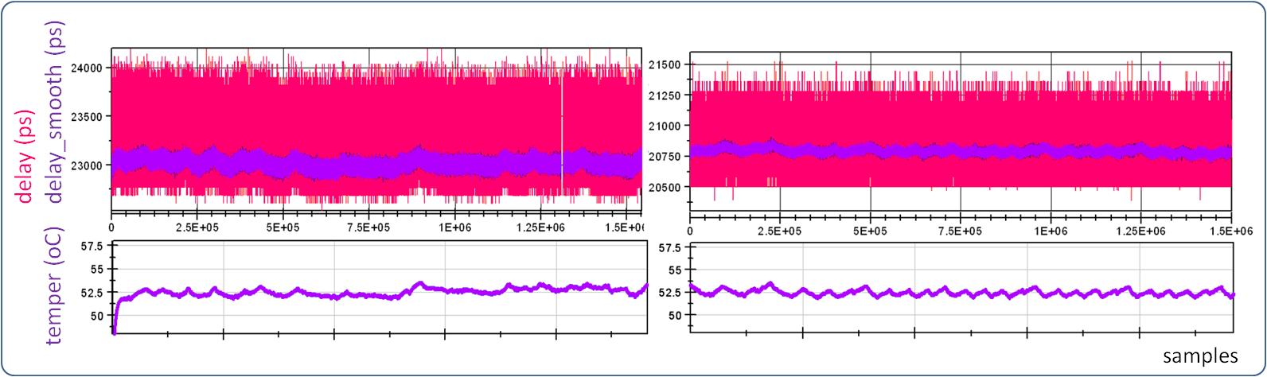

Figure : Measurements-Temperature correlation on Setup #1. Board #003 with termination on ch4 (left) and ch2 (right).

To allow for proper termination of both channels we introduced the ”CLOCK FAN_OUT” board; the new setup is shown in Figure 6.

# Test Setup #2

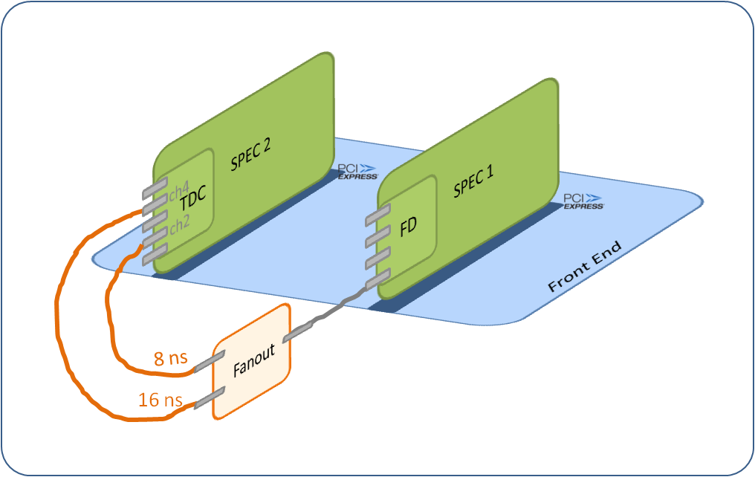

Figure : Test Setup #2

Several tests on all the available boards have been performed in this setup. The measurements of all the boards are around the expected value of 8ns. The following table summarizes the tests.

|  |  |  |  |
| --- | --- | --- | --- |
| Test Set # | Boards | Channels | Remarks |
| Test Set #2.1 | #003, #004, #006, #007, #008 | (2, 4) | comparison between different **boards** |
| Test Set #2.2 | #004 | (2, 4) | comparison between different **data volumes** |
| Test Set #2.3 | #003, #004 | (2, 4) (1, 3) | comparison between different **channel pairs** |
| Test Set #2.4 | #003, #004 | (1, 3) | comparison between different **testing days** |

We noted that with this setup, there was no correlation between the measurements and temperature.

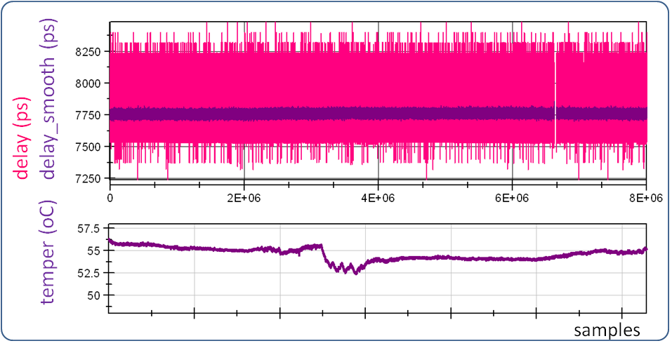

Figure : Measurements-Temperature correlation on Setup #2. Board #003 on Test Set#2.1.

## Test Set #2.1

|  |  |
| --- | --- |
| Test Set #2.1 | |
| Boards | #003, #004, #006, #007, #008 |
| Channels | 2, 4 |

The following figure shows the distributions of the measurements of each one of the five boards.

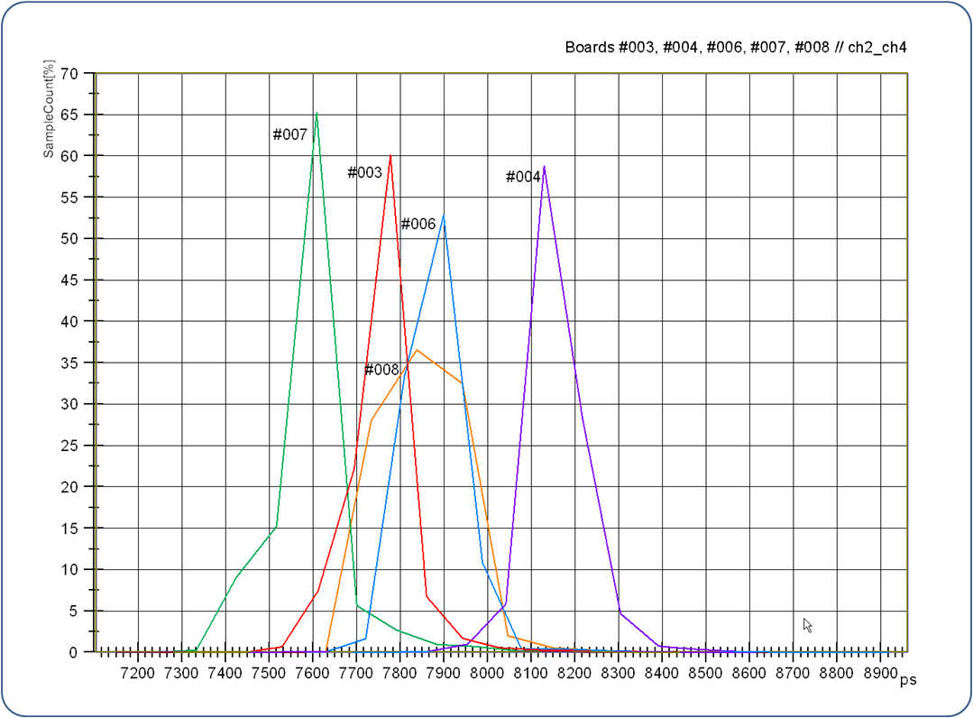

Figure : Histograms of the same test on different boards

|  |  |  |  |  |  |  |  |  |
| --- | --- | --- | --- | --- | --- | --- | --- | --- |
| **Board** | **Data Volume** | **Mean(ps)** | **Sigma(ps)** | **Min(ps)** | **Max(ps)** | **Max-Min(ps)** | **% Data out of +/-500 ps (*)** | **% Data out of +/-687 ps (**)** |
| **#007** | 8M | 7605 | 83 | 7104 | 8480 | 1376 | 0.08 | ~0.002 |
| **#003** | 8M | 7758 | 72 | 7240 | 8480 | 1240 | 0.004 | 0 |
| **#008** | 8M | 7868 | 77 | 7160 | 8724 | 1564 | 0.02 | ~0.0005 |
| **#006** | 8M | 7861 | 78 | 7320 | 8656 | 1336 | 0.02 | 0 |
| **#004** | 8M | 8133 | 72 | 7648 | 8960 | 1312 | 0.02 | 0 |

(*) +/- 500 ps correspond to ~+/-4σ of the ACAM distribution

(**) +/- 687 ps correspond to +/-6σ of the ACAM distribution

The difference in the mean values of Figure 8 could be explained by the characteristics of the [CDCLVC clock buffer](http://www.ti.com/lit/ds/symlink/cdclvc1102.pdf) used in the input of every TDC stop channel. The documentation mentions 500 ps difference from chip to chip; the maximum difference between the mean values of Figure 8 is 528 ps.

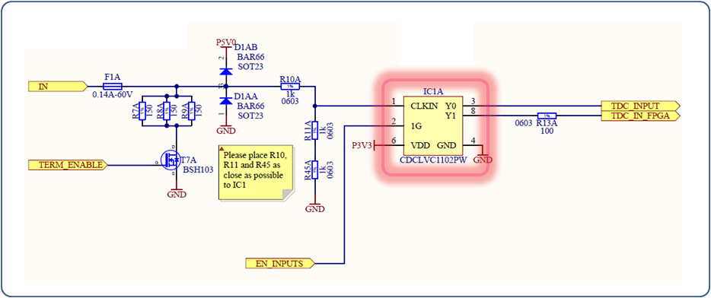

Figure : TDC Input logic

It is important to note that the voltage level of a pulse on the input of a buffer is measured ~1.7V which is lower than the 2.25V of the recommended conditions. This could be an origin of imprecision.

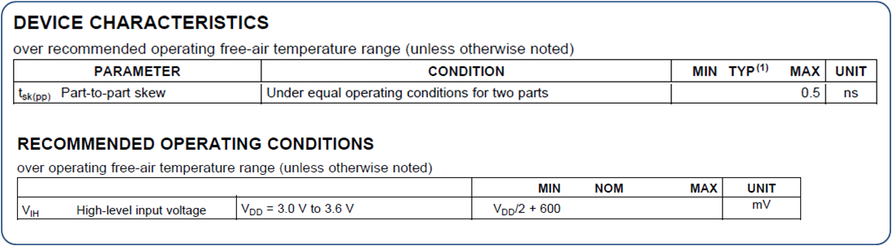

Figure : Texas Instruments CDCLVC11xx specification

## Test Set #2.2

|  |  |
| --- | --- |
| Test Set #2.2 | |
| Board | #004 |
| Channels | 2, 4 |

In this set of tests we tested two boards for different data volumes.

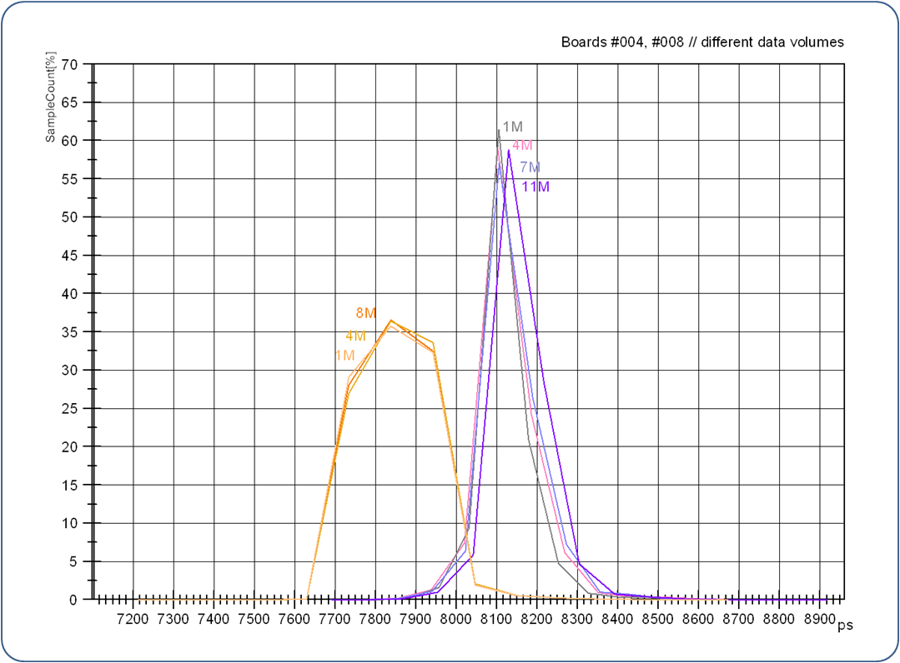

Figure : Histograms of the same test with different data volumes

|  |  |  |  |  |  |  |  |  |
| --- | --- | --- | --- | --- | --- | --- | --- | --- |
| **Board** | **Data Volume** | **Mean(ps)** | **Sigma(ps)** | **Min(ps)** | **Max(ps)** | **Max-Min** | **% Data out of**  **+/-500 ps** | **% Data out of +/-687 ps** |
| **#004** | **11M** | 8137 | 72 | 7648 | 8960 | 1312 | 0.02 | 0 |
| **#004** | **7M** | 8133 | 72 | 7648 | 8896 | 1248 | 0.02 | 0 |
| **#004** | **4M** | 8129 | 71 | 7648 | 8888 | 1240 | 0.02 | 0 |
| **#004** | **1M** | 8121 | 70 | 7700 | 8840 | 1104 | 0.02 | 0 |
| **#008** | **8M** | 7868 | 77 | 7160 | 8724 | 1564 | 0.02 | ~0.0005 |
| **#008** | **4M** | 7870 | 77 | 7160 | 8724 | 1564 | 0.02 | ~0.0005 |
| **#008** | **1M** | 7868 | 77 | 7160 | 8724 | 1564 | 0.02 | ~0.0005 |

We could conclude that there is no significant difference between 1M and 11M data.

## Test Set #2.3

|  |  |
| --- | --- |
| Test Set #2.3 | |
| Boards | #003, #004 |
| Channels | (2, 4) and (1,3) |

In this set of tests we tested two boards for different channel pairs.

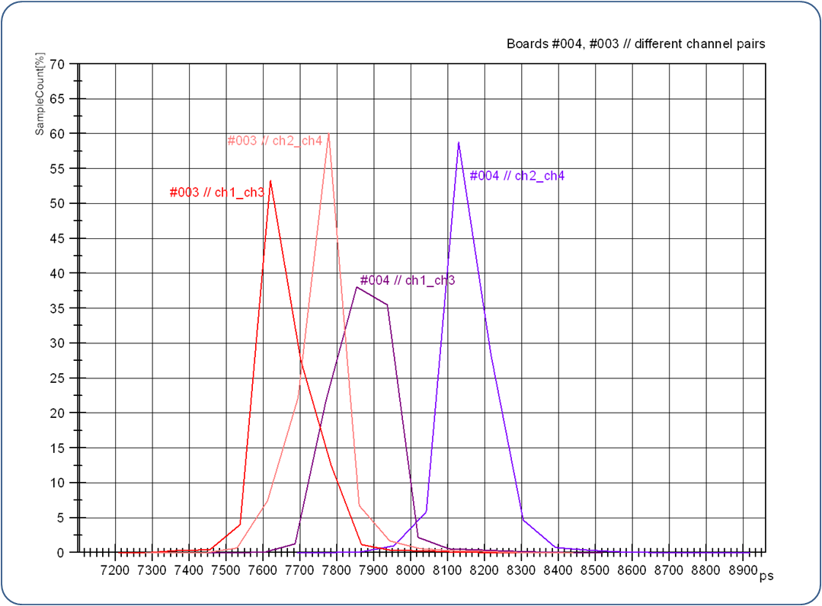

Figure : Histograms of the same test on different channels

|  |  |  |  |  |  |  |  |  |  |
| --- | --- | --- | --- | --- | --- | --- | --- | --- | --- |
| **Board** | **Channels** | **Data Volume** | **Mean(ps)** | **Sigma(ps)** | **Min(ps)** | **Max(ps)** | **Max-Min** | **% Data out of**  **+/-500 ps** | **% Data out of +/-687 ps** |
| **#004** | **2, 4** | 7M | 8133 | 72 | 7648 | 8960 | 1312 | 0.02 | 0 |
| **#004** | **1, 3** | 7M | 7876 | 75 | 7482 | 8560 | 1078 | 0.012 | 0 |
|  |  |  | 257 |  |  |  |  |  |  |
| **#003** | **2, 4** | 7M | 7758 | 72 | 7240 | 8480 | 1240 | 0.004 | 0 |
| **#003** | **1, 3** | 7M | 7660 | 74 | 7168 | 8400 | 1232 | 0.02 | 0 |
|  |  |  | 98 |  |  |  |  |  |  |

Similarly to Test Set #2.1, the difference in the mean values of Figure 12 could be explained by the characteristics of the [CDCLVC clock buffer](http://www.ti.com/lit/ds/symlink/cdclvc1102.pdf).

## Test Set #2.4

|  |  |
| --- | --- |
| Test Set #2.4 | |
| Boards | #003, #004 |
| Channels | 1, 3 |

In this set of tests we repeated the exact same test on two boards on different days.

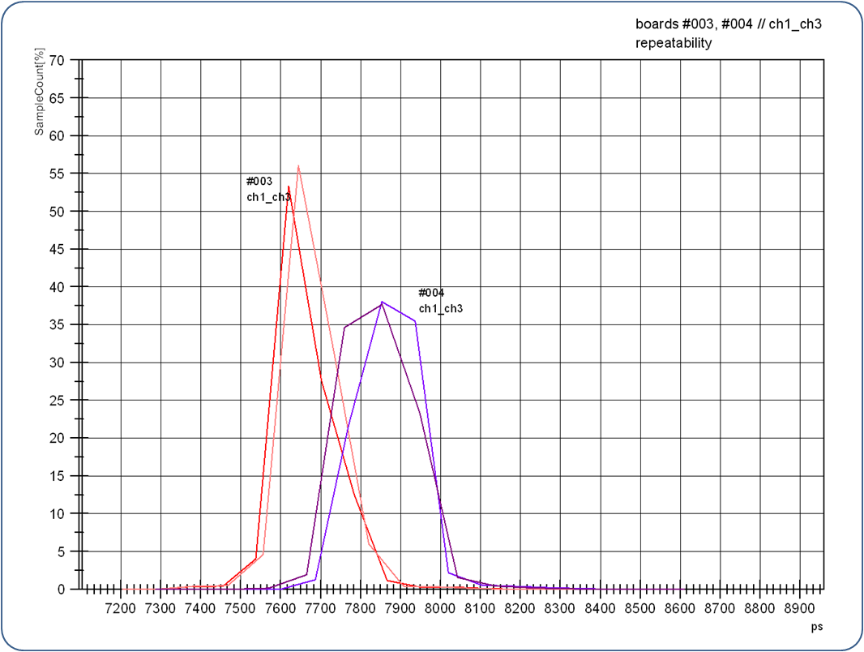

Figure : Histograms of the same test on different days

|  |  |  |  |  |  |  |  |  |  |  |
| --- | --- | --- | --- | --- | --- | --- | --- | --- | --- | --- |
| **Board** | **Data Volume** | | **Mean(ps)** | | **Sigma(ps)** | **Min(ps)** | **Max(ps)** | **Max-Min** | **% Data out of**  **+/-500 ps** | **% Data out of**  **+/-687 ps** |
| **#003** | 7M | | 7660 | | 74 | 7168 | 8400 | 1232 | 0.02 | 0 |
| **#003** | 5M | | 7655 | | 73 | 7160 | 8480 | 1320 | 0.02 | 0 |
|  |  | | 5 | |  |  |  |  |  |  |
|  |  | |  | |  |  |  |  |  |  |
| **#004** | 5M | | 7852 | | 75 | 7240 | 8656 | 1416 | 0.007 | 0.0002 |
| **#004** | 5M | | 7876 | | 75 | 7648 | 8960 | 1312 | 0.02 | 0 |
|  | | 24 | |  | | | | | | |
| We could conclude that there is repeatability. | | | | | | | | | | |

# After a conversation with T. Wlostowski it was clarified that two FD channels configured to generate pulses at the same moment offer precision of few ps! A new setup was introduced, using 2 FD channels as Figure 14 shows.

# Test Setup #3

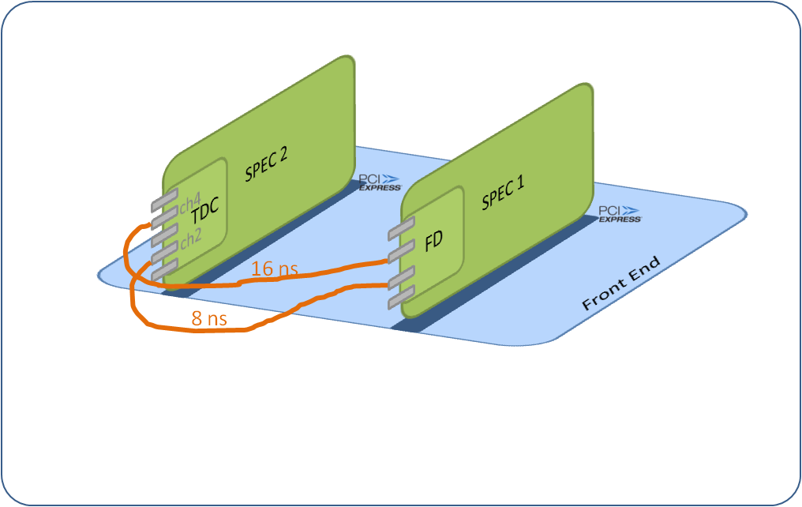

Figure : Test Setup #3

So far, only one set of tests has been performed in this setup.

|  |  |  |  |
| --- | --- | --- | --- |
| Test Set # | Boards | Channels | Remarks |
| Test Set #3.1 | #003, #007, #008 | (2, 4) | comparison between different **boards** |

Similarly to the Setup #2, no correlation of the measurements with the temperature has been observed.

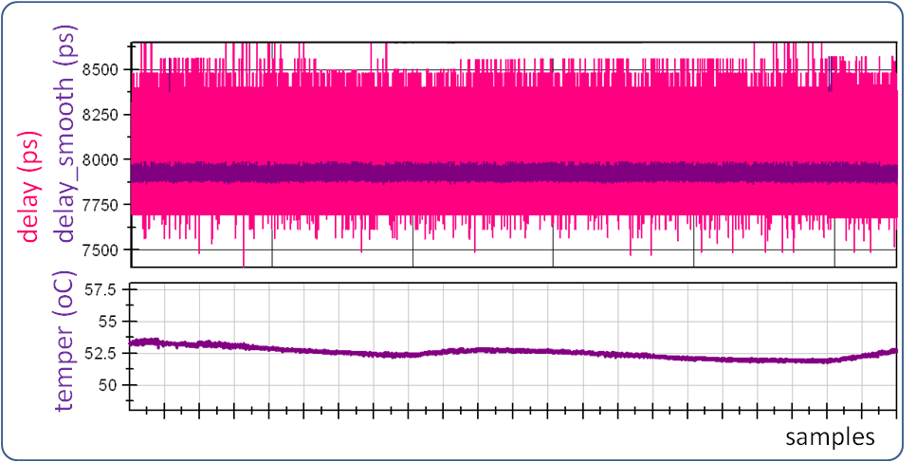

Figure : Measurements-Temperature correlation on Setup #3. Board #003 on Test Set#1.

## Test Set #3.1

|  |  |
| --- | --- |
| Test Set #3.1 | |
| Boards | #003, #007, #008 |
| Channels | 2, 4 |

The following figure shows the distribution of the measurements of each one of the three boards.

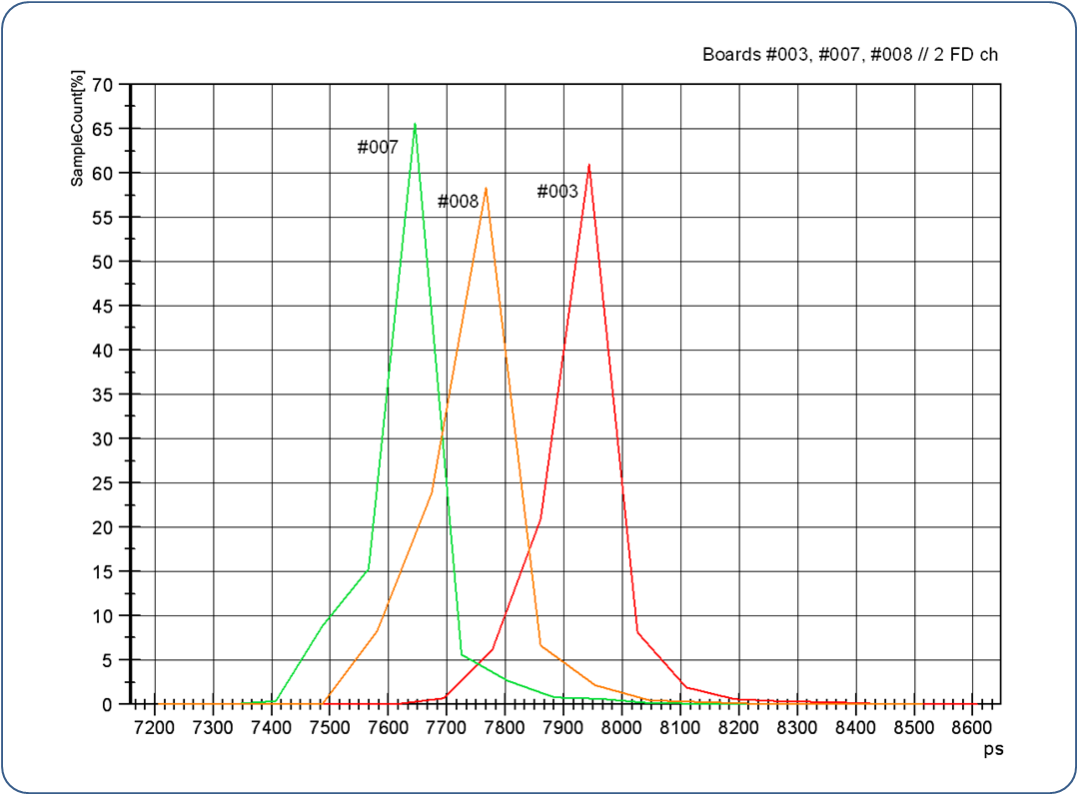

Figure : Histograms of the same test on different boards

|  |  |  |  |  |  |  |  |  |
| --- | --- | --- | --- | --- | --- | --- | --- | --- |
| **Board** | **Data Volume** | **Mean(ps)** | **Sigma(ps)** | **Min(ps)** | **Max(ps)** | **Max-Min(ps)** | **% Data out of +/-500 ps** | **% Data out of +/-687 ps** |
| **#007** | 5M | 7605 | 82 | 7208 | 8400 | 1192 | 0.08 | 0 |
| **#008** | 1M | 7757 | 74 | 7160 | 8560 | 1400 | 0.01 | ~0 |
| **#003** | 2M | 7926 | 74 | 7404 | 8648 | 1244 | 0.01 | 0 |

The results are similar to the ones of Test Set#2.1. Testing the rest of the boards and maybe in bigger data volume could give a clearer idea.

## Conclusions

## The TDC board initial specification of +/- 500 ps precision is not achieved by <0.1% of the data.

## There is a good level of confidence for the data being within +/-700ps.

## A calibration is needed to correct for the accuracy offsets introduced by the input clock buffers.

## Modifications on the board are required to achieve higher voltage level on the inputs of the clock buffers.

## Looking into the results of the experiments for the definition of the ACAM precision done by the company could also be helpful.