White Rabbit TDC Calibration

As explained in [[1]](http://www.ohwr.org/projects/pts/repository/revisions/fmctdc1ns5cha_calib/show/test/fmctdc1ns5cha/calibration/documentation) the first version of the TDC design without White Rabbit support is used to calculate time differences between pulses arriving on the different channels of a board. In this first design the timekeeping is relaying on the TDC local oscillator. The oscillator is significantly drifting through time and because of that the time-base accuracy of the timestamps is in the order of ±4ppm (for example for a measurement of 1 sec, the timebase accuracy range is ±4’000’000ps). Also the dependency on the local oscillator makes it impossible to relate timestamps coming from different TDC boards.

The new design with White Rabbit support enables the TDC to provide absolute timestamping. The time-base accuracy is in the order of sub-ns. Also pulses arriving to different TDC boards can be correlated to each other.

Regarding the calibration procedure, the SPEC-TDC is connected to any of the ports of the White Rabbit switch; few seconds later through the White Rabbit Ethernet mechanisms the SPEC-TDC manages to synchronize itself to the time of the switch, which means that it obtains the same operating frequency and time as the switch.

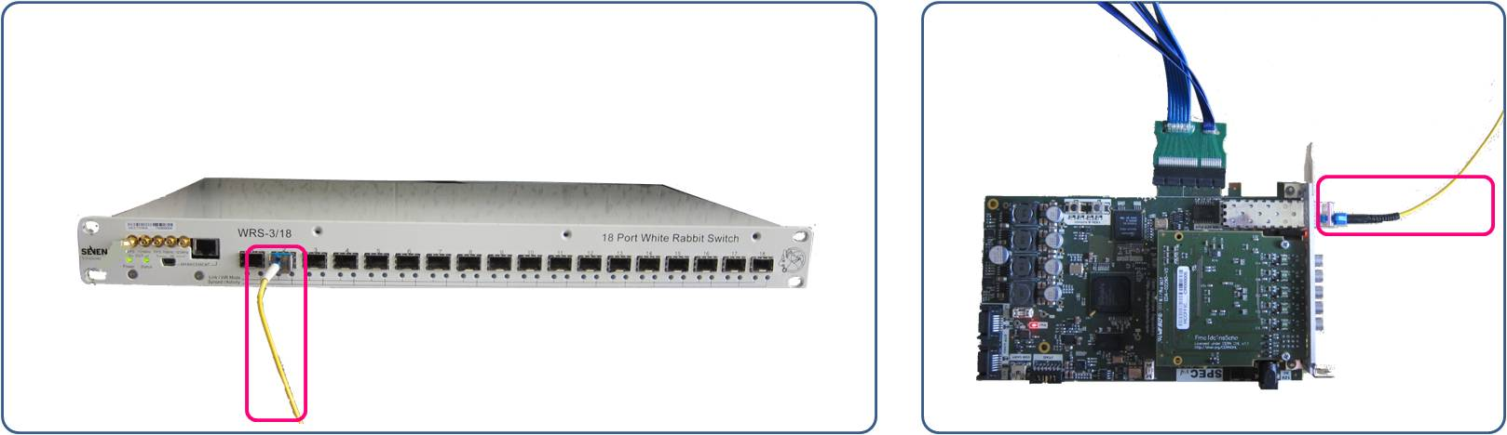

Figure : Fiber connecting the SPEC-TDC with any of the ports of the White Rabbit switch. The fiber can be of any length.

Then we use the PPS output of the White Rabbit switch to feed a TDC input channel with pulses to be timestamped.

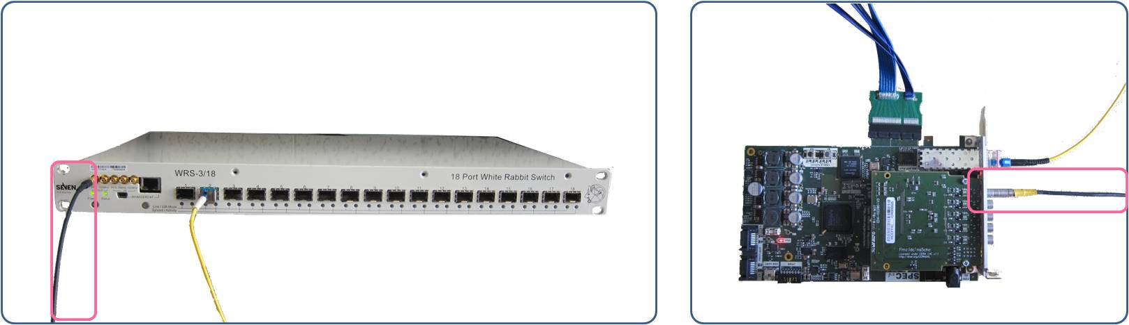

Figure : LEMO-SMC cable connecting the PPS output of the White Rabbit switch with the TDC Channel 1. The cable is of specific length.

The PPS pulses at the input of the TDC board are expected to arrive with a delay equal to the length of the cable from the output of the switch PPS to the input of the TDC board, as the following figure shows.

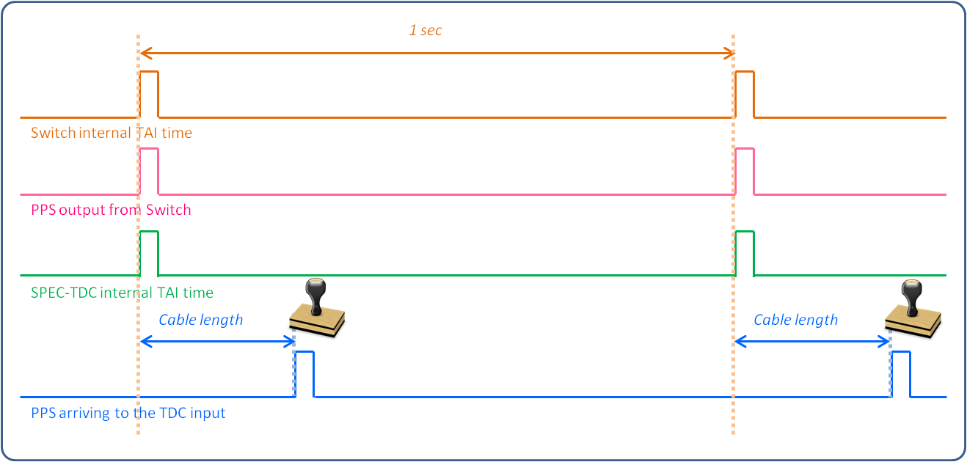

Figure : SPEC-TDC internal timing and arrival of the input pulses

Remember that the TDC is providing timestamps related to the last TAI second. Therefore for example for a 38ns cable, the timestamps acquired from the TDC are expected to have the following format:

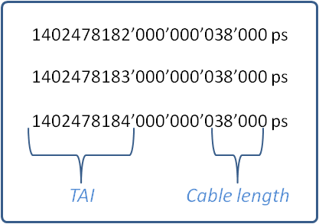

Figure : Expected timestamps

However, because of an offset added by the ACAM calculations and also because of the extra delay from the TDC LEMO to the ACAM input pin, some actual timestamp are for example:

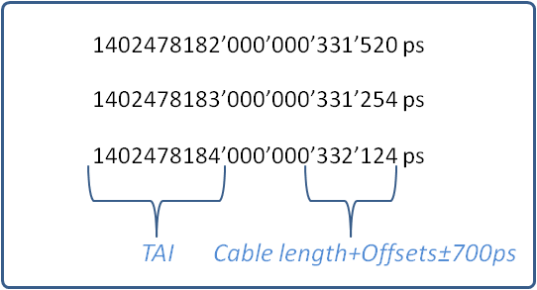

Figure : Actual timestamps including the ACAM calculation offset, the delay from the TDC input logic and the ±700ps accuracy range

The ACAM offset is in the order of 293 ns and it is the same for all the channels and all the boards. The track length and input buffer delay differ slightly per channel and board. Note that the TDC calibration [[1]](http://www.ohwr.org/projects/pts/repository/revisions/fmctdc1ns5cha_calib/show/test/fmctdc1ns5cha/calibration/documentation) is responsible for defining these input delays for each channel with respect to the reference Channel 1. The White Rabbit calibration is responsible for defining the combined ACAM offset and input delay for the TDC Channel 1. During the calibration several hundreds of measurements (like the one of Figure 7) are taken, their average is calculated and finally there is a subtraction from the expected value of Figure 6.

It is important to note that the length of the LEMO-SMC cable used for the calibration is very well defined. For that we use cables coming from the same batch and we also verify the length with a Fine Delay board.

To sum up, the outcome of the White Rabbit calibration is:

[Channel 1 input delay + ACAM calculations offset].

The outcome of the TDC calibration [[1]](http://www.ohwr.org/projects/pts/repository/revisions/fmctdc1ns5cha_calib/show/test/fmctdc1ns5cha/calibration/documentation) is:

[Channel 1 input delay - Channel X input delay], with X ranging from 2 to 5.

If one is interested only in time differences between pulses arriving to different channels of the same board, there is no need for the White Rabbit calibration calculation. For example to calculate the time difference between two timestamps that arrived to Channel 2 and Channel 5, the calculation is:

[timestamp from Channel 2] - [timestamp from Channel 5] -

[Channel 1 input delay - Channel 2 input delay] + [Channel 1 input delay - Channel 5 input delay]

If though one is interested in absolute timestamps coming for example from Channel 2, the calculation is:

[timestamp from Channel 2] -

[Channel 1 input delay + ACAM calculations offset] - [Channel 1 input delay – Channel 2 input delay]

[1] TDC calibration User Guide: [www.ohwr.org/projects/pts/repository/revisions/fmctdc1ns5cha_calib/show/test/fmctdc1ns5cha/calibration/documentation](http://www.ohwr.org/projects/pts/repository/revisions/fmctdc1ns5cha_calib/show/test/fmctdc1ns5cha/calibration/documentation)