**FMC TDC 1 ns 5 channels | gateware guide**

for SPEC| SVEC carriers

E.Gousiou | November 2013



FMC TDC 1 ns 5 cha | ohwr.org/projects/fmc-tdc/wiki

**Contents**

1 Introduction 6

2 Gateware architecture overview 7

3 FMC TDC Mezzanine 10

3.1 TDC core 10

3.1.1 Clock Domains 12

3.1.2 Timestamping concept 13

3.1.3 Clocks and Resets Manager 17

3.1.4 Registers controller 18

3.1.5 Data Engine 21

3.1.6 ACAM databus interface 24

3.1.7 Circular buffer 25

3.1.8 One Hz Generator 25

3.1.9 Start Retrigger Controller 26

3.1.10 Data Formatting 28

3.1.11 Interrupts generator 32

3.1.12 ACAM timecontrol interface 32

3.1.13 LEDs 32

3.2 Embedded Interrupt Controller 33

3.3 1-Wire 34

3.4 I2C 34

3.5 Crossbar 34

3.6 Clock domains 35

4 SPEC TDC 36

4.1 Clock domains 37

4.2 GN4124 core 38

4.3 Crossbar 39

4.4 Carrier 1-Wire 40

4.5 Carrier info 40

4.6 VIC 41

5 SVEC TDC 43

5.1 Clock domains 44

5.2 VME64x core 46

5.3 Crossbar 46

5.4 Carrier 1-Wire 47

5.5 Carrier info 47

5.6 VIC 48

5.7 Clock crossing 50

6 HDL repository 51

7 TDC mezzanine board calibration 52

8 TDC application performance 52

9 References 53

# Introduction

The Time to Digital Converter mezzanine board FmcTdc1ns5cha has 5 input channels. Its purpose is to calculate time differences between pulses arriving to the channels with a precision of ±700 ps. It follows the FMC architecture [1] and can be carried by any carrier board like the SPEC [2] or the SVEC [3]. It is using a dedicated time-to-digital converter chip TDC-GPX [4] of the European company ACAM.

This document describes the gateware developed to support the FmcTdc1ns5cha mezzanine board, later referred to as fmc-tdc. The gateware (sometimes referred to as firmware) is the HDL code used to generate the bitstream that configures the FPGA on the carrier. The gateware is designed in a modular way so that it can easily be adapted to any kind of carrier. Here we describe the gateware architecture for both a SPEC and a SVEC carrier. The configuration and operation of the fmc-tdc is also explained. For the Linux device drivers of the fmc-tdc, consult the dedicated documentation [5].

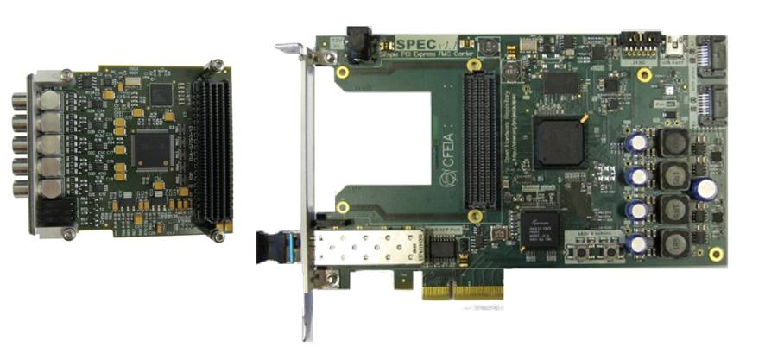

Figure 1: TDC mezzanine and SPEC carrier

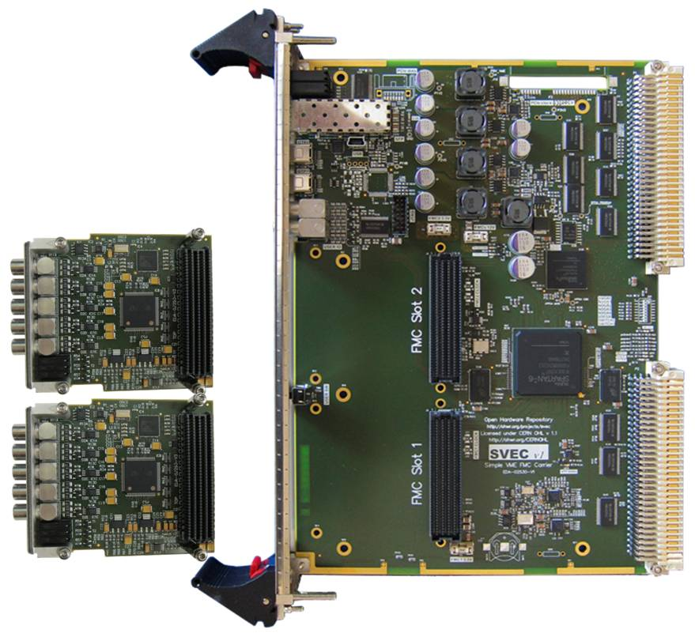

Figure : TDC mezzanines and SVEC carrier

The carrier board, SPEC or SVEC, provides FPGA logic, power supplies, clocking resources as well as the interface to the PCIe (SPEC) or VME64x (SVEC) bus. The TDC mezzanine board houses mainly the five input channels and the ACAM time-to-digital converter chip. One mezzanine can be plugged on the SPEC carrier, whereas up to two mezzanines can be plugged on the SVEC carrier.

# Gateware architecture overview

Figure 3 shows the gateware architecture for the simpler case of the SPEC carrier. Figure 4 zooms into the main module depicted in green. As both figures show the design is highly modular and the communication of all the modules with the PCIe interface is based on WISHBONE.

The **GN4124** core [6] is the interface to the Gennum GN4124 PCIe bridge chip. The core provides a WISHBONE master where all the other FPGA modules can connect to and gain access to the PCIe.

The **1-wire** core communicates with the DS18B20 thermometer and unique ID chip on the SPEC.

The **carrier info** core contains control and status registers related to the SPEC (e.g. PCB version).

The **FMC TDC mezzanine** is the application specific part of the design and includes all the modules essential for the communication with the different parts of the TDC mezzanine board:

* the ACAM chip for the retrieval of the timestamps
* the input termination resistors
* the front panel LEDs
* the DS18B20 thermometer and unique ID chip
* the 24AA64 EEPROM memory chip
* the PLL AD9516 and DAC AD5662.

The vector interrupt controller, **VIC**, is multiplexing different interrupt lines into one single line to the host. In this case (in comparison to the SVEC case of Figure 5) there is only one interrupt line coming from the FMC TDC mezzanine.

The **crossbar** is used to map the different slaves in the WISHBONE address space.

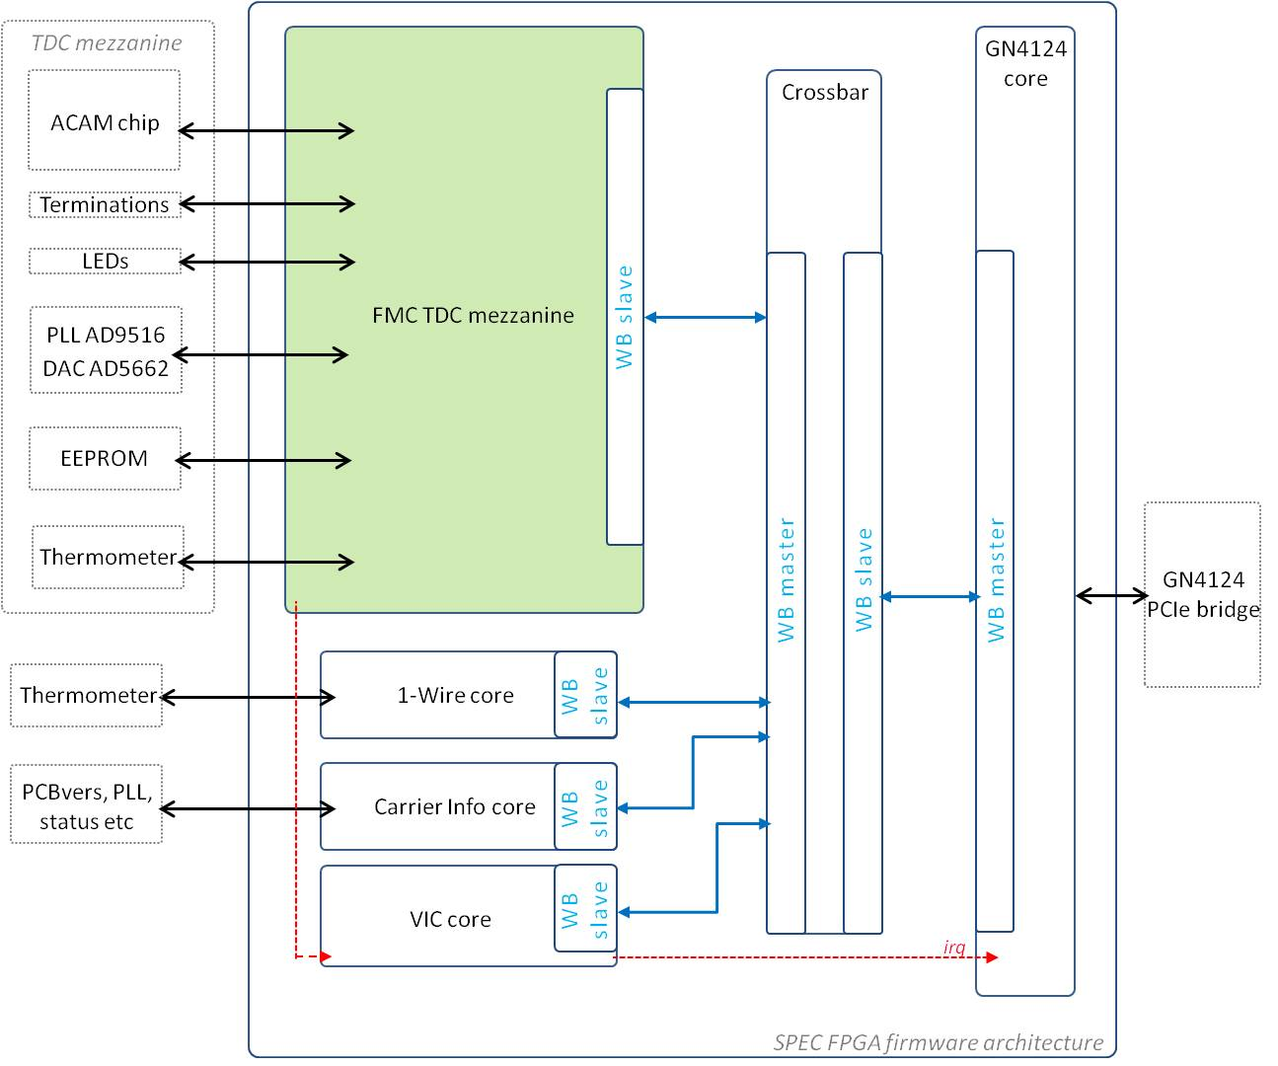

Figure 3: SPEC TDC gateware architecture

Figure 4 shows the different parts of the FMC TDC mezzanine module and their connections to the TDC mezzanine board. The heart of this module is the TDC core, depicted in pink. The TDC core is first responsible for configuring the ACAM chip. The configuration instructions are provided through the PCIe interface. Once the ACAM chip is configured, rising edges arriving to any of its channels are time-stamped. The TDC core is responsible for retrieving the timestamps; it is then putting them in a user-convenient format and finally it is making them available to the PCIe interface.

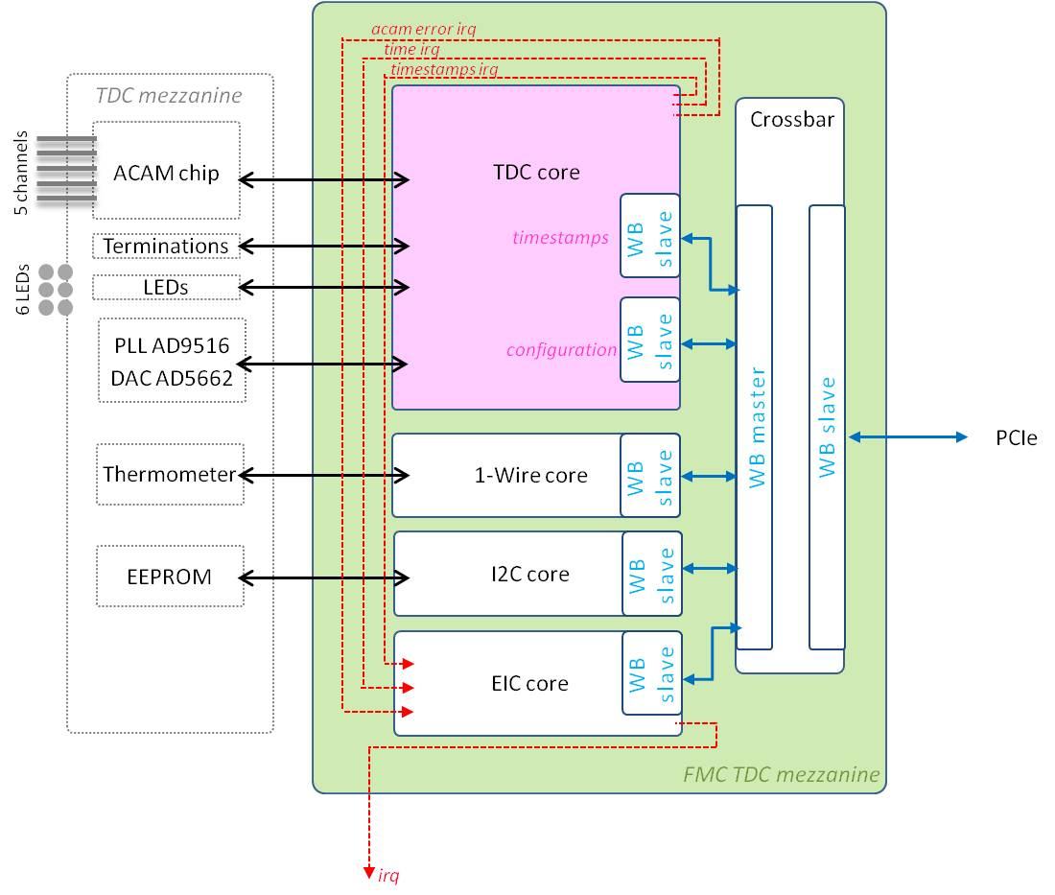

Figure : FMC TDC mezzanine architecture

The **I2C** core communicates with the 24AA64 EEPROM memory chip located on the mezzanine.

The **1-wire** core communicates with the DS18B20 thermometer and unique ID chip.

For the configuration of the **TDC core** as well as of the ACAM chip, dedicated registers are allocated; they are accessible through a WISHBONE interface. The timestamps that are received by the ACAM and formatted in the core are then stored in a circular buffer, that is accessible through a different WISHBONE interface. The core has also embedded an SPI master interface for the configuration of the PLL AD9516 and the DAC AD5662 on the mezzanine.

The embedded interrupts controller, **EIC core**, gathers all the interrupts generated by the TDC core into one single interrupt request line. The result is forwarded to the Vector Interrupt Controller, VIC.

The **crossbar** is used to map the different slaves in the WISHBONE address space.

Figure 6 shows the gateware architecture for the case of a SVEC carrier. The communication of all the modules with the VME interface is done through WISHBONE, as in the case of SPEC. Notice that the GN4121 core is replaced by the VME64x core and that two FMC TDC mezzanine modules are instantiated, one for each one of the mezzanine boards plugged on the SVEC. A small extra complication is inserted in the SVEC design, the **clocks crossing core** is needed because the VME core can only run up to 62.5 MHz, whereas the FMC TDC mezzanine runs at 125 MHz.

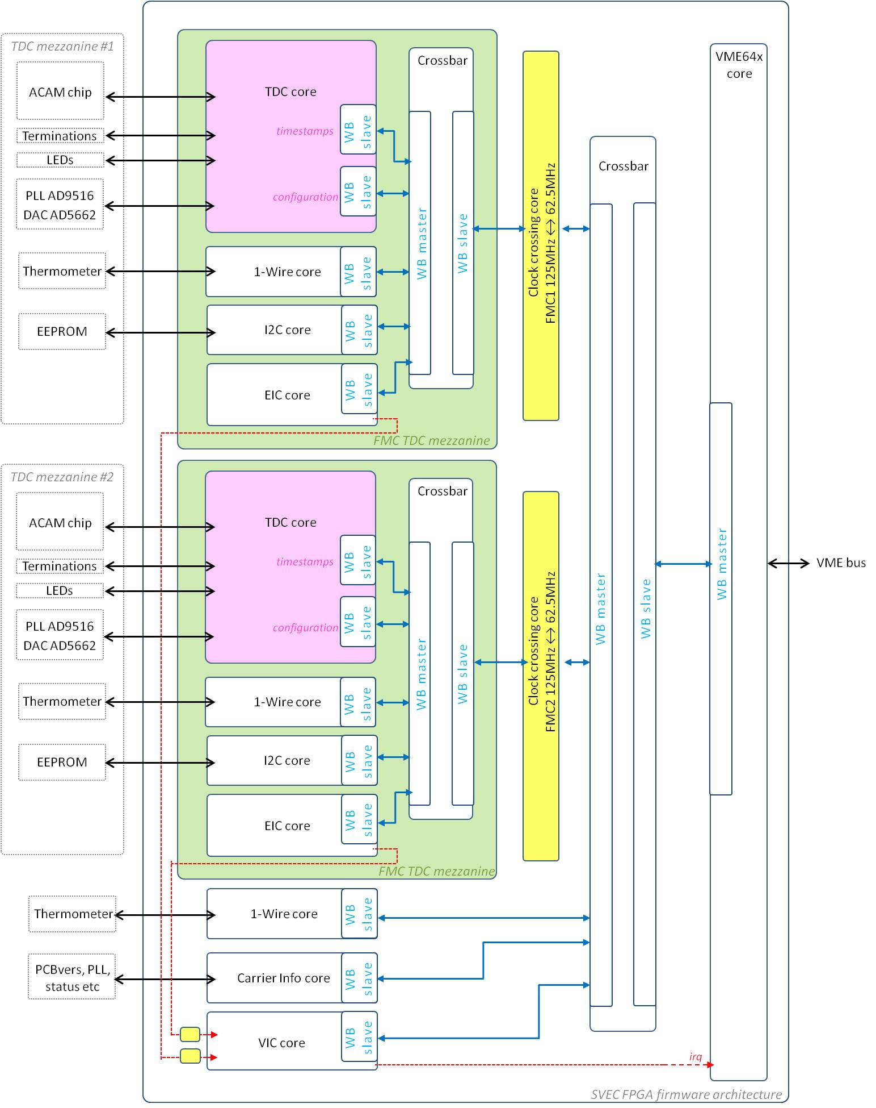

Figure : SVEC TDC gateware architecture

# FMC TDC Mezzanine

The FMC TDC mezzanine module is the interface to the TDC mezzanine board. On a SPEC carrier one of this modules in instantiated, whereas on a SVEC two. The internal architecture is shown in Figure 4 and the following sections describe each module in detail.

## TDC core

The TDC core is the main block of the design. On the mezzanine interface side, it is communication with the ACAM chip for the configuration and timestamps retrieval. It also manages theinput channel terminations and the front panel LEDs. On the internal interface side, it has two WISHBONE slaves: one from where the configuration registers are received from the PCIe/VME interface and one from where the PCIe/VME can retrieve the timestamps.

The TDC core is retrieving timestamps generated by the ACAM chip, adapting them to a comprehensive format and making them available in a RAM to the PCIe/VME interface.

Each final timestamp is a 128-bit word with the following structure:

|  |  |
| --- | --- |
| Bits | Description |
| [127:96] | Metadata: rising/falling tstamp, channel number |
| [95:64] | Local UTC time: the resolution is 1 s |
| [63:32] | Coarse time within the current UTC time: the resolution is 8 ns |
| [31:0] | Fine time: the resolution is 81.03 ps |

Table 1: Timestamp format. Timestamp [ps] = (Local UTC * 1012) + (Coarse time * 8 * 103) + (Fine time * 81.03)

As the structure indicates, each timestamp is referred to a UTC second. The coarse and fine times indicate with 81.03 ps resolution the amount of time passed after the last UTC second.

Figure 6 shows the main components of the core followed by a short description of each component.

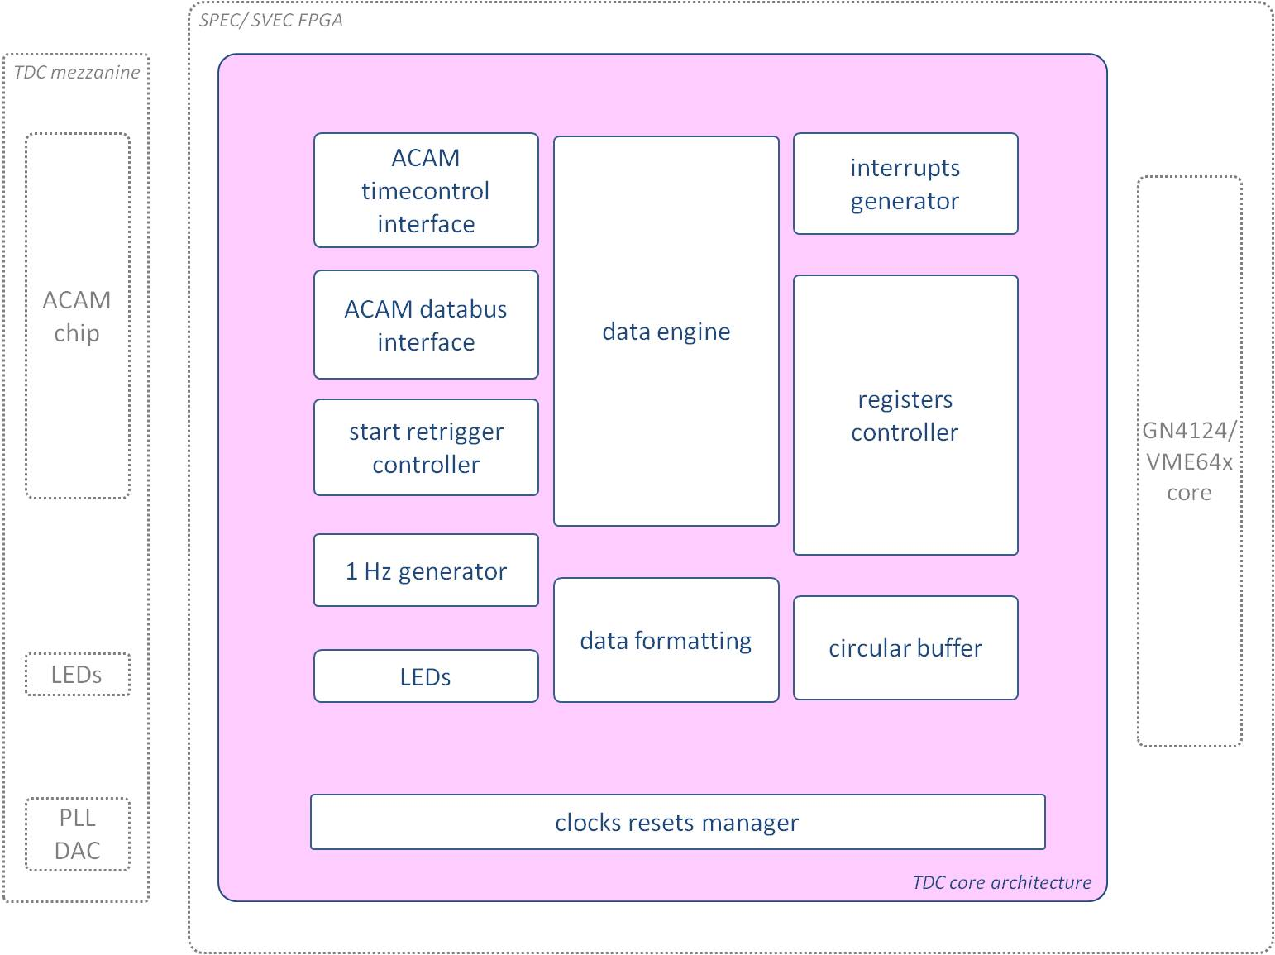

Figure 6: Main components of the TDC core

The “**one Hz generator**” unit is responsible for keeping the UTC time. Currently this timekeeping depends on the AD9516 PLL on the mezzanine board, which provides a 125 MHz clock. Future upgrades of the core will provide White Rabbit [7] accuracy.

The timestamps are formatted to the structure of Table 1 in the “**data formatting**” unit.

Then they are stored in a RAM block implemented in the “**circular buffer**” unit, where the GN4124 or the VME64x core has direct access.

In this application, the ACAM is used in I-Mode [4]. This provides unlimited measuring range with internal start retriggers. ACAM's counter of retriggers however is not large enough and there is the need to follow ACAM’s retriggers inside the core; the “**start retrigger control**” unit is responsible for that.

The “**registers controller**” implements the communication with the GN4124/ VME64x core for the configuration of the TDC core and of the ACAM chip. Amongst the registers, one in particular is utterly important: the “control register” defines the action to be taken in the core (ex. activation of timestamps acquisition, loading of configuration to the ACAM chip, etc)

The “**data engine**” unit is managing the state of the core according to the “control register”.

The “**acam databus interface**” implements the communication with the ACAM chip for its configuration as well as for the timestamps retrieval.

The “**acam timecontrol interface**” is responsible for delivering to the ACAM chip the start pulse, to which all timestamps are related.

The core is providing an interrupt in any of the following three cases:

* accumulation of timestamps larger than the settable threshold
* more time passed than the settable time threshold and >=1 timestamps accumulated
* error occurred in the ACAM chip

The “**interrupts generator**” unit is responsible for generating the corresponding interrupt pulses.

The “**clocks and resets manager**” unit is configuring the PLL AD9516 and DAC AD5662 on the TDC mezzanine for the production of two clocks: a 125 MHz clock for the TDC core and 31.25 MHz clock for the ACAM chip. It is also managing the TDC core resets.

Finally, the “**leds**” unit manages the six TDC mezzanine front panel LEDs.

### Clock Domains

There are two clock domains in the TDC core, as Figure 4 shows. Upon power-up or after a PCIe/VME reset, the “clocks and resets manager” is using the 20 MHZ VCXO of the SPEC/SVEC carrier to configure the DAC and the PLL on the TDC mezzanine. The PLL generates a 125 MHz clock arriving to the TDC core to be used by the rest of the logic. The 31.25 MHz clock is a division of the 125 MHz clock provided by the same PLL and is the reference clock for the ACAM chip.

The “clocks and resets manager” is keeping the rest of the TDC core logic under reset until the PLL gets locked. The only signal crossing domains in the core is the reset.

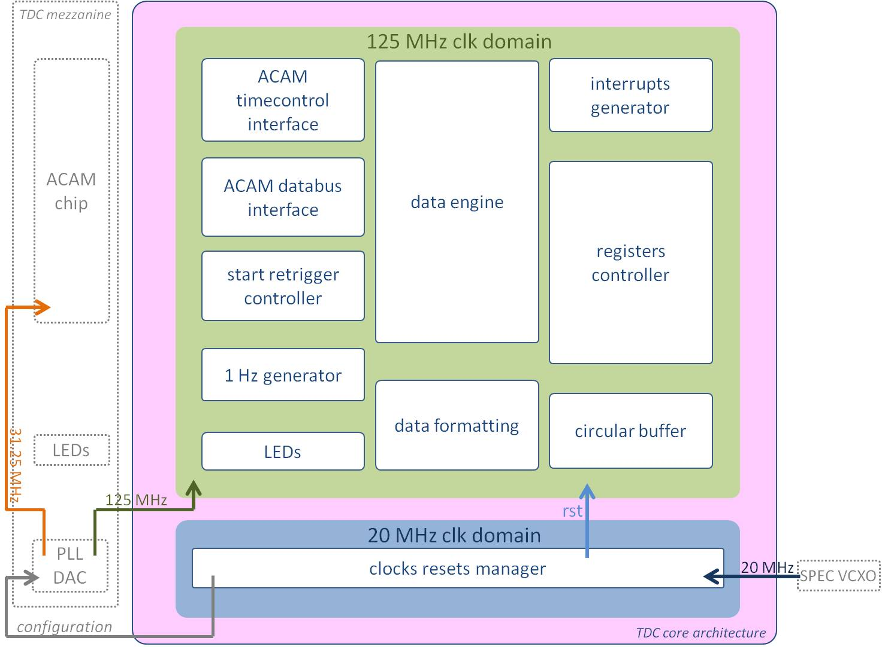

Figure 7: TDC core clock domains

### Timestamping concept

The ACAM chip is receiving a 31.25 MHz clock from the AD 9516 PLL. The TDC core is receiving a 125 MHz clock from the same PLL.

The ACAM chip notifies the TDC core of a new timestamp by deactivating the signal “Empty flag”. When the core sees a falling edge on the Empty flag, it starts reading from the ACAM FIFO. When the Empty flag goes back to high, no reading should take place, as that could unbalance the FIFO pointers.

The ACAM is configured in I-mode. One start pulse is sent by the FPGA (upon the “activate acquisition” command sent through the PCIe/VME interface - see Table 4) and all the ACAM timestamps are referred to that start pulse. Figure 5 shows the FPGA start pulse and a stop pulse arriving later through one of the TDC mezzanine input channels.

The ACAM is programmed to retrigger every (16*acam_clk_period) = 512 ns. On each timestamp the ACAM is providing three measurements:

* Start01: the difference between the start pulse and the first ACAM retrigger
* Start#: the number of retriggers
* Stop: the difference between the last retrigger and the stop pulse.

The timestamp = (Start01) + (Start# * retrigger period) + (Stop)

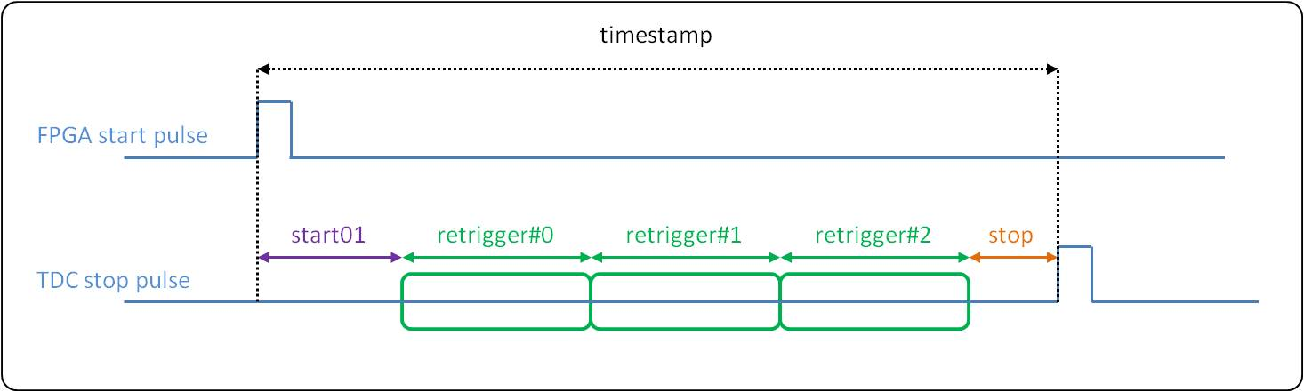

Figure 8: ACAM timestamping

According to the ACAM documentation, there is indeterminacy to whether the stop time refers to the previous retrigger or the current one. This means that any of the figures 4 or 5 could be possible.

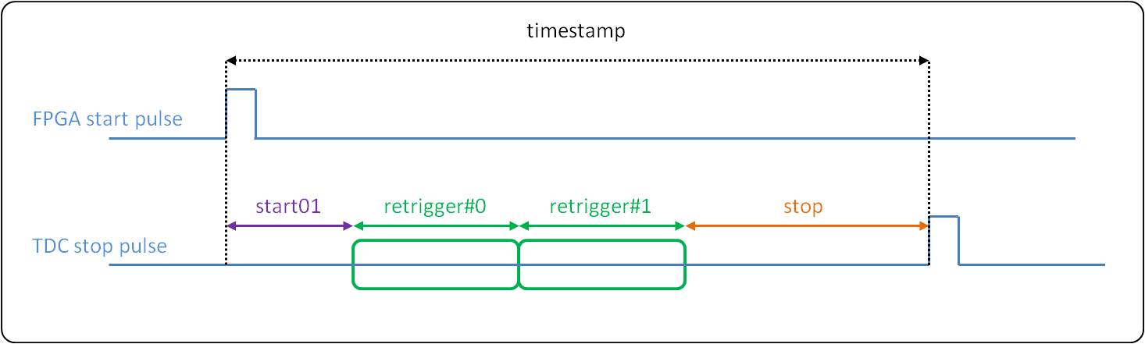

Figure 9: ACAM timestamping. Stop time refers to the previous retrigger

In this TDC application, we are only interested in differences between stop pulses, therefore the constant value “Start01” is irrelevant in the calculations. The following figure shows a simple scenario. timestamp B – timestamp A =

[(Start01) + (Start#A * retrigger period) + (StopA)] - [(Start01) + (Start#B * retrigger period) + (StopB)]

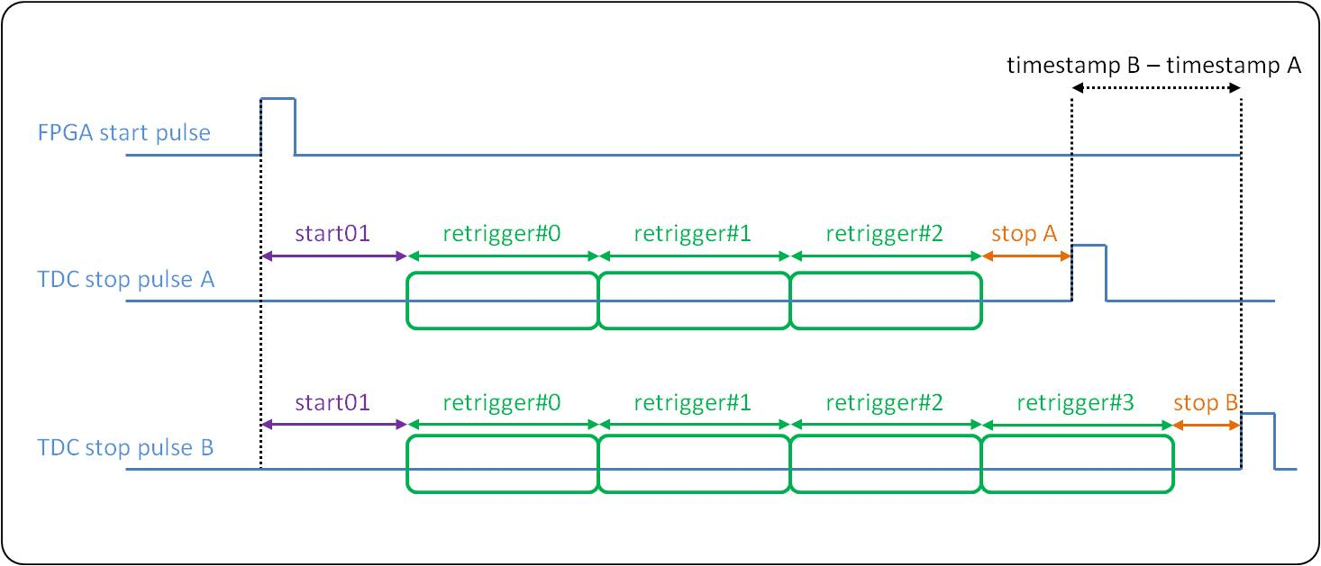

Figure 10: Time difference between pulses

The counter of the ACAM chip that counts the retriggers, Start#, is restricted to 8 bits, and can only count up to 256 retriggers = 131’072 ns. Since our application needs to measure pulses separated by any amount of time, the TDC core needs to be tracking how many times the ACAM retriggers counter overflows. To do so, the ACAM Interrupt flag has been configured to follow the highest bit of the Start#. In the TDC core, a counter called “rollover counter” is following the Interrupt flag and is counting the overflows.

Note also that in one second, there are 7629 rollovers.

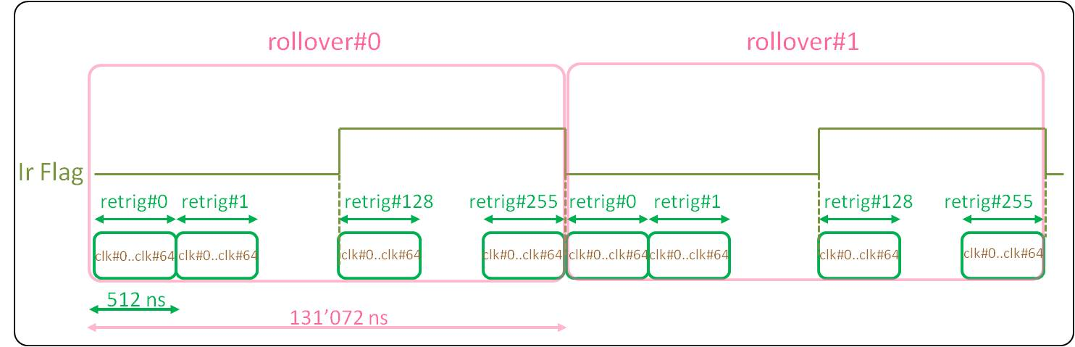

Figure 11: The TDC core is following the ACAM retriggers

In addition, the core is keeping track of the retrigger number and the number of clock cycles after the last retrigger, as Figure 8 shows.

As described in Table 1, each timestamp provided to the PCIe/VME interface, has a UTC time component, a coarse time component and the fine time. Therefore, the ACAM retriggers have to be associated to the UTC time. The ACAM however has no knowledge of the UTC time and the arrival of a new second happens completely independently.

The “one Hz generator” unit is generating a pulse per second and is also responsible for counting the number of these pulses, keeping the UTC time. When this “one Hz pulse” arrives:

* The rollover counter is reset.
* The current retrigger number is registered (retrigger#_offset).
* The current number of clock cycles after the last retrigger is registered (clk#_offset).

Through the retrigger#_offset and clk#_offset the amount of time t1 can be calculated. Figure 12 shows in detail these actions.

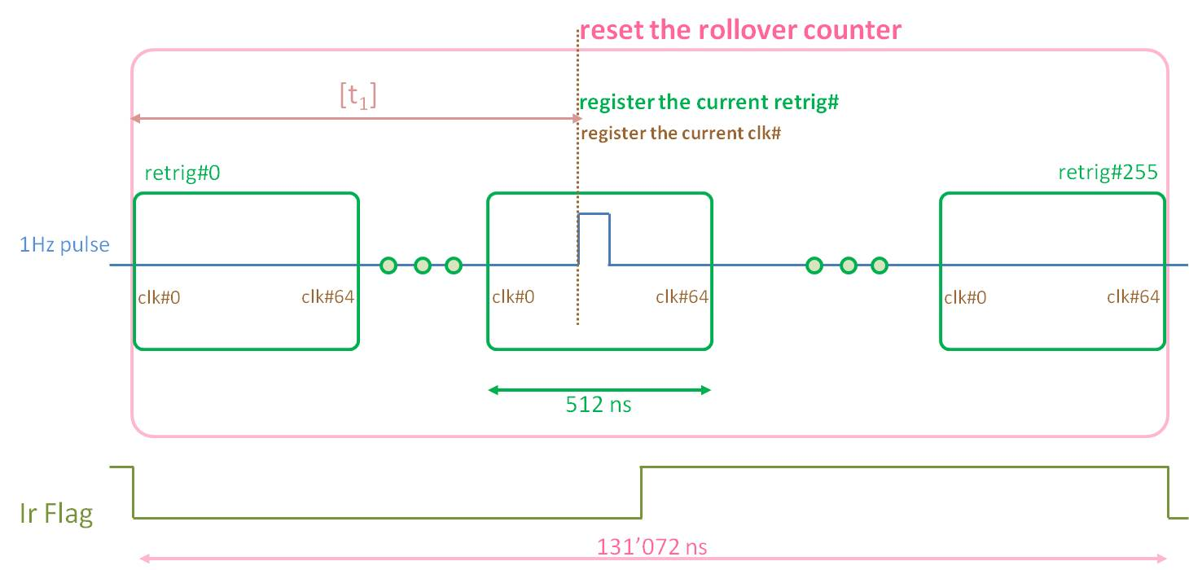

Figure 12: Actions upon the arrival of a new "1 Hz pulse"

Putting everything into the picture now, when a stop pulse arrives to any of the TDC channels, the ACAM chip registers the timestamp to its FIFO and puts the “Empty flag” to low. The TDC core receives the timestamp and in the “data formatting” unit it brings it into the form of Table 1. For that, as Figure 10 shows, the amounts of time t1’, t2 and t3 need to be calculated.

The amount t3 is exclusively provided by the ACAM chip in the form of Start# and Stop.

The amount t2 is the number of rollovers of the IrFlag between the last “one Hz pulse” and the Stop pulse. The rollover counter that has been reset upon the “one Hz pulse” arrival provides this amount.

The amount t1’ is the complementary of t1 and is calculated using the retrigger#_offset and the clk#_offset registered values.

This is the way the TDC core is functioning in terms of timespamps retrieval and formatting. The sections that follow describe in detail each unit of the TDC core.

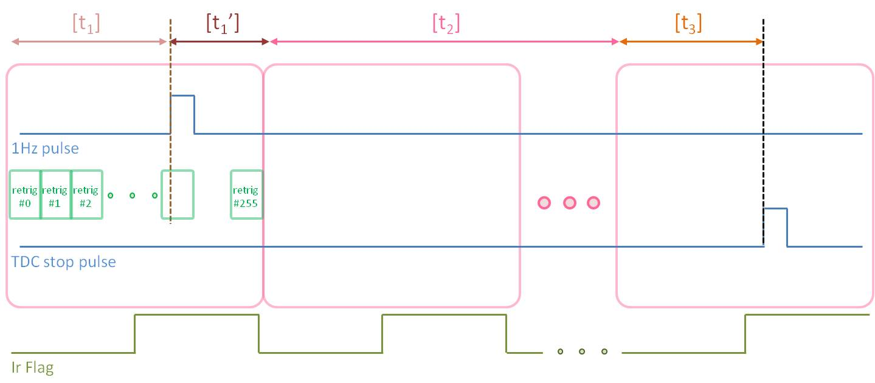

Figure 13: Essential calculations to associate each timestamp to the current UTC time

Notice that the Start pulse is not in the picture and the Start01 amount of time is not used.

### Clocks and Resets Manager

The “clocks and resets manager” unit is responsible for providing the clocking resources to the rest of the modules. It configures the PLL AD9516 and the DAC AD5662 on the TDC mezzanine board. Upon the power up or after a PCIe/VME reset, the unit is using the 20 MHz clock on the SPEC carrier board to configure the DAC and PLL through their SPI interfaces. The time needed for that is in the order of 1 ms.

The PLL is configured to provide a 125 MHz clock for the rest of the TDC core and a 31.25 MHz clock for the ACAM chip (i.e. the ACAM chip is running 4 times slower than the TDC core). The registers for the PLL configuration are hard-coded in the TDC core, in this unit.

The DAC output is connected to a voltage-controlled-oscillator which in turn controls the PLL. Alterations on the DAC voltage change slightly the frequency of the pulses coming out of the PLL. Since the “one Hz generator” unit is counting seconds based on the 125 MHz of the PLL, the timestamps are affected by the DAC voltage. For example, the difference between two pulses separated by 9 ms can be measured as 8.999967000 ms with the DAC at 1.25 V and as 9.000000300 ms with the DAC at 1.65 V. During the calibration of each TDC mezzanine board, the optimal value for the DAC is measured (see Section 11 on TDC calibration). The register for the DAC configuration is received through the PCIe/VME interface. Note that extension of the TDC core with White Rabbit, will relieve the design from this dependence on the local oscillator.

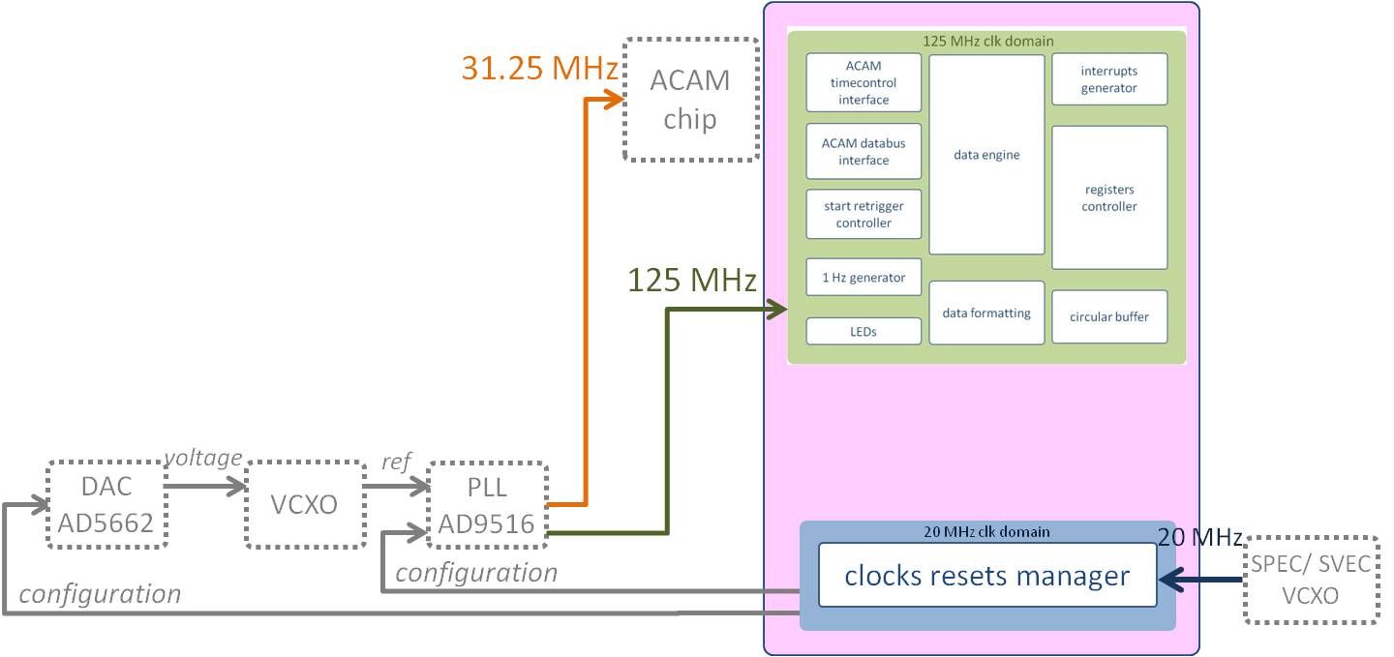

Figure 14: TDC clocks

The “clocks resets manager” is resetting the rest of the logic until the “PLL_lock” signal is activated. The reset pulse is synchronized to the 125 MHz domain.

### Registers controller

The unit interfaces with the GNUM/VME64x core for the configuration of the ACAM chip and of the TDC core. The unit implements a WISHBONE slave. All the registers are of size 32 bits, as the WISHBONE data bus.

Through **WISHBONE write cycles**, the unit receives:

* The ACAM configuration registers. Table 2 describes the registers.
* The TDC core configuration registers. Table 3 describes the registers.
* The “control register” that defines the action to be taken in the core; the register is decoded and the corresponding signals are used by the different units in the design.

Through **WISHBONE read cycles**, the unit transmits:

* The ACAM configuration registers read back from the ACAM chip. Table 5 describes these registers.
* The TDC core status registers. These are the read-only registers in Table 3.

Table 2 lists the ACAM configuration registers and the value they should be set to through the PCIe/VME interface and WISHBONE writes. Note that the default reset value of all the registers in the FPGA is 0x0. The [ACAM documentation](http://www.acam.de/fileadmin/Download/pdf/English/DB_GPX_e.pdf), section 1.7 “Register Settings” describes in detail each register. Note that the registers are first transferred in the TDC core by the PCIe/VME interface and then they have to be loaded to the ACAM chip. For that, the “control register” has to be properly activated (Table 4, bit 2 = ‘1’).

|  |  |  |  |  |
| --- | --- | --- | --- | --- |
| ACAM Config. | R/W | Description | Byte Addr | Set Value |
| reg. 0 | R/W | Timestamping of both rising and falling edges | 0x000 | 0x01F0FC81 |
| reg. 1 | R/W | Not used (channel adjustments for other modes) | 0x004 | 0x00000000 |
| reg. 2 | R/W | I-mode selection | Disabling of unused channels | 0x008 | 0x00000E02 |
| reg. 3 | R/W | Not used (resolutions and tests for other modes) | 0x00C | 0x00000000 |
| reg. 4 | R/W | Start retriggers set to 16 | Resets | 0x010 | 0x0200000F |
| reg. 5 | R/W | External start retrigger OFF | Offset set to 2.000 | 0x014 | 0x000007D0 |
| reg. 6 | R/W | Not used for the moment (load flags) | 0x018 | 0x00000003 |
| reg. 7 | R/W | PLL values: RefClkDiv=7 | HSDiv=234 | PhaseNeg | 0x01C | 0x00001FEA |
| reg. 11 | R/W | Error flag configured on the 8 Hit FIFOs | 0x02C | 0x00FF0000 |
| reg. 12 | R/W | Interrupt flag configured on the Start# overflow | 0x030 | 0x04000000 |
| reg. 14 | R/W | 16-bit mode control | 0x038 | 0x00000000 |

Table : ACAM configuration registers

Table 3 lists the local configuration registers and the value they should be set to through the PCIe/VME interface and WISHBONE writes. Note that the default reset value of the registers is 0x0.

|  |  |  |  |  |  |
| --- | --- | --- | --- | --- | --- |
| Name | R/W | Description | | Byte Address | Typical  Set Value |
| Starting UTC time | R/W | [bits 31..0] | updated by PCIe/VME; initialized after a reset | 0x080 |  |
| Inputs enable | R/W | [bit 0] | input ch 1 termination enable | 0x084 | 0x0000009F |
| [bit 1] | input ch 2 termination enable |
| [bit 2] | input ch 3 termination enable |
| [bit 3] | input ch 4 termination enable |
| [bit 4] | input ch 5 termination enable |
| [bit 7] | general enable for all channels |
| [bits 5,6,31..8] | not used |
| IRQ tstamp thresh | R/W | [bits 7..0] | an interrupt is issued if the number of accumulated timestamps since the last irq exceeds this threshold | 0x090 | 0x000000FF  = full mem |
| [bits 31..8] | not used |
| IRQ time thresh | R/W | [bits 31..0] | an interrupt is issued if this amount of ms has passed after the last irq and at least a timestamp has been registered | 0x094 | 0x0001E848  = 1 ms |
| DAC word | R/W | [bits 24..0] | word to be sent to the DAC | 0x098 | 0x0000A8F5  = 1.65 V |
| [bits 31..25] | not used |
| Current UTC time | R | [bits 31..0] | calculated by the core according to the local 125 MHz clk | 0x0A0 |  |
| Circular buffer write pointer | R | [bits 11..0] | number of 8-bit-words to be read from the circular buffer  = number of 128-bit-timestamps*16 | 0x0A8 |  |
| Da Capo counter | [bits 31..12] | number of times the circular buffer has been overwritten |
| Control Register | W | [bits 11..0] | Commands the main core FSM | 0x0FC | See Table 4 |
| [bits 31..12] | Not used |

Table : TDC core local registers

Table 4 describes the control register, which defines the state of the “data engine” state machine. Only one bit at a time can be activated since each bit is carrying a command. Upon a WISHBONE write of the control register by the PCIe/VME, a 1-tick-long control pulse is generated defining the action to be taken (ex: activate_acquisition_p, reset_acam_p..etc); then the register is cleared.

|  |  |  |  |
| --- | --- | --- | --- |
| Control Register Bit | Action Description | Control Register Value | |
| Bit 0 | Activate acquisition | | 0x00000001 |
| Bit 1 | De-activate acquisition | | 0x00000002 |
| Bit 2 | Load ACAM configuration registers | | 0x00000004 |
| Bit 3 | Read back ACAM configuration | | 0x00000008 |
| Bit 4 | Read ACAM status register | | 0x00000010 |
| Bit 5 | Read ACAM IFIFO 1 register | | 0x00000020 |
| Bit 6 | Read ACAM IFIFO 2 register | | 0x00000040 |
| Bit 7 | Read ACAM Start01 register | | 0x00000080 |
| Bit 8 | Reset ACAM chip | | 0x00000100 |
| Bit 9 | Load UTC time | | 0x00000200 |
| Bit 10 | Clear Write pointer and Da Capo counter | | 0x00000400 |
| Bit 11 | Configure DAC and reset the core | | 0x00000800 |
| Bits [31 downto 12] | Unused, ignored on read | |  |

Table : The bits of the control Register

describes the registers read back from the ACAM chip. These are read-only registers. To initiate a reading of this set of registers, the “control register” bit 3 needs to be activated. Note that this set of registers includes the configuration registers listed in (the values now represent what is read from the ACAM rather than what is being set through PCIe/VME) plus the ACAM Read-only registers Start01 and Interface FIFOs.

|  |  |  |  |  |
| --- | --- | --- | --- | --- |
| ACAM Config.  Read-back | R/W | Description | Byte Address | Typical Value |
| reg. 0 | R | Timestamping of both rising and falling edges | 0x040 | 0xC1F0FC81 |
| reg. 1 | R | Not used (channel adjustments for other modes) | 0x044 | 0xC0000000 |
| reg. 2 | R | I-mode selection | Disabling of unused channels | 0x048 | 0xC0000E02 |
| reg. 3 | R | Not used (resolutions and tests for other modes) | 0x04C | 0xC0000000 |
| reg. 4 | R | Start retriggers set to 16 | Resets | 0x050 | 0xC200000F |
| reg. 5 | R | External start retrigger OFF | Offset set to 2.000 | 0x054 | 0xC00007D0 |
| reg. 6 | R | Load flag levels at maximum | 0x058 | 0xC00000FC |
| reg. 7 | R | PLL values: RefClkDiv=7 | HSDiv=234 | PhaseNeg | 0x05C | 0xC0001FEA |
| reg. 8 | R | Interface FIFO 1 | 0x060 | Start# and Stop |
| reg. 9 | R | Interface FIFO 2 | 0x064 | Start# and Stop |
| reg. 10 | R | Start01 | 0x068 | Start01 |
| reg. 11 | R | Error flag configured on the 8 Hit FIFOs | 0x06C | 0xC0FF0000 |
| reg. 12 | R | Interrupt flag configured on the Start# overflow | 0x070 | 0xC4000000 |
| reg. 14 | R | 16-bit mode control | 0x078 | 0xC0000000 |

Table : ACAM read-back registers

### Data Engine

According to the value of the “control register” and the generated control pulses, the “data engine” unit is managing:

* The writing of the ACAM configuration.
* The reading back of the ACAM configuration/status registers.
* The timestamps' acquisition from the ACAM.

Figure 12 shows the states structure of the state machine. The default state is “inactive”.

From the “inactive” state the FSM jumps to “load ACAM configuration” upon the activation of the “control register” bit 3. In this state, the set of registers described in Table 2 are transferred one by one to the ACAM chip. The “data engine” is providing the values of the registers (as received by the PCIe/VME interface in the “registers controller” unit) as well as the ACAM addresses to the “acam databus interface” unit that is actually implementing the interface with the ACAM chip. Figure 13 shows the flow of actions for one register. When all the eleven registers have been transferred, the FSM jumps back to the “inactive” state. Note that the configuration registers need to be loaded before setting the “control register”.

Similarly, the “read back ACAM configuration” state initiates readings of the set of registers described in Table 5. When all the fourteen registers have been read, the FMS goes back to the “inactive” state

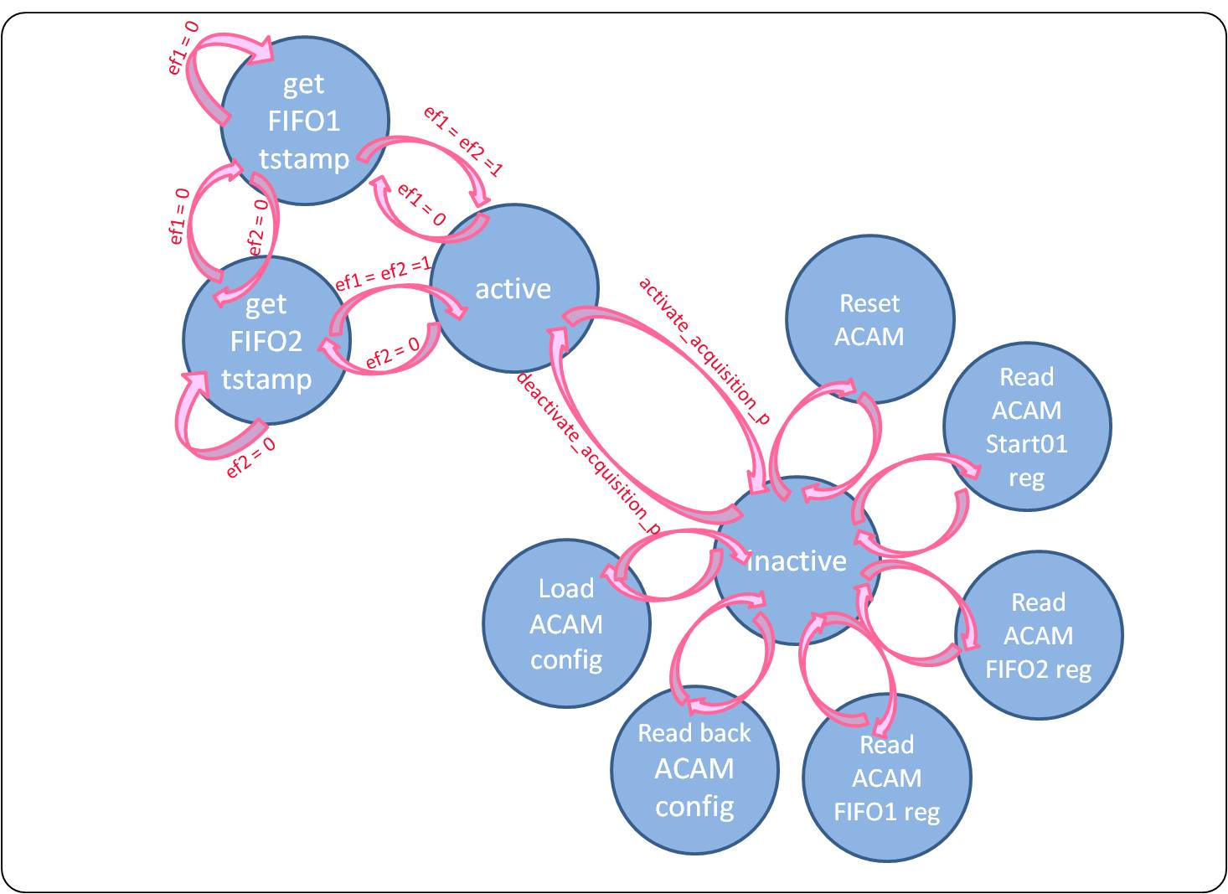

Figure 15: Data engine main FSM

Each one of the states “read ACAM FIFO1 register”, “read ACAM FIFO2 register” and “read ACAM Start01 register” initiates a single reading of the corresponding register (read-back reg 8, 9 and 10 respectively. See Table 5).

Finally the state “reset ACAM” initiates the writing of a particular word to the ACAM configuration register 4 (see Table 2) that resets the chip.

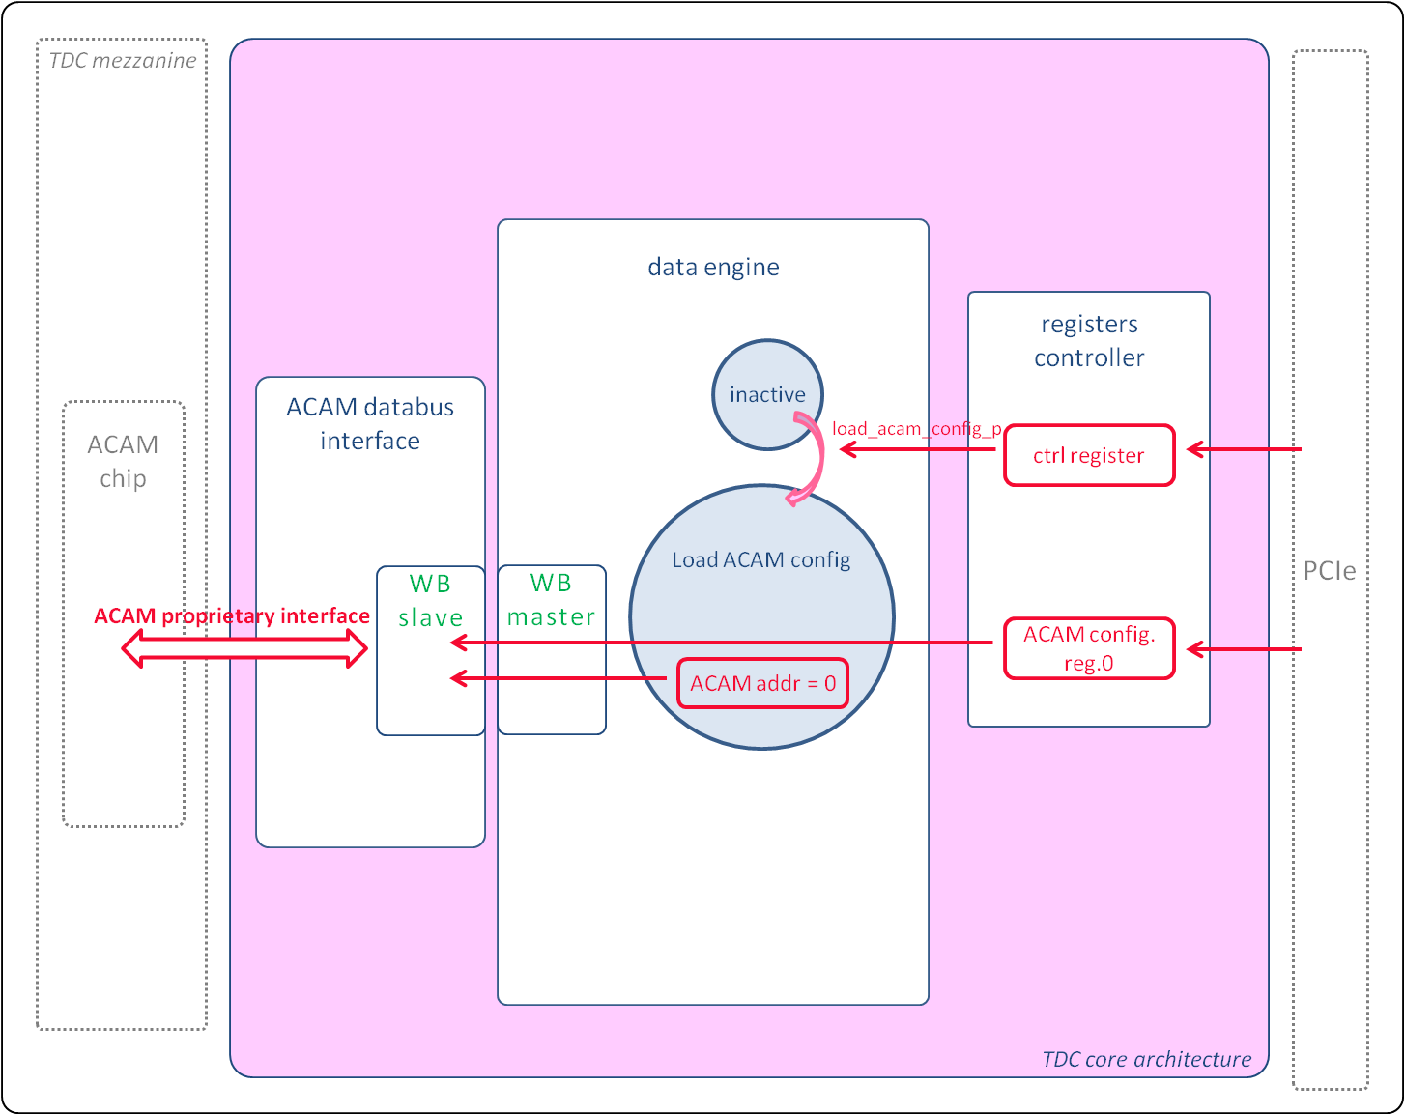

Figure 16: Snapshot of the transfer of one configuration register to the ACAM chip

In acquisition mode (“control register” bit 0 = ‘1’) the unit monitors permanently the ACAM Empty flags (ef1, ef2) and retrieves the timestamps by reading the ACAM read-only registers 8 or 9 (see Table 5). As described in Section 2, the register Start01 is not read. The timestamps are received by the “data formatting” unit for the formatting and are finally stored in the “circular buffer”. Figure 14 shows the sequence of events upon the Empty flag deactivation.

The maximum speed with which the ACAM can be retrieving timestamps is 31.25 MHz. If the ACAM is receiving more timestamps than that, then the ACAM Error flag is raised and the TDC core is issuing an interrupt. For the TDC core to be able to keep up with the maximum speed of 31.25 MHz (so that no timespamp gets lost by the core) it has to retrieve, format and store a timestamp within 4 cycles of the 125 MHz clock (4 * 31.25 = 125!).

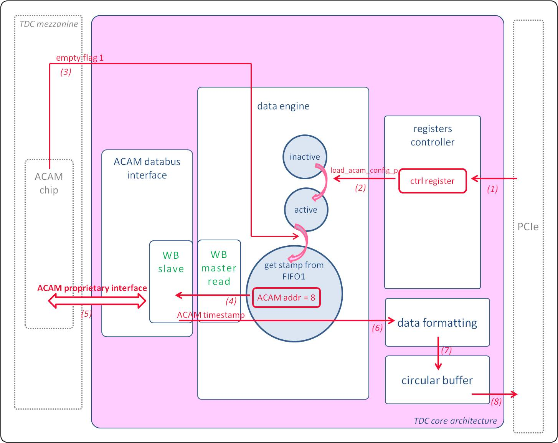

Figure 17: Snapshot of the transfer of a timestamp from the ACAM to the circular buffer. The numbers below the arrows indicate the sequence of events.

### ACAM databus interface

The unit interfaces with the ACAM chip pins for the configuration of the registers and the acquisition of the timestamps. The ACAM proprietary interface is converted to a WISHBONE classic interface, with which the unit communicates with the “data_engine” unit. The WISHBONE master is implemented in the “data_engine” and the slave in the “acam_databus_interface” unit.

Note that the TDC mezzanine board has 5 input channels. The ACAM chip is treating channels 1 to 4 in the FIFO1 and channel 5 in the FIFO2.

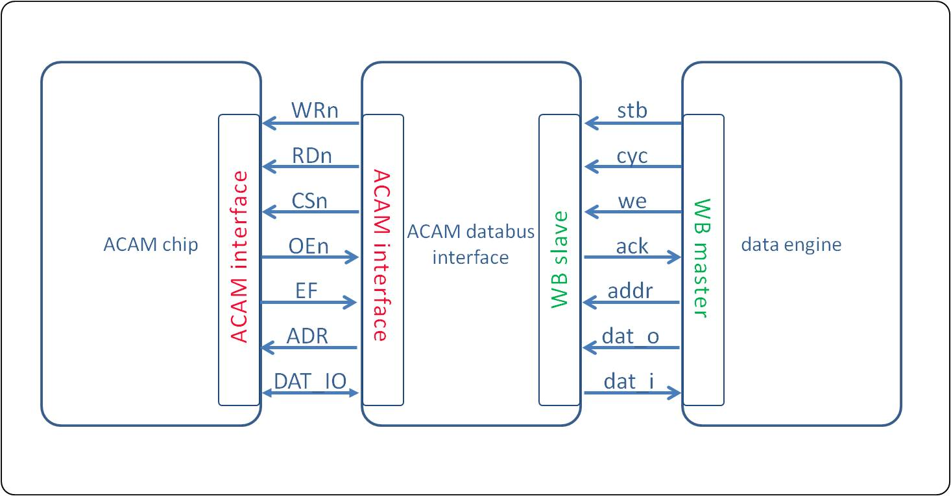

Figure 18: Interfaces between the "data engine", "ACM databus interface" units and the ACAM chip

Here is the description of the ACAM proprietary interface for a read operation:

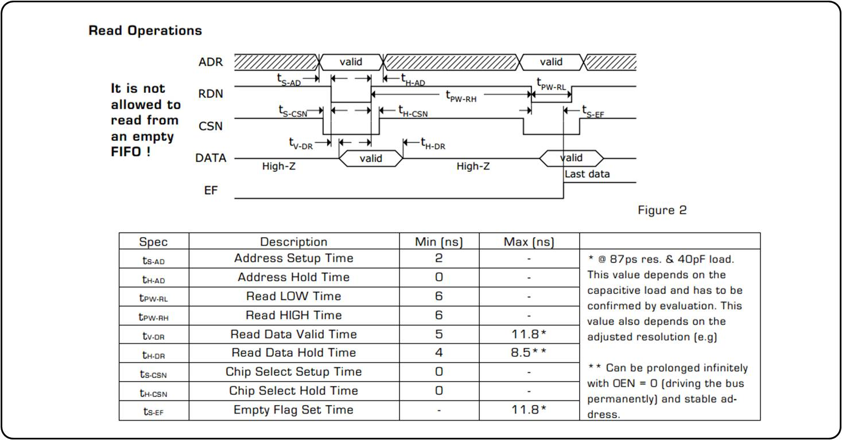

Figure 19: The ACAM proprietary interface

Special attention needs to be put on the ACAM Empty Flag maximum set time of Figure 16. A violation of this time, by initiating a new reading before the Empty Flag has been updated, could translate to reading from an empty FIFO and would unbalance the ACAM FIFO pointers.

In order for the “ACAM databus interface” unit to be able to keep retrieving timestamps from the ACAM at the ACAM's maximum speed (31.25 M timestamps/ sec), it needs to complete one retrieval per 4 * clk cycles = 4 * 8 ns = 32 ns. To achieve that it is allowing 16 ns from the moment it activates the RDN until it checks the ACAM Empty flag signal and decides whether to continue reading or not. ACAM's specification defines that the maximum Empty flag set time is 11.8 ns; this allows for >4 ns for the signals routing. To make sure this constraint is met, the **Xilinx design map option "Pack IO Registers/Lathes into IOBs" should be enabled**.

### Circular buffer

The unit implements a Dual port RAM. Port A is attached to the WISHBONE interface where the “data formatting” unit is writing timestamps. Port B is connected to the WISHBONE master of the GN4124/VME64x core. The “data formatting” unit is only writing in the RAM and the GN4124/VME64x core is only reading from it.

The “data formatting” unit is writing timestamps of size 128 bits each (see Table 1). From port A the memory is of size: 256 * 128 bits. The GN4124/VME64x core is reading 32-bit words. Readings take place using pipelined WISHBONE interface. From this side the memory is of size: 1024 * 32.

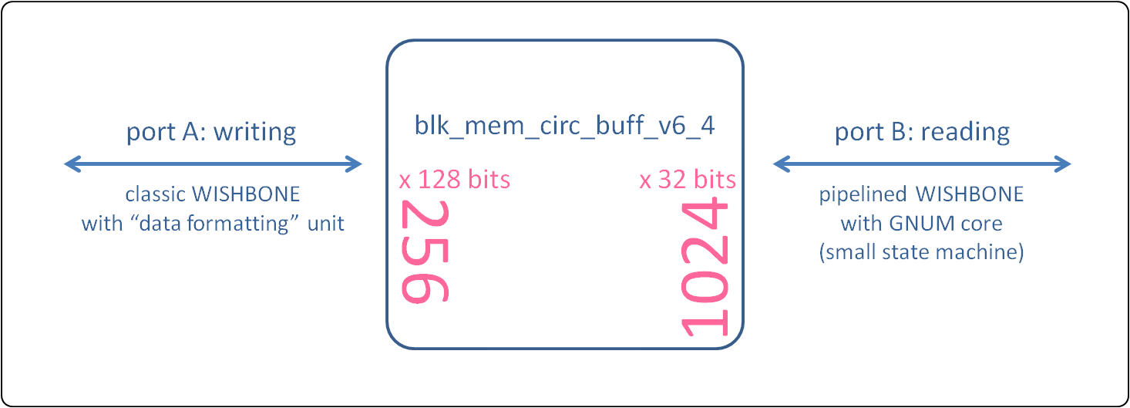

Figure 20: The circular buffer

The GN4124/VME64x core is reading words of 32-bits, but the addressing is per byte. This is why the “write pointer” register (Table 3) is providing the number of bytes to be read (=number of timestamps*16).

### One Hz Generator

The unit implements two counters. The first one counts seconds using the 125 MHz clock. When a second has passed a 1-tick-long pulse is generated. The second counter is used to count the amount of those 1-tick-long pulses. The initial value of this second counter is zero, after a reset or after the power-up. A different initial value can be given through the PCIe/VME register “starting utc time”. To this initial value a +1 is added after each second.

Finally, the current value of the counter can be read back through the PCIe/VME register “local utc time”.

### Start Retrigger Controller

The “start retrigger controller” unit provides the main components for the calculation of the "coarse time" of the final timestamps (see Table 1). These components are sent to the “data_formatting” unit where the actual coarse time calculation takes place. Figure 8 and Figure 9 in section 3.2 describe the main actions taken in this unit. Note again that the Interrupt flag of the ACAM chip has been configured to follow the highest bit of the Start# counter.

In more detail, three counters are implemented. They are described in the following paragraphs.

The “retrigger period counter” and the “retrigger number counter” keep continuously track of the current internal start retrigger of the ACAM, in parallel to the ACAM itself. The “retrigger period counter” is counting clock periods, up to 512 ns; this is one ACAM retrigger. The counting is initiated by an ACAM Interrupt flag falling edge. The “retrigger number counter” is counting the number of ACAM retriggers, from 0 to 255, in the same way the Start# counter in the ACAM chip does.

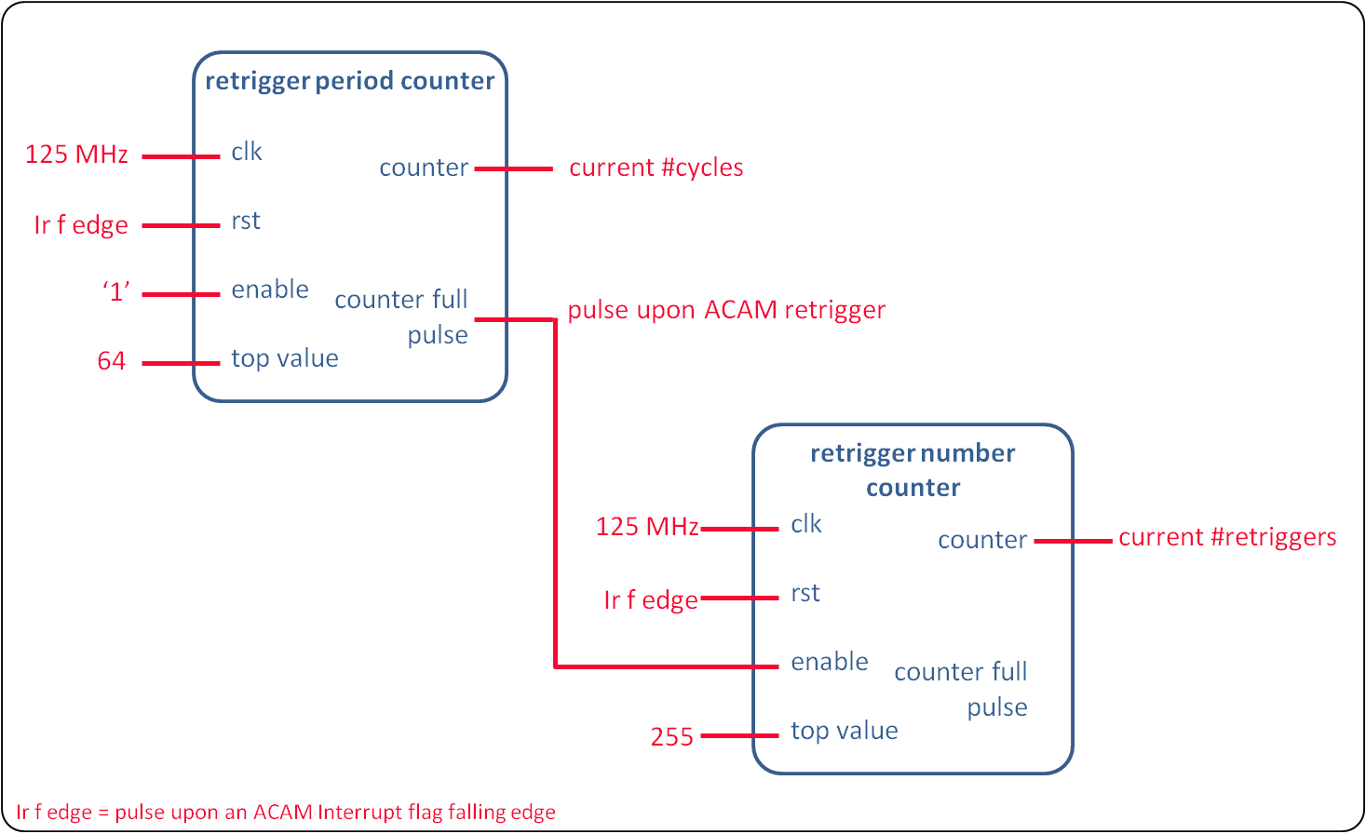

Figure 21: The “retrigger period counter” and the “retrigger number counter”

The arrival of a “one HZ pulse” means that a new second has just started and the timestamps that will come after that point should be referenced to that new second. Upon the “one Hz pulse”, the values of the “retrigger period counter” and of the “retrigger number counter” are registered. The registered values are referred to as “clk#_offset” and “retrigger#_offset”. As Figure 13 shows, these values represent the amount of time t1 and need to be subtracted upon the arrival of a stop pulse.

One more counter is essential. The “rollover counter” is counting the number of overflows (rollovers) of the ACAM Start# counter since the last “one HZ pulse”. In Figure 10, this represents the amount of time t2.

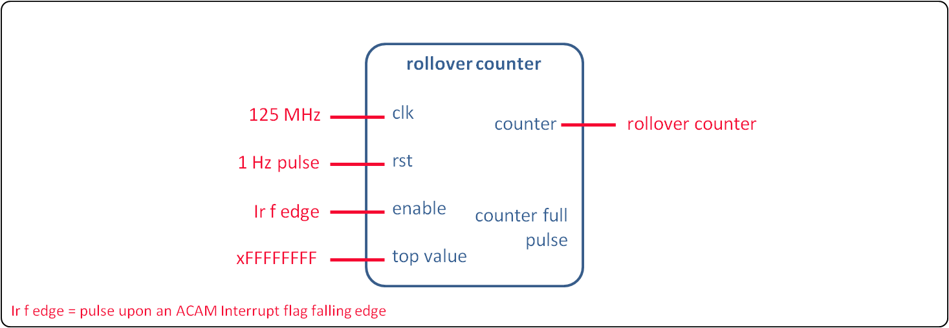

Figure 22: The “rollover counter”

Upon the arrival of a timestamp, the “data formatting” unit is using the “clk#_offset”, “retrigger#_offset” and the current value of the “rollover counter” for the calculations of the values to be used to arrive to a timestamp related to the current second.

### Data Formatting

The “data formatting” unit brings the ACAM timestamps to the format of Table 1. It also writes them to the “circular buffer” unit is responsible for keeping track of how many timestamps have been written.

When a timestamp arrives the UTC time, coarse time and fine time need to be calculated.

The UTC time comes directly from the “one Hz generator” unit. The timestamp will be referenced to the last UTC second.

The fine time comes directly from the Stop value of the ACAM timestamp (Figure 5).

Now, for the coarse time, i.e. amount of 8 ns cycles between the last “one Hz pulse” and the timestamp, the following calculations need to take place.

* The “roll over counter” has been counting the multiples of 256 retriggers since the last “one Hz pulse” (i.e. number of pink boxes in Figure 20).
* The “retrigger#_offset” has kept the amount of retriggers that had preceded the arrival of the “one Hz pulse” (ie. number of green boxes inside the first pink box in Figure 20).
* The ACAM Start# indicates the amount of retriggers within the last pink box of Figure 20.

Therefore, the number of retriggers:

“#retriggers” = “current value of the rollover counter”*256 + “Start#” – “retrigger#_offset” [I]

Now we need to translate this number of retriggers to the amount of 8 ns cycles. The ACAM is configured to retrigger each 512 ns.

Therefore “#cycles from retriggers” = “#retriggers” * 64.

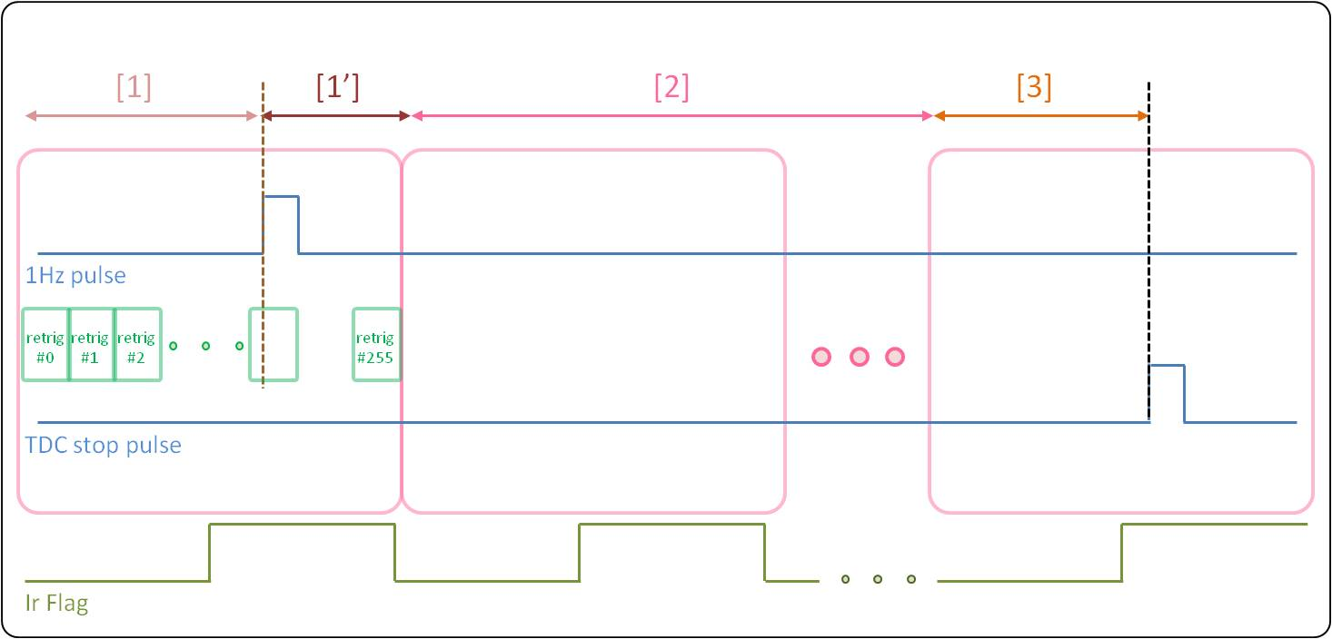

Figure 23: Data formatting calculations. Same as Figure 10

Zooming into the first pink box of Figure 20, brings us to Figure 21, which shows that to the number of 8 ns cycles between the last “one Hz pulse” and the “stop” pulse, we need to add the ones described by the “clk#_offset”.

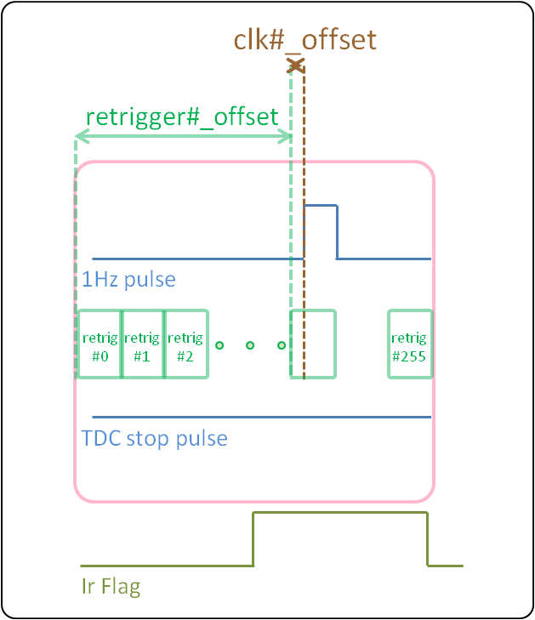

Figure 24: Zoom into Figure 20 first pink box

Finally coarse time = “#cycles from retriggers” + “clk#_offset”.

Unfortunately, there are few exceptions in the calculation above.

The first exception comes from the marginal case where the “one Hz pulse” and the “stop” pulse arrive within the same retrigger. In this case equation [I] equals to zero! The “current value of the rollover counter” is zero and both the ACAM and the TDC core are at the same retrigger number.

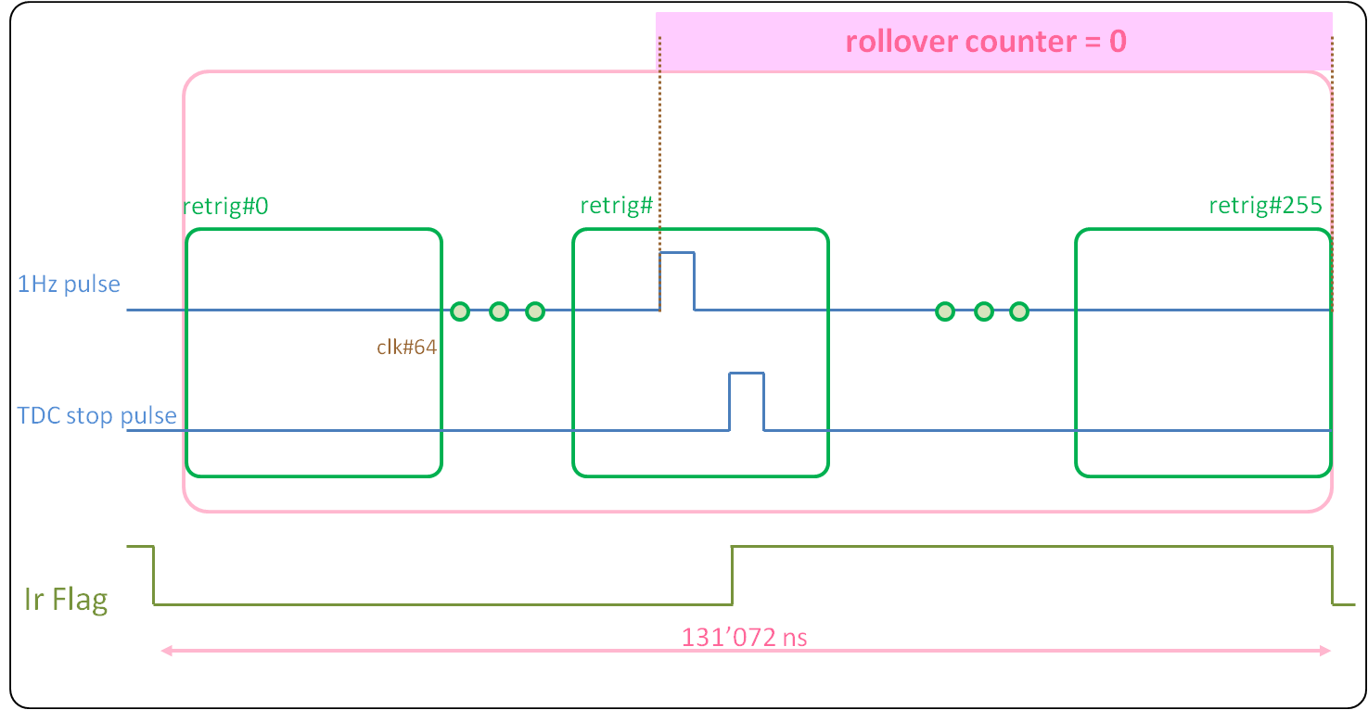

Figure 25: Marginal case where the “one Hz pulse” and the “stop” pulse arrive within the same retrigger

For this case, the timestamp needs to be referenced to the previous second. As shows, the pulse is referenced to the previous “one Hz pulse” and the amount of time t3 is provided exclusively by the ACAM.

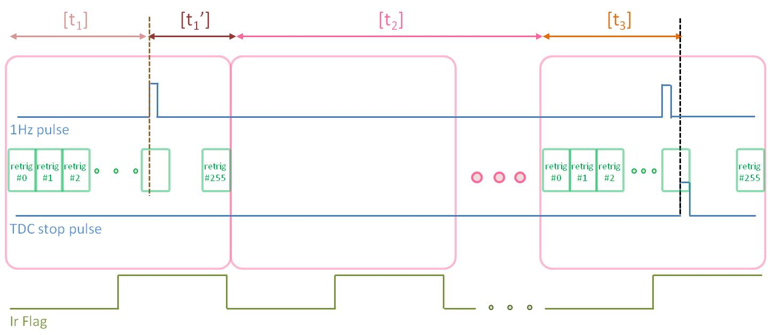

Figure 26: Calculations on the marginal case where the “one Hz pulse” and the “stop” pulse arrive within the same retrigger

Attention though needs to be put in the case described in Figure 6 where the fine time refers to the previous retrigger rather than the current one. In this case:

* “current value of the rollover counter” = 0
* “Start#” = “retrigger#_offset” - 1
* ACAM “Stop” is > 6318 (6318 * 81 ps = 512 ns)

If all the conditions above are valid, it means, exactly as described before, that that the last “one Hz pulse” and the “stop” pulse have arrived within the same retrigger. In this case again, as Figure 23 shows the timestamp is referenced to the to the previous “one Hz pulse”.

The last exception comes from the marginal case where a timestamp is received from the ACAM when the “rollover counter” has just been increased. In this case, it is possible that the timestamp belongs to the previous roll-over value. This is because the moment the ACAM IrFlag is taken into account in the TDC core is different from the moment the “stop” pulse has arrived to the ACAM (several 8 ns cycles are needed to empty ACAM FIFOs). In this case if the ACAM “Start#” of the received timestamp is close to the upper end (close to 255) and on the moment of processing in the “data formatting” unit the IrFlag has recently increased, that means that in equation [I], the “current value of the rollover counter” - 1 needs to be considered.

### Interrupts generator

The “interrupts generator” is responsible for the generation of 1-tick-long pulses in any of the following 3 cases:

* when the amount of timestamps written in the “circular_buffer”, since the last interrupt or since the startup of the acquisition, exceeds the PCIe/VME settable threshold irq_tstamp_threshold. We refer to this interrupt as “timestamps interrupt”.
* when some timestamps have been written in the circular_buffer (>=1 timestamp) and the amount of time passed since the last interrupt or since the acquisition startup, exceeds the PCIe/VME settable threshold irq_time_threshold. We refer to this interrupt as “time interrupt”.
* when the ACAM raises the Error flag; this means that the ACAM Hit FIFOs have been receiving pulses with a frequency > 31.25 MHz. We refer to this interrupt as “acam error interrupt”.

The pulses are retrieved by the “tdc eic” core (see Figure 4) which gathers them into a single line.

### ACAM timecontrol interface

Upon the activation of the acquisition through the “control register” bit 0 (see Table 4), the unit generates a 16 ns long pulse that represents the ACAM start pulse (see Figure 5).

### LEDs

The LEDs manager is responsible for the generation of the signals that drive the front panel LEDs on the TDC mezzanine. There are 6 orange LEDs on the front panel of the TDC mezzanine board.

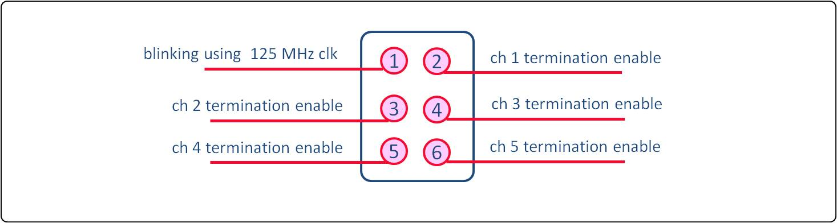

Figure 27: TDC mezzanine board front panel LEDs

## Embedded Interrupt Controller

The TDC EIC gathers the interrupts from the TDC core. It has three interrupt inputs, as described in Section 3.11 and one interrupt request output. The three inputs are multiplexed and the result is forwarded to the VIC. Interrupt sources can be masked using the enable and disable registers. The HDL code has been automatically generated using wbgen2.

|  |  |  |  |  |  |  |  |
| --- | --- | --- | --- | --- | --- | --- | --- |
| Name | R/W | Description | | | | | Byte Address |
| EIC IRR  Interrupt disable register | W | Writing ‘1’ disables the handling of the interrupt associated with the corresponding bit. Writing ‘0’ has no effect. | | | | | 0x00 |
| [bit 1] | write ‘1’to disable “tstamps irq” | | | |
| [bit 0] | write ‘1’ to disable “acam error irq” | | | |
| [bit 2] | write ‘1’ to disable “time irq” | | | |
| [bits 31..3] | not used | | | |
| EIC IER  Interrupt enable register | W | Writing ‘1’ enables the handling of the interrupt associated with the corresponding bit. Writing ‘0’ has no effect. | | | | | 0x04 |
| [bit 0] | | write ‘1’to enable “tstamps irq” | | |
| [bit 1] | | write ‘1’ to enable “time irq” | | |
| [bit 2] | | write ‘1’ to enable “acam error irq” | | |
| [bits 31..3] | | not used | | |
| EIC IMR  Interrupt mask register | R | Shows which interrupts are enabled. Reading ‘1’ means that the interrupt associated with the bitfield is enabled. | | | | | 0x08 |
| [bit 0] | | | read ‘1’ means “tstamps irq” is enabled | |
| [bit 1] | | | read ‘1’ means “time irq” is enabled | |
| [bit 2] | | | read ‘1’ means “acam error irq” is enabled | |
| [bits 31..3] | | | not used | |
| EIC ISR  Interrupt status register | R/W | Each bit represents the state of the corresponding interrupt. Reading ‘1’ means the interrupt is pending. Writing ‘1’ to a bit clears the corresponding interrupt. Writing ‘0’ has no effect. | | | | | 0x0C |
| [bit 0] | | | | read ‘1’ means “tstamps irq” is pending  read ‘0’ means no pending interrupt  write ‘1’ to clear the “tstamps irq”  write ‘0’ has no effect |
| [bit 1] | | | | read ‘1’ means “time irq” is pending  read ‘0’ means no pending interrupt  write ‘1’ to clear the “time irq”  write ‘0’ has no effect |
| [bit 2] | | | | read ‘1’ means “acam error irq” is pending  read ‘0’ means no pending interrupt  write ‘1’ to clear the “t acam error irq”  write ‘0’ has no effect |
| [bits 31..3] | | | | not used |

Table : TDC EIC registers

## 1-Wire

The 1-Wire master controls the “DS18B20 thermometer and unique ID” chip located on the mezzanine board. The unit is based on an OpenCores design [8].

The unit is clocked by the 125 MHz clock.

The dividers configuration are CDR_N=624 and CDR_O=124.

CDR_N = f_sys * 5E-6 - 1

CDR_O = f_sys * 1E-6 - 1

## I2C

The I2C master accesses the 24AA64 64Kb EEPROM memory chip [9] located on the mezzanine board. This memory is mandatory as specified in the FMC standard (VITA 57.1). It is connected to the system management I2C bus, also specified in the FMC standard. The unit is based on an OpenCores design [10].

The unit is clocked by the 125 MHz clock. For a SCL clock of 100 kHz, the prescaler configuration is PRESCALER=249.

PRESCALER = f_sys / (5 * f_scl) – 1

The I2C slave address is 0x50.

## Crossbar

The crossbar is used to map the different slaves in the WISHBONE address space. It also implements SDB records [11]. The unit is part of the general-cores library [12].

The SDB records describe the WISHBONE slaves and their mapping to the bus. The SDB records ROM is located at address 0x0.

|  |  |
| --- | --- |
| Byte Address | WISHBONE slave |
| 0x00000 | Crossbar SDB records |
| 0x10000 | 1-Wire |
| 0x11000 | TDC configuration |
| 0x12000 | EIC |
| 0x13000 | I2C |
| 0x14000 | TDC memory for timestamps retrieval |

Table : FMC TDC mezzanine WISHBONE bus memory mapping

## Clock domains

Figure 28 shows the two clock domains of the FMC TDC mezzanine module. As described in section 3.1.3 the clcks_rsts_manager unit is configuring the PLL AD9516 on the mezzanine using the 20 MHz clock of the SPEC/SVEC VCXO. The PLL-generated 125 MHz clock is then used by all the rest of the logic.

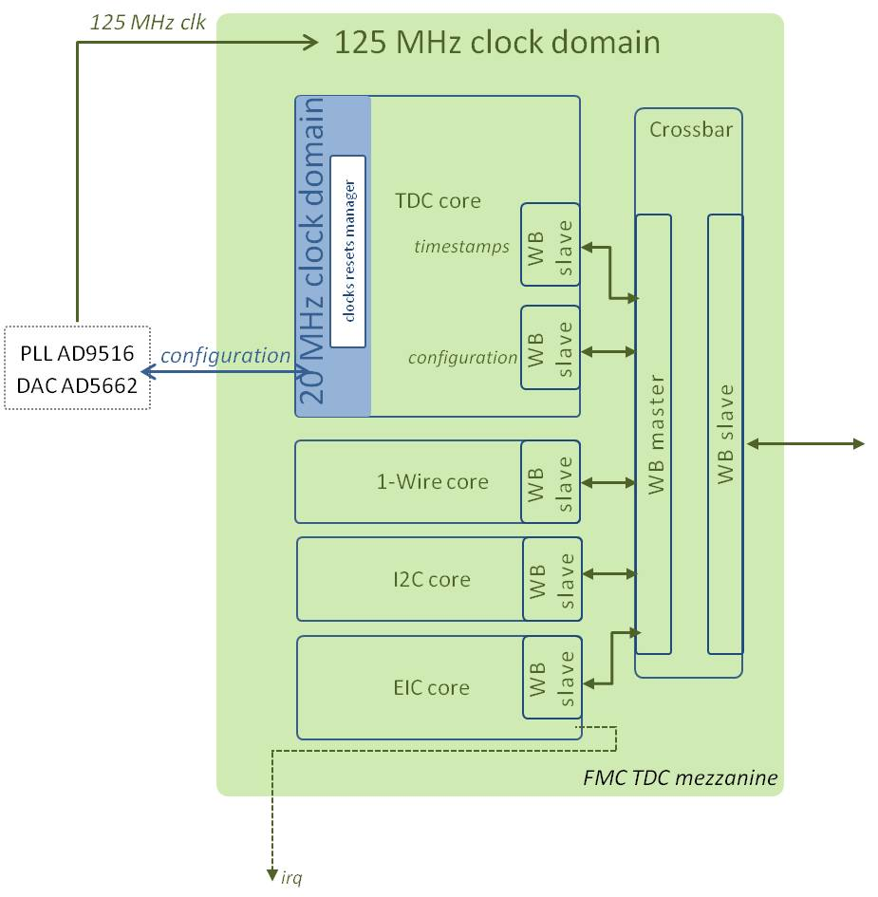

Figure : FMC TDC mezzanine clock domains

# SPEC TDC

Figure 28 shows the gateware architecture on a SPEC carrier. All the blocks are connected to the PCIe interface using the same WISHBONE bus.

Six components are instantiated:

* The **FMC TDC mezzanine,** as described thoroughly in section
* The **crossbar** is used to map the different slaves in the WISHBONE address space
* The **GN4124** core is the interface to the Gennum GN4124 PCIe bridge chip
* The **1-wire** core communicates with the DS18B20 thermometer and unique ID chip on the SPEC
* The **carrier info** core contains control and status registers related to the SPEC
* The **VIC** is the interrupts handler

The following sections describe the different modules.

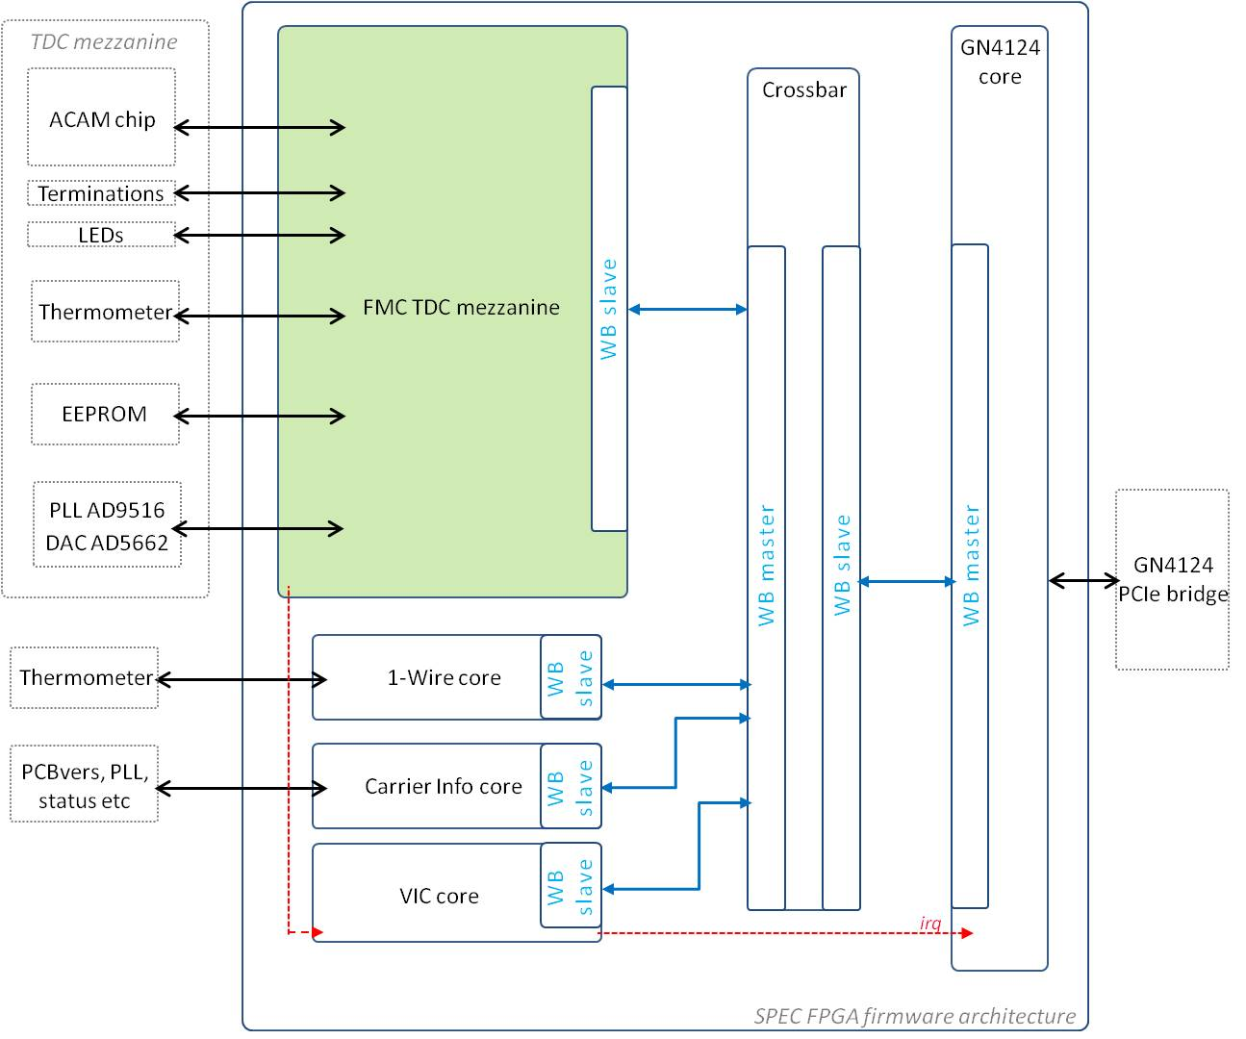

Figure : SPEC TDC gateware architecture (same as Figure 1)

## Clock domains

As Figure 30 shows, there are three clock domains in the design.

* Section 3.1.3 explains how the clks_rsts_manager unit is using the 20 MHz SPEC VCXO clock to configure the PLL AD9516.
* The PLL-generated 125 MHz clock is used by the rest of the design for the communication with the GN4124 core.
* The GN4124 core on the PCIe bridge side operates using the 200 MHz local bus clock p2l_clk.

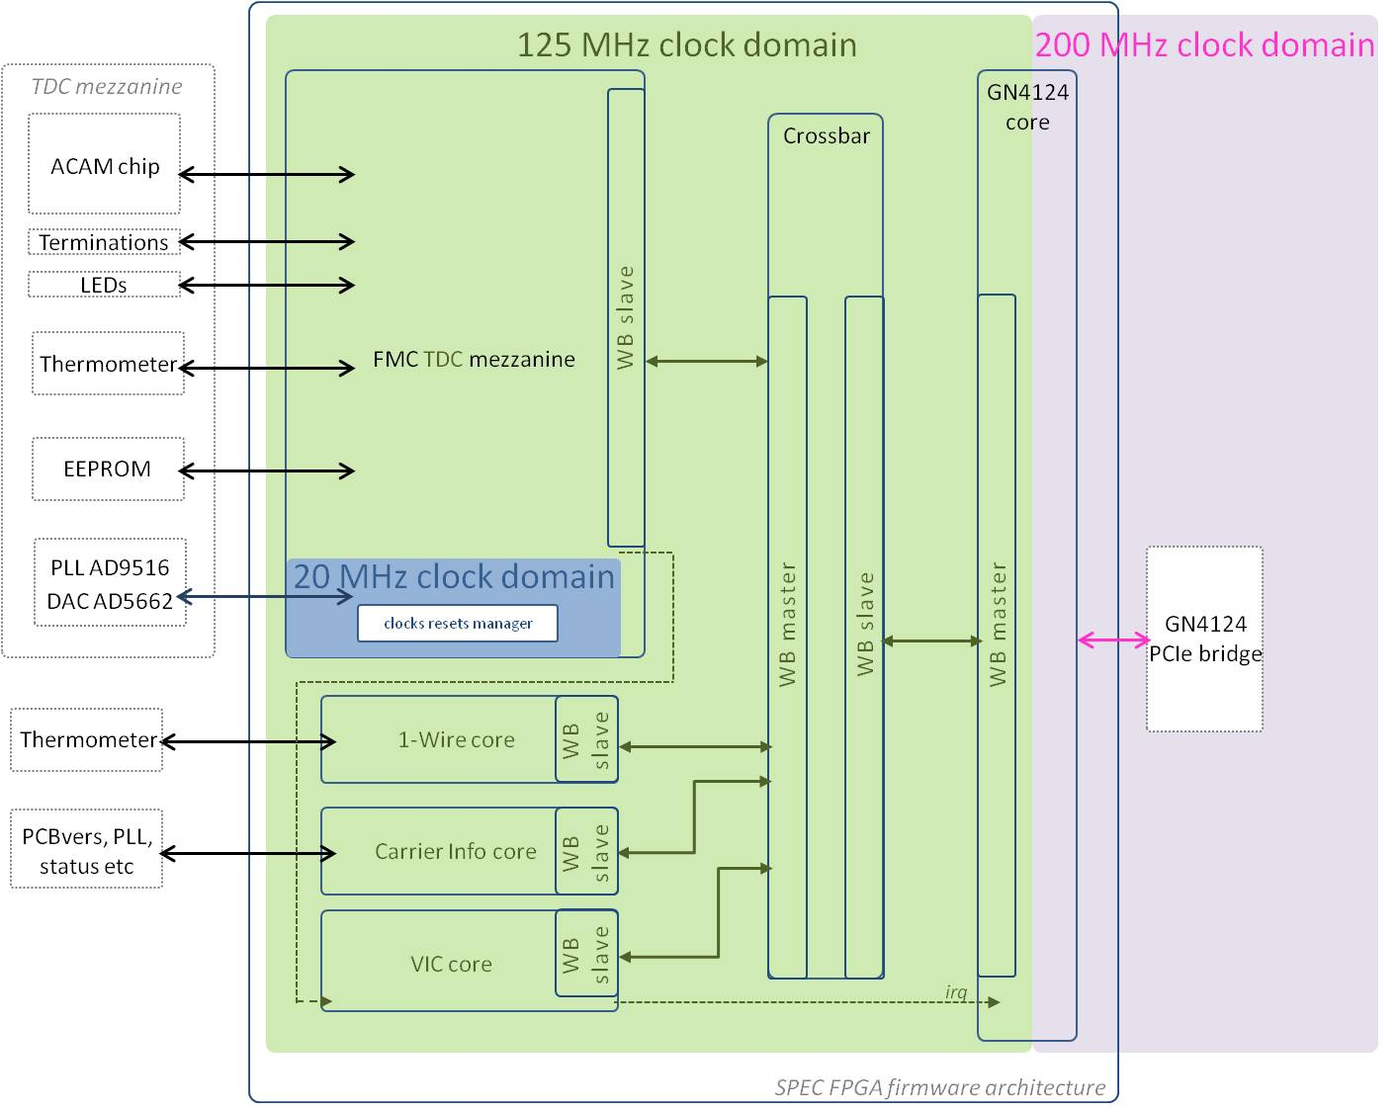

Figure : SPEC TDC clock domains

Table 10 lists the three clocks.

|  |  |  |  |
| --- | --- | --- | --- |
| Name | Description | Frequency | Source |
| clk_125m | System clock | 125 MHz | PLL AD9516 on the mezzanine |
| clk_20m_vcxo | Clock used for the configuration of the PLL | 20 MHz | VCXO on the carrier |
| p2l_clk | PCIe bus clock | 200 MHz | GN4124 chip on the carrier |

Table : SPEC TDC clock domains

## GN4124 core

This block is the interface between the GN41245 local bus and the other blocks in the FPGA.

The GN4124 chip is a four lane PCI Express Generation 1.1 bridge. In addition to the PHY, it contains the data link and transaction layers. The GN4124 bridge is used to access the FPGA registers, but also to generate MSI interrupts and re-program the FPGA.

The BAR 4 (Base Address Register) allows access to the GN4124 chip internal registers. The BAR 0 is connected to the local bus and therefore allows access to the FPGA.

The GN4124 core is made of a local bus interface with the GN4124 chip, a WISHBONE bus master mapped to BAR0 and a DMA controller. The TDC design is not making use of the DMA controller. The GN4124 core WISHBONE interfaces (masters and slave) are 32-bit data width and 32-bit word aligned addresses.

## Crossbar

The crossbar is used to map the different slaves in the WISHBONE address space. Table 8 shows the WISHBONE slaves mapping and hierarchy. The first column represents the byte address offset from the start of the WISHBONE address space (BAR 0).

|  |  |
| --- | --- |
| Byte Address | WISHBONE slave |
| 0x00000 | Crossbar SDB records |
| 0x10000 | Carrier 1-Wire |
| 0x20000 | Carrier info |
| 0x30000 | VIC |
| 0x40000 | Bridge FMC TDC mezzanine (Crossbar SDB records) |
| 0x50000 | 1-Wire |
| 0x51000 | TDC configuration |
| 0x52000 | EIC |
| 0x53000 | I2C |
| 0x54000 | TDC memory for timestamps retrieval |

Table : WISHBONE bus memory mapping (BAR 0)

In order to identify the gateware, the crossbar includes three SDB meta-information records: “Integration”, “Top module repository url” and “Synthesis tool information”. Table 8 describes the different fields of each record.

|  |  |  |  |
| --- | --- | --- | --- |
| SDB record | Fields | Field content | Description |
| Integration | vendor_id | 0x0000CE42 | CERN vendor ID |
| device_id | 0x593b56e5 | echo "spec_fmc-tdc-1ns5cha" | md5sum | cut -c1-8 |
| Version | 0x00050000 | bcd encoded, [31:16] = major, [15:0] = minor |
| date | 0x20140121 | bcd encoded, 32 bits, YYYYMMDD |
| name | "spec_top_fmc_tdc " | string, 19 char |
| Repo url | repo_url | "http://svn.ohwr.org/fmc-tdc/hdl/spec/ " | string, 63 char |
| Synthesis | syn_module_name | "spec_top_fmc_tdc" | string, 16 char |
| syn_commit_id |  |  |
| syn_tool_name | "SynpliDP" | string 8 char |
| syn_tool_version | 0x00201203 | bcd encoded, 32 bits |
| syn_date | 0x20140121 | bcd encoded, 32 bits |
| syn_username | "egousiou " | string, 15 char |

Table : SDB meta-information records

## Carrier 1-Wire

Similarly to the “mezzanine 1-Wire master” of section 3.3, the “carrier 1-wire master” controls the “DS18B20 thermometer and unique ID” chip located on the SPEC carrier board. The unit is based on an OpenCores [8] design.

The unit is clocked by the 125 MHz clock.

The dividers configuration are CDR_N=624 and CDR_O=124.

CDR_N = f_sys * 5E-6 - 1

CDR_O = f_sys * 1E-6 – 1

## Carrier info

The unit contains control and status registers related to the carrier board. Table 11 describes the registers.

|  |  |  |  |  |
| --- | --- | --- | --- | --- |
| Register name | R/W | Description | | Byte Address |
| Carrier type and PCB version | R | [bits 4..0] | Binary coded PCB layout version | 0x00 |
| [bits 15..5] | Carrier type : 0x1 = SPEC  0x2 = SVEC  0x3 = VFC  0x4 = SPEXI |
| [bits 31..6] | not used |
| Status | R | [bit 0] | FMC presence, active low | 0x04 |
| [bit 2] | System clock PLL status, active high |
| [bits 31..3] | not used |

Table : Carrier info registers map

## VIC

In order to redirect interrupts from different cores to the corresponding driver in the Linux kernel in a generic way, a two layers scheme is used. The first layer is the Embedded Interrupt Controllers, explained in section 3.2, which is multiplexing the different interrupt sources of the FMC TDC mezzanine module into one single line. The second layer is the Vectored Interrupt Controller, VIC, which is multiplexing interrupt lines from different EICs into a single line to the host. On the SPEC carrier, the VIC interrupt request output is connected to the GPIO 8 of the GN4124 chip. Therefore, the GN4124 must be configured to generate a MSI when a rising edge is detected on GPIO 8.

The VIC keeps a table (IVT_RAM) initialized with the base addresses of the EICs connected to each of the input. Here there is only the FMC TDC EIC at address 0x52000. Table 12 describes all the VIC registers.

|  |  |  |  |  |  |  |
| --- | --- | --- | --- | --- | --- | --- |
| Register name | R/W | Description | | | | Byte Address |
| CTL  VIC Control reg | R/W | [bit 0] | ENABLE | Write ‘1’ to enable the VIC operation  Write ‘0’ to disable the VIC operation | | 0x00 |
| [bit 1] | POL | Write ‘1’ to set the IRQ output active high  Write ‘0’ to set the IRQ output active low | |
| [bit 2] | EMU_  EDGE | Write ‘1’ to force a low pulse of EMU_LEN clock cycles at each write to EOIR.  Write ‘0’ for a normal IQR master line behavior | |
| [bit 2] | EMU_  LEN | Length of the delay between write to EOIR and re-assertion of irq_master_o | |
| RISR  Raw Irq Status | R | [bit 0] | Current state of the FMC TDC mezzanine interrupt | | | 0x04 |
| [bits 31..1] | Not used | | |
| IER  Irq Enable Reg | W | [bit 0] | Write ‘1’ to enable the FMC TDC mezzanine interrupt  Write ‘0’ has no effect | | | 0x08 |
| [bits 31..1] | Not used | | |
| IDR  Irq Disable Reg | W | [bit 0] | Write ‘1’ to disable the FMC TDC mezzanine interrupt  Write ‘0’ has no effect | | | 0x0C |
| [bits 31..1] | Not used | | |
| IMR  Irq Mask | R | [bit 0] | Read ‘1’ means FMC TDC mezzanine interrupt is enabled  Read ‘0’ means FMC TDC mezzanine interrupt is disabled | | | 0x10 |
| [bits 31..1] | Not used | | |
| IMR  Vector Address reg | R | [bits 31..0] | Address of the pending interrupt vector, read from the IVT_RAM | | | 0x14 |
| SWIR  Software Irq Reg | W | [bits 31..0] | Writing ‘1’ to one of the bits causes a software emulation of the respective interrupt. | | | 0x18 |
| EOIR  End Of Irq Ack Reg | W | [bit 0] | Writing ‘1’ acknowledges an FMC TDC mezzanine pending interrupt | | | 0x1C |
| [bits 31..1] | Not used | | |
| MEM  RAM with Interrupt Vector Table | R | [bits 31..0] | IVT_RAM | | Contain the address “0x52000” of the FMC TDC mezzanine EIC WISHBONE slave | 0x20 |
|  | Rest of the RAM not used | 0x24..  0x3F |

Table : VIC register map

As the GN4124 chip is an edge-only IRQ controller, an edge sensitive configuration should be used by the drivers for the VIC, with the following characteristics:

|  |
| --- |
| VIC control register |
| ENABLE = ‘1’ |
| POL = ‘1’ |
| EMU_EDGE = ‘1’ |
| EMU_LEN = 750 |

Table : VIC configuration for SPEC

# SVEC TDC

Figure 29 shows the gateware architecture on a SPEC carrier. All the blocks are connected to the VME interface using the same WISHBONE bus.

The design is composed of:

* Tow **FMC TDC mezzanines,** as described thoroughly in section
* The **crossbar** is used to map the different slaves in the WISHBONE address space
* The **VME64x** core is the interface to the VME bus
* The **1-wire** core communicates with the SVEC DS18B20 thermometer and unique ID chip
* The **carrier info** core contains control and status registers related to the SVEC
* The **VIC** is the interrupts handler
* The clock_crossing cores are used to pass the signals from the 125 MHz clock domains of the FMC TDC mezzanines to the 62.5 MHz domain that the VME core functions.



Figure : SPEC TDC gateware architecture (same as Figure 5)

## Clock domains

As Figure 30 shows, there are four clock domains in the design.

* Section 3.1.3 explains how the clks_rsts_manager unit of each one of the two FMC TDC mezzanine modules is using the 20 MHz SVEC VCXO clock to configure their PLL AD9516.
* On the TDC#1 the PLL-generated 125 MHz clock is used by the FMC TDC mezzanine #1 module
* On the TDC#2 the PLL-generated 125 MHz clock is used by the FMC TDC mezzanine #2 module
* The VME core that cannot operate at high frequencies, is working at 62.5 MHz. The 62.5 MHz clock is generated using the 20 MHz SVEC VCXO and the Xilinx internal PLL. The crossbar, 1-wire core, carrier info core and the vic also operate at 62.5 MHz. 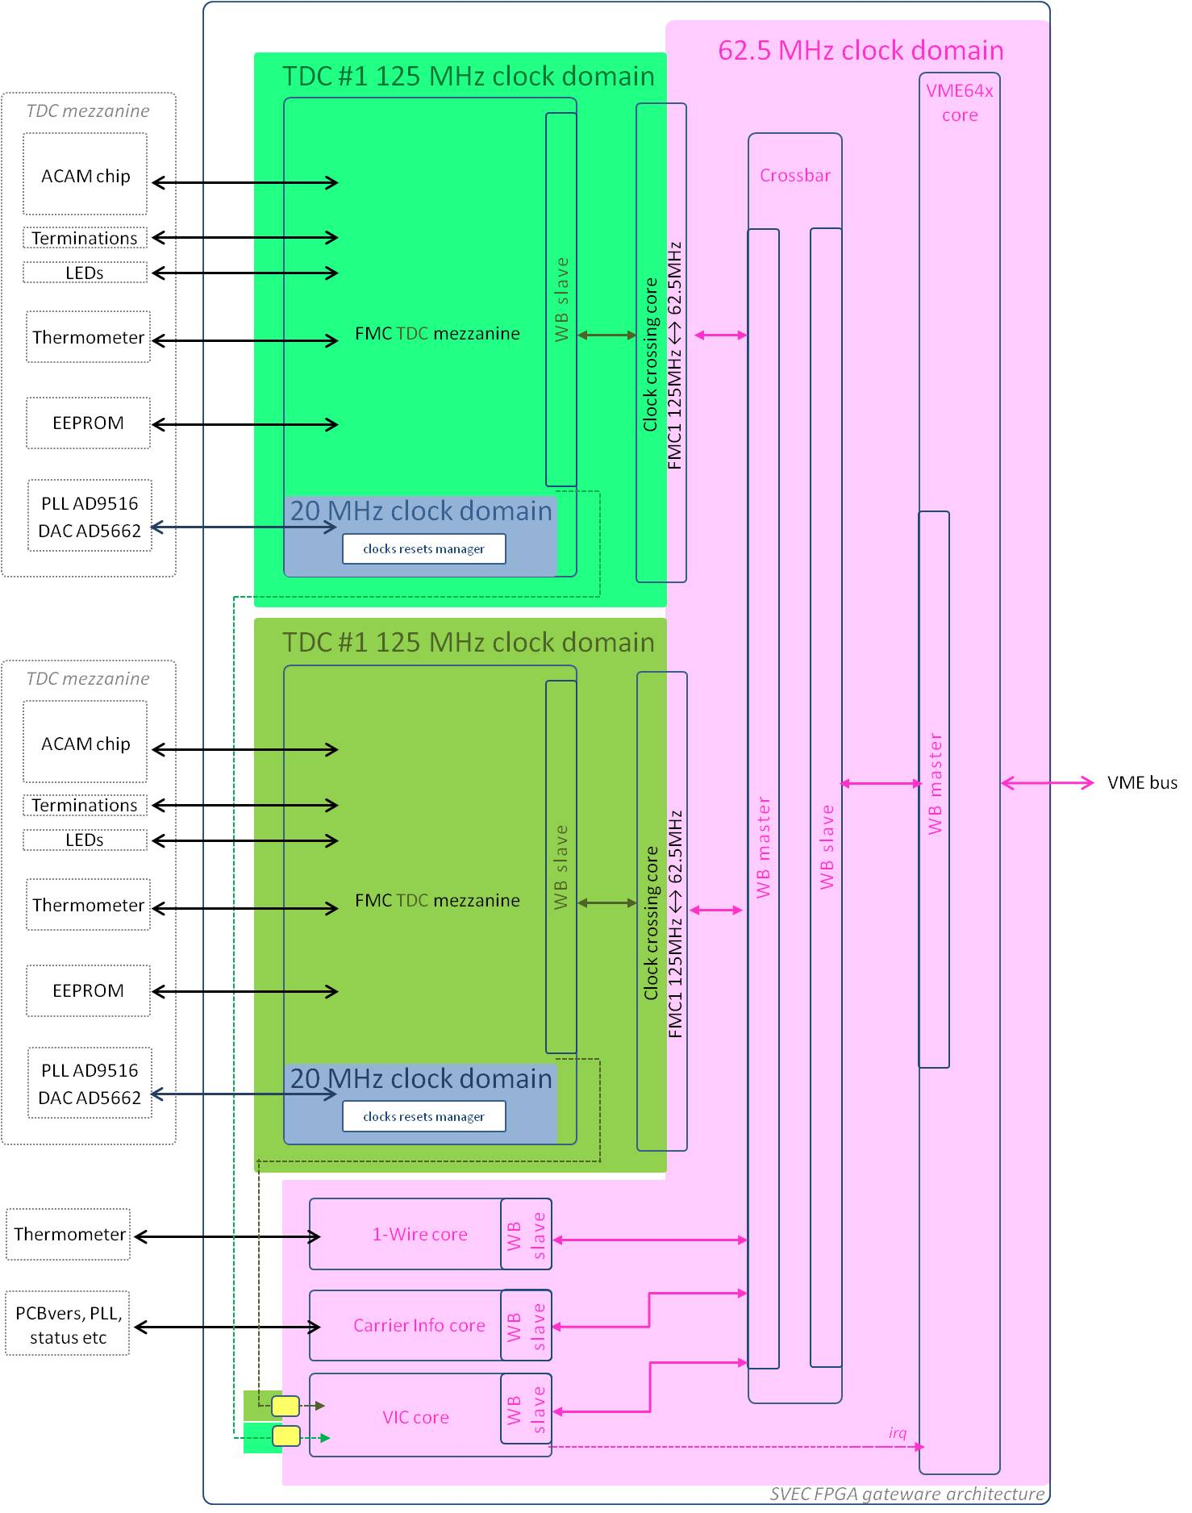

Figure : SPEC TDC clock domains

Table 14 lists the four clocks.

|  |  |  |  |
| --- | --- | --- | --- |
| Name | Description | Frequency | Source |
| clk_20m_vcxo | Clock used for the configuration of the PLLs on the two TDC mezzanines | 20 MHz | VCXO on the carrier |
| tdc1_clk_125m | FMC TDC mezzanine #1 clock | 125 MHz | PLL AD9516 on TDC#1 |
| tdc1_clk_125m | FMC TDC mezzanine #2 clock | 125 MHz | PLL AD9516 on TDC#2 |
| clk_62m5_sys | System clock | 62.5 MHz | VCXO on the carrier and Xilinx PLL |

Table : SPEC TDC clock domains

## VME64x core

The VME64x core implements a VME slave on one side and a WISHBONE pipelined master on the other side. For more information about the VME64x core, visit the OHWR page [13].

## Crossbar

The crossbar is used to map the different slaves in the WISHBONE address space. Table 15 shows the WISHBONE slaves mapping and hierarchy. The first column represents the byte address offset from the start of the WISHBONE address space.

|  |  |
| --- | --- |
| Byte Address | WISHBONE slave |
| 0x00000 | Crossbar SDB records |
| 0x10000 | Carrier 1-Wire |
| 0x20000 | Carrier info |
| 0x30000 | VIC |
| 0x40000 | Bridge FMC TDC mezzanine #1 (Crossbar SDB records) |
| 0x50000 | 1-Wire |
| 0x51000 | TDC configuration |
| 0x52000 | EIC |
| 0x53000 | I2C |
| 0x54000 | TDC memory for timestamps retrieval |
| 0x60000 | Bridge FMC TDC mezzanine #2(Crossbar SDB records) |
| 0x60000 | 1-Wire |
| 0x61000 | TDC configuration |
| 0x62000 | EIC |
| 0x63000 | I2C |
| 0x64000 | TDC memory for timestamps retrieval |

Table : WISHBONE bus memory mapping for SVEC

In order to identify the gateware, the crossbar includes three SDB meta-information records: “Integration”, “Top module repository url” and “Synthesis tool information”. Table 8 describes the different fields of each record.

|  |  |  |  |
| --- | --- | --- | --- |
| SDB record | Fields | Field content | Description |
| Integration | vendor_id | 0x0000CE42 | CERN vendor ID |
| device_id | 0x593b56e5 | echo "spec_fmc-tdc-1ns5cha" | md5sum | cut -c1-8 |
| Version | 0x00050000 | bcd encoded, [31:16] = major, [15:0] = minor |
| date | 0x20140121 | bcd encoded, 32 bits, YYYYMMDD |
| name | "spec_top_fmc_tdc " | string, 19 char |
| Repo url | repo_url | "http://svn.ohwr.org/fmc-tdc/hdl/spec/ " | string, 63 char |
| Synthesis | syn_module_name | "spec_top_fmc_tdc" | string, 16 char |
| syn_commit_id |  |  |
| syn_tool_name | "SynpliDP" | string 8 char |
| syn_tool_version | 0x00201203 | bcd encoded, 32 bits |
| syn_date | 0x20140121 | bcd encoded, 32 bits |
| syn_username | "egousiou " | string, 15 char |

Table : SDB meta-information records

## Carrier 1-Wire

Similarly to the “mezzanine 1-Wire master” of section 3.3, the “carrier 1-wire master” controls the “DS18B20 thermometer and unique ID” chip located on the SVEC carrier board. The unit is based on an OpenCores [8] design.

The unit is clocked by the 62.5 MHz clock.

The dividers configuration on the driver side are CDR_N=311.5 and CDR_O=61.5.

CDR_N = f_sys * 5E-6 - 1

CDR_O = f_sys * 1E-6 – 1

## Carrier info

The same unit as the one described in section 4.5 is used. Table 17 describes the registers of this unit.

|  |  |  |  |  |
| --- | --- | --- | --- | --- |
| Register name | R/W | Description | | Byte Address |
| Carrier type and PCB version | R | [bits 4..0] | Binary coded PCB layout version | 0x00 |
| [bits 15..5] | Carrier type : 0x1 = SPEC  0x2 = SVEC  0x3 = VFC  0x4 = SPEXI |
| [bits 31..6] | not used |
| Status | R | [bit 0] | FMC 0 presence, active low | 0x04 |
| [bit 1] | FMC 1 presence, active low |
| [bit 2] | System clock PLL status, active high |
| [bits 31..3] | not used |

Table : Carrier info registers map for SVEC

## VIC

As described in section 4.6, in order to redirect interrupts from different cores to the corresponding driver in the Linux kernel in a generic way, a two layers scheme is used. The first layer is the Embedded Interrupt Controllers, explained in section 3.2, which is multiplexing the different interrupt sources of the FMC TDC mezzanine module into one single line. The second layer is the Vectored Interrupt Controller, VIC, which is multiplexing interrupt lines from different EICs into a single line to the host.

The VIC keeps a table (IVT_RAM) initialized with the base addresses of the EICs connected to each of the input. Here the FMC TDC #1 EIC at address 0x52000 and the FMC TDC #1 EIC at address 0x62000. Table 12 describes all the VIC registers.

|  |  |  |  |  |  |  |
| --- | --- | --- | --- | --- | --- | --- |
| Register name | R/W | Description | | | | Byte Address |
| CTL  VIC Control reg | R/W | [bit 0] | ENABLE | Write ‘1’ to enable the VIC operation  Write ‘0’ to disable the VIC operation | | 0x00 |
| [bit 1] | POL | Write ‘1’ to set the IRQ output active high  Write ‘0’ to set the IRQ output active low | |
| [bit 2] | EMU_  EDGE | Write ‘1’ to force a low pulse of EMU_LEN clock cycles at each write to EOIR.  Write ‘0’ for a normal IQR master line behavior | |
| [bit 2] | EMU_  LEN | Length of the delay between write to EOIR and re-assertion of irq_master_o | |
| RISR  Raw Irq Status | R | [bit 0] | Current state of the FMC TDC mezzanine #1 interrupt | | | 0x04 |
| [bit 1] | Current state of the FMC TDC mezzanine #2 interrupt | | |
| [bits 31..2] | Not used | | |  |
| IER  Irq Enable Reg | W | [bit 0] | Write ‘1’ to enable the FMC TDC mezzanine #1 interrupt  Write ‘0’ has no effect | | | 0x08 |
| [bit 1] | Write ‘1’ to enable the FMC TDC mezzanine #2 interrupt  Write ‘0’ has no effect | | |
| [bits 31..2] | Not used | | |  |
| IDR  Irq Disable Reg | W | [bit 0] | Write ‘1’ to disable the FMC TDC mezzanine #1 interrupt  Write ‘0’ has no effect | | | 0x0C |
| [bit 1] | Write ‘1’ to disable the FMC TDC mezzanine #2 interrupt  Write ‘0’ has no effect | | |
| [bits 31..2] | Not used | | |  |
| IMR  Irq Mask | R | [bit 0] | Read ‘1’ means FMC TDC mezzanine #1 interrupt is enabled  Read ‘0’ means FMC TDC mezzanine #1 interrupt is disabled | | | 0x10 |
| [bit 1] | Read ‘1’ means FMC TDC mezzanine #2 interrupt is enabled  Read ‘0’ means FMC TDC mezzanine #2 interrupt is disabled | | |
| [bits 31..2] | Not used | | |
| IMR  Vector Address reg | R | [bits 31..0] | Address of the pending interrupt vector, read from the IVT_RAM | | | 0x14 |
| SWIR  Software Irq Reg | W | [bits 31..0] | Writing ‘1’ to one of the bits causes a software emulation of the respective interrupt. | | | 0x18 |
| EOIR  End Of Irq Ack Reg | W | [bit 0] | Writing ‘1’ acknowledges an FMC TDC mezzanine #1 pending interrupt | | | 0x1C |
| [bit 1] | Writing ‘1’ acknowledges an FMC TDC mezzanine #2 pending interrupt | | |
| [bits 31..2] | Not used | | |
| MEM  RAM with Interrupt Vector Table | R | [bits 31..0] | IVT_RAM | | Contain the address “0x52000” of the FMC TDC mezzanine #1 EIC WISHBONE slave | 0x20 |
| [bits 31..0] | Contain the address “0x62000” of the FMC TDC mezzanine #2 EIC WISHBONE slave | 0x24 |
|  | Rest of the RAM not used | 0x28..  0x3F |

Table : VIC register map

Table 19 shows how the SVEC VIC is configured by the driver.

|  |
| --- |
| VIC control register |
| ENABLE = ‘1’ |
| POL = ‘1’ |
| EMU_EDGE = ‘0’ |

Table : VIC configuration for SVEC

## Clock crossing

The WISHBONE clock crossing core is part of the general cores library [12]. It is used to transfer a FMC TDC WISHBONE slave from the 125 MHz domain to the 62.5 MHz domain of the VME core.

To transfer the EIC interrupt signals from the 125 MHz domains to the 62.5 MHz, simple pulse synchronizers with two DFFs are used.

# HDL repository

The TDC design is available under svn in the ohwr.org repository: <http://www.ohwr.org/projects/fmc-tdc/repository/show/hdl>

# TDC mezzanine board calibration

The TDC mezzanine board has 5 input channels. The track length from an input to the ACAM chip differs from channel to channel. In addition the input logic (clock buffers) of each channel is introducing different delays that can vary up to 2 ns. That is why it is essential to calibrate the TDC board channels. For more information, refer to the [channels calibration](http://www.ohwr.org/projects/fmc-tdc/repository/changes/documentation/TDC_calibration/Channels_calibration.pdf) documentation.

Moreover the DAC IC2 on the board controls the OSC2 voltage-controlled-oscillator which in turn controls the PLL IC6. Alterations on the DAC voltage change slightly the frequency of the pulses coming out of the PLL and therefore the timestamp measurements. For example, the difference between two pulses separated by 9 ms can be measured as 8.999967000 ms with the DAC at 1.25 V and as 9.000000300 ms with the DAC at 1.65 V. Note also that the VCXO OSC2 is strongly influenced by temperature changes; the documentation specifies 0.5ppm/oC. For more information, refer to the [DAC calibration](http://www.ohwr.org/projects/fmc-tdc/repository/changes/documentation/TDC_calibration/DACcalibration.xlsx) document.

The [TDC-PTS-Calibration suite](http://www.ohwr.org/projects/pts/repository/revisions/fmctdc1ns5cha_calib/changes/test/fmctdc1ns5cha/calibration/documentation/TDC_PTScalibration_UserGuide.pdf) provides the automated environment for the calibration of each board. It is using a very precise pulse generator, the Pendulum CNT-91 connected to a Cesium clock. The calibration data along with IPMI information is written in the TDC EEPROM.

# TDC application performance

Long term tests on the precision and general performance of the TDC mezzanine application are available [here](http://www.ohwr.org/projects/fmc-tdc/repository/show/board_testing).

# References

[1]: FMC projects: <http://www.ohwr.org/projects/fmc-projects/wiki>

[2]: SPEC board: <http://www.ohwr.org/projects/spec/wiki>

[3]: SVEC board: <http://www.ohwr.org/projects/svec/wiki>

[4]: ACAM TDC GPX: <http://www.acam.de/fileadmin/Download/pdf/English/DB_GPX_e.pdf>

[5]: FMC TDC software support: <http://www.ohwr.org/projects/fmc-tdc-sw/wiki>

[6]: GN4124core: <http://www.ohwr.org/projects/gn4124-core/wiki>

[7]: The White Rabbit project: <http://www.ohwr.org/projects/white-rabbit/wiki>

[8]: Open cores One Wire master: <http://opencores.org/project,sockit_owm>

[9]: EEPROM 24AA64: <http://ww1.microchip.com/downloads/en/devicedoc/21189f.pdf>

[10]: Open cores I2C master: <http://opencores.org/project,sockit_owm>

[11]: SDB records: <http://www.ohwr.org/projects/fpga-config-space/wiki>

[12]: General cores library: http://www.ohwr.org/projects/general-cores

[13]: VME64x core: <http://www.ohwr.org/projects/vme64x-core>