Group Member: Steven Qiao, Jialu Xia, Jiarui Li, Kei Chon Sio
Course: GGR376H5
Date: 2026/3/6

Project Proposal - Group 15

1. Spatial Research Question background

1.1 Background
The COVID-19 pandemic has severely impacted the catering industry. To help restaurants overcome the difficulties, the City of Toronto launched the CaféTO, allowing restaurants to set up outdoor seating on roadside lanes and sidewalks. Originally, this was just a temporary policy, but after the pandemic ended, it was retained and became a permanent measure in Toronto. The CaféTO program also generated significant economic benefits for Toronto’s restaurant sector. A survey conducted by the Toronto Association of Business Improvement Areas (TABIA, 2022) estimated that CaféTO patios contributed approximately $203 million in economic activity in 2022. Although the outdoor dining permit of CaféTO was introduced during the pandemic, its distribution across various communities in Toronto was far from uniform. We conducted this research to determine two things: first, are these outdoor dining areas clearly concentrated in certain areas; second, is its distribution related to the economic recovery of different communities?
We wanted to explore whether the distribution of CaféTO in Toronto was random or related to the characteristics of local communities. We believe that its distribution was definitely uneven, and this unevenness might be related to many factors, such as the varying commercial activity levels in different communities, the tendency of restaurants to cluster on main streets, and differences in local economic conditions. One key reason is consumer spending power. After all, when businesses choose locations, the most important factor is whether they can make a profit, so the outdoor seating of CaféTO should be more likely to appear in communities with higher after-tax income of families.

1. Background
The COVID-19 pandemic had a significant impact on the restaurant industry in Toronto, disrupting indoor dining and reducing business activity. In response, the City of Toronto introduced the CaféTO program, which allowed restaurants to expand outdoor seating onto sidewalks and curb lanes. Although this policy was originally designed as a temporary emergency measure, it was later retained as a permanent initiative due to its economic benefits and popularity among businesses and customers.
According to the Toronto Association of Business Improvement Areas (TABIA, 2022), CaféTO patios contributed approximately $203 million in economic activity in 2022. This suggests that CaféTO is not only a short-term recovery strategy, but also an important part of Toronto’s urban commercial system.
However, despite being implemented across the city, the distribution of CaféTO permits appears uneven across neighbourhoods. Some areas, particularly in the downtown core, have a high concentration of outdoor dining spaces, while many peripheral neighbourhoods have few or none. This uneven distribution raises an important question about whether access to these public-commercial spaces is equally shared across the city, or whether it reflects deeper spatial inequalities.

2. Research Question and Hypotheses

2.1 Primary Research Question
Is the spatial distribution of CaféTO permits across Toronto’s neighbourhoods spatially random, or does it exhibit statistically significant clustering that reflects localized socioeconomic inequalities?

2.2 Hypotheses
In order to systematically address our research questions and understand the reasons behind the distribution of CaféTO, we proposed three testable hypotheses:
- Hypothesis 1 (Spatial Clustering): We believe that the distribution of CaféTO is not random; it should be concentrated in a certain area. This also indicates that public space facilities in cities are not evenly distributed among each neighbourhood.
- Hypothesis 2 (Market Capacity and Income): CaféTO is essentially a commercial facility, and merchants will definitely consider whether they can make a profit when choosing an address. Therefore, we speculate that the number of CaféTO per 1,000 residents in a neighbourhood is positively correlated with the median household income of this neighbourhood. Thus, the more affluent the neighbourhood, the more people may use CaféTO, and businesses are more likely to set up their stores here.

2. Research Question and Hypotheses

2.1 Primary Research Question

Our primary research question is :
Does the spatial distribution of CaféTO permits across Toronto neighbourhoods exhibit statistically significant spatial clustering, and to what extent is this pattern associated with neighbourhood-level socioeconomic conditions (e.g., median household income)?

2.2 Hypotheses
To address the research question, we propose the following testable hypotheses:
- Hypothesis 1 (Spatial Clustering):
CaféTO permit density (number of permits per 1,000 residents) exhibits positive spatial autocorrelation across Toronto neighbourhoods, indicating that areas with high (or low) densities are spatially clustered rather than randomly distributed.
- Hypothesis 2 (Income Association):
CaféTO permit density is positively associated with neighbourhood median household income, such that higher-income neighbourhoods tend to have higher CaféTO density.

3. Preliminary ESDA
To examine whether CaféTO density exhibits spatial structure, we first conduct exploratory spatial data analysis (ESDA). Since the population in each neighbourhood varies, directly comparing the number of CaféTO permits is unfair because it doesn't take into account the population size. Therefore, we calculated "the number of CaféTO permits per 1000 residents" to eliminate the influence of population size.
From Figure 1, it can be clearly seen that there are a total of 1,281 CaféTO locations throughout Toronto, with most of them concentrated in the central and southern areas, especially along the lake and in the city center. However, in the northern and western peripheral neighbourhoods of the city, there is hardly any trace of CaféTO. This visual pattern suggests that the distribution may not be random, but formal spatial statistical tests such as Moran’s I are required to determine whether significant spatial clustering exists.
We calculated some basic statistics and drew histograms and box plots to see what the key indicators are approximately. The distribution in Figure 4 is highly uneven and strongly right-skewed. There are approximately 90 neighbourhoods that have CaféTO densities close to zero, while only a few neighbourhoods have extremely high densities, some exceeding 1.5 per 1,000 people, and the highest even approaching 5.0. The median is also far below 0.5, indicating that CaféTO is highly concentrated in a few neighbourhoods.
Figure 2 also once again proves this concentration trend. Only near the city center and a few neighbourhoods in the south have the highest CaféTO density (0.73 to 5.04 per 1,000 people), while most other neighbourhoods are in the lowest two density ranges.
In Figure 3, the distribution of areas with higher household income is relatively scattered, not concentrated in one area. When comparing Figures 2 and 3, it can be observed that the areas with a higher number of CaféTO and the high-income areas do not have any obvious overlap. This indicates that the relationship between income and the distribution of CaféTO may not be as simple as we initially thought. At Figure 5, it can also be noticed that there is no obvious linear pattern between the two, and no obvious correlation can be seen. This further demonstrates that we need to conduct more formal spatial statistical analysis to determine whether there is a significant relationship between income and the distribution of CaféTO.

3. Preliminary ESDA
To examine whether CaféTO density exhibits spatial structure, we first conducted exploratory spatial data analysis (ESDA). Since neighbourhood populations vary, directly comparing the number of CaféTO permits would be misleading. Therefore, we normalized the data by calculating the number of CaféTO permits per 1,000 residents.
Figure 1 shows the geographic distribution of CaféTO locations across Toronto. Visually, many permits appear to be located in the central and southern parts of the city, while fewer are observed in peripheral areas. However, this visual pattern alone is not sufficient to determine whether the distribution is statistically clustered or random. Formal spatial statistical analysis, such as Moran’s I, is required to confirm the presence of spatial autocorrelation.
To better understand the distribution, we examined summary statistics and distribution plots. The histogram and boxplot (Figure 4) indicate that CaféTO density is highly right-skewed. A large number of neighbourhoods have very low or zero density, while a small number of neighbourhoods exhibit relatively high values. The median density is below 0.5 permits per 1,000 residents, suggesting that most neighbourhoods have limited CaféTO presence.
Figure 2 maps CaféTO density using a quantile classification. Higher-density neighbourhoods appear more frequently in central areas, while lower-density neighbourhoods are more common in outer regions. However, this pattern should be interpreted cautiously, as quantile classification can exaggerate differences between classes.
Figure 3 presents the distribution of median household income across neighbourhoods. Unlike CaféTO density, income appears more spatially dispersed rather than concentrated in a single area.
When comparing CaféTO density (Figure 2) with income (Figure 3), there is no clear visual evidence of a strong spatial overlap between high-income areas and high CaféTO density. Similarly, the scatterplot (Figure 5) does not show a clear linear relationship between the two variables. These observations suggest that income alone may not fully explain the distribution of CaféTO permits.
Overall, the ESDA results indicate that CaféTO density is unevenly distributed and potentially spatially structured. However, formal spatial statistical tests are necessary to determine whether this pattern reflects statistically significant clustering and to better understand its relationship with socioeconomic variables.

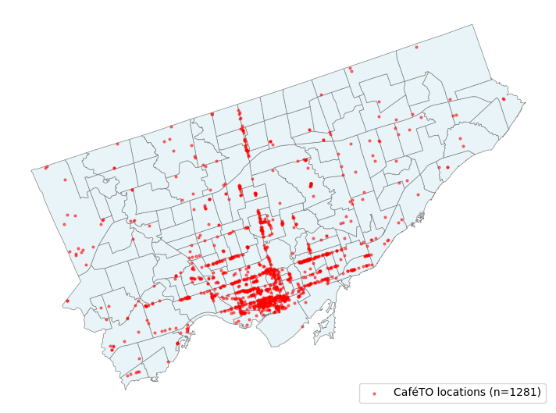

Figure 1: Toronto Neighbourhoods and CaféTO Locations
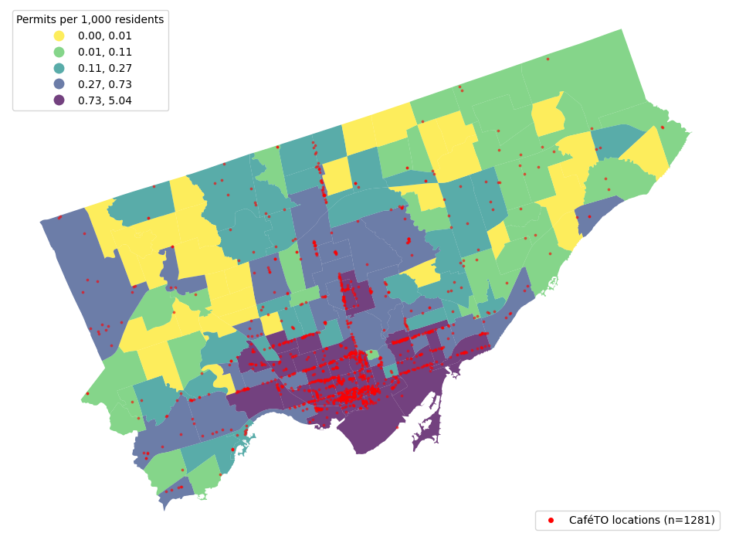
Figure 2: CaféTO Permits per 1,000 Residents by Neighbourhood (Quantile Classification)
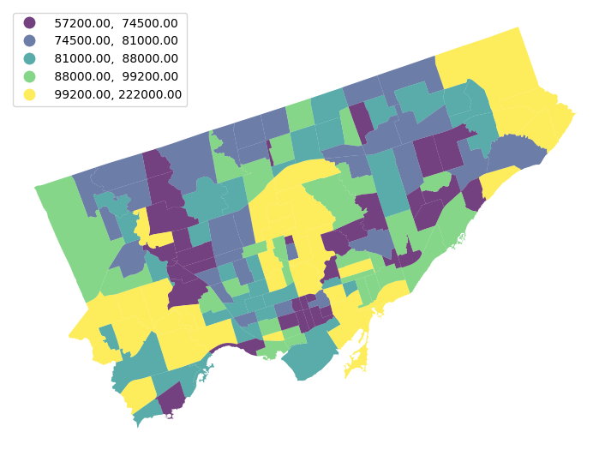

Figure 3: Median Household Income by Neighbourhood, 2021 Census (Quantile Classification)

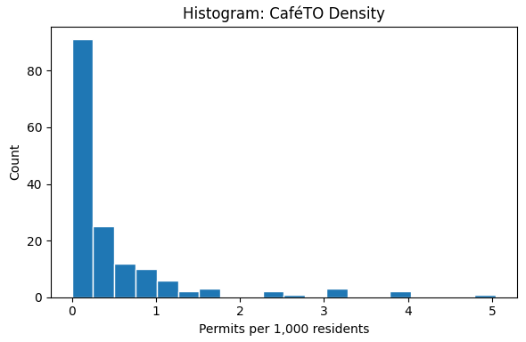
Figure 4a. Histogram of CaféTO permits per 1,000 residents across Toronto neighbourhoods.

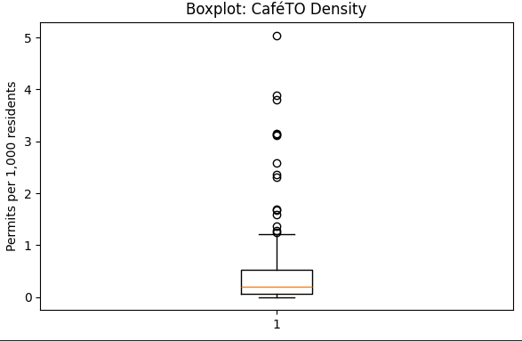
Figure 4b. Boxplot of CaféTO permits per 1,000 residents across Toronto neighbourhoods.

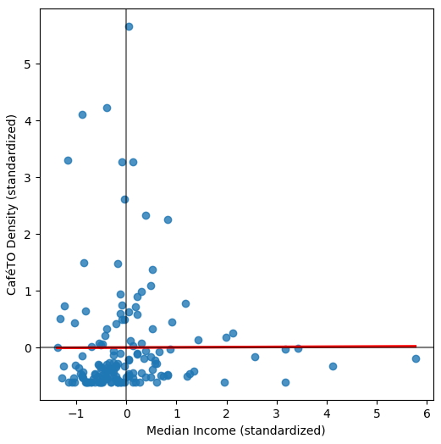
Figure 5: CaféTO permit density compared with median household income across Toronto neighbourhoods.

4. Methodology and Justification

4.1 Spatial Weights
In this study, Queen contiguity weights are used to define the spatial relationships between neighbourhoods. Since the spatial units are polygons, neighbourhoods sharing boundaries are likely to exhibit continuity in commercial environment and population composition. Neighbourhoods sharing only corner points may also have spatial interactions. Therefore, Queen contiguity weights capture neighbourhood relationships more comprehensively than Rook contiguity. All weights are row-standardized so that the sum of weights for each neighbourhood equals 1 which removes the influence of variation in the number of neighbours.

4.2 Global Spatial Auto-correlation
Global Moran's I is used to see if there were any spatial patterns in the distribution of CaféTO across different neighbourhoods. This method will calculate an I value to help us determine whether areas with a large number of CaféTO permits will cluster together rather than be randomly scattered throughout the city. If the I value is significantly positive, it indicates that neighbourhoods with a high number of CaféTO permits tend to be close to each other; if it is significantly negative, it means that neighbourhoods with a high and low number of CaféTO permits alternate. The result of this step can help determine from which socioeconomic factors that drive this spatial distribution pattern. During the specific calculation, we use the variable of the number of CaféTO permits per 1,000 residents to calculate the Moran's I value.

4.3 Local Spatial autocorrelation (LISA)
Local Spatial autocorrelation (LISA) further identifies which specific neighbourhoods are in the dominant spatial aggregation pattern based on the global Moran's I. Through the LISA clustering graph, each neighbourhood is classified into the following four categories: High-high aggregation areas (H-H, where the density of CaféTO permits in this neighbourhood and surrounding neighbourhoods is significantly higher than the average level), low-low aggregation areas (L-L, where the density in this neighbourhood and surrounding neighbourhoods is significantly lower than the average level), spatial outliers (where there is a significant difference in density between this neighbourhood and surrounding neighbourhoods), and areas with no statistical significance. This helps to precisely identify the specific geographical locations where the distribution of CafeTO resources is unequal among various neighbourhoods in Toronto. In the specific calculation, the number of CafeTO permits per 1,000 residents is also used as a variable.

4.4 Spatially Constrained Clustering
After LISA identified which neighbourhoods had clustering phenomena, we plan to use spatially constrained clustering for further analysis. This method takes into account both the number of CaféTO permits per 1,000 residents and the median household income, grouping neighbourhoods that are geographically adjacent but have similar situations into one group. The difference from ordinary clustering is that it requires that the neighbourhoods within the same group must be adjacent. In this way, we can directly see on the map which contiguously clustered areas have both high-income and high-density or low-income and low-density situations, more intuitively reflecting the inequality in resource allocation.

​​4. Methodology and Justification

4.1 Spatial Weights
In this study, Queen contiguity weights are used to define spatial relationships between neighbourhoods. Under this approach, two neighbourhoods are considered neighbours if they share either a common boundary or a vertex. This definition is appropriate for polygon-based spatial units, as it captures spatial adjacency more comprehensively than Rook contiguity.
All spatial weights are row-standardized so that the weights of neighbouring units sum to 1 for each observation. This ensures comparability across neighbourhoods with different numbers of neighbours.

4.2 Global Spatial Autocorrelation
Global Moran’s I is used to assess whether CaféTO permit density exhibits spatial autocorrelation across neighbourhoods. Specifically, it tests whether similar values (either high or low CaféTO density) are more spatially clustered than would be expected under a random distribution.
A significantly positive Moran’s I indicates clustering of similar values (high-high or low-low), while a significantly negative value suggests spatial dispersion. This step allows us to formally evaluate whether the observed spatial pattern is non-random.

4.3 Local Spatial Autocorrelation (LISA)
Local Indicators of Spatial Association (LISA) are used to identify the location of local spatial clusters and outliers. Each neighbourhood is classified into one of four categories: high-high (high values surrounded by high values), low-low (low values surroundwaed by low values), high-low, and low-high spatial outliers.
This analysis helps locate specific areas where CaféTO density is significantly higher or lower than expected relative to neighbouring areas, providing a more detailed view of the spatial structure identified by Moran’s I.

4.4 Spatially Constrained Clustering
To further explore spatial patterns, we apply spatially constrained clustering, which groups neighbouring areas into contiguous regions based on similarity in selected variables. In this study, clustering is based on CaféTO permit density and median household income.
Before clustering, variables are standardized to ensure comparability. The number of clusters will be selected based on interpretability and balance between within-cluster similarity and between-cluster differences.
Unlike conventional clustering methods, spatially constrained clustering ensures that all neighbourhoods within a cluster are geographically contiguous. This allows us to identify spatially coherent regions with similar characteristics.

5. Expected Challenges, Limitations, and Contingency Plans
We expect to run into a few practical issues during this project, and here is how we plan to deal with them.

5.1 The Neighbourhood Boundary Problem (MAUP)
Since CaféTO is a policy implemented in Toronto, we use 158 neighbourhoods from Open Data Toronto as our spatial units. However, these boundaries were set by the municipal government for social planning purposes, not based on the actual distribution of CaféTO permits or commercial activity. This means that maybe two cafés on the same commercial street could end up in different neighbourhoods simply because of where the boundary falls.
- Contingency Plan: If it is found that our clustering area does not match the known commercial streets in Toronto, such as Queen West Street and Ossington Avenue, we will switch to the "Dissemination Areas" (DA), which is a more refined spatial scale, for re-analysis. If the two results are similar, it indicates that our discovery is reliable. If there are significant differences, we will discuss the impact of boundary selection in the final report.

5.2 The possible misjudgment caused by a zero value
What we aim to investigate is the spatial correlation between income and the distribution of CaféTO permits. However, in the data, there are 32 out of 158 neighbourhoods where the number of CaféTO permits is zero, accounting for approximately 20%. The problem is that these zero values do not necessarily indicate that the income is low; rather, it is likely that those neighbourhoods are purely residential areas with no commercial activities.
If the analysis results show that areas with low CaféTO density and low income overlap spatially, we cannot directly determine whether it is the low income that leads to fewer CaféTO permits, or whether there are no CaféTO permits because the area is originally a residential zone and thus has no commercial activities. This confusion will affect our judgment of the research question.
- Contingency Plan: If this issue is relatively obvious in the analysis, we will consider using the land use zoning Data of Open Data Toronto, retaining only the neighbourhoods with commercial zoning for the analysis. In this way, the result can more truly reflect the relationship between income and the distribution of CaféTO permits.

5.3 Ecological Fallacy
We are using neighbourhood-level median household income data, but this does not necessarily represent the actual income of the people who live in or use CaféTO spaces. Our findings describe spatial patterns at the neighbourhood level, meaning we can say something about how CaféTO permits are distributed relative to neighbourhood wealth, but we cannot make any claims about individual behaviour.
- Contingency Plan:: We will make this clear in the final report and avoid overstating the findings beyond the neighbourhood level.

5. Expected Challenges, Limitations, and Contingency Plans
This study may encounter several methodological and data-related limitations. The following issues and corresponding strategies are identified in advance.

5.1 Modifiable Areal Unit Problem (MAUP)
The analysis is conducted using the 158 Social Planning Neighbourhoods defined by the City of Toronto. However, these administrative boundaries are not designed based on the spatial distribution of CaféTO permits or commercial activity. As a result, spatial patterns may be influenced by the choice of spatial unit.
For example, restaurants located along the same commercial corridor may fall into different neighbourhoods due to boundary definitions, which can affect the observed clustering patterns.
To assess the sensitivity of our results to spatial scale, we will conduct a supplementary analysis using Dissemination Areas (DA), which represent a finer spatial resolution. The results from both spatial scales will be compared to evaluate whether the identified spatial patterns are consistent across different levels of aggregation.

5.2 Zero-Value Neighbourhoods and Land Use Context
A portion of neighbourhoods in the dataset have zero CaféTO permits. These zero values do not necessarily reflect low economic activity or low income, but may instead indicate areas with primarily residential land use and limited commercial presence.
This introduces a potential bias when interpreting the relationship between CaféTO density and income, as the absence of permits may be driven by land use rather than socioeconomic conditions.
To address this issue, we will incorporate land use information (if available) to contextualize neighbourhoods with zero values. This allows for a more accurate interpretation of whether observed patterns are associated with economic factors or structural characteristics of urban space.

5.3 Ecological Fallacy
This study uses neighbourhood-level median household income as a proxy for socioeconomic conditions. However, this aggregated measure does not represent individual-level income or behaviour.
As a result, any relationships identified in this study should be interpreted at the neighbourhood level only. The analysis does not allow for conclusions about individual decision-making or behaviour.

6. Data Sources & Spatial Units
The spatial unit for this study is the 158 Social Planning Neighbourhoods defined by the City of Toronto. “ before esda figures “

6.1 Toronto Neighbourhoods Boundary
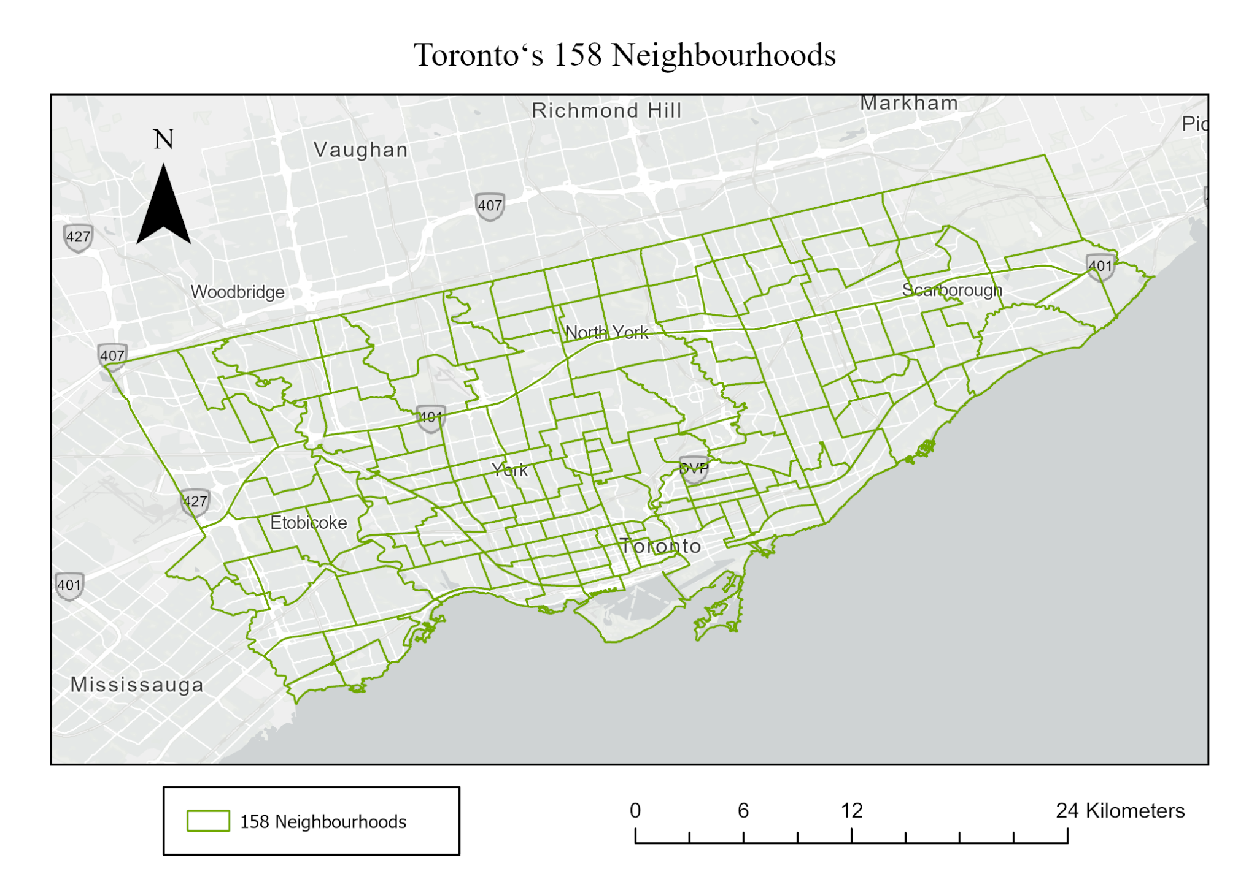
Vector boundary data for the 158 neighbourhoods, obtained from Open Data Toronto (City of Toronto, 2010).

Figure 6. Toronto's 158 Social Planning Neighbourhoods

6.2 Toronto Neighbourhood Profiles, 2021 Census
Socioeconomic attributes including population and median household income at the neighbourhood level, obtained from Open Data Toronto (City of Toronto, 2026). Table 1 shows a sample of the dataset used in the analysis.

Table 1: Sample of neighbourhood-level population and median household income data used in the analysis.

Neighbourhood | Population | Median Household Income (2020)
West Humber-Clairville | 33,300 | $92,000
Mount Olive-Silverstone-Jamestown | 31,345 | $76,500
Thistletown-Beaumond Heights | 9,850 | $86,000
Rexdale-Kipling | 10,375 | $77,000
Elms-Old Rexdale | 9,355 | $82,000

6.3 CaféTO Locations
Point locations of CaféTO permits across Toronto, obtained from Open Data Toronto (City of Toronto, 2022).

References:
- Toronto Association of Business Improvement Areas (TABIA). (2022). 2022 CaféTO Impact Survey.
- City of Toronto. (2010). Neighbourhoods. Open Data Toronto.https://open.toronto.ca/dataset/neighbourhoods/
- City of Toronto. (2026). Neighbourhood Profiles. Open Data Toronto.https://open.toronto.ca/dataset/neighbourhood-profiles/
- City of Toronto. (2022). CaféTO Locations. Open Data Toronto.https://open.toronto.ca/dataset/cafeto-curb-lane-parklet-cafe-locations/

