1. **Install Docker**
2. To install docker
3. Create ec2 instance and switch to root user
4. sudo su
5. sudo yum -y install docker
6. sudo systemctl start docker
7. sudo systemctl status docker

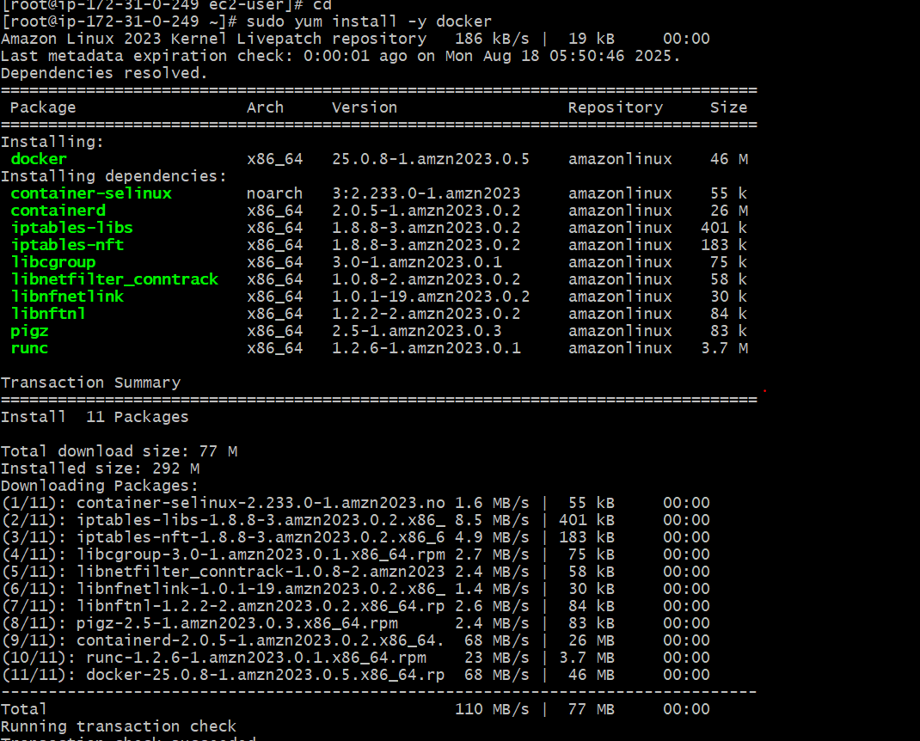

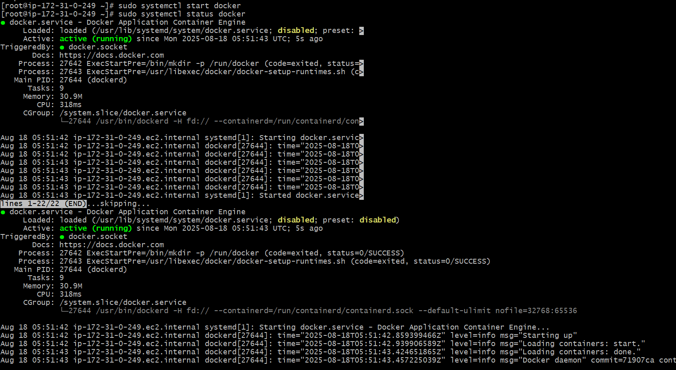

1. **Install jenkins**
2. To install Jenkins we should first install java version and need to install the Jenkins
3. sudo yum update -y
4. sudo amazon-linux-extras enable corretto17
5. sudo yum install java-17-amazon-corretto -y
6. Than we need to install jenkins by using command
7. sudo yum install jenkins
8. sudo systemctl start jenkins
9. sudo systemctl status jenkins
10. Than we need to configure the jenkins using command (sudo alternatives --config java)
11. Than go to browser check with ip address and it will show the jenkins unlock page

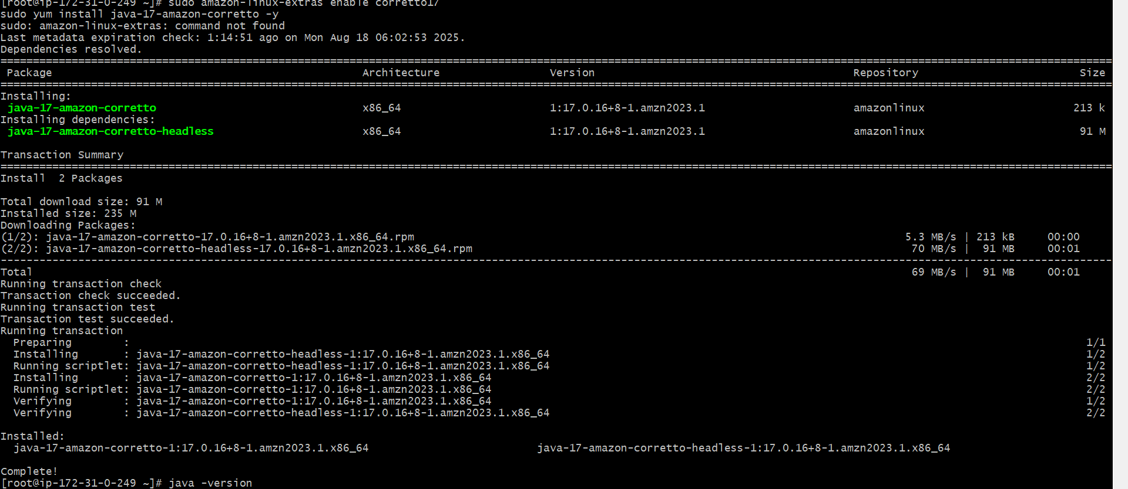

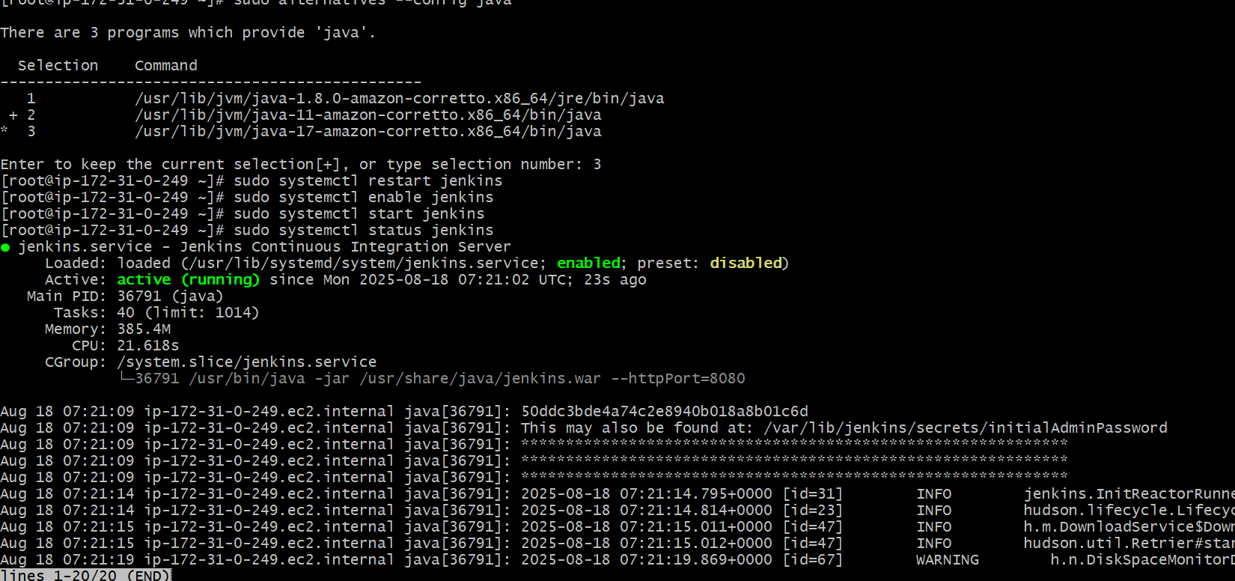

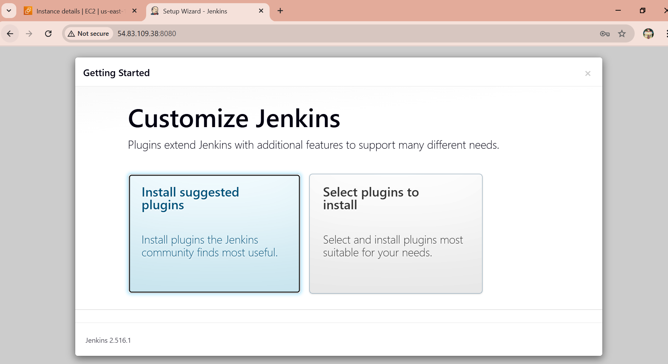

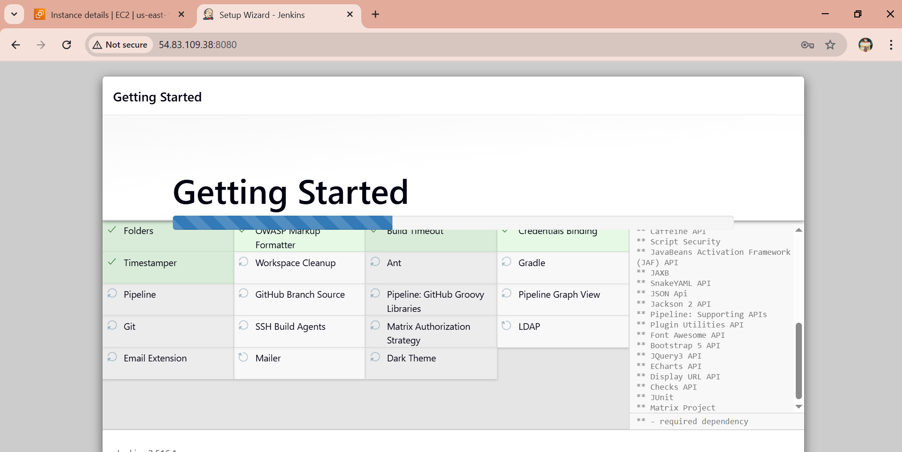

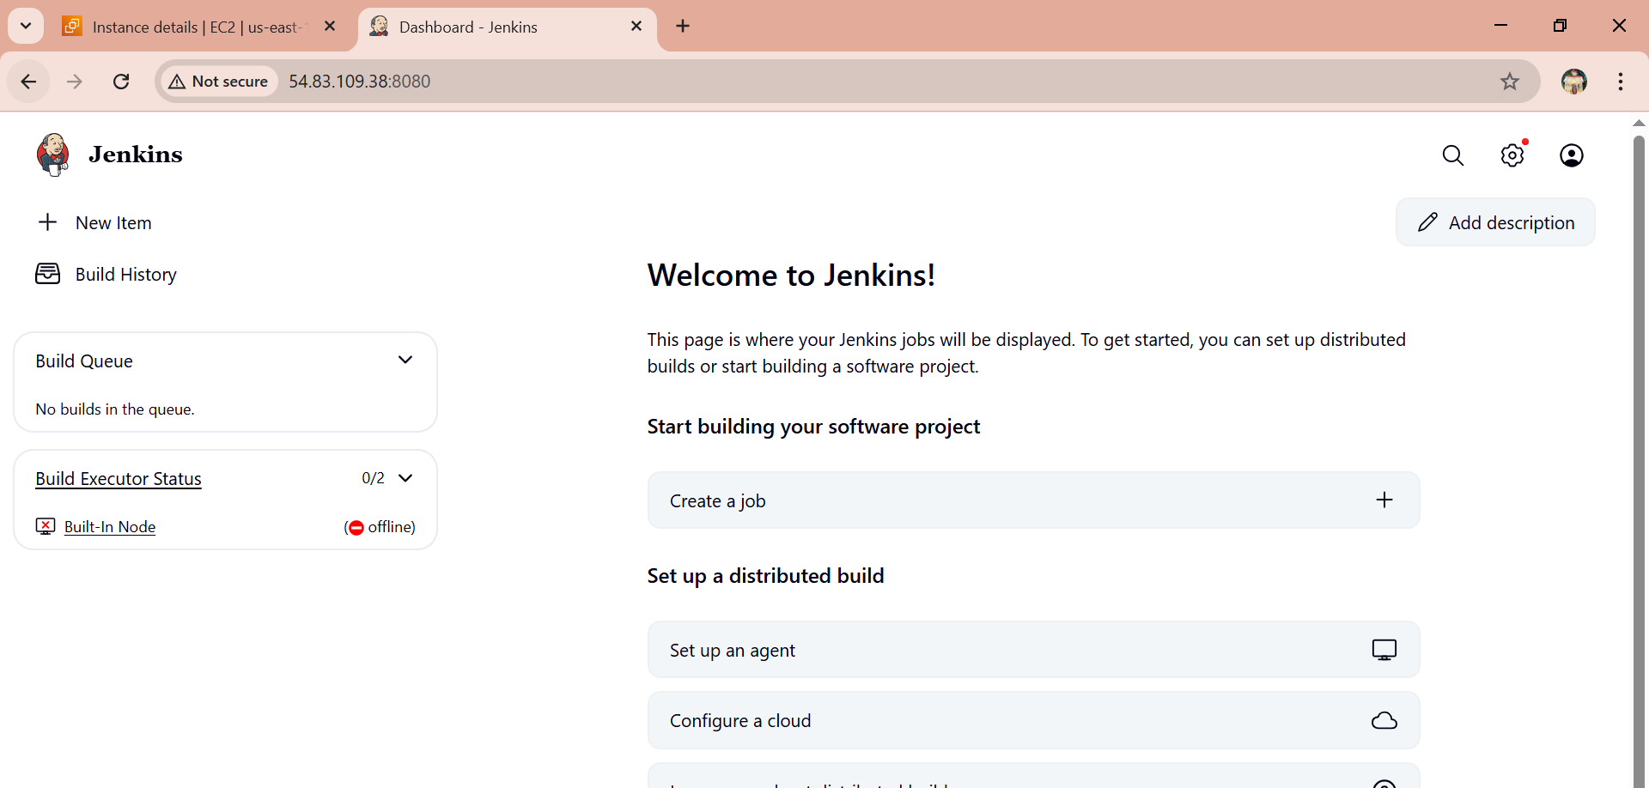

1. **Install apache**
2. To install nginx
3. sudo yum update -y
4. sudo yum install nginx -y
5. sudo systemctl start nginx
6. sudo systemctl enable nginx
7. sudo systemctl status nginx

Than need to check with Ip address of instance on browser

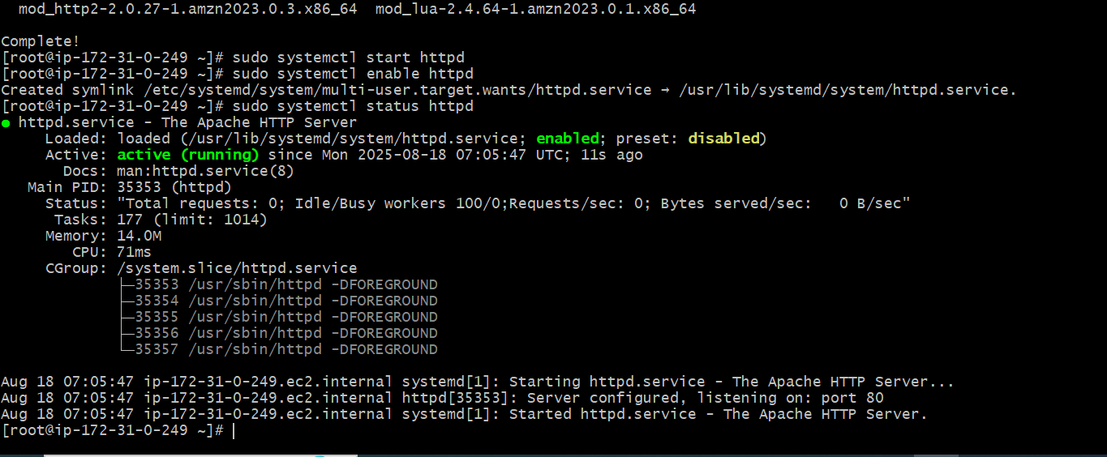

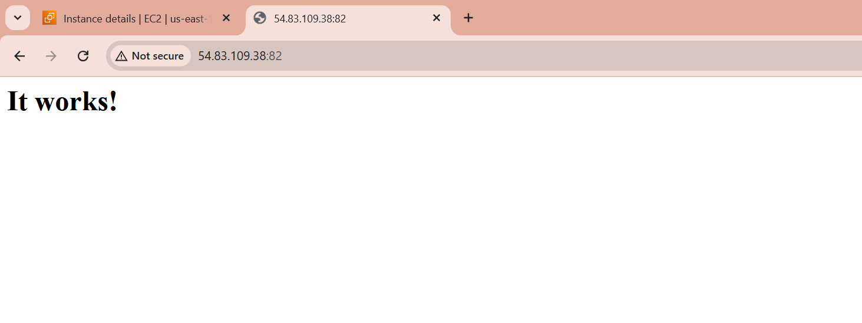

1. **Install nginx**
2. To install nginx
3. sudo yum update -y
4. sudo yum install nginx -y
5. sudo systemctl start nginx
6. sudo systemctl enable nginx
7. sudo systemctl status nginx
8. Than need to check with Ip address of instance on browser

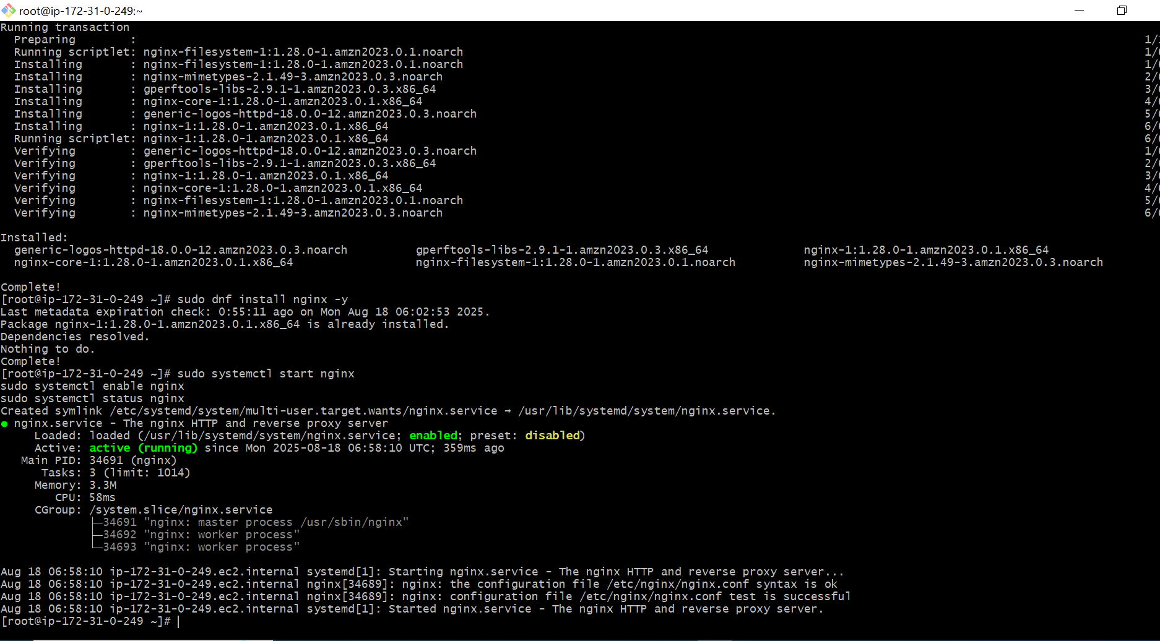

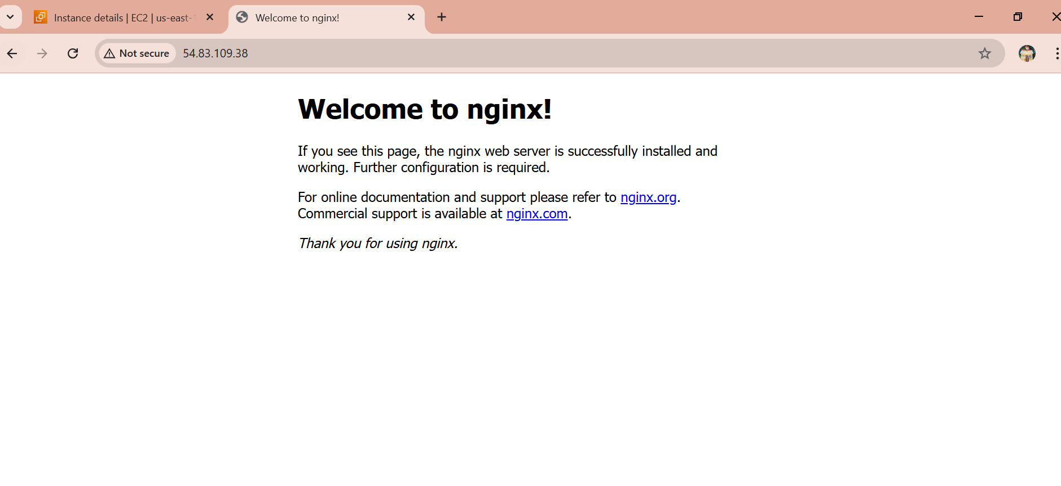

1. **Install Apache Tomcat**
2. Need to install the tomcat from link
3. Wget <https://dlcdn.apache.org/tomcat/tomcat-9/v9.0.108/bin/apache-tomcat-9.0.108.tar.gz>
4. Than go to tomcat file>cd opt>cd bin
5. Than need need to give ./startup.sh
6. Apachetomcat will get run
7. Than need to check with ip address with port#8080, it will get work

