1. **Created EC2 as new-server**

Snapshot deleted after that

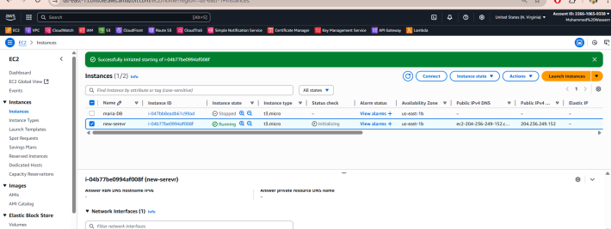

1. **Created the Lambda Function**

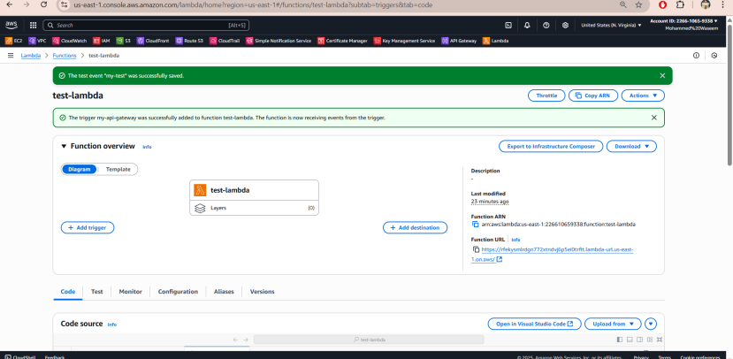

1. **Created policy for deleting the snapshot of EC2**

{

"Version": "2012-10-17",

"Statement": [

{

"Effect": "Allow",

"Action": [

"ec2:CreateSnapshot",

"ec2:DeleteSnapshot",

"ec2:DescribeSnapshots",

"ec2:CreateTags",

"ec2:ModifySnapshotAttribute",

"ec2:DescribeSnapshotAttribute",

"ec2:CopySnapshot"

],

"Resource": "*"

}

]

}

1. **Created the role by giving permission**

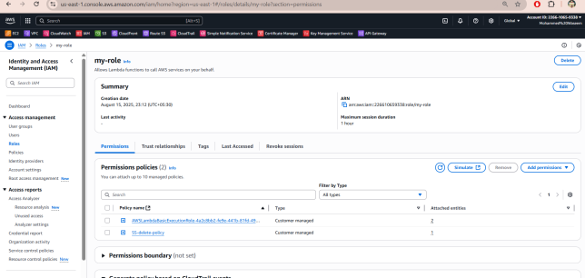

1. **We have deleted the EC2 instance**
2. After refreshing the page snapshot also got deleted after the instance deleted

