1. **SQS Purpose**  
    Managed message queuing service to decouple and scale microservices.
2. **Amazon MQ Purpose**  
    Managed message broker (RabbitMQ, ActiveMQ) for applications using standard protocols (JMS, AMQP, etc.)
3. Key Differences
4. SQS: Simple, scalable, fully managed, works with AWS native apps.
5. Amazon MQ: For existing apps requiring traditional brokers
6. Go to AWS Console → SQS → Create Queue.
7. Select Standard Queue (FIFO queues behave slightly differently).
8. Give it a name: demo-queue.
9. Keep default settings (Visibility Timeout = 30 seconds).

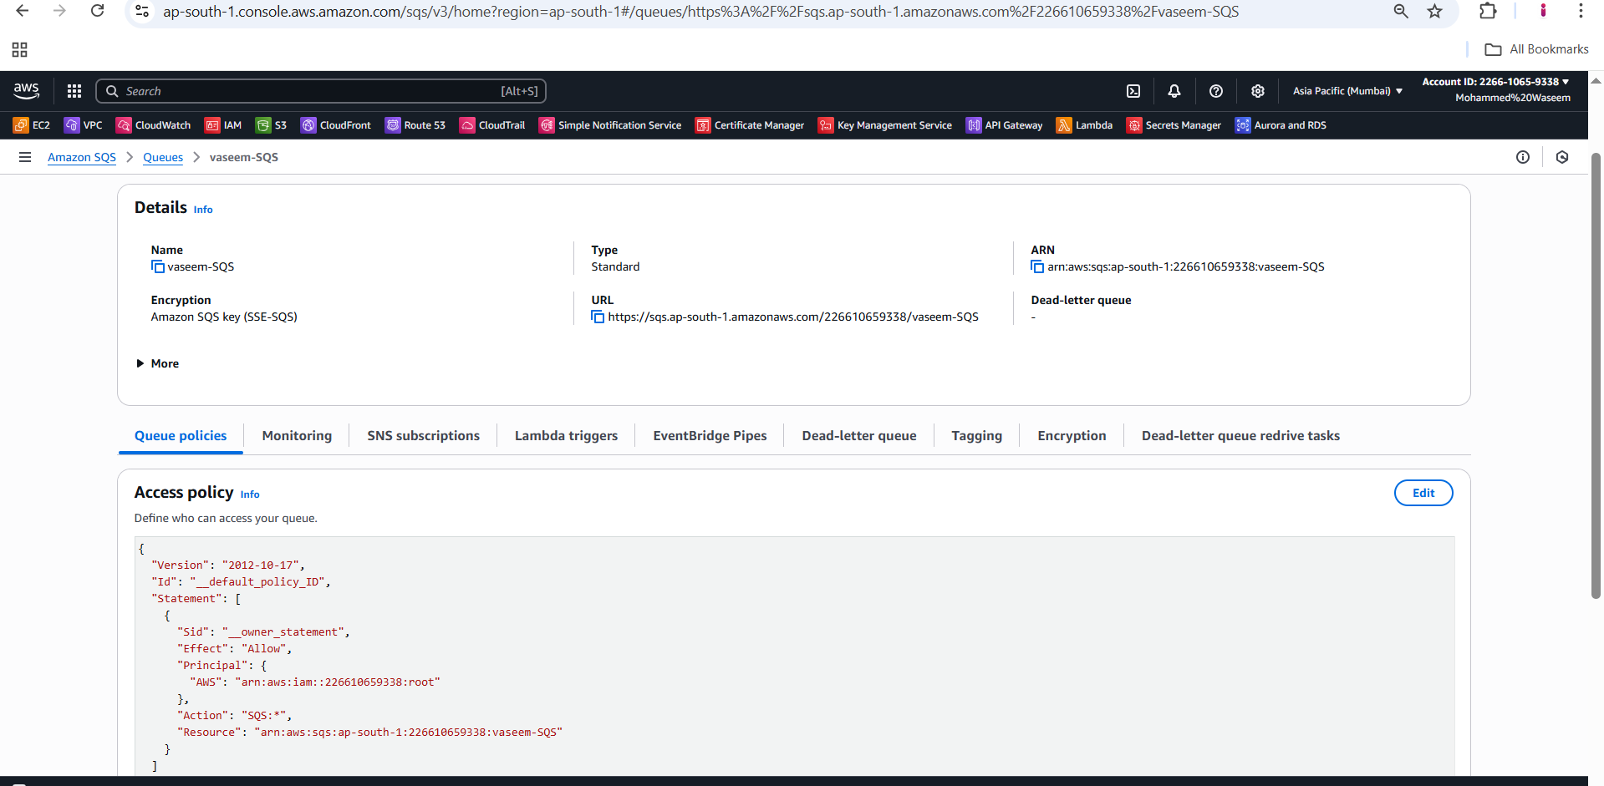

1. **Here we have send the message in created SQS**

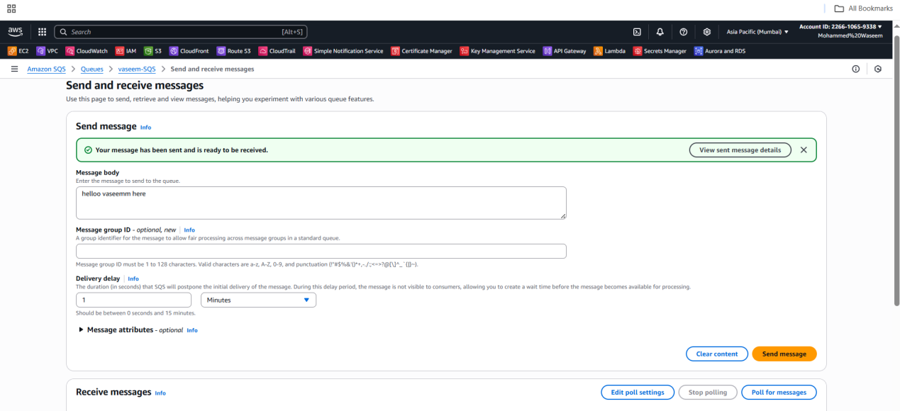

1. **Here the messgege is apper which we have been done**

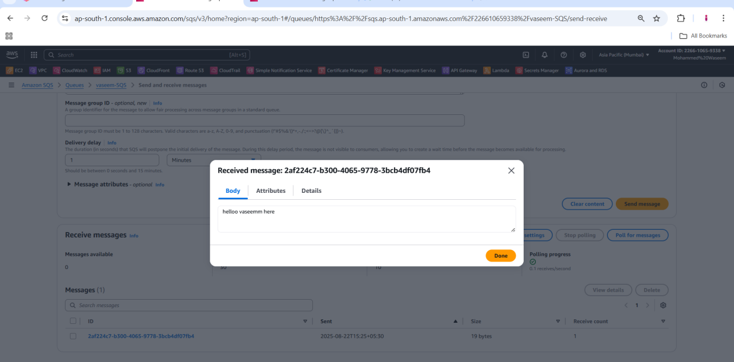

1. **Need to send the message from here**

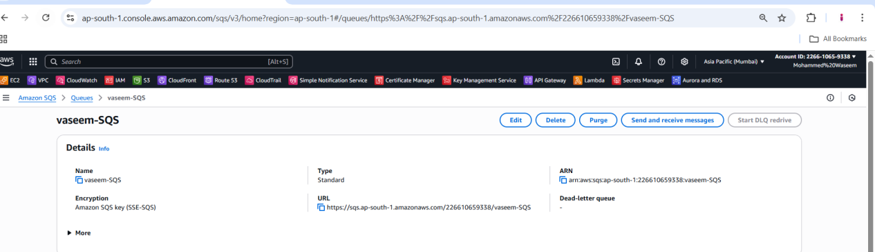

1. **To check the message need to ht the poll message option**

