**AWS Systems Manager Parameter Store**

Secrets and configuration data management

Centralized storage and management of your secrets and configuration data such as passwords, database strings, and license codes. You can encrypt values, or store as plain text, and secure access at every level.

### Improve the security posture of your ecosystem

Separate secrets and configuration data from code and common administration tasks while ensuring that only approved users have access to parameter values. Use the console or programmatic tools to access parameters across AWS services and from your custom solutions.

### Benefit from a native and salable AWS solution

Start quickly and ease management overhead by not having to host and manage servers or adopt third-party solutions. Experience improved performance with integrated caching that delivers high throughput for applications and services of any size.

1. **Created the System manager**
2. /my-app/dev/db-url
3. Need to give name in path format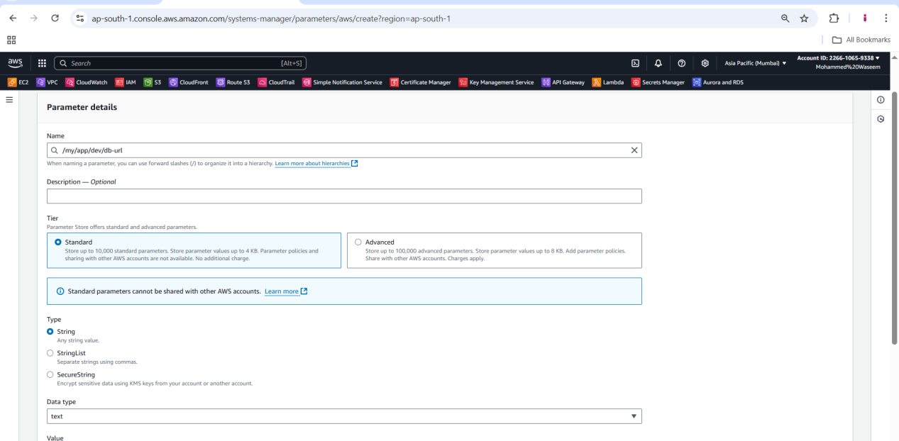
4. **Than again created the system manager for password**
5. /my-app/dev/password
6. Than again created the system manager for password

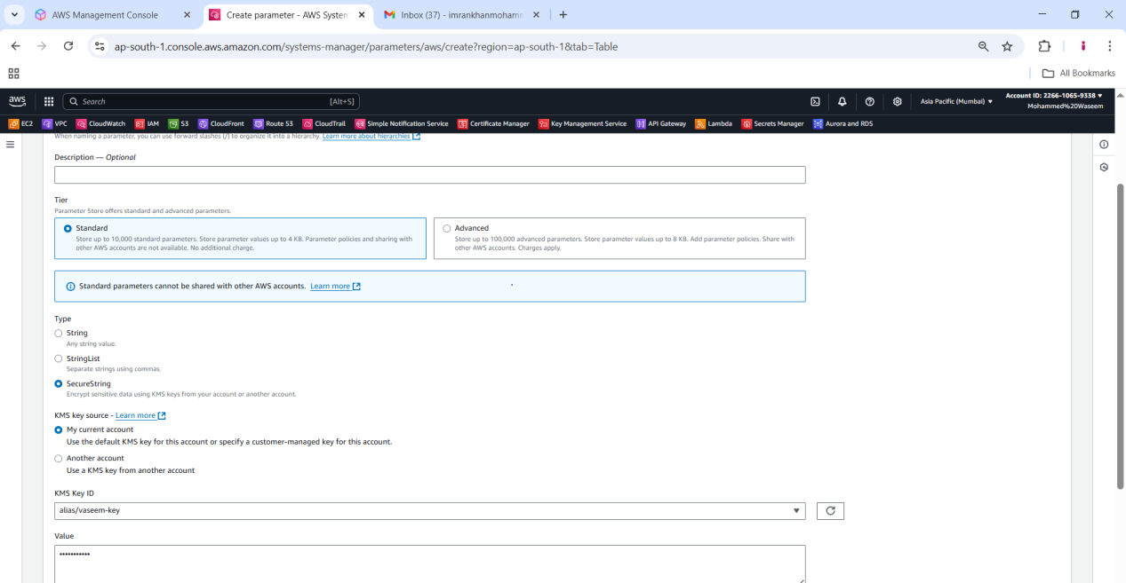

1. **Here we have parameters for**
2. [/my-app/dev/db-url](https://ap-south-1.console.aws.amazon.com/systems-manager/parameters/%2Fmy%2Fapp%2Fdev%2Fdb-url/description?region=ap-south-1&tab=Table" \t "https://ap-south-1.console.aws.amazon.com/systems-manager/parameters/_self)
3. [/my-app/dev/password](https://ap-south-1.console.aws.amazon.com/systems-manager/parameters/%2Fmy%2Fapp%2Fdev%2Fpassword/description?region=ap-south-1&tab=Table" \t "https://ap-south-1.console.aws.amazon.com/systems-manager/parameters/_self)
4. [/my-app/prod/db-url](https://ap-south-1.console.aws.amazon.com/systems-manager/parameters/%2Fmy%2Fapp%2Fprod%2Fdb-url/description?region=ap-south-1&tab=Table" \t "https://ap-south-1.console.aws.amazon.com/systems-manager/parameters/_self)
5. [/my-app/prod/password](https://ap-south-1.console.aws.amazon.com/systems-manager/parameters/%2Fmy%2Fapp%2Fprod%2Fpassword/description?region=ap-south-1&tab=Table" \t "https://ap-south-1.console.aws.amazon.com/systems-manager/parameters/_self)

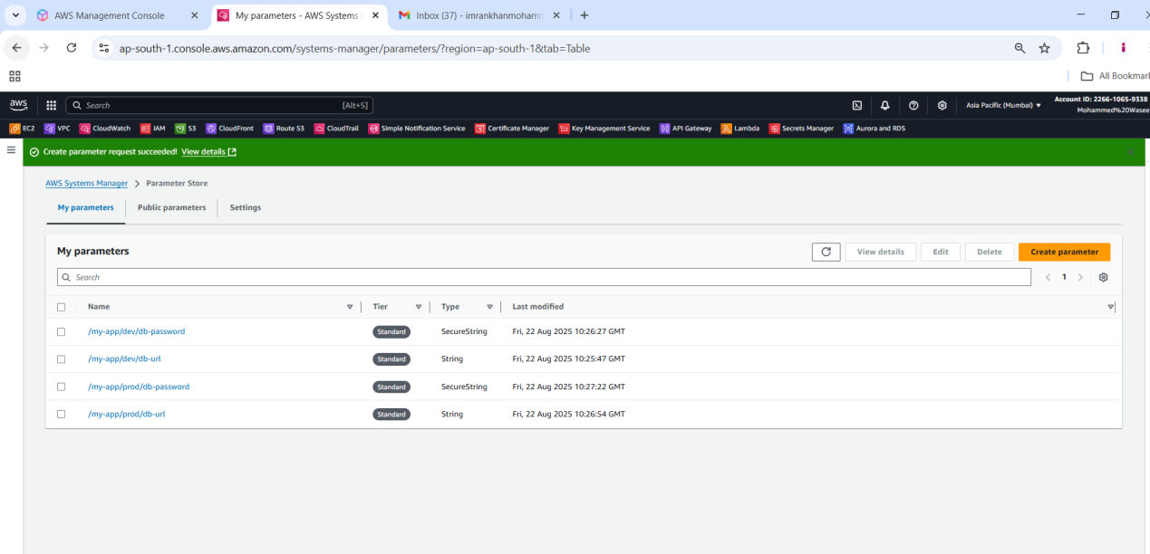

1. **Here after the creating the paramerts we need to open cloud shell in AWS console then give command as**
2. Need to execute in cloud shell with below command with system manager name and passowrd in path format
3. It will show the path link
4. aws ssm get-parameters --names /my-app/dev/db-url /my-app/dev/db-password

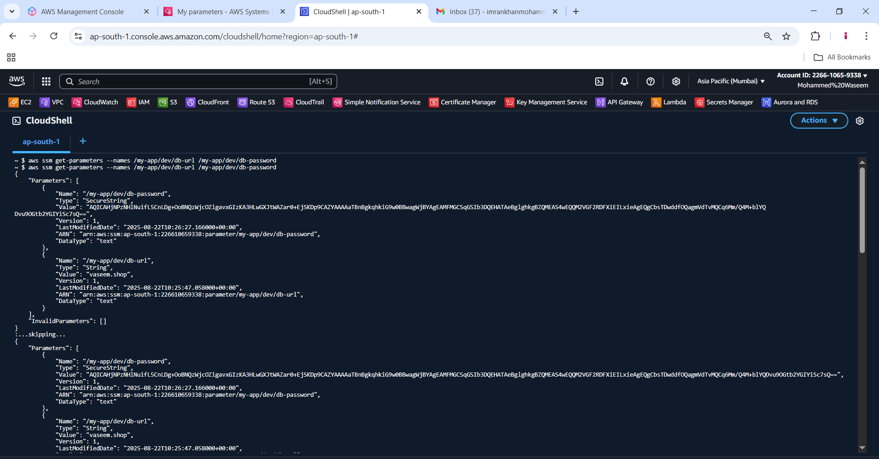

1. **Than we have decrypted that with using below command**
2. aws ssm get-parameters --names /my-app/dev/db-url /my-app/dev/db-password --with-decryption

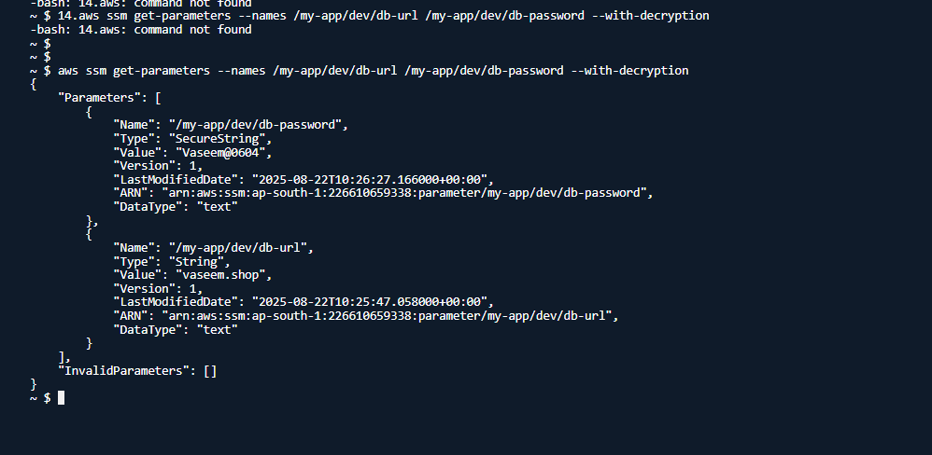

1. **And we can get parameter by giving the path as well**
2. aws ssm get-parameters-by-path --path /my-app/dev

