1. **Create VPC**

**Here need to create the folder as terraform-aws-web in that needto create files as main.tf, var.tf, out.tf, provider.tf and need to update the terraform script to create vpc, IGW, RT, Subnet, SG, Elastic ip, ubuntu server….!**

Here we have created the vpc by using the terraform

**resource "aws_vpc" "main" {**

**cidr_block = var.vpc_cidr**

**enable_dns_hostnames = true**

**tags = {**

**Name = "MyVPC"**

**}**

**}**

**terraform init --> terraform apply**

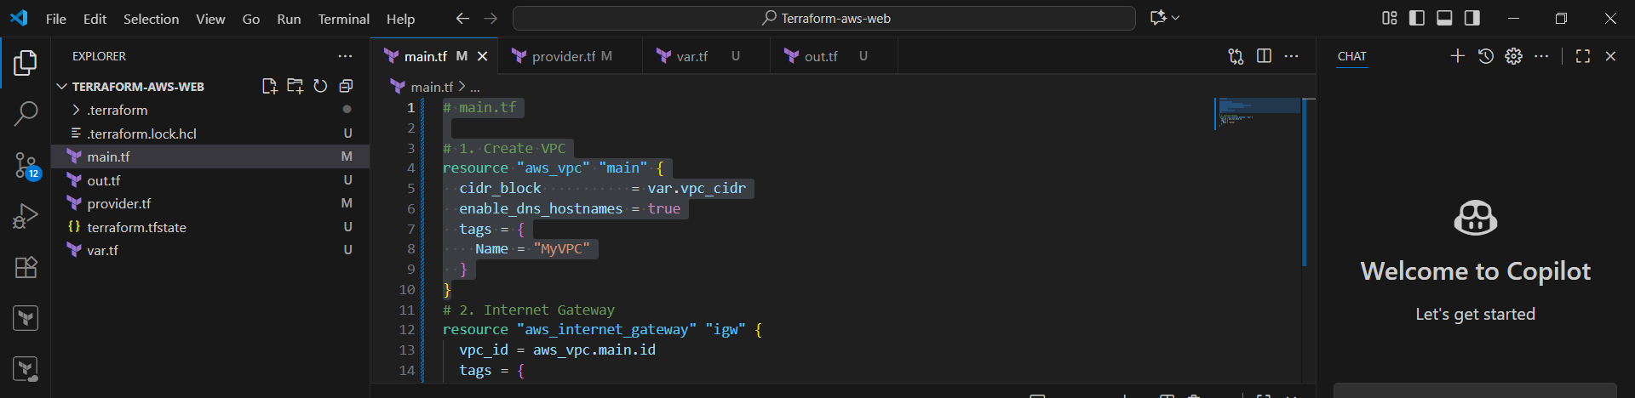

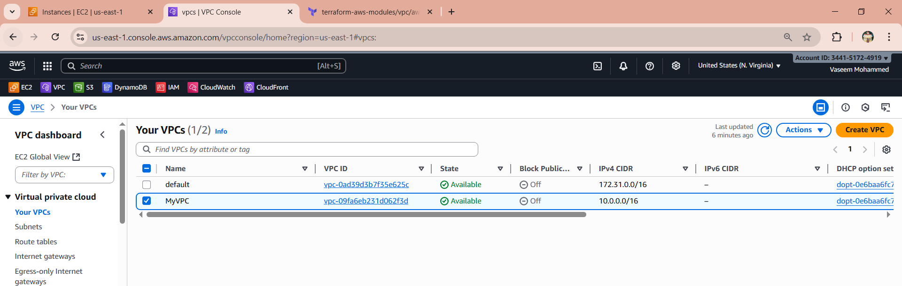

1. **Create Internet gateway**

Now we have created the IGW by terraform

**resource "aws_internet_gateway" "igw" {**

**vpc_id = aws_vpc.main.id**

**tags = {**

**Name = "MyIGW"**

**}**

**}**

**terraform init --> terraform apply**

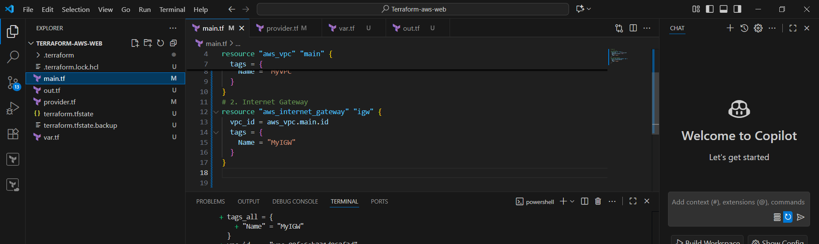

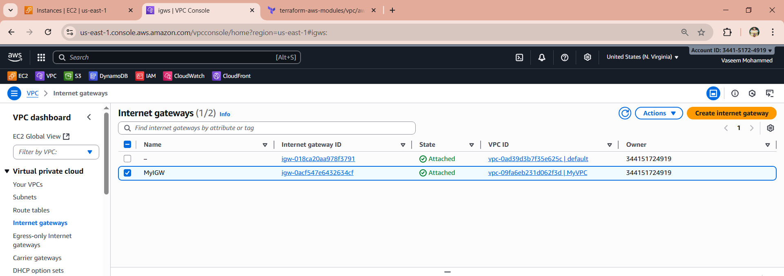

1. **Create Custom Route Table**

Now we have created the RT

**resource "aws_route_table" "public" {**

**vpc_id = aws_vpc.main.id**

**tags = {**

**Name = "PublicRouteTable"**

**}**

**}**

**terraform init --> terraform apply**

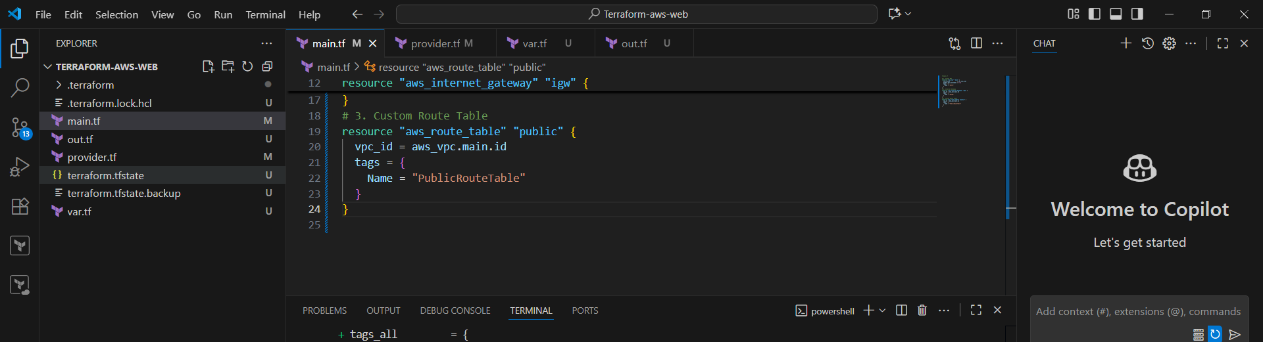

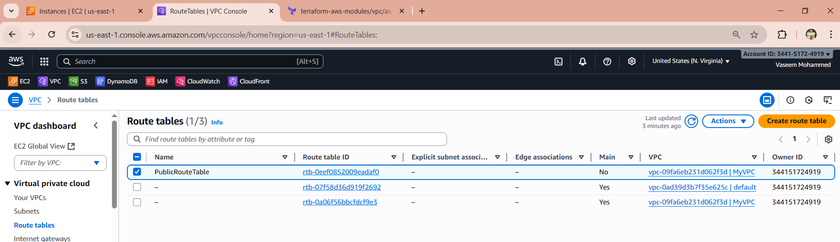

1. **Create Subnet**

Here we have created the subnet

**resource "aws_subnet" "public" {**

**vpc_id = aws_vpc.main.id**

**cidr_block = var.subnet_cidr**

**availability_zone = var.availability_zone**

**map_public_ip_on_launch = false**

**tags = {**

**Name = "PublicSubnet"**

**}**

**}**

**terraform init --> terraform apply**

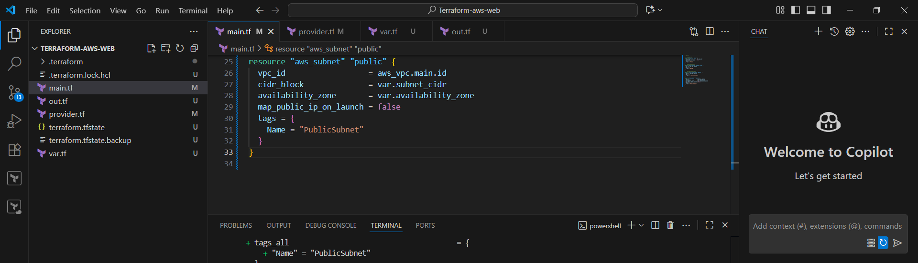

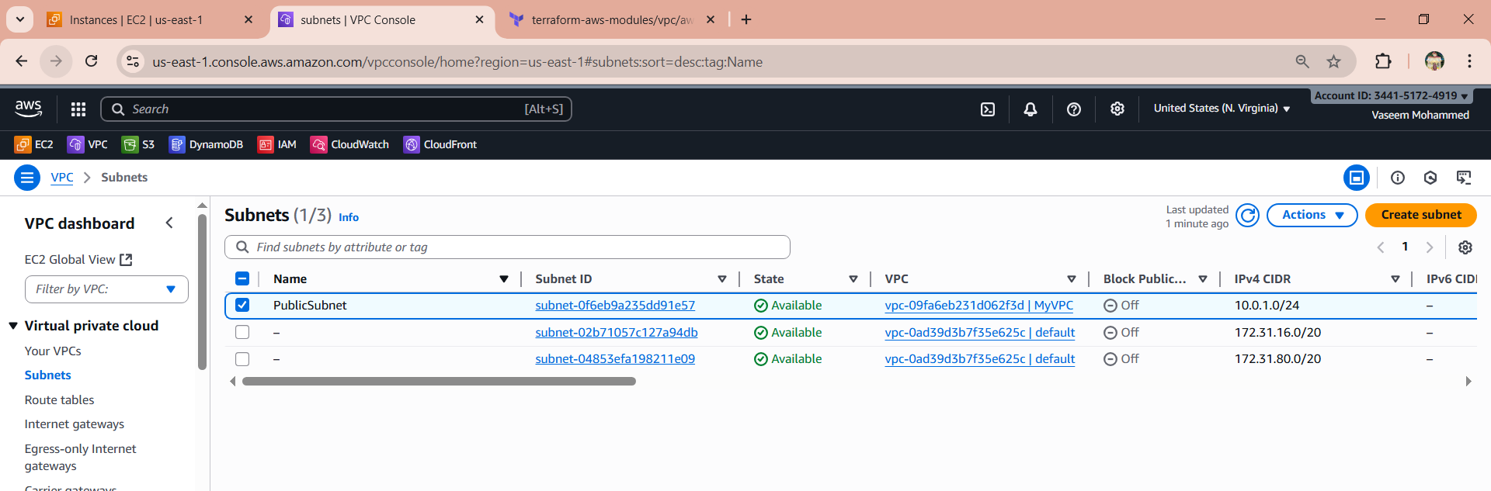

1. **Associate subnet with Route Table**

Now we have attached the subnet to route table by terraform

**resource "aws_route_table_association" "public_assoc" {**

**subnet_id = aws_subnet.public.id**

**route_table_id = aws_route_table.public.id**

**}**

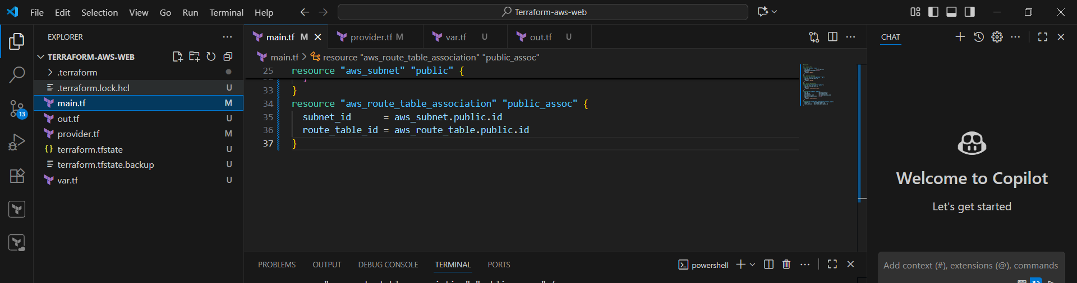

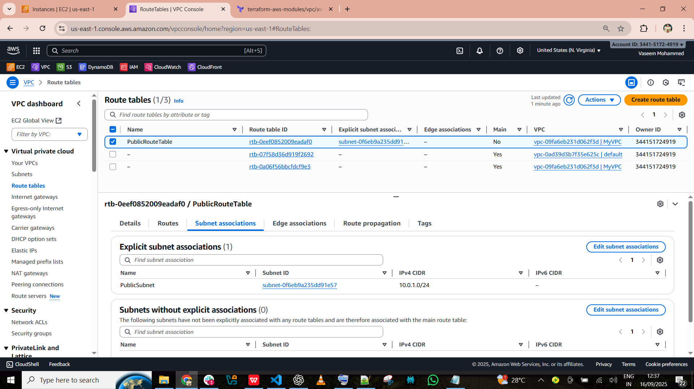

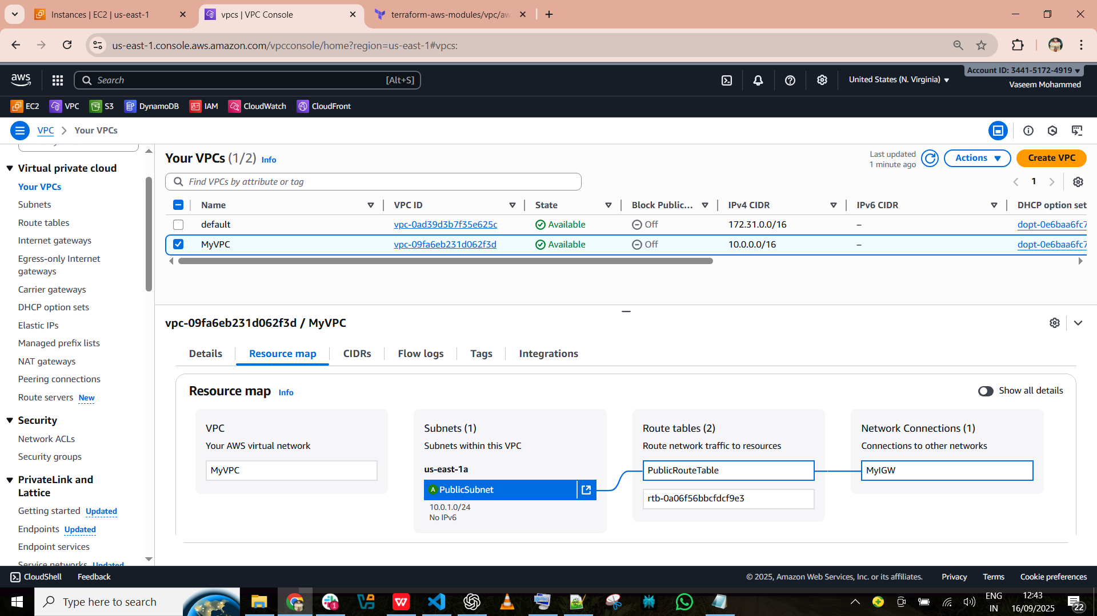

1. **Create Security Group to allow port 22,80,443**

Here we have created the SG

**resource "aws_security_group" "web_sg" {**

**vpc_id = aws_vpc.main.id**

**name = "web-sg"**

**ingress {**

**description = "Allow SSH"**

**from_port = 22**

**to_port = 22**

**protocol = "tcp"**

**cidr_blocks = [var.allowed_ssh_cidr]**

**}**

**ingress {**

**description = "Allow HTTP"**

**from_port = 80**

**to_port = 80**

**protocol = "tcp"**

**cidr_blocks = ["0.0.0.0/0"]**

**}**

**ingress {**

**description = "Allow HTTPS"**

**from_port = 443**

**to_port = 443**

**protocol = "tcp"**

**cidr_blocks = ["0.0.0.0/0"]**

**}**

**egress {**

**description = "Allow all outbound"**

**from_port = 0**

**to_port = 0**

**protocol = "-1"**

**cidr_blocks = ["0.0.0.0/0"]**

**}**

**tags = {**

**Name = "WebSG"**

**}**

**}**

**terraform init --> terraform apply**

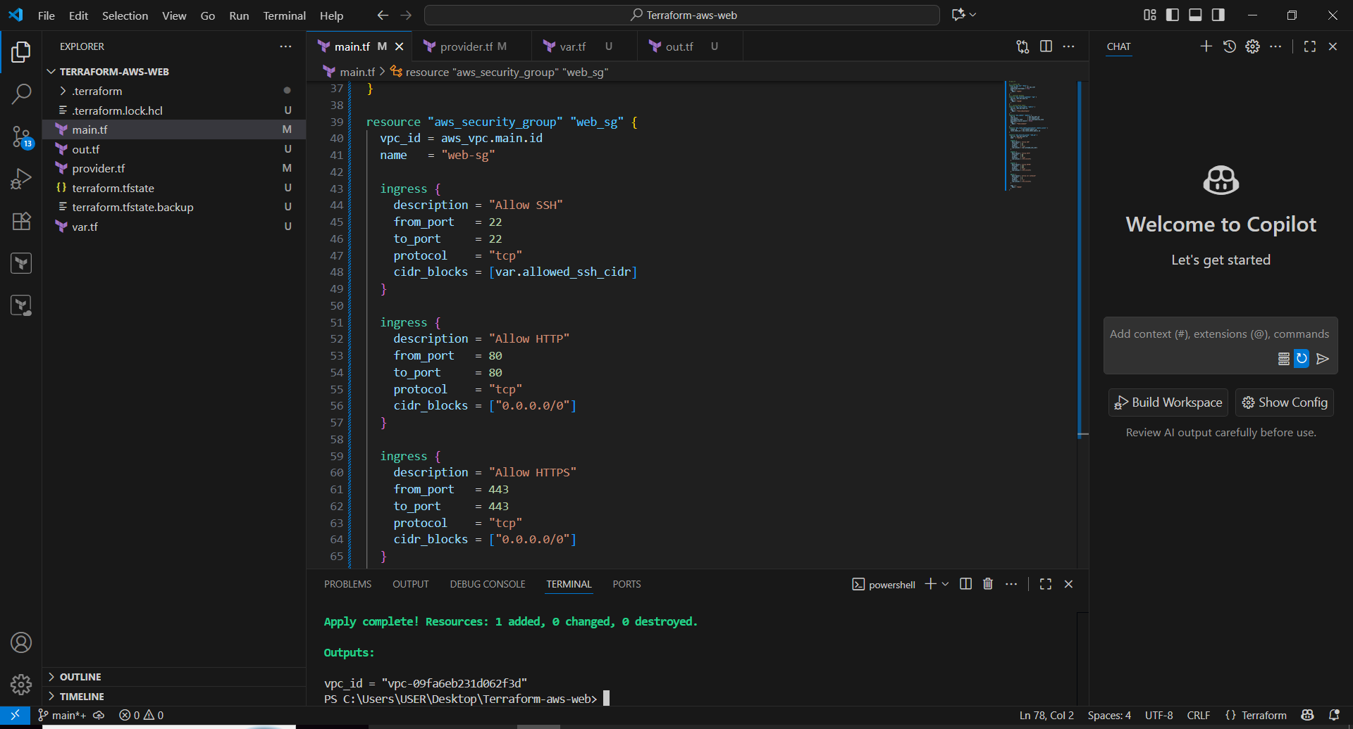

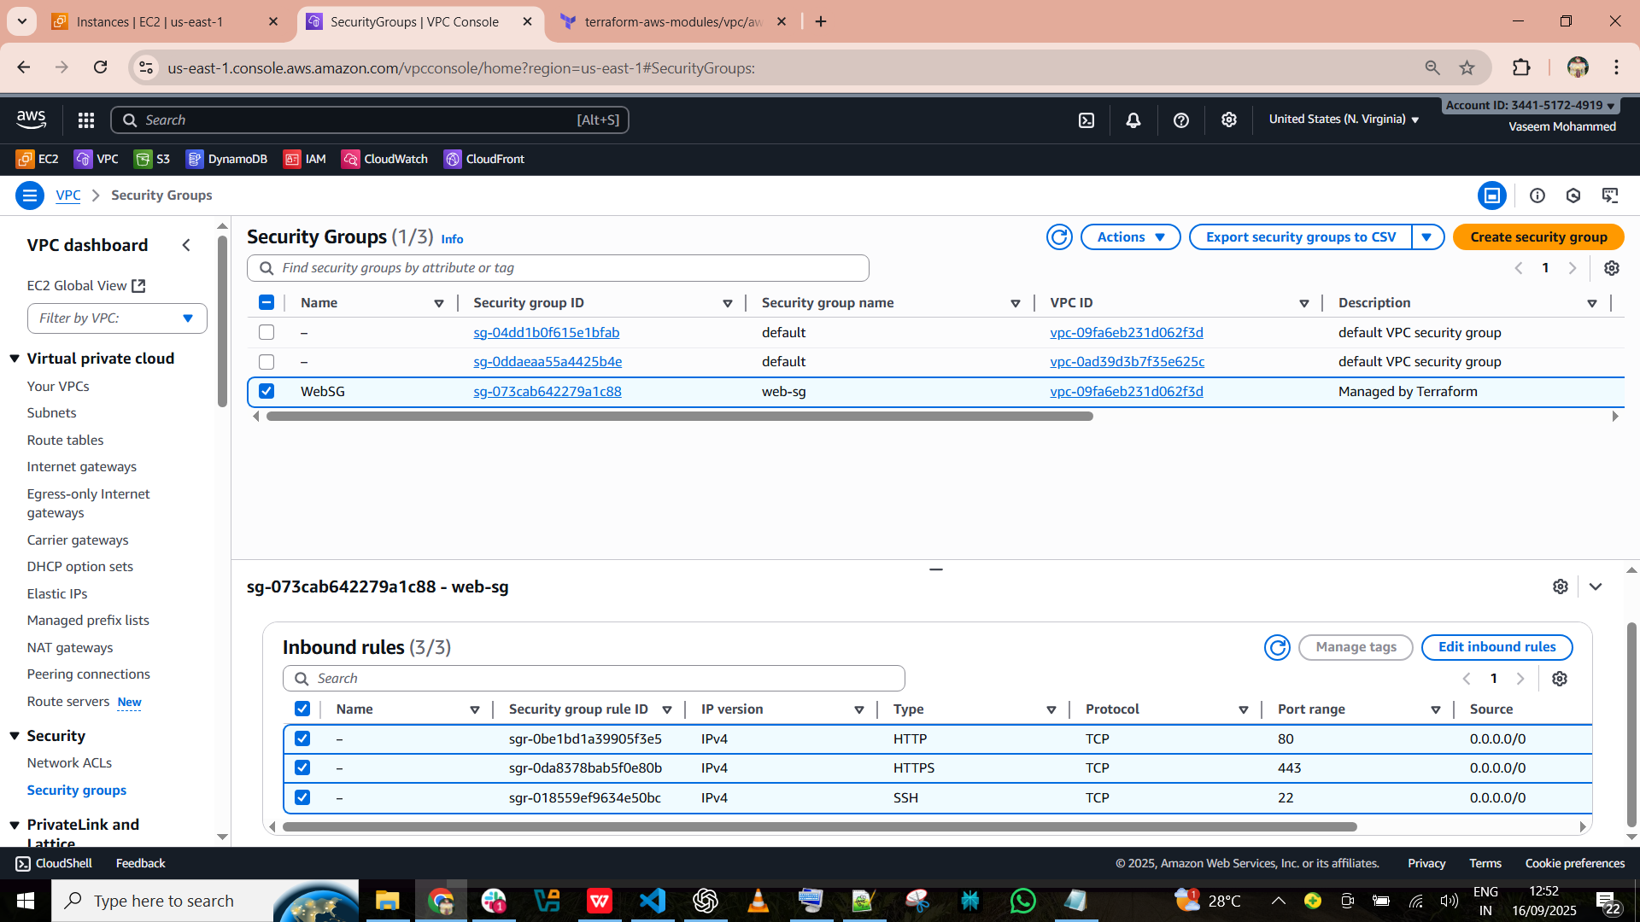

1. **Create a network interface with an ip in the subnet that was created in step 4**

Now we have created the NI by terraform

**resource "aws_network_interface" "web_eni" {**

**subnet_id = aws_subnet.public.id**

**private_ips = [var.instance_private_ip]**

**security_groups = [aws_security_group.web_sg.id]**

**tags = {**

**Name = "tf-NI"**

**}**

**}**

**terraform init --> terraform apply**

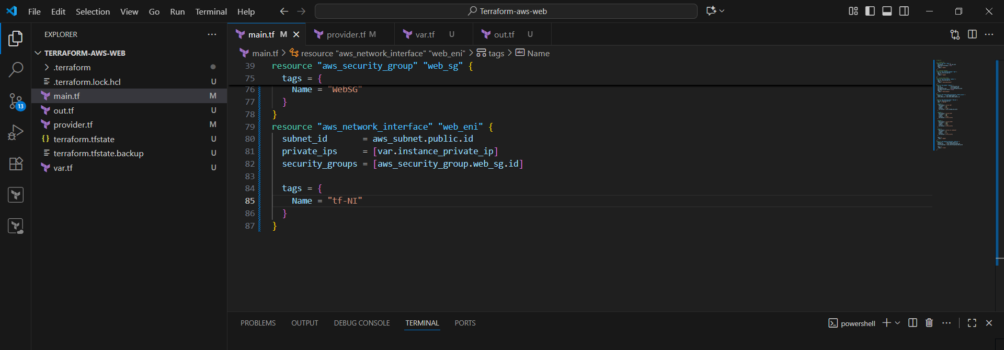

Go to EC2 -->scroll down --> Network interface

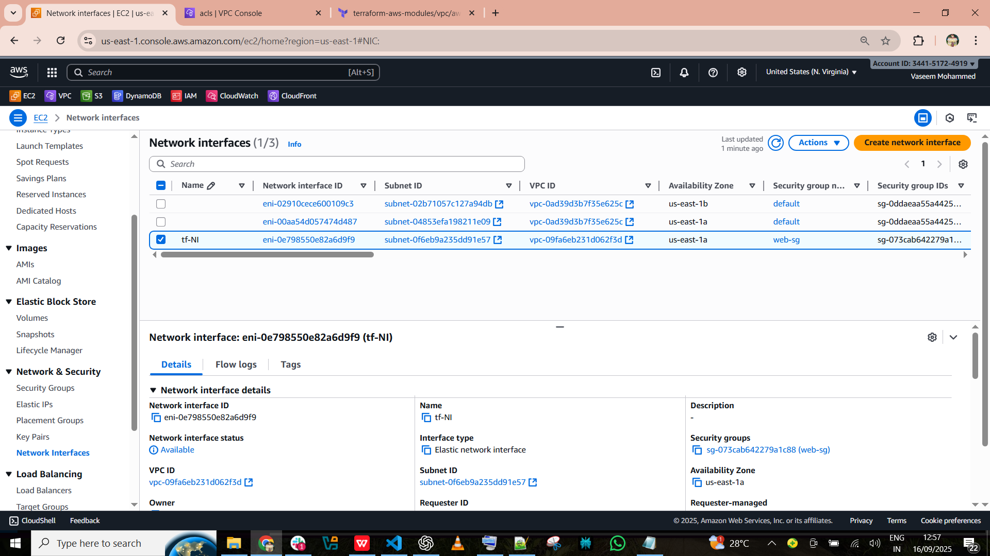

1. **Assign an elastic IP to the network interface created in step 7**

Here we have created the Elastic ip for step 7

**resource "aws_eip" "web_eip" {**

**domain = "vpc"**

**network_interface = aws_network_interface.web_eni.id**

**depends_on = [aws_internet_gateway.igw]**

**}**

**terraform init --> terraform apply**

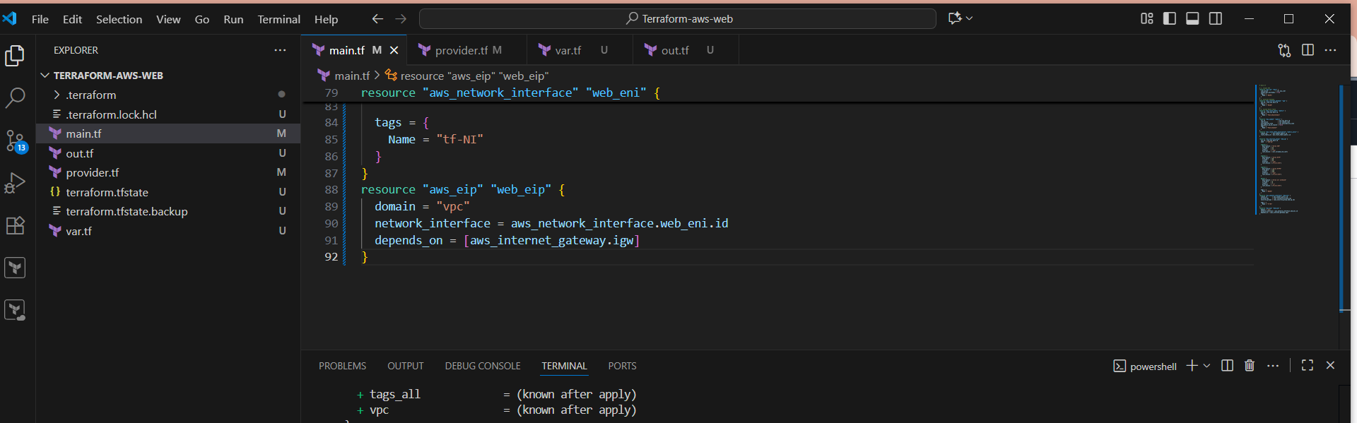

Go to EC2 -->scroll down --> elastic IP’s

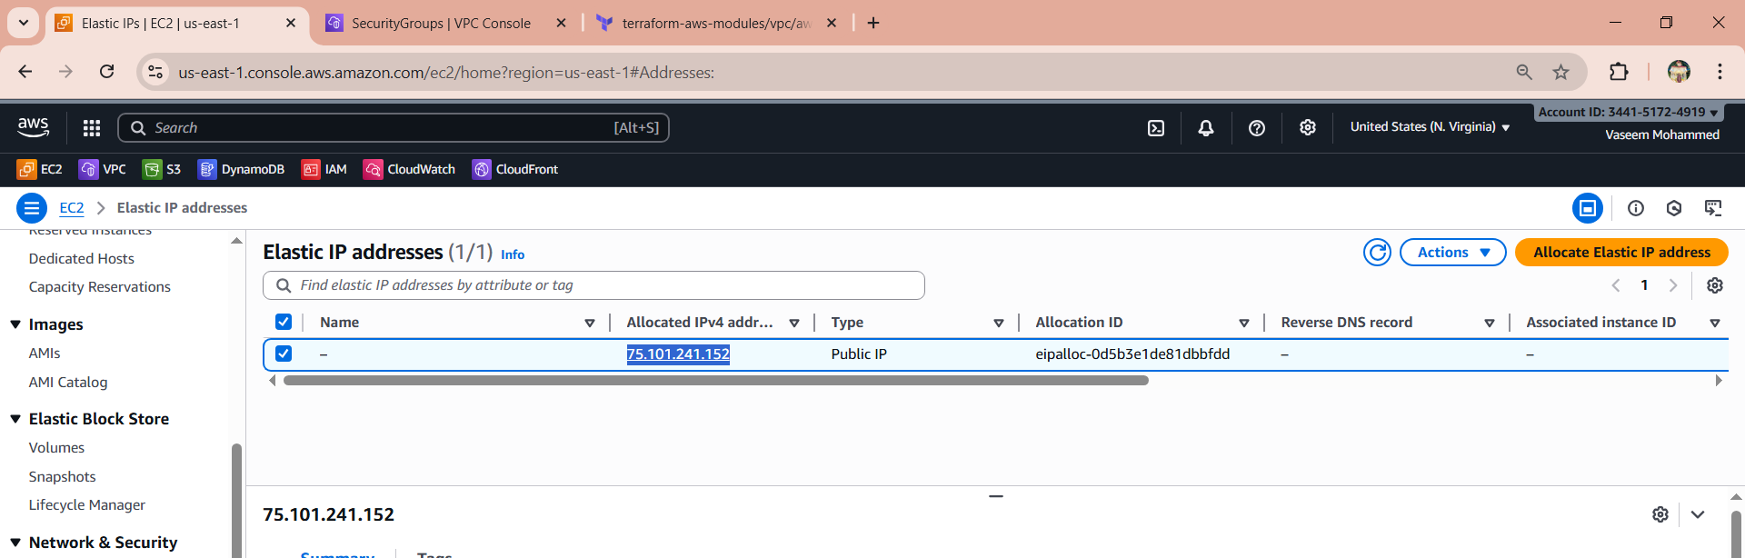

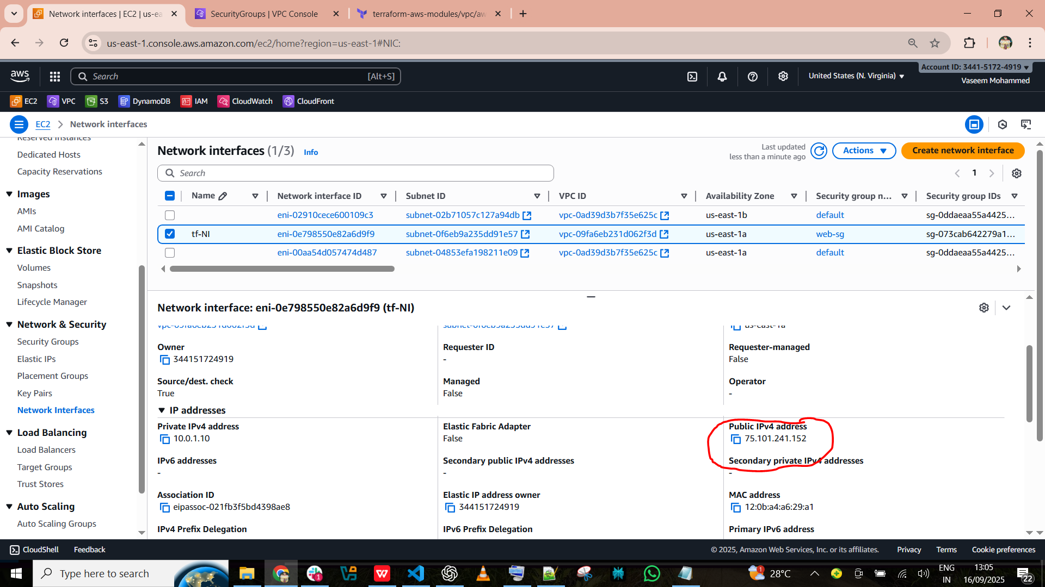

1. **Create Ubuntu server and install/enable apache2**

Here we have launch the instance by AMI ubuntu by terraform

**data "aws_ami" "ubuntu" {**

**most_recent = true**

**owners = ["099720109477"] # Canonical**

**filter {**

**name = "name"**

**values = ["ubuntu/images/hvm-ssd/ubuntu-focal-20.04-amd64-server-*"]**

**}**

**}**

**resource "aws_instance" "web" {**

**ami = data.aws_ami.ubuntu.id**

**instance_type = "t2.micro"**

**key_name = var.key_name**

**network_interface {**

**device_index = 0**

**network_interface_id = aws_network_interface.web_eni.id**

**}**

**user_data = <<-EOF**

**#!/bin/bash**

**apt-get update -y**

**apt-get install -y apache2**

**systemctl enable apache2**

**systemctl start apache2**

**EOF**

**tags = {**

**Name = "UbuntuWebServer"**

**}**

**}**

**terraform init --> terraform apply**

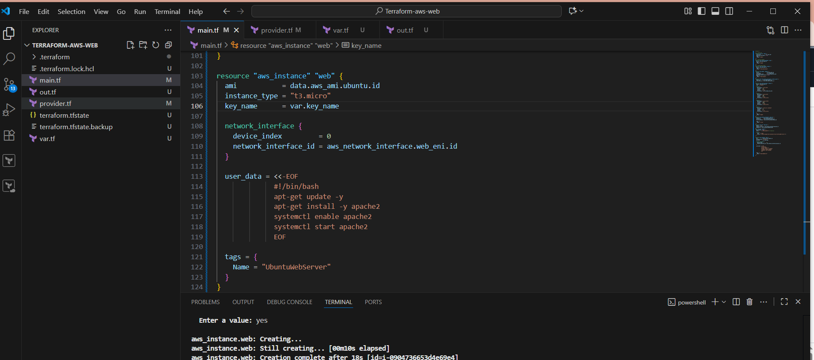

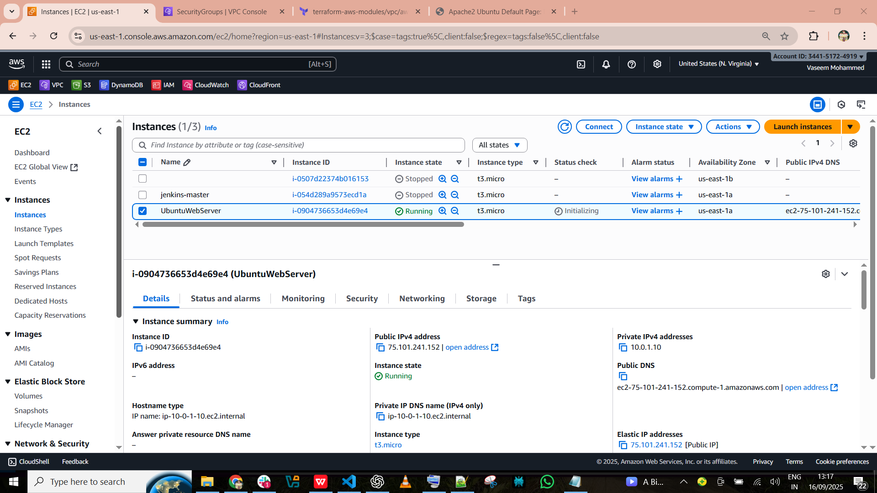

Now copy the public IP and check the outcome with that ip ddress on browser

