NAND2TETRIS
Arithmetic Operations
Using Hack Assembly
CPU Emulator Practical

Student Name | Vaseem Akram
Course | B.Tech – Computer Science and Engineering
Subject | Computer Organization / Nand2Tetris
University | K.R. Mangalam University

Objective
To implement four basic arithmetic operations—addition, subtraction, increment and decrement—using Hack Assembly instructions and inspect the result stored at RAM address 15.

1. Addition
Aim: Add the values 5 and 15 and store the result at RAM[15].
Assembly Code
// Addition
@5
D=A
@15
D=D+A
M=D
Emulator view
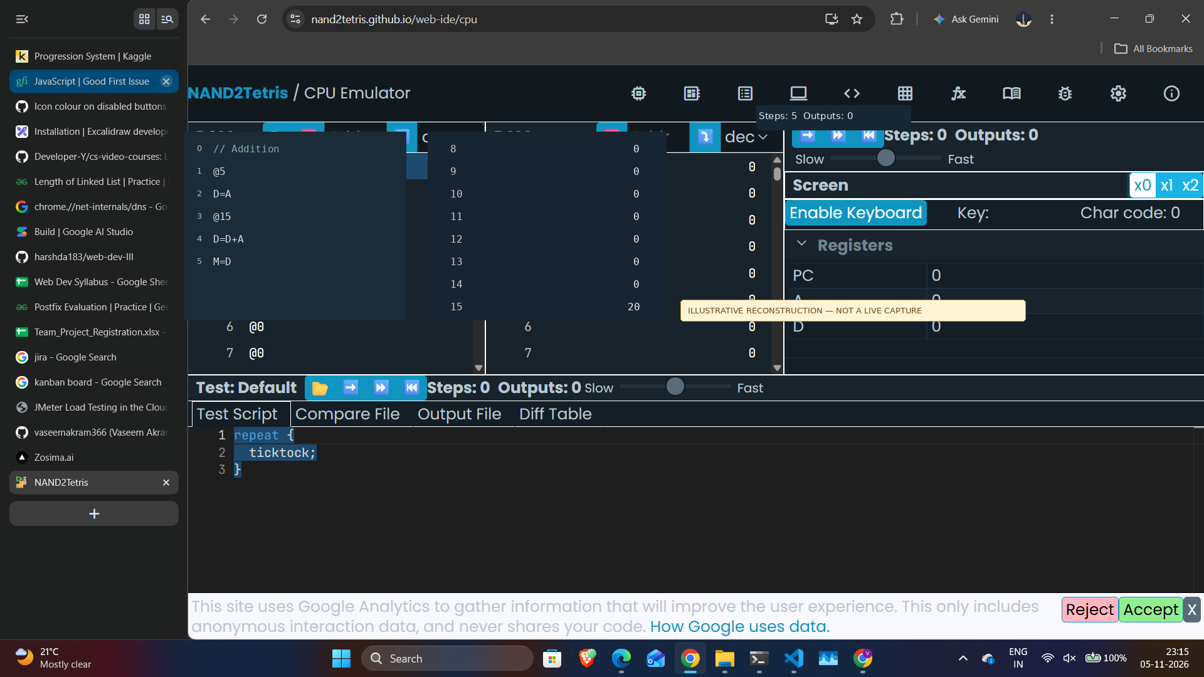
Illustrative reconstruction based on the supplied CPU Emulator interface. 5 + 15 = 20.

2. Subtraction
Aim: Subtract 15 from 5 and store the result at RAM[15].
Assembly Code
// Subtraction
@5
D=A
@15
D=D-A
M=D
Emulator view
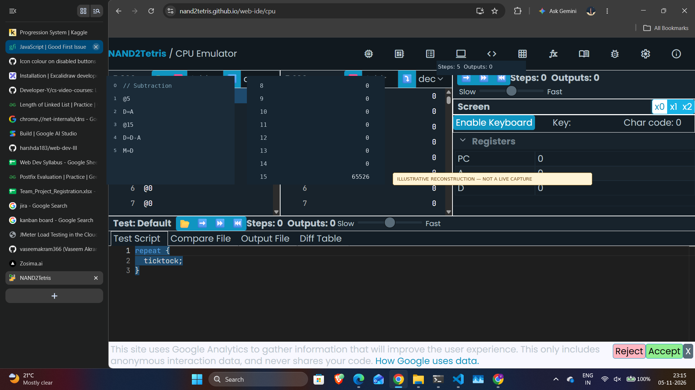
Illustrative reconstruction based on the supplied CPU Emulator interface. 5 - 15 = -10 (16-bit unsigned display: 65526).

3. Increment
Aim: Increment the value 5 by one and store the result at RAM[15].
Assembly Code
// Increment
@5
D=A
@15
D=D+1
M=D
Emulator view
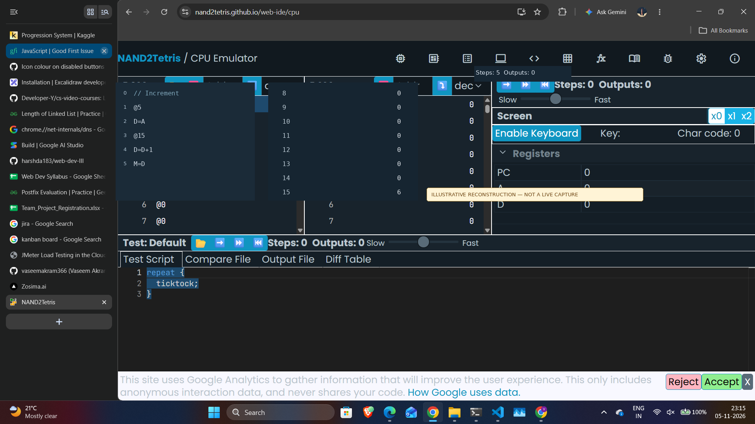
Illustrative reconstruction based on the supplied CPU Emulator interface. 5 + 1 = 6.

4. Decrement
Aim: Decrement the value 5 by one and store the result at RAM[15].
Assembly Code
// Decrement
@5
D=A
@15
D=D-1
M=D
Emulator view
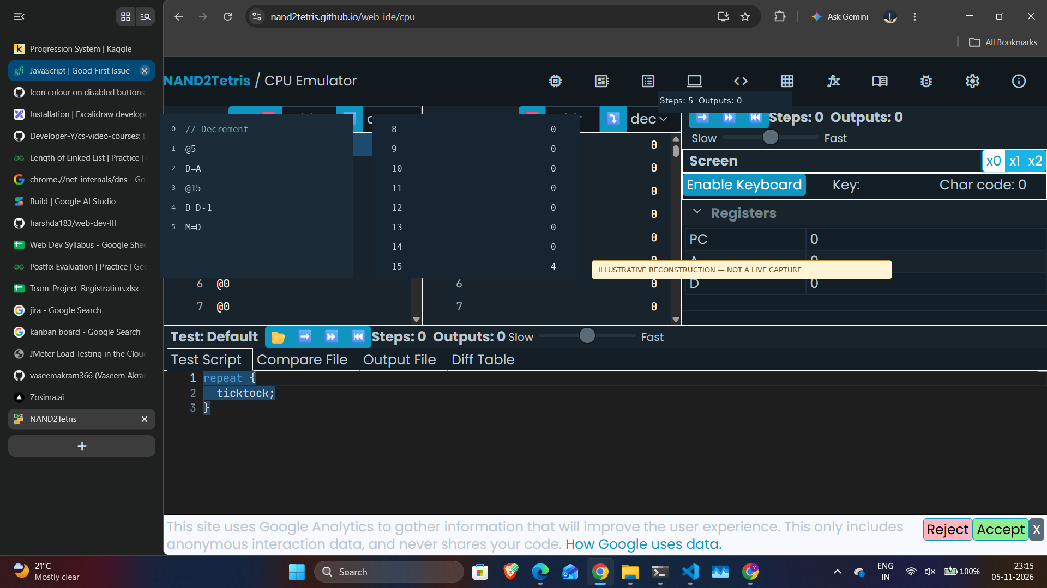
Illustrative reconstruction based on the supplied CPU Emulator interface. 5 - 1 = 4.

Conclusion
The four Hack Assembly programs demonstrate addition, subtraction, increment and decrement operations. The calculated results are 20, -10, 6 and 4 respectively, with each result intended to be stored in RAM address 15.
Note: The emulator views in this document are illustrative reconstructions made from the sample interface image. They are not screenshots of live execution in the browser simulator.

