CPE 464 Lab 1 Worksheet

Name: Victoria Asencio-Clemens

This lab worksheet needs to be typed. Each student must type in their own answers. You will upload your worksheet to Canvas. This worksheet is due on the Friday after lab at 11:59 pm.

In this lab we are going to look at some basic networking concepts and tools. The steps in this lab are:

- Program #1 questions
- Ping
- Traceroute (tracert on windows)
- Wireshark for packet analysis

This lab assumes you have already installed Wireshark. (https://www.wireshark.org/#download)

- Ping

The ping command allows you to query another computer to see if that computer is correctly connected to a network.

The format for the ping command is: ping <hostname>
You can execute this command in a Linux terminal or in the windows command window. On a Linux/Mac use: ping -c 5 <hostname>. This will limit the ping command to 5 requests/replies.

- ping a University. e.g. ping www.msu.edu. (DO NOT use www.msu.edu... Pick some other university in the US and try them. If the entire class goes to the same university, they may lock us out. Keep trying until you get all successful pings for a site.)

What is the average time it takes for this ping to be successful? (note – a ping is measured by sending and then receiving a ping packet – so it’s a round trip. We can refer to this time as RTT or round trip time.)
Average Round Trip Time = 8ms

- ping www.imperial.ac.uk. What is the average time (RTT) it takes for this ping to be successful?

Average Round Trip Time = 211ms

- We talked about latency (RTT or round trip time) in lecture. Can you speculate why it takes longer to ping www.imperial.ac.uk than the US based university?
It takes longer to ping a location in the UK because it’s further, thus we have to travel farther to reach routers and the final destination.

We will look at the ping command again as part of our use of wireshark later in this lab.

- Traceroute (on windows its tracert or tracepath on newer Linux boxes)

The traceroute (tracert, tracepath) command allows you to see the path taken across the Internet. It returns the IP address or name of the routers that the packet traverses. Let’s look at the path between your location and some other locations.

- In a terminal/command window type: traceroute www.imperial.ac.uk (or on windows: tracert www.imperial.ac.uk or on some Linux boxes: tracepath www.imperial.ac.uk)

- How many hops (routers) are between you and www.imperial.ac.uk?
23 hops

- Speculate which hop takes you from the US to England, which hop is it?

I believe the 13th hop takes me from the US to England because the response times because much larger after that. Also, only names of the routers after hop 13 include “london”.

- About the first router in England:

From the traceroute, what is the name of the first router you think is in England:
ae24.londtt-sbr1.ja.net [146.97.35.193]

Let’s look up information on that router by its name. Go to Google and search for the name of the router. (For me the router is JANET.ear3.London2.Level3.net, so I typed ‘who has JANET.ear3.London2.Level3.net’ in Google. Note, you could also look it up by IP address.)
Jisc Services Limited
In what country (and city) is this router located?
London, England

- Traceroute to www.umich.edu (traceroute www.umich.edu)

- How may hops are between you and www.umich.edu?
16 hops

- How many routers are the same in the traceroute results for www.imperial.ac.uk and www.umich.edu?
The first five hops hit the same router in both traceroute results.

- Wireshark.

In this part of the lab you need Wireshark (www.wireshark.org) on your computer. Wireshark allows you to analyze packet traces. These packets may be captured on a live network (this is called packet sniffing) or wireshark can analyze packet traces previously captures and stored in a file with the extension ‘.pcap’ or ‘.pcapng.’ In this lab (and in program 1) you will analyze packet trace files that I captured on my network.

Note…Your first program, called trace, is to write a simple version of a packet analyzer. You will be given packet trace files (.pcap) and are required to output information on each packet.

- Download and install wireshark (www.wireshark.org) on your computer
- Download the ping.pcap file from canvas
- Open the ping.pcap file in wireshark

First, you are going to look at the headers for ping packets. For the first part of the lab, there are three headers that we are interested in. These are the Ethernet header, IP header and ICMP (ping) header.

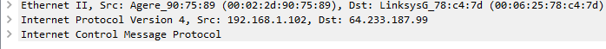

Using Wireshark, you will expand each of these headers and look at the values in these headers.

- Ethernet Overview (using the ping.pcap file)

  - Based on the lecture, draw (or list the fields in) a standard ethernet header, include the length of each field. (If you don’t remember google ethernet header).
A standard ethernet header contains the destination and source MAC addresses. Each MAC address is 6 bytes, the first three bytes identify the vendor and the second three bytes are a unique number to the vendor.

Looking at the Ethernet header in 4th packet in the ping.pcap file via wireshark. Expand the Ethernet PDU so you can see all of the fields.

  - What is the source Ethernet MAC address in the colon notation (e.g. 05:03:…)?
00:06:25:78:c4:7d
  - What is the destination Ethernet MAC address?
00:02:2d:90:75:89
  - This Ethernet frame caries an IP payload, what is the Ethernet Type value that specifies the this?
IPv4 (0x0800)
What is the hex value for the type field for the following payloads that may be carried by Ethernet (see https://en.wikipedia.org/wiki/EtherType):

  - Type field value for Internet Protocol version 4 (IPv4)?
0x0800
  - Type field value for Internet Protocol version 6 (IPv6)?
0x86DD
  - Type field value for Address Resolution Protocol (ARP)?
0x0806
  - Explain how you could determine that an Ethernet Frame carries a TCP segment (talk about it with your group)?
If the Ethernet type value indicates IP, you can check the IP header to see if the protocol is set to TCP.

- Internet Protocol Overview (using the ping.pcap file)

Go to the 1st packet in the file. The ping protocol is called ICMP. Expand the packet in the middle window (right click then “Expand All”).

- What is the source IP address for the 1st ping request
129.168.1.102
- What is the destination IP address for the 1st ping request packet?
66.94.230.35

Compare the packet in the ping.pcap file and the IP header figure from Wikipedia:

https://en.wikipedia.org/wiki/IPv4#/media/File:IPv4_Packet-en.svg

- What Version of IP is this in binary and decimal?
4’b0100 or 4
- What is the header length (IHL) value in binary and decimal?
4’b0101 or 5
- What is the total length value?
60
- What is the Time to Live (TTL) value?
128
- What is the Protocol value?
ICMP (1)

Go to Wikipedia for a list of protocol numbers: https://en.wikipedia.org/wiki/List_of_IP_protocol_numbers

- What is the protocol number for TCP?
6
- What is the protocol number for UDP?
17
- What is the protocol number for ICMP?
1

- Ping – officially called Internet Control Message Protocol (ICMP)

Looking at the “Internet Control Message Protocol” section of packet #1.

    - What is the ICMP type value for the ICMP Echo request packet (packet 1)?
Type: 8
    - Look at packet 2, what is the type value for the ICMP Echo reply packet?
Type: 0
    - Back to packet 1, what is the data that was sent in the ping request packets (in ASCII – select the data in the middle window and look at what is highlighted in the bottom window)?
Data: 6162636465666768696a6b6c6d6e6f7071727374757677616263646566676869
    - When you turn in this lab, include a screenshot of wireshark running on your computer with the ping.pcap packets.
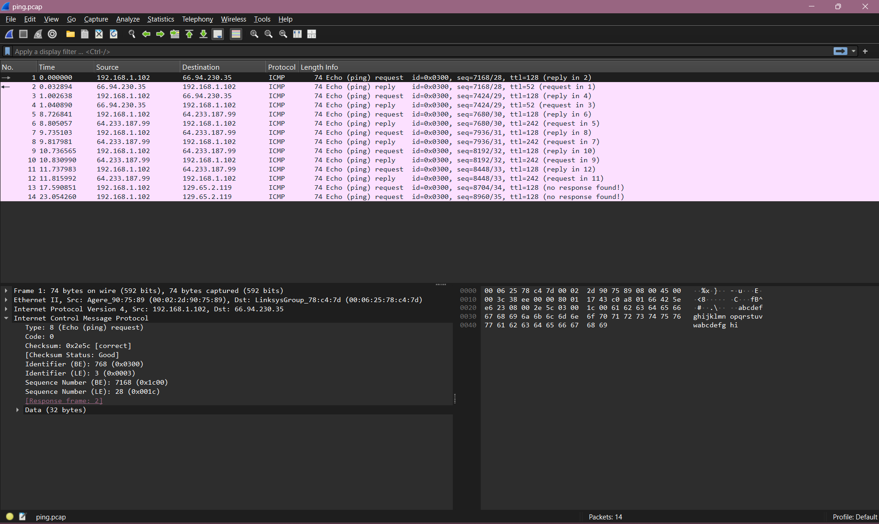

- DHCP (still using wireshark)

Now we are going to study one of the network protocols we use every day. This protocol is called DHCP. Using Google answer the questions below.

  - What does DHCP stand for?
Dynamic Host Configuration Protocol
  - What is the purpose of DHCP?
To assign IP addresses to devices so they can communicate with other IP networks and use their services.
  - Name and explain the four basic packets used in DHCP
Discover is sent from the client to find a DHCP server, Offer is sent from the server to the client to provide the client with the IP address, Request is sent from the client to the server to select and confirm an offer, and Acknowledge is sent by the server to finalize the assignment of an IP address.
  - Draw a packet flow diagram of the packets that flow between your computer and the DHCP server.
DHCP Discover
Client Server
DHCP Offer

DHCP Request

DHCP Acknowledge

  - Looking at the DHCP packet trace file (found on canvas, dhcp_trace.pcapng) using wireshark, answer the following questions:

                - Looking at the first packet, expand the Ethernet II header:

  - what is the source (src) MAC address?
98:5f:d3:4e:bc:13
  - In the same packet, what is the destination (dst) MAC Address?
ff:ff:ff:ff:ff:ff
  - The destination MAC address is a broadcast address, explain why.
The server connects to all the clients
                - Looking at the DHCP Offer packet (expand this header) answer the following questions:

- What is the IP address of the DHCP server?
192.168.86.1
- How long is the lease for this DHCP offer?
1 day
- What is the client offered (your) IP Address?
192.168.86.221
- What is the Router’s IP address (this is also called a default gateway)?
192.168.86.1

  - Describe two different types of DHCP Vulnerabilities. (google DHCP security issues)
One major security threat involving DHCP are rogue DHCP servers. These are unauthorized servers that offer DHCP services to clients and can be used by attackers to gain control over clients. Another DHCP is also vulnerable to starvation, when an attacker send an large influx of DHCP requests with fake MAC addresses. This causes all IP addresses available to the DHCP server to be used and thus no real clients will be able to connect.

Because we are using live networks with real sites, sometimes those sites are not available or think Cal Poly is sending them too much weird traffic and stop responding. If this happens just pick another university (or really any site).
The IP version is in the first 4 bits of the first byte of the IP Header. The IHL field is the last four bits of the first byte of the IP header.

