Product and Order Inventory Architecture
End to end product creation, checkout reservation, payment and stock update flow

Purpose. This document explains how a product enters the catalogue and how its inventory changes when a customer places and pays for an order. The design prevents overselling by separating physical stock from inventory temporarily reserved during checkout.

Main conclusion
A product is not deducted when checkout begins. Checkout temporarily increases reserved stock. Only a verified, captured Razorpay payment decreases physical stock. Failed, cancelled, or expired checkouts release the reservation without changing physical stock.

System components
Layer | Primary component | Responsibility
Client | Angular storefront | Admin product editor, catalogue, cart, checkout and payment user interface.
Application | Express API | Validates requests, coordinates orders, inventory transactions and payment verification.
Persistence | MongoDB | Stores products, variants, stock, reservations, orders and external synchronization state.
Payments | Razorpay | Creates the gateway order, captures payment and provides signed payment details.
Integration | External Storefront API | Receives paid orders by SKU and reports downstream stock, Tally and Sheets updates.

End to end architecture
The flow moves from catalogue administration to checkout reservation and then to one of two payment outcomes.
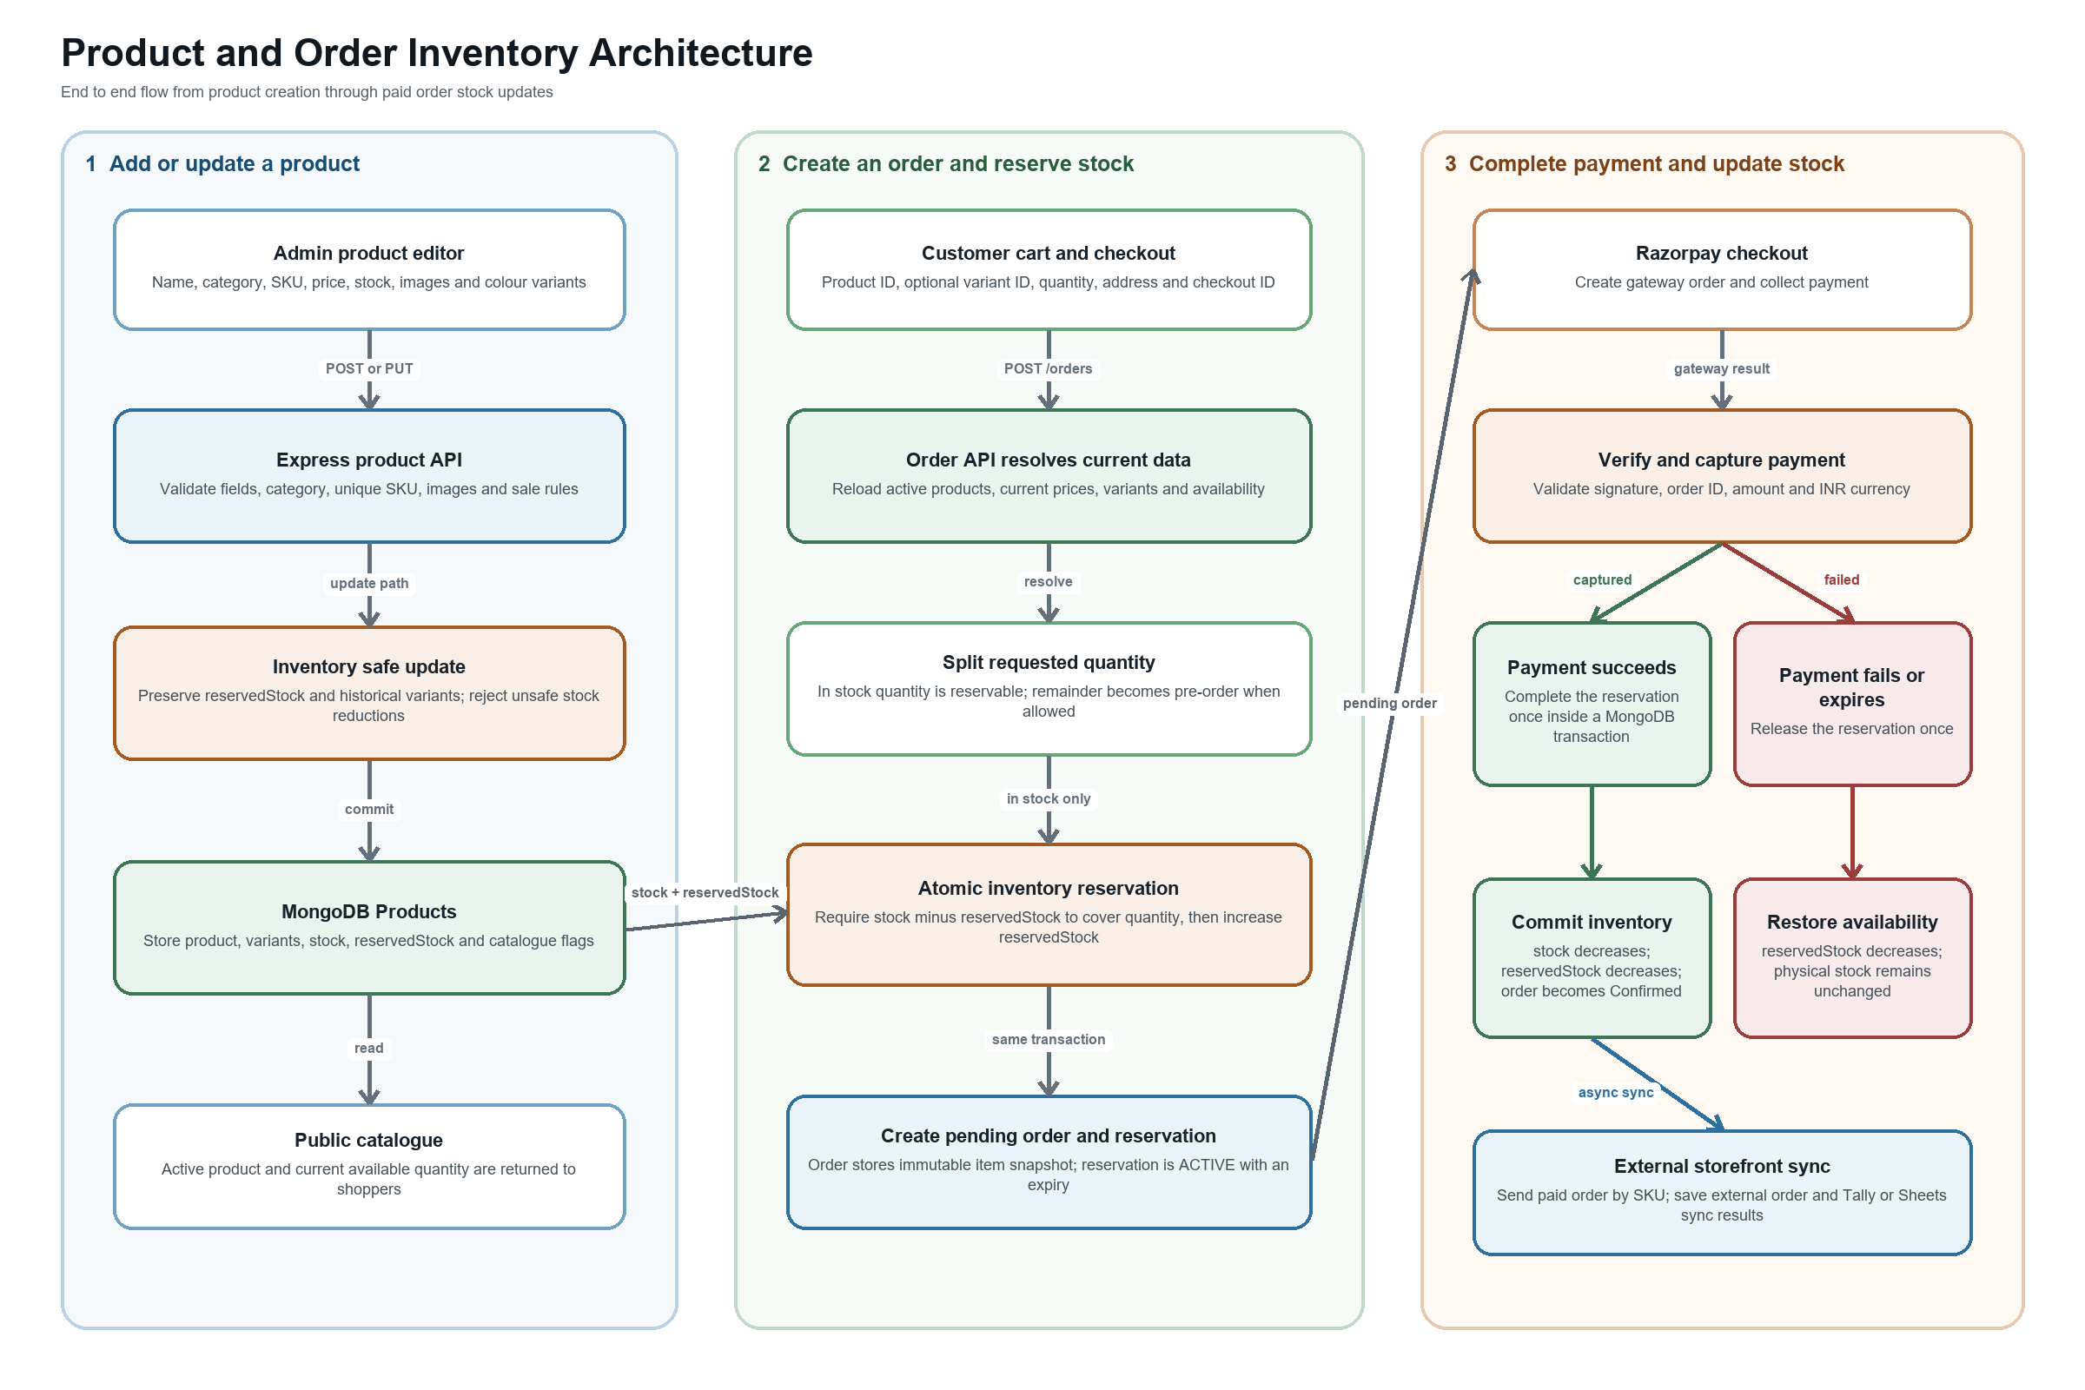
Figure 1 Product creation and post order inventory update flow

Product creation and administration flow
An administrator creates or edits a product in the Angular admin panel. The client sends a complete product payload to the protected Express product API.
- The API validates the active category, optional subcategory, product name, fabric, colour, price, MRP, images and sale dates.
- Product and variant SKUs must be unique. A unique product slug is generated from the product name.
- When variants exist, product stock is the sum of active variant stock. Variant reserved quantities are preserved during edits.
- An administrator cannot reduce stock below reservedStock or hide a variant that has inventory reserved by an active checkout.
- Optimistic concurrency uses updatedAt so a stale product edit cannot overwrite a newer inventory change.

Checkout and reservation flow
Checkout does not trust catalogue values cached in the browser. The API reloads the current products and variants, recalculates prices, and validates availability before creating the order.
Step | Action | Result
1 | Resolve cart | Load active products, selected variants, current prices and pre-order rules.
2 | Split quantity | Separate each line into stockQuantity and preOrderQuantity. Only stockQuantity is reserved.
3 | Reserve atomically | Require stock minus reservedStock to be at least the requested in-stock quantity, then increment reservedStock.
4 | Create records | Create the Pending Payment order and ACTIVE inventory reservation in the same MongoDB transaction.
5 | Preserve history | Store product name, SKU, image, variant, price and quantities as an immutable order item snapshot.

Inventory updates after payment
Razorpay payment verification checks the signature, gateway order, amount and currency. Inventory and order state are then committed in a MongoDB transaction, and the reservation can only be completed once.
Outcome | Product update | Reservation update | Order update
Payment captured | stock decreases; reservedStock decreases | COMPLETED | Paid and Confirmed
Payment failed | reservedStock decreases; stock unchanged | RELEASED | Failed
Checkout cancelled | reservedStock decreases; stock unchanged | CANCELLED | Failed
Reservation expired | reservedStock decreases; stock unchanged | EXPIRED | Failed

External synchronization after a paid order
After local inventory is committed, the server sends the paid order to the configured external Storefront API. The payload includes the order number, customer, SKU, product and variant name, quantity, unit price, total, and payment method. The local order records whether the external operation is synced, failed, unknown, or not configured, together with returned stock updates and Tally or Sheets results.

Inventory invariants
- Available to reserve equals stock minus reservedStock.
- reservedStock must never be negative or greater than stock.
- Physical stock changes only after a captured payment is verified.
- Reservation completion and release are idempotent, preventing duplicate stock changes.
- Pre-order quantities are recorded on the order but are not reserved or deducted from physical stock.
- Historical orders remain stable because each order stores a product and pricing snapshot.

