**DevOps Training-Day-1**

# InstallingandSettingUpWSLwithUbuntuonWindows10 Step 1: Enable WSL

BeforeinstallingUbuntu,ensurethatWSLisenabledonyourWindowssystem.

# EnableWSLFeature

1. Open**PowerShell** asAdministratorandrun:
2. wsl--install

ThisinstallsthedefaultLinuxdistributionandenablesnecessary components.

1. IfWSLisalready installedbutnotenabled, use:
2. dism.exe/online/enable-feature/featurename:Microsoft-Windows-Subsystem-Linux

/all /norestart

1. EnabletheVirtualMachinePlatformfeature(requiredforWSL2):
2. dism.exe/online/enable-feature/featurename:VirtualMachinePlatform/all/norestart
3. Restartyourcomputerto applychanges.

# Step2:InstallUbuntu

1. Open**CommandPrompt**or**PowerShell**andrun:
2. wsl--install -dUbuntu

Iftheinstallationfailsduetotimeoutissues,retrythecommandaftershuttingdownWSL: wsl --shutdown

wsl--install -dUbuntu

1. Onceinstalled,startUbuntu:
2. wsl.exe-dUbuntu

# Step3:SetUpUbuntu

WhenUbunturunsfor thefirsttime,it willaskyouto create anewuser account.

1. **Enterausername**(muststartwithalowercaseletterorunderscore,andcontainonly lowercase letters, digits, underscores, and dashes).
2. **Setapassword**(enterandconfirmthepassword).Ifpasswordsdonotmatch,you will need to retry.
3. Oncesuccessful,Ubuntuwillbesetupand readyto use.

# Step4:VerifyInstallation

Tochecktheinstalleddistributionsandtheirversions:

wsl-l-v

ToverifyUbuntuisrunning:

wsl-d Ubuntu

# Step5:ConfigureUbuntu Update System Packages

Afterloggingin,updatethepackagelistandupgradeinstalledpackages: sudo apt update &&sudo apt upgrade -y

# SetDefaultWSLVersion

TouseWSL2asthedefaultversionforfutureinstallations:

wsl--set-default-version2

TocheckthecurrentWSLversion:

wsl-l-v

ToconvertanexistinginstallationtoWSL2:

wsl--set-versionUbuntu2

# Step6:Enable.hushlogintoSuppressLoginMessage

Todisablethedailyloginmessage,createa.hushloginfileinyourhomedirectory: touch ~/.hushlogin

# AdditionalCommands Restart WSL:

wsl--shutdown

# Uninstall a Distribution:

wsl--unregisterUbuntu

# AccessWindowsFilesinWSL:

cd/mnt/c

# Conclusion

YouhavesuccessfullyinstalledandsetupWSLwithUbuntuonWindows10.Youcannow use the Ubuntu terminal to run Linux commands and manage your system efficiently.

# Step-by-StepGuidetoCreatingaFreestyleJobinJenkinstoInstallNginxonaLocal Ubuntu VM

**PrerequisitesforSettingUpaFreestyleJobtoInstallNginxin Jenkins**

BeforecreatingtheFreestyleJob,ensurethatthefollowingprerequisitesaremet:

# InstallJenkinsonUbuntu(IfNotInstalled)

IfJenkinsisnotinstalledon yourUbuntuVM, followthese steps:

# Step1:UpdatePackage Lists

sudoaptupdate-y

# Step2:InstallJava(RequiredforJenkins)

sudoaptinstall-yopenjdk-17-jdk

# Step3:VerifyJavaVersion

java-version

**Step4:AddJenkinsRepositoryKey**

**(Note:Theapt-keyaddcommandisdeprecatedinnewerUbuntuversions.Usethe correct method below.)**

**CorrectWaytoAddJenkinsRepository(Withoutapt-key)**

**Step4.1:Add JenkinsGPGKey**

wget-q-O-https://pkg.jenkins.io/debian-stable/jenkins.io-2023.key|sudotee

/usr/share/keyrings/jenkinskeyring.asc>/dev/null

# Step4.2:Add JenkinsRepository

echo"deb[signed-by=/usr/share/keyrings/jenkins-keyring.asc]https://pkg.jenkins.io/debian- stable binary/" |

sudotee/etc/apt/sources.list.d/jenkins.list>/dev/null

# Step5:InstallJenkins

sudoaptupdate-y

sudoapt install-y jenkins

# Step6:StartandEnableJenkins Service

sudosystemctl start jenkinssudosystemctl enable jenkins**Step7:CheckJenkinsStatus** sudosystemctl status Jenkins

# AccessJenkinsWebInterface

Jenkinswillbeavailableat http://<VM_IP>:8080

# ToGettheJenkinsServerURL,FollowTheseSteps: Method 1: Check the Default URL

Bydefault,Jenkinsrunsonport8080.Openinabrowser: http://<your-server-ip>:8080

Ifyou'reonthesamemachineasJenkins,use: [http://localhost:8080](http://localhost:8080/)

# Method2:GetServerIPAddress

hostname-I or

ipa|grepinet

# Method3:CheckJenkinsLogs(IfUnabletoAccess)

sudojournalctl-ujenkins--no-pager--lines=50

Lookfor linesmentioning*"Jenkinsisfullyup andrunning"*andthe URL.

# AccessJenkinsWebInterfaceandLogIn

* 1. Openabrowserandgotohttp://<JENKINS_SERVER_IP>:8080
  2. Entertheusername(admin)andtheadminpasswordretrievedfromthefollowing command:

sudocat/var/lib/jenkins/secrets/initialAdminPassword

* 1. Choose*InstallSuggestedPlugins*(recommended)ormanuallyselect plugins.

# EnsureSudoAccessforJenkinsUser

Jenkinsrunsasasystemuser(jenkins).Ifyourscriptrequiressudo,allowJenkinstoexecute commands without a password:

sudovisudo

Addthefollowing lineat theendofthe file:

jenkinsALL=(ALL)NOPASSWD:ALL

Saveandexit.

# Step-by-StepGuidetoCreatingaFreestyleJobinJenkinstoInstallNginx Step 1: Create a New Freestyle Job

* 1. Clickon**NewItem** from theJenkinsDashboard.
  2. Enteranameforthe job,e.g.,*Install-Nginx*.
  3. Select**Freestyleproject**.
  4. Click**OK**.

# Step2:ConfiguretheJob Add Build Step

1. Scrolldownto**Build**→Click*Add buildstep*→Select**Execute shell**.
2. Pastethefollowingscriptinthecommandbox: #!/bin/bash

echo"Updatingpackagelists..." sudo apt update -y

echo"InstallingNginx..." sudo apt install -y nginx

echo"StartingNginxservice..." sudosystemctl start nginx

echo"EnablingNginxtostartonboot..." sudosystemctl enable nginx

echo"NginxInstallationCompleted!"

# Step3:SaveandRuntheJob

1. Click**Save**.
2. Click**BuildNow**.
3. Checkthe**ConsoleOutput**toverifythe installation.

# Step4:VerifytheInstallation

1. **CheckNginx Status**

systemctlstatusnginx

Ifrunning, you should seeoutput like *"active(running)"*.

# OpenNginxin Browser

http://<VM_IP>

YoushouldseethedefaultNginxwelcome page.

# Conclusion

YouhavesuccessfullysetupaJenkinsFreestyleJobtoinstallNginxonalocalUbuntuVM. ThisguidecoverseverythingfromJenkinsinstallation,configuration,andrunningthejobto verify that Nginx is installed and running correctly.

’•˙¸.s7Now,yourJenkinsautomationisreadytodeployNginxeffortlessly!

Sssss**Screenshot**

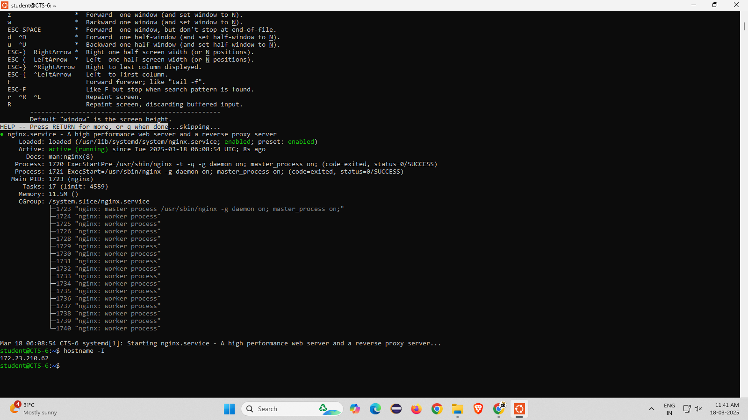

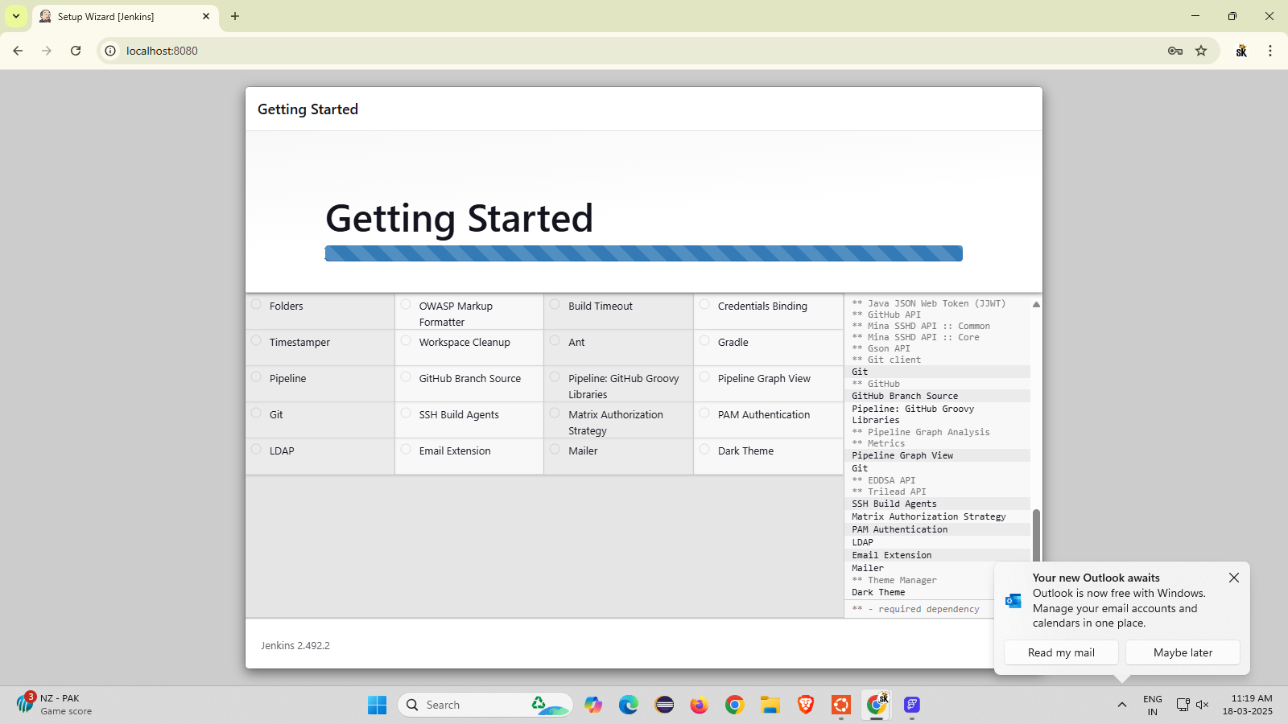

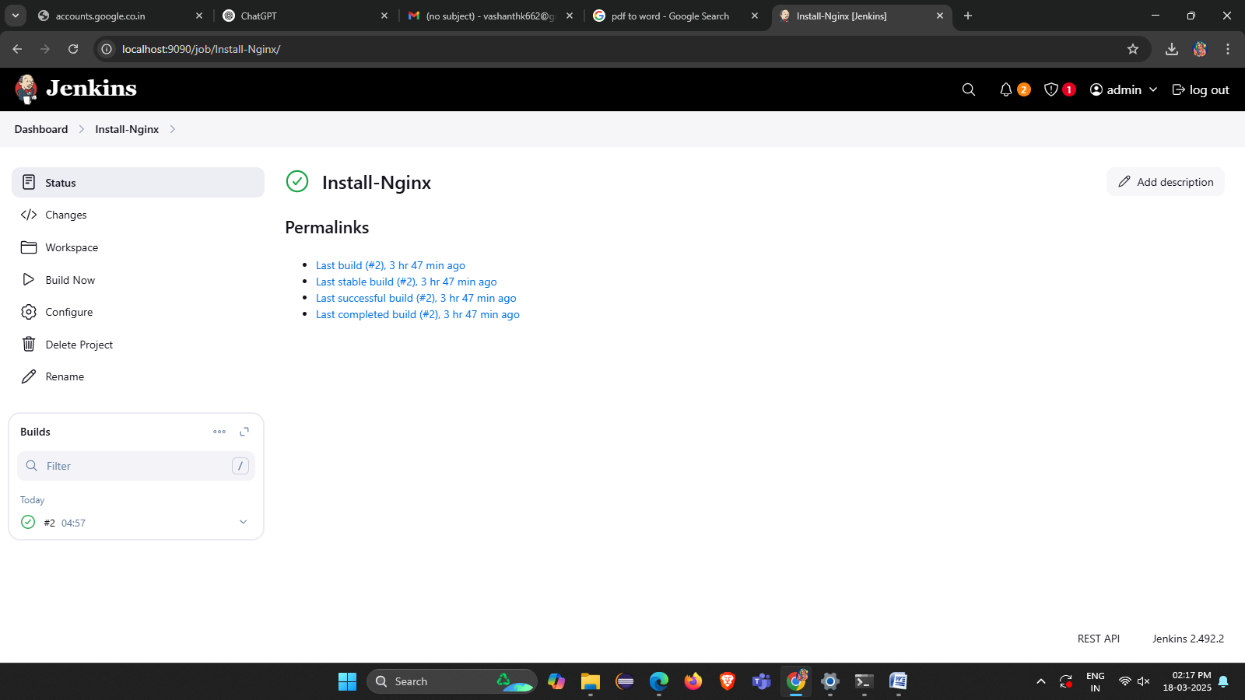

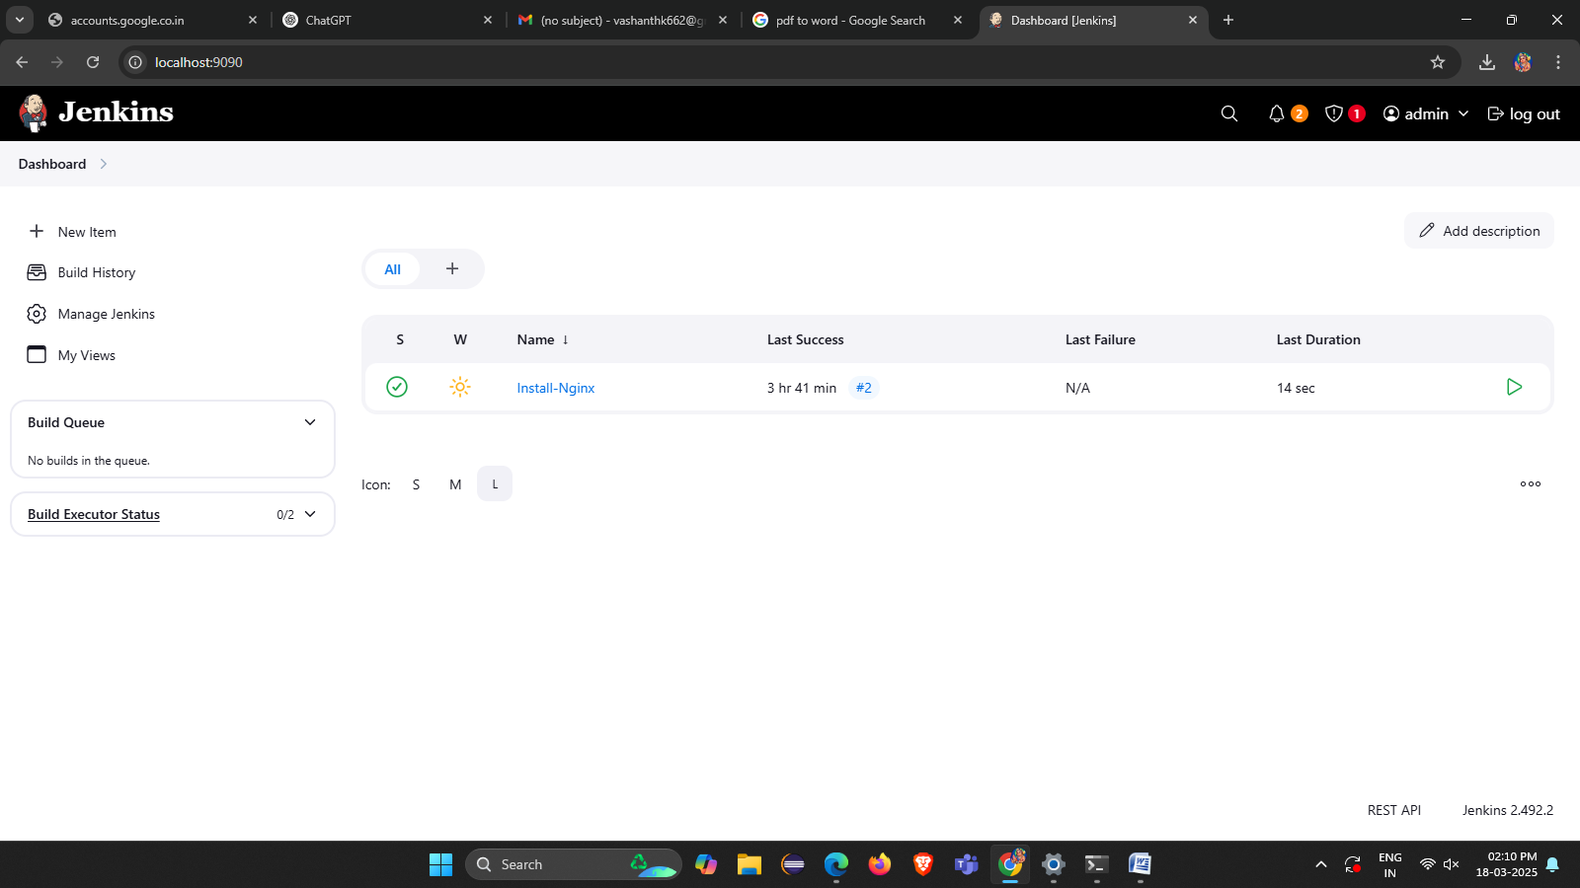

·~ª.˙~‘

