**E-LEARNING PLATFORM DATA ANALYTICS DASHBOARD USING POWER BI**

**POWER BI PROJECT REPORT**

**Submitted by**

**VASHANTHAKUMAR K S**

**(Reg.No:24MCR124)**

***In partial fulfilment of the requirements for award of the degree of***

**MASTER OF COMPUTER APPLICATION**

**IN**

**DEPARTMENT OF COMPUTER APPLICATION**

**KONGU ENGINEERING COLLEGE**

**(Autonomous)**

**PERUNDURAI ERODE – 638 060**

**DECEMBER 2024**

# *"As technology continues to evolve, Power BI will undoubtedly play an even more crucial role in helping businesses harness the power of data to drive innovation and growth."*

Online E-Learning Platform

# Abstract :

This project aims to design and implement an interactive Power BI dashboard that visualizes essential metrics for an e-learning platform, offering insights into course enrollments, student demographics, engagement rates, and course performance. By integrating data from multiple sources, the dashboard provides a holistic view of platform activity, allowing stakeholders to identify patterns, trends, and correlations in user behavior and learning outcomes.

With a user-friendly interface, the dashboard enables decision-makers to drill down into specific areas such as regional engagement or course-specific enrollment to understand drivers of platform success. Additionally, it includes predictive insights to help forecast enrollment trends, recognize seasonal or marketing-driven peaks, and plan future content offerings. This predictive capability empowers stakeholders to make informed, strategic adjustments based on data-driven evidence.

Ultimately, this Power BI dashboard simplifies complex information and generates actionable insights through interactive visualizations. It not only supports operational needs by streamlining data access and real-time insights but also encourages continuous improvement, positioning the e-learning platform for sustained growth and increased user satisfaction.

# Problem Statement

E-learning platforms accumulate substantial data, ranging from student enrollments and course completion rates to detailed engagement and feedback metrics. Managing and interpreting this data effectively is crucial for educational success but is often challenging without a structured approach. The goal of this project is to address these challenges by developing a Power BI dashboard that visualizes key performance indicators (KPIs) to inform strategic decisions. This dashboard allows stakeholders to pinpoint successful courses, identify student engagement patterns, and understand the demographic profile of users, making it a valuable tool for improving course offerings and learner satisfaction.

# Objectives

This project has several key objectives to guide the development of the Power BI dashboard:  
  
**Monitor Enrollment Trends:** Track new and total enrollments over time, helping stakeholders understand periods of growth and assess the impact of marketing or seasonal factors.  
**Analyze Student Demographics:** Profile users by age, gender, and location, providing insights into the primary audience and areas for market expansion.  
**Assess Course Performance:** Evaluate courses based on enrollment, completion, and dropout rates to identify high-value content and improve courses with lower engagement.  
**Track Engagement Levels:** Measure user activity, such as average session duration and time spent on different courses, to optimize content delivery and improve retention.  
**Measure Revenue and Profitability:** Identify revenue streams, high-earning courses, and profit margins to support balanced growth and long-term financial sustainability.

# Dashboard Sections and Visuals

Each dashboard component is designed to offer a unique perspective on platform performance, allowing stakeholders to obtain a granular understanding of user behavior, course success, and revenue sources.

## Enrollment Overview Dashboard

**Purpose:** Provides an overarching view of platform usage through total and new enrollments, allowing stakeholders to monitor growth and respond to changes in enrollment patterns.

**Key Visuals:**  
 **Line Chart:** Visualizes enrollment trends over days, weeks, or months, helping identify high-interest periods and correlate spikes with events or promotions.  
 **Funnel Chart:** Illustrates the user journey from initial registration through course completion, highlighting drop-off points where improvements could reduce churn.

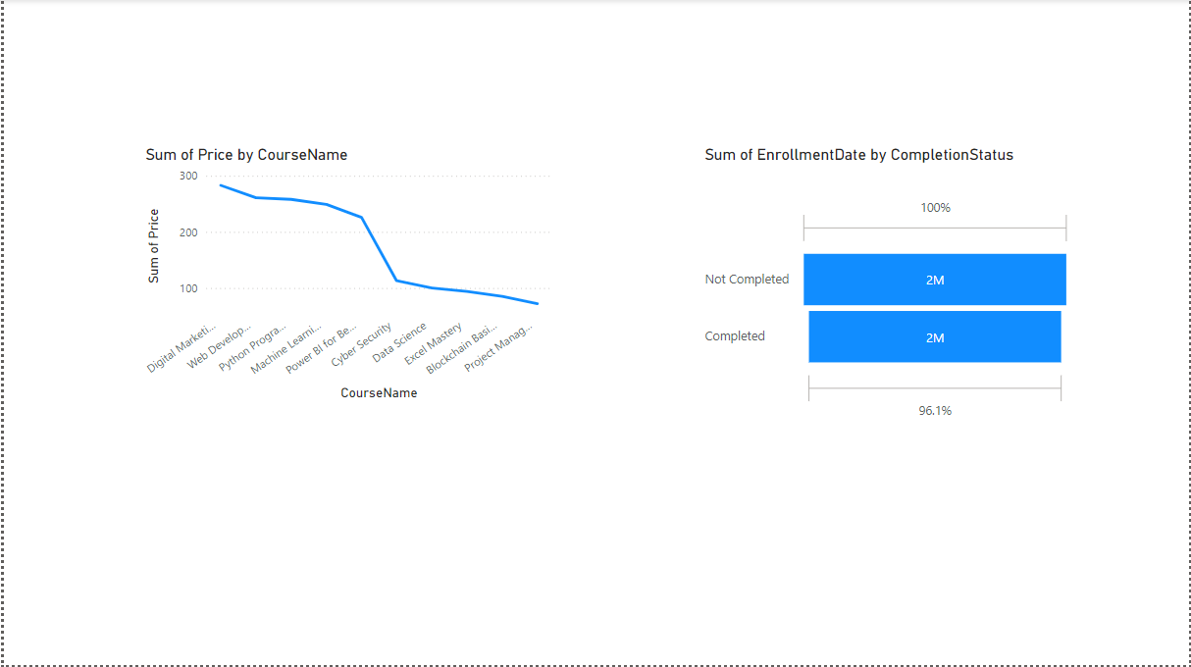

## Demographic Analysis Dashboard

**Purpose:** Offers a comprehensive view of the demographic makeup of the platform’s user base, aiding in content tailoring and marketing strategies.

**Key Visuals:**  
 **Bar Chart:** Displays age distribution of enrolled students, making it easy to identify age groups that may benefit from targeted content.  
 **Pie Chart:** Shows gender distribution, offering insights for gender- specific engagement and course design.  
 **Geographic Map:** Provides a heatmap of enrollments by region or country, indicating where the platform has the most reach and potential areas for growth.

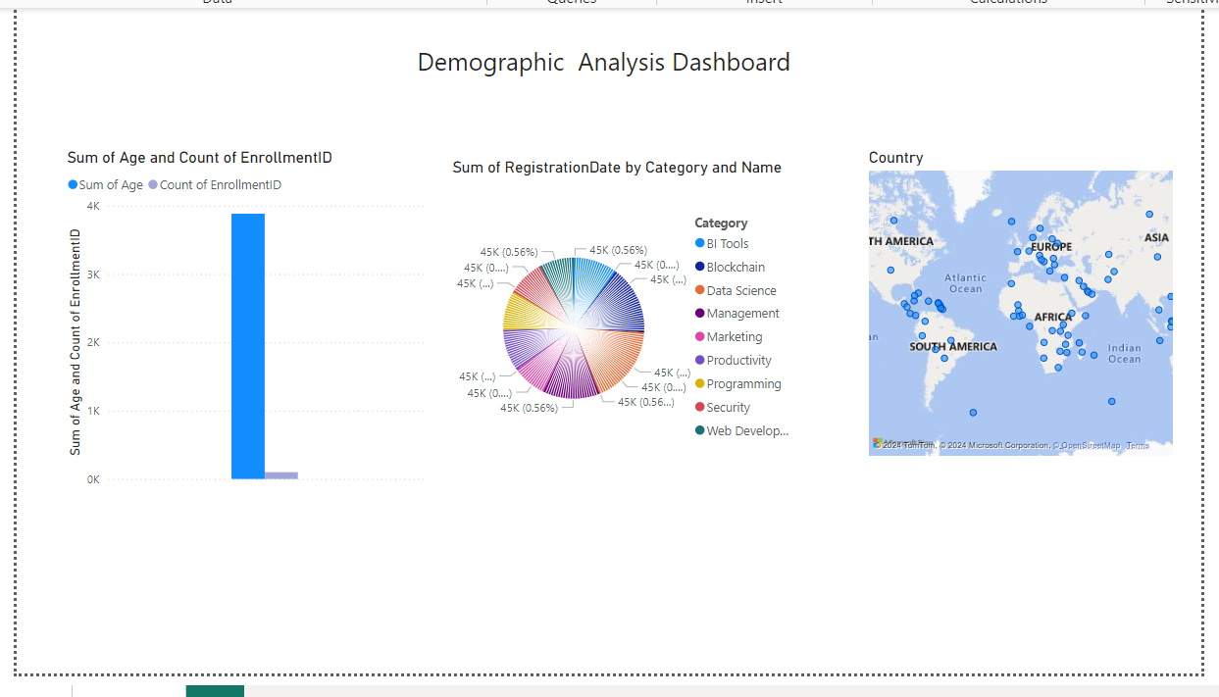

## Course Performance Dashboard

**Purpose:** Assesses course popularity and success, aiding in identifying which courses resonate most with users and which require adjustments.

**Key Visuals:**  
 **Stacked Bar Chart:**Highlights completion rates across courses, indicating user interest and potential barriers to course completion.  
 **Table:** Lists detailed metrics, including average scores, dropout rates, and completion counts per course, supporting deep analysis of course effectiveness.

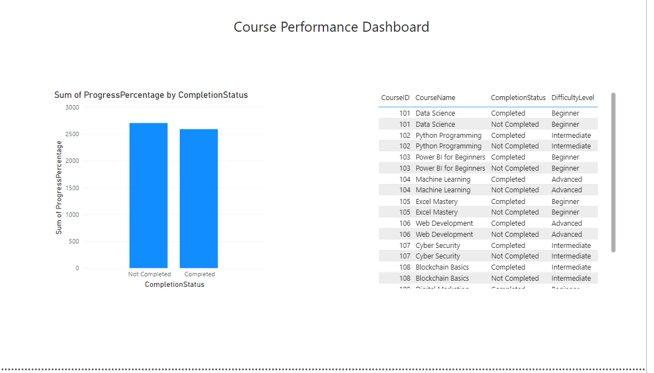

## Engagement Dashboard

**Purpose:** Measures user engagement levels to understand how students interact with the platform, helping identify areas for user experience improvements.

**Key Visuals:**  
 **Line Chart:** Displays average time spent on the platform per session, signaling whether users are engaged and staying on the platform for extended periods.  
 **Scatter Plot:** Maps engagement against completion rates for each course, allowing easy identification of courses that hold student attention versus those that may need restructuring.

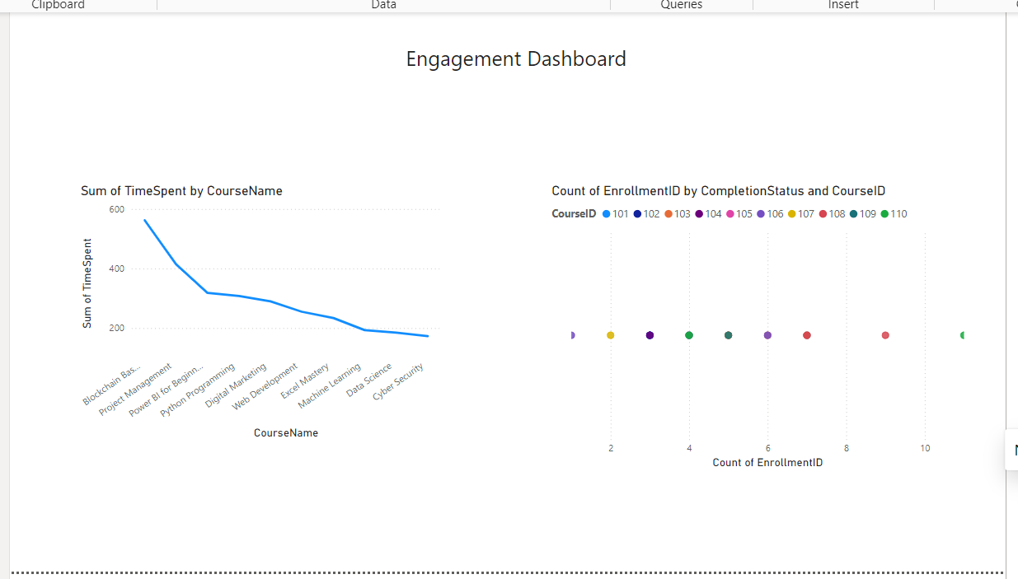

## Feedback and Ratings Dashboard

**Purpose:** Collects and organizes user feedback to assess course quality and identify trends in student satisfaction.

**Key Visuals:**  
 **Donut Chart:** Illustrates the distribution of course ratings, providing a quick overview of course reception.  
 **Table:** Displays average ratings, review counts, and qualitative feedback summaries, allowing for targeted improvements to content and delivery based on user input.

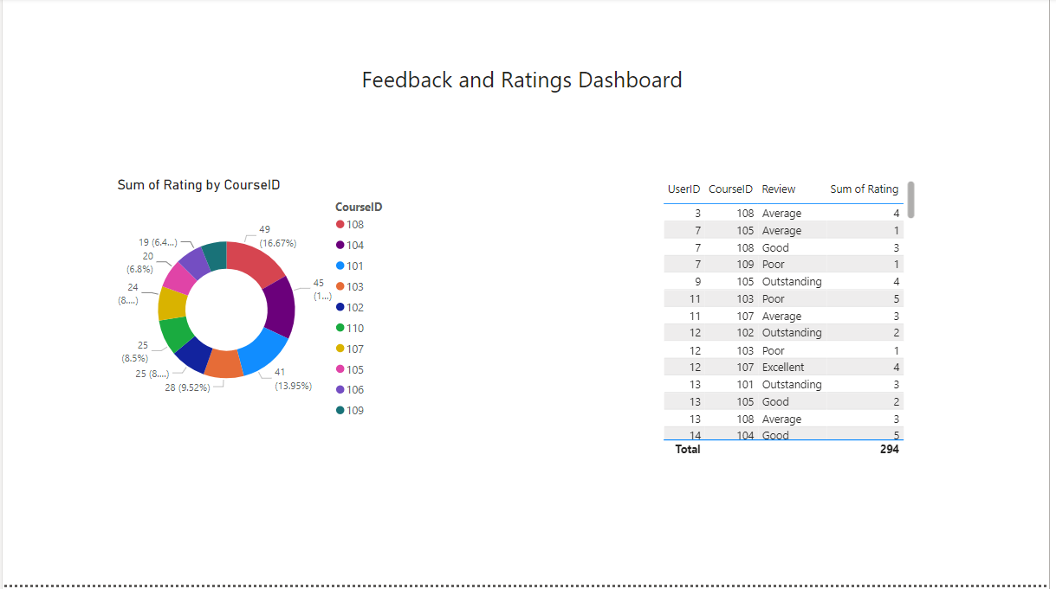

## Revenue and Profitability Dashboard

**Purpose:** Tracks revenue and profitability across different courses to identify financially successful content and potential growth opportunities.

**Key Visuals:**  
 **Bar Chart:** Shows revenue per course, allowing stakeholders to compare income-generating potential among different offerings.  
 **Matrix:** Displays profit margins by course category or type, helping to prioritize content that balances profitability with user engagement.

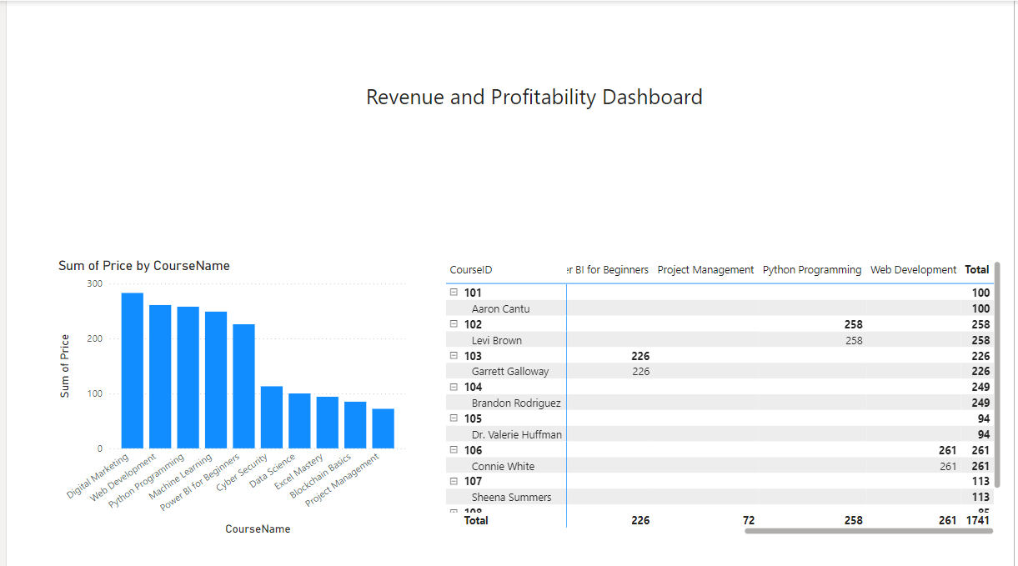

## Interactive Filtering & Drilldown Dashboard

**Purpose:** Provides a dynamic, interactive interface that allows users to filter data by various parameters and drill down into specifics, enabling a customized view for different analytical needs.

**Key Visuals:**  
 **Filters:** Include options for date range, course type, region, and user demographics, giving users control over the data shown.  
 **Detailed Table or Chart:** Automatically updates based on applied filters, providing an in-depth view for focused analysis of specific user segments or courses.

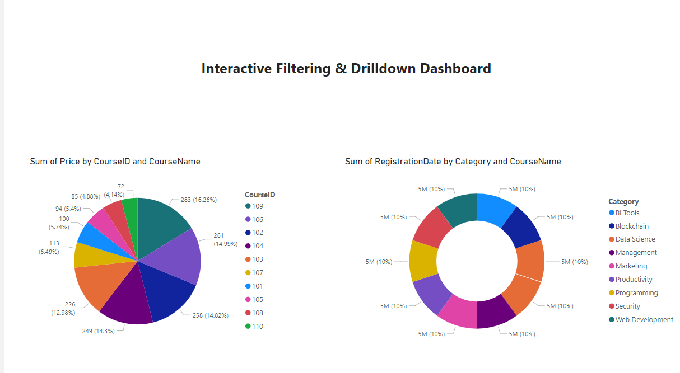

Overall Project : <https://github.com/vashanth-kumar/Project-Power-BI>

# Conclusion

The proposed dashboard suite provides e-learning platform stakeholders with critical insights, from understanding student demographics and course engagement to tracking financial performance. Through visualizing data in charts, maps, and matrices, the dashboards support strategic decision-making aimed at enhancing the learning experience and optimizing course offerings. The interactive capabilities further empower users to explore data from multiple perspectives, making it easier to identify actionable insights. By leveraging this data-driven approach, the platform can continuously evolve and improve, meeting user needs more effectively while fostering sustained growth.