TGD2151 Computer Graphics Fundamentals

Assignment01 (10%)

1. Foreword
- This is a group assignment with maximum of TWO (2) students per group. Individual work is permitted.
- Students will be randomly assigned to complete one of the tasks given below.
- The deadline for the submission is on or before 7th of August 2019 (Wednesday 11am, 3 weeks from now). The time length is more than enough to complete the task. Hence, NO LATE WORK WILL BE ACCEPTED.
- EMAIL the source code and report to kwng@mmu.edu.my.

2. Task

Task 1:
In this assignment, students are to create a program that will display a 3D model such as in the Figure 1 below. Students can press on w/W or v/V or f/F keys to change the display mode to Wireframe/Vertices/Faces.

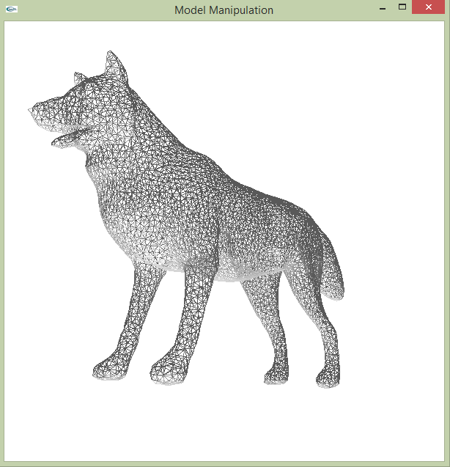
Figure 1: A dog model.

Apply the followings to the output window in Figure 1:
i) Apply some basic controls such as text box, button, radio button, arrows of direction, list box and etc. through using GLUI library (refer to Figure 2) into the output window in Figure 1. [Note: Apply only the necessary controls.]

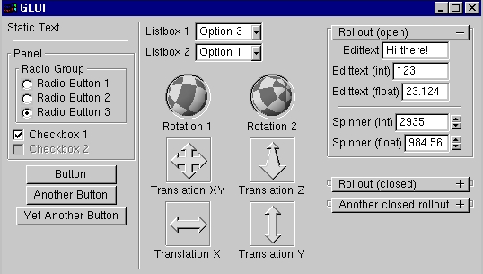
Figure 2: GLUI library

Students may refer to the following websites for more information on GLUI library.

- https://www.codeproject.com/Articles/20286/GLUI-Window-Template
- https://www.cs.unc.edu/~rademach/glui/src/release/glui_manual_v2_beta.pdf
- https://henry2005.jimdo.com/2011/11/30/glui-a-gui-library-for-opengl-rendering/
- https://bruceoutdoors.wordpress.com/2014/07/02/building-glui-with-vs2013-and-mingw-in-
windows/
- https://masdel.wordpress.com/2010/10/21/installing-glui-using-codeblocks-on-windows/
- https://masdel.wordpress.com/2010/06/13/installing-glut-for-vc-200320052008-in-windows/

Task 2:

Try to find the best neat of bounding box for the model in Figure 1 (as illustrated in Figure 3). Hint: Students can find the X_{min}, X_{max}, Y_{min}, Y_{max}, Z_{min} and Z_{max} to form a rough bounding box. For a better bounding box, the model shall be rotated to a good position before applying the X_{min}, X_{max}, Y_{min}, Y_{max}, Z_{min} and Z_{max} to form the bounding box. Students can search for the better way from the Internet to form the bounding box. Higher marks will be given to a good neat bounding box.

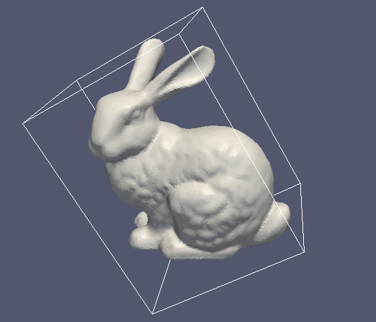
Figure 3: Bounding box around a model.

3. What to Submit?

Written Report

You are to prepare a written report that introduces and describes your program. You are free to design your report in any format you like as long as it is clear, neat, and interesting. Be brief but informative, it should contain at least the following contents:

- A Cover Page – It should at least contain your name, ID, email address and Phone number. A sample is included in this document.

- Introduction – Briefly introduces the purpose of your program and what your program can do.

- User Manual / Instructions – Instructions on how to use your program, buttons and keys to press, what to look for and what special feature your program has.

- Screen Shots – Screen shots of the major screen output of your system.
- Acknowledgment – State who have helped you in doing the assignment, and the people whom you have collaborated.

- References – State the source of materials you have borrowed but properly cited and acknowledged in the report.

Source Code

You also need to provide the source code of the program that you have written. It is your full responsibility to make sure that source code is error-free. Your code must be able to be compiled with Code::Blocks with MinGW/g++ compiler. Source codes that only work on other compilers such as Microsoft Visual Studio will NOT BE ACCEPTED.

You need to submit source code of your program and the softcopy of your report by email. All submissions are through emails only and hardcopy submissions will not be accepted. The email address to send your submissions is:

kwng@mmu.edu.my

Take note that the email will not accept executable files. You will receive an email reply if your email has reached the above recipient.

Please follow the instructions below carefully, failure to do so will result marks to be deducted.
a) You are to put all your files in a folder with the folder name in the following format:

CGF IDOfStudent1 NameOfStudent1 IDOfStudent2 NameOfStudent2

Example:
CGF 1101025432 SITI NORIDA BT HUSSEIN 1102007007 JAMES BOND

- Place only the .cpp, .hpp, .h and all the required resource files, assignment files, and your report in the folder. DO NOT include any .exe file at all.

- Zip the folder using 7Zip program and use the .zip format.

- Email the zipped file with email subject line as:

CGF IDOfStudent1 NameOfStudent1 IDOfStudent2 NameOfStudent2
Example:
CGF 1101025432 SITI NORIDA BT HUSSEIN 1102007007 JAMES BOND

- For all your source code files, insert the following information at the top of the file:

/********************************************

Course | : TGD2151 |  | Computer Graphics Fundamentals
Session: Trimester 1, 2019/20
ID and | Name | #1 : IDOfStudent1 NameOfStudent1
Contacts |  | #1 : PhoneNoOfStudent1 EmailOfStudent1
ID and | Name | #2 : IDOfStudent2 NameOfStudent2
Contacts |  | #2 : PhoneNoOfStudent2 EMailOfStudent2
********************************************/



FACULTY OF COMPUTING AND INFORMATICS

TGD2151 Computer Graphics Fundamentals

TRIMESTER 1, 2019/2020

ASSIGNMENT
Report

Lecture Section : TC 101
Tutorial Section : TT 101

For:

Dr. Ng Kok Why

From:

Student ID | Name | Email Address | Phone No.
1171301301 | Vashiegaran | 1171301301@student.mmu.edu.my | 011-35617621
 | Adam Lai bin Azman Lai | adamlai999@gmail.com
1151105268 |  |  | 012-3793720

Introduction.

In Task 1, Some basic control such as button, radio button, arrows of direction, Spinner box and
Rotation Box is added to 3D model .User interface is used in order to make the program user friendly and able to use it easily.

In task 2 , a 3D model is used to form a rough bounding box by finding the X_{min}, X_{max}, Y_{min}, Y_{max}, Z_{min} and Z_{max} of the model.Bounding boxes are imaginary boxes that are around objects that are being checked for collision.

User Manual / Instructions

Task 1:
User interface is used which have clear explanation for each buttons.

Task 2:

Screen Shots
Task 2:

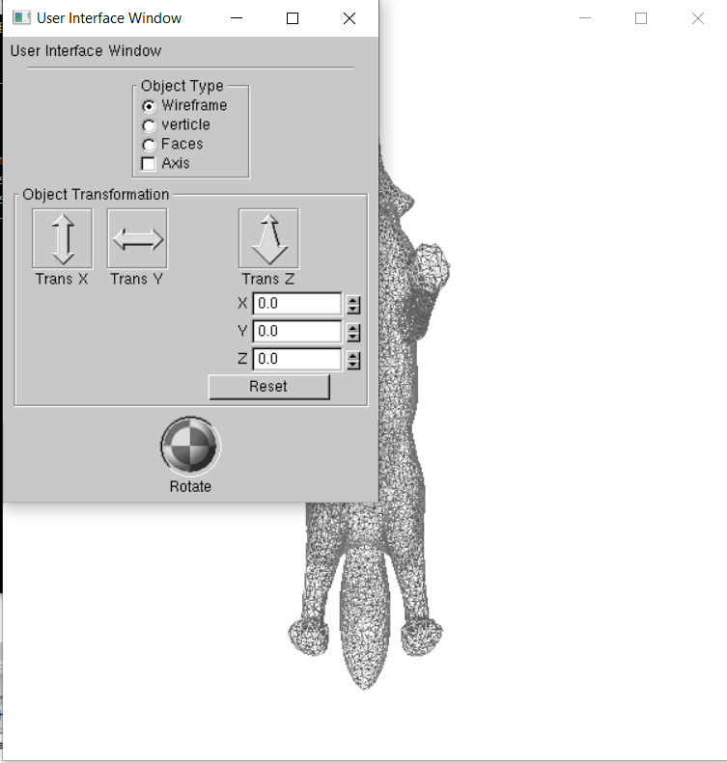

Object Type determines the following which is either wireframe , verticles or faces .
The axis button show the x,y,z axis.
In the object translation panel, the Trans x move along the x axis ,Trans y moves along y axis and Trans z move along z axis.The spinner button basically move the x,y,z axis with the increase or decrease in the floating numbers .The reset button resets the whole model.

Task 2:
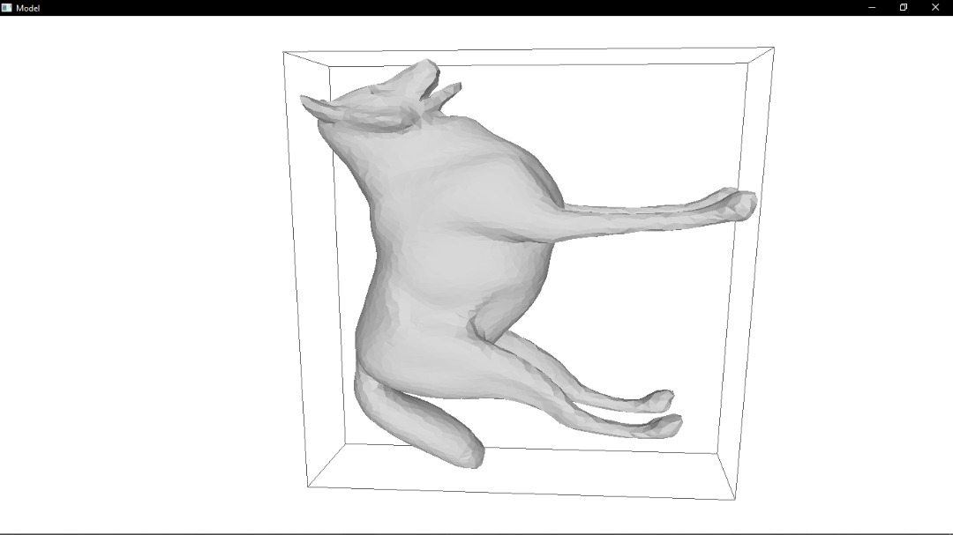

The bounding box for task 2 which is enclosed by lines .

Acknowledgment
We would like to thank My lecturer Dr Ng Kok Why for the guidance throughout the
assignement ,Furthermore I would like to appreciate the help from my classmates and especially google search.

References

- https://www.codeproject.com/Articles/20286/GLUI-Window-Template
- https://www.cs.unc.edu/~rademach/glui/src/release/glui_manual_v2_beta.pdf
- https://henry2005.jimdo.com/2011/11/30/glui-a-gui-library-for-opengl-rendering/
- https://bruceoutdoors.wordpress.com/2014/07/02/building-glui-with-vs2013-and-mingw-in-
windows/
- https://masdel.wordpress.com/2010/10/21/installing-glui-using-codeblocks-on-windows/
- https://masdel.wordpress.com/2010/06/13/installing-glut-for-vc-200320052008-in-windows/
- https://discourse.mcneel.com/t/bounding-box-with-c/32043

4. Evaluation Criteria

Please refer to the assignment mark sheet at the end of this document for specific criteria and to know how your assignment is evaluated.

Assignment Mark Sheet
TGD2151 Computer Graphics Fundamentals

Trimester 1, Session 2019/2020

To be filled by Examiner. This is for your reference only.

 |  | Max |  | Actual Marks
 | 1. Written Report (20%)
 | a. First Impression (bad = 0, okay = 1, good = 2) | 2
 | b. Introduction | 6
 | c. User Guide / Instructions | 6
 | d. Screen Shots (Pictures With Descriptions) | 6
 | 2. Source Code (30%)
 | a. Code Efficiency and Strategy | 10
 | b. Modularity (small functions) | 10
 | c. Error Reporting Capabilities | 5
 | d. Style - Self Documentation | 3
 | e. Style – Indentation (inconsistent = 0, consisten t = 2) | 2
 | 3. Program Execution (50%)
 | (If the program cannot run-even if it can compile, 0 mark will be given
 | for this section)
 | a. General Impression (Appearance and Beauty) | 5
 | (including good lighting, colours, textures etc) | 5
 | b. Level of Completion | 25
 | i. Performs All Required Features | 15
 | j. Error-free During Runtime (has error = 0, no error = 3) | 5
 | TOTAL | 100

