Merge Sort Algorithm basically divided the array list into two until there is only one element left and then merge it together. When it merge the array is sorted in ascending order or descending order based on how you code it.

procedure mergesort( array,N )
array – list of elements to be sorted
N – number of elements in the list
begin
if ( N == 1 ) return array
var array1 as array = a[0] ... a[N/2]
var array2 as array = a[N/2+1] ... a[N]
array1 = mergesort(array1)
array2 = mergesort(array2)
return merge( array1, array2 )
end procedure
procedure merge(array1, array2 )
array1 – first array
array2 – second array
begin
var c as array
while ( a and b have elements )
if ( array1[0] > array2[0] )
add array2 [0] to the end of c
remove array2 [0] from array2
else
add array1 [0] to the end of c
remove array1 [0] from array1
end if
end while
while ( a has elements )
add a[0] to the end of c
remove a[0] from a
end while

while ( b has elements )
add b[0] to the end of c
remove b[0] from b
end while

return c
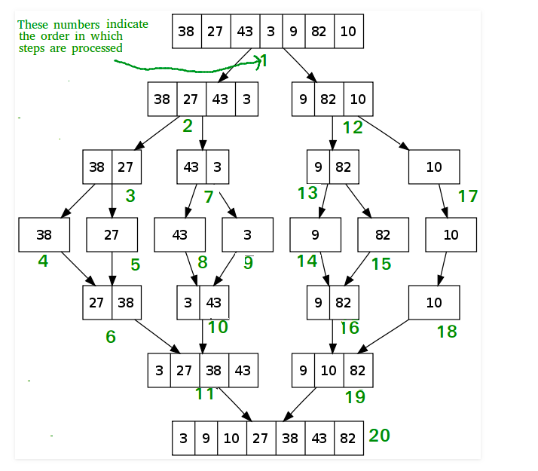
end procedure

