**Prog5:** this program is to merge tap file and Tap _A-B file to create a complete data record.

Input file: this program takes three input files:

1. Tap_Jun19.csv
2. Jun2019_finalfile.csv
3. Jun2019_finalfile_B-A.csv

Output file: this program returns only one output file i.e. Tap_Jun19_res.csv

User input: user need to enter the name of month and the year(only last two digits i.e ‘19’ for year 2019)

**nof = input("enter the name of month 'Jun':", )  
yr = input("enter the name of yr '19':", )**

**f1 = open(nof+"20"+yr+"_finalfile.csv", "r")  
f2 = open(nof+"20"+yr+"_finalfile_B-A.csv", "r")  
f3 = open("Tap_"+nof+yr+"_res.csv", "w")  
  
c1 = csv.reader(f1)  
c2 = csv.reader(f2)  
c3 = csv.writer(f3)  
  
file_1 = list(c1)  
file_2 = list(c2)  
  
for i in range(len(file_1)):  
 for j in range(len(file_2)):  
 if file_1[i][0:5] == file_2[j][0:5]:  
 res = file_1[i][0:34]  
 # print(res)  
 c3.writerow(res)  
  
f1.close()  
f2.close()  
f3.close()**

the above code is to read two input files i.e. f1 = final file created by prog1 and f2 = B-A file created by prog3 and the store the output in f3=”Tap_Jun19_res.csv” file

the above code compares the f1 and f2 and if the rows are similar then store the row in f3.

**df = pd.read_csv("Tap_"+nof+yr+"_res.csv", header=None)  
df.columns = ['Flt_No', 'Flt_Dt', 'AC_Reg', 'Dep_Stn', 'Arr_Stn', 'Pay_Max', 'Pay_Act', 'ZFW_Max', 'ZFW_Act', 'Take_Off_Fuel', 'TOW_Max', 'TOW_Act', 'Trip_Fuel', 'LW_Max', 'LW_Act', 'Pax_F', 'Pax_C', 'Pax_Y', 'Pax_Male', 'Pax_Female','Pax_Child', 'Pax_Infant', 'Pax_Load', 'Load_Comp', 'Bag_Load', 'Cargo_Load', 'Mail_Load', 'Engg_Load', 'Dry_Op_Wt', 'Cockpit_Crew', 'Cabin_Crew', 'Pad_F', 'Pad_C', 'Pad_Y']  
df.sort_values(['Flt_No', 'Flt_Dt'], axis=0, ascending=True, inplace=True)  
# print(df)  
df.to_csv("Tap_"+nof+yr+"_res.csv", index=False)**

the above code is used to read csv file using pandas and add headers to the file and sort the rows w.r.t column_0 (flight number) and column_1(flight departure date) and save it to “Tap_Jun19_res.csv” file.

**# consist of rows present in Apr2019_finalfile_B-A data  
a = pd.read_csv("Tap_"+nof+yr+"_res.csv")  
# read tap file  
b = pd.read_csv("Tap_"+nof+yr+".csv")  
# appending tap file data in a file  
merged = a.append(b, sort=False)  
# print(merged)  
merged.to_csv('Tap_'+nof+yr+'_res.csv', index=False**)

The above code read two csv file i.e Tap_Jun19_res.csv and Tap_Jun19.csv file and merge the both file into Tap_Jun19_res.csv file

**# reading result file consist of 42 columns  
df = pd.read_csv('Tap_'+nof+yr+'_res.csv')  
# dropping uneccessary column  
df = df.drop(['LDM_Dt', 'RMK', 'UndLoadBefLMC', 'ThruBagLoad', 'ThruCargoLoad', 'ThruMailLoad', 'Leg_No', 'Flt_No_Flt_Dt_Dep_Stn_Arr_Stn'], axis=1)  
# sorting the file  
df.sort_values(['Flt_No', 'Flt_Dt'], axis=0, ascending=True, inplace=True)  
# saving the result file  
df.to_csv('Tap_'+nof+yr+'_res.csv', index=False)**

The above code read the Tap_Jun19_res.csv file and drop the uneccessary columns and sort the vales w.r.t flight Number and flight departure date columns and save the file in Tap_jun19_res.csv file.

**Note:** Prog 5 and Prog 6 has same working only the input changes.

**Flow chart (prog5):** to search for similar rows using key column.

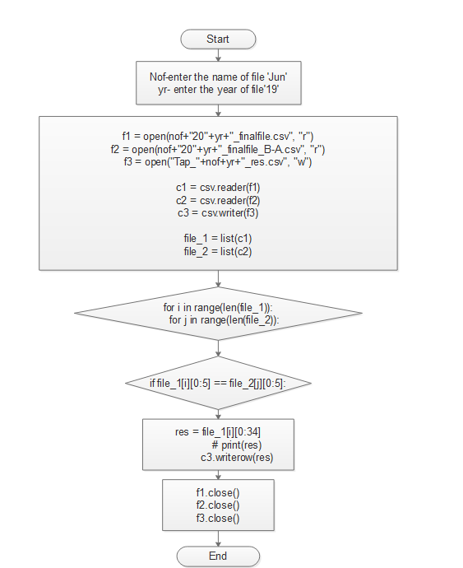

**Flow chart (prog 5):** to merge two files A-Tap file and B-month file.

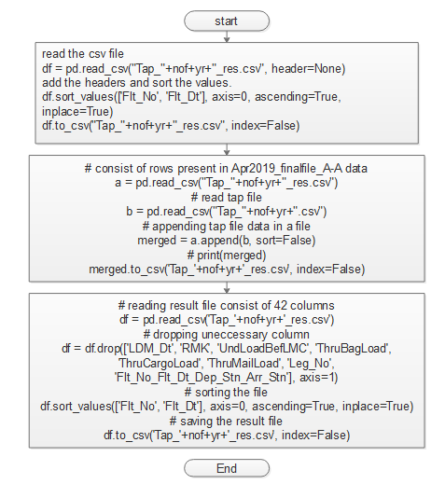

**Prog 7**: this program is to drop all the rows consist of RMK as ‘XXD’.

Input: Tap_file.

Output: Tap_file.

Module used: pandas

Working:

**import pandas as pd  
  
nof = input("Enter the name of file ", )  
yr = input("Enter the yr(only last 2 digits) ", )  
  
df = pd.read_csv("Tap_"+nof+yr+".csv")  
df = df[~df.RMK.str.contains("XXD")]  
df.to_csv("Tap_"+nof+yr+".csv", index=False)**

read the csv file and negate the rows using RMK column which Contains ‘XXD’ (as shown above) and store the data in csv.

**Prog 4:** this program is to extract similar rows using specific columns.

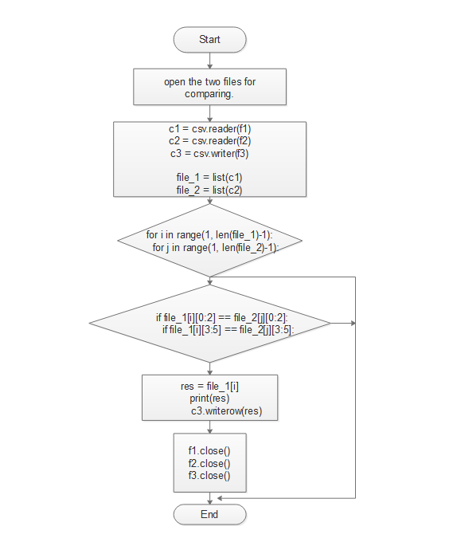

Input: Tap_file and month_finalfile

Output: res_mmyy.csv

Code:

Initially read csv file and make a list run a loop and the store the data in csv file.

**for i in range(1, len(file_1)-1):  
 for j in range(1, len(file_2)-1):  
 if file_1[i][0:2] == file_2[j][0:2]:  
 if file_1[i][3:5] == file_2[j][3:5]:  
 res = file_1[i]  
 print(res)  
 c3.writerow(res)**