E-Commerce Sales & Customer Analysis
Project Report
AICTE | IBM SkillsBuild - Data Analytics with AI Internship
Submitted by: Mayank Vashishath
Institution: Accurate Institute of Management & Technology Greater Noida
Date: September 2026

1. Project Overview
This project analyses e-commerce order data to understand sales performance, customer behaviour, and profitability, and to turn that analysis into clear, actionable business recommendations. The goal is to move from raw transaction data to an executive-level view: the key numbers that matter, the trends behind them, and what management should do next.
An interactive Streamlit dashboard was built on top of the analysis so that any of these questions can be explored by category, city, customer type, order status, or date range.

1.1 Objectives
- Clean and prepare the raw order data for analysis.
- Compute key business KPIs: total sales, profit, profit margin, delivery rate.
- Break down performance by category, product, city, customer type, and time period.
- Study the effect of discounts and payment methods on profitability.
- Generate actionable insights and Risk / Opportunity / Action recommendations.

2. Dataset Description
The dataset used is a synthetic e-commerce dataset generated with ChatGPT for this project, containing 1,000 orders across 14 columns, covering 291 customers, 25 products, 5 categories, and 8 Indian cities, for orders placed between January and December 2025.
Column | Description
Order_ID | Unique order identifier
Order_Date | Date of purchase (Jan-Dec 2025)
Customer_ID | Unique customer identifier (291 customers)
Customer_Type | New / Returning / Premium
Product | Product name (25 products)
Category | Electronics, Fashion, Sports, Beauty, Home & Kitchen
City | One of 8 Indian cities
Quantity | Units ordered
Unit_Price | Price per unit (INR)
Discount | Discount rate (0.0 - 1.0)
Payment_Method | UPI, Credit/Debit Card, Net Banking, COD
Sales | Original sales value
Profit | Profit amount
Order_Status | Delivered / Cancelled / Returned

2.1 Data Quality Check
Before analysis, the dataset was checked for missing values, duplicate rows, and invalid entries (negative quantity/price, out-of-range discount). The dataset was found to be clean: 1,000 rows, 0 missing values, 0 duplicate rows.

3. Data Cleaning & Feature Engineering
The following steps were applied to prepare the data for analysis:
- Removed exact duplicate rows and rows with missing critical fields.
- Converted Order_Date to a proper datetime type.
- Stripped extra whitespace from text columns.
- Clipped the Discount column to a valid 0-1 range.
- Removed rows with non-positive Quantity or Unit_Price.
New columns were then engineered for analysis:
- Calculated_Sales = Quantity x Unit_Price x (1 - Discount)
- Profit_Margin_% = (Profit / Calculated_Sales) x 100
- Year, Month, Month_Name, Quarter — extracted from Order_Date
- Revenue_Bucket — Low / Medium / High, based on sales terciles

4. Key Performance Indicators
The table below summarises the headline business metrics across all 1,000 orders.
Metric | Value
Total Orders | 1,000
Total Customers | 291
Total Products | 25
Total Sales | Rs 1,63,24,204
Total Profit | Rs 36,03,371
Average Order Value | Rs 16,324
Overall Profit Margin | 22.07%
Delivered Orders | 922 (92.2%)
Cancelled Orders | 50 (5.0%)
Returned Orders | 28 (2.8%)

5. Sales by Category and Product
Electronics is the clear leader, contributing over half of total sales, followed by Home & Kitchen and Sports. Fashion and Beauty have smaller sales volumes but the highest profit margins of all categories.
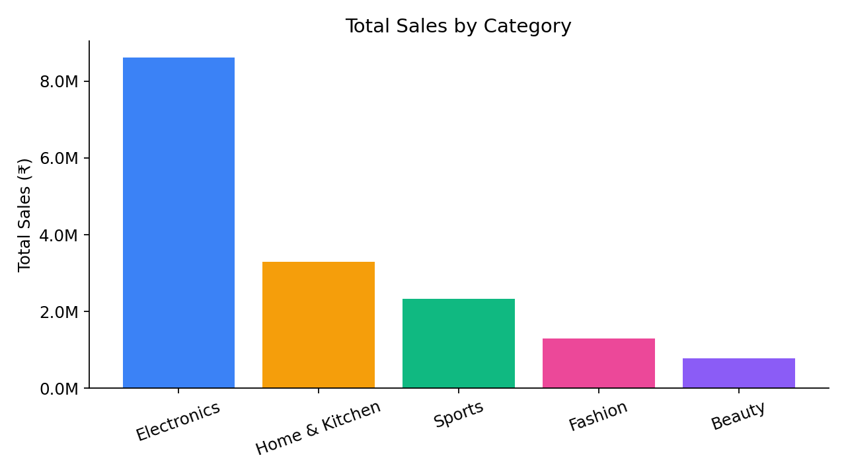
Figure 1: Total sales by category
At the product level, the Bluetooth Speaker is the best-selling individual product by total sales value.
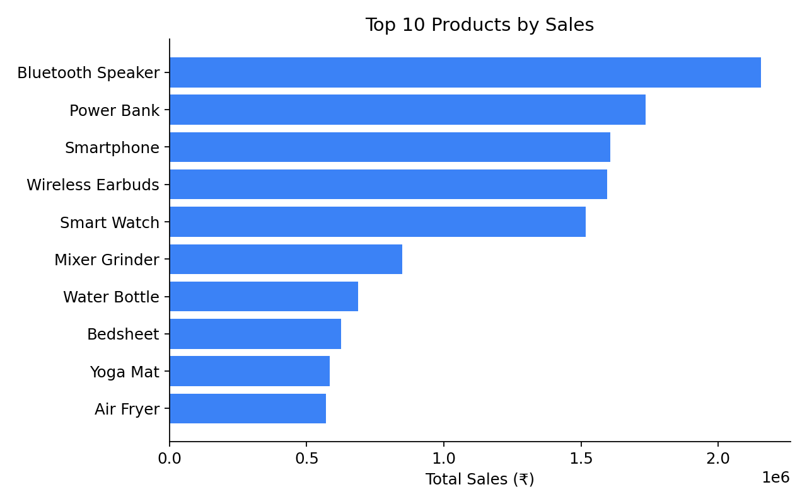
Figure 2: Top 10 products by sales

6. City-wise Performance
Bangalore and Mumbai are the top two cities by sales, closely followed by the other metros. This indicates a fairly even geographic spread of demand across the 8 cities in the dataset, with Bangalore holding a slight edge.
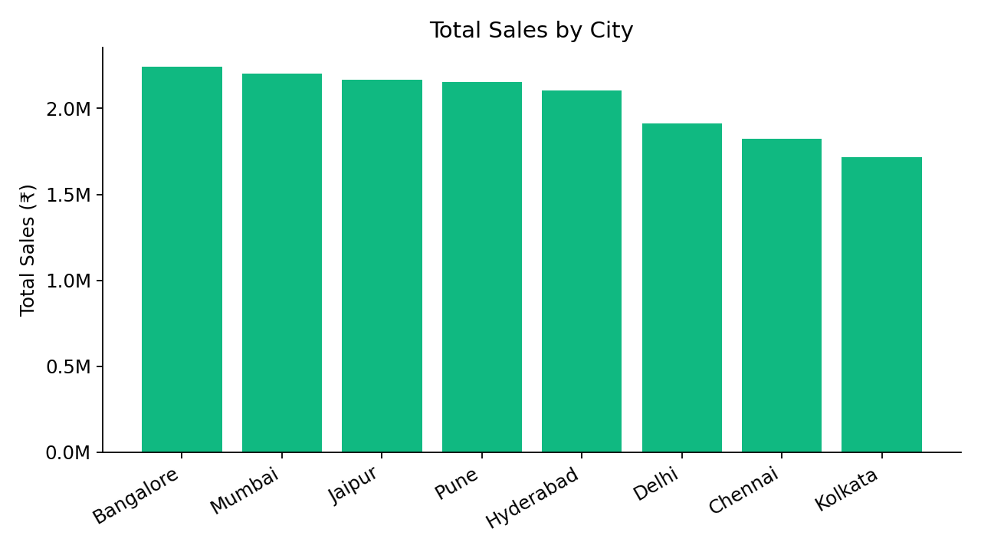
Figure 3: Total sales by city

7. Customer Segmentation
Customers are grouped into three types: New, Returning, and Premium. New customers currently contribute the largest share of sales, which highlights both strong customer acquisition and an opportunity to convert more first-time buyers into repeat, loyal customers.
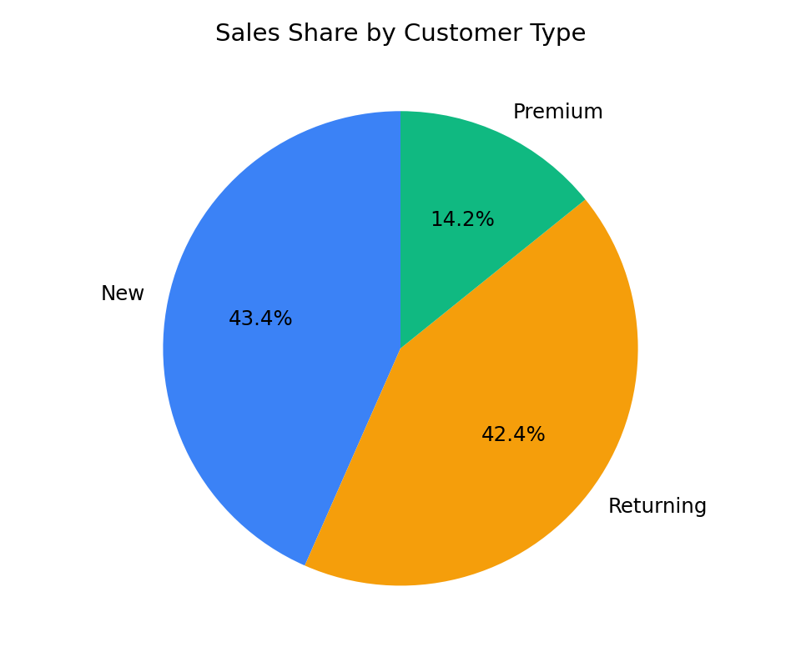
Figure 4: Sales share by customer type

8. Time Trends
Monthly sales were tracked across the full year to identify seasonality and growth patterns. The chart below plots total sales by month, which helps spot peak and low-demand periods for planning inventory and marketing campaigns.
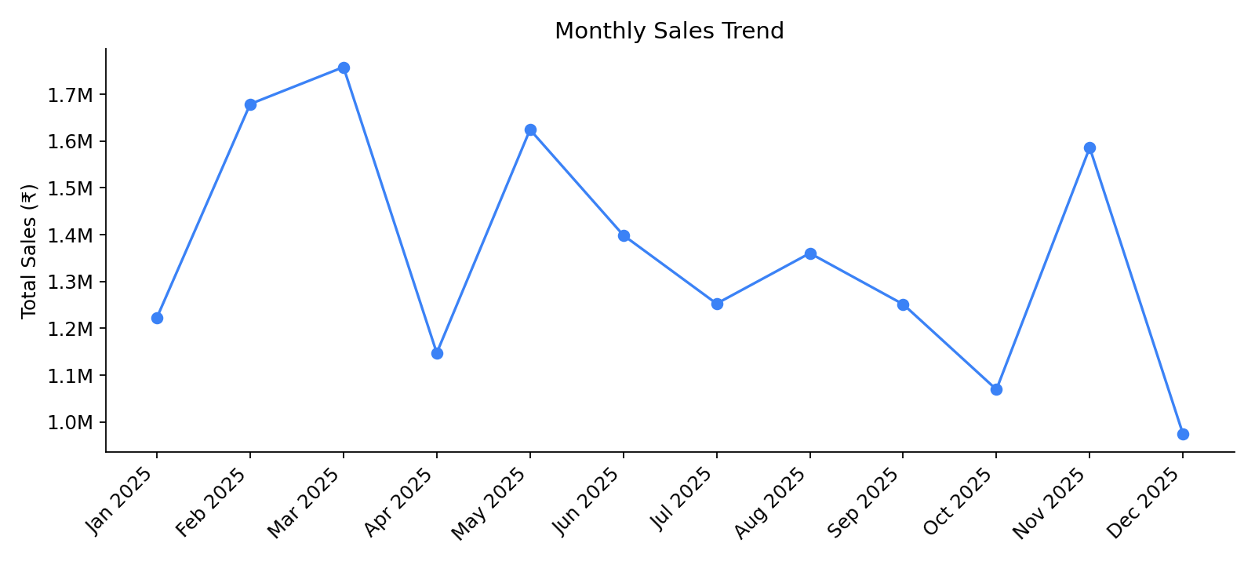
Figure 5: Monthly sales trend

9. Payments and Discounts
Orders are fairly distributed across the four available payment methods (UPI, Credit/Debit Card, Net Banking, COD), with digital payment methods together accounting for the majority of orders.
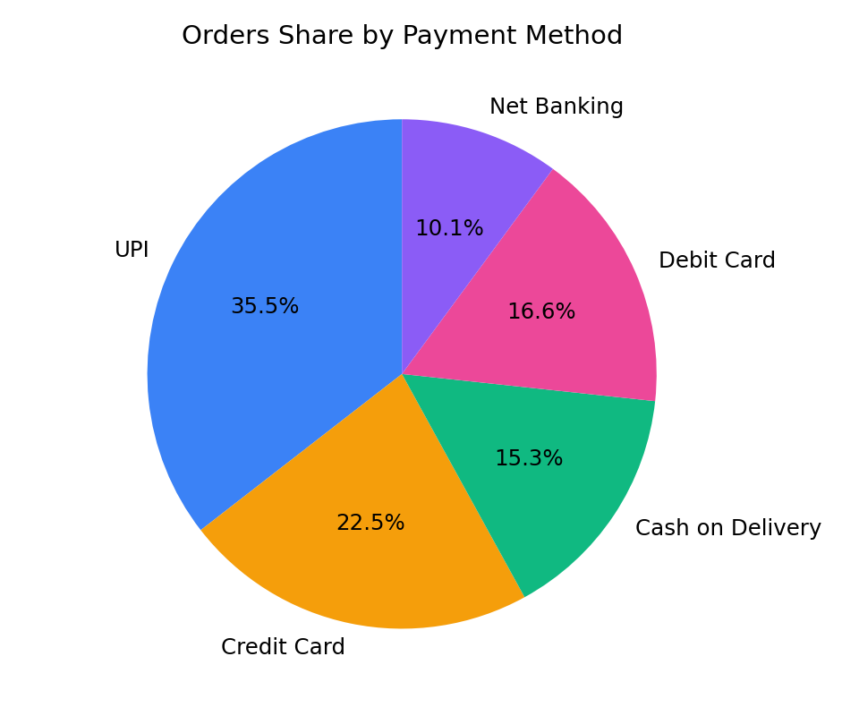
Figure 6: Orders share by payment method
The discount-impact analysis compares average profit margin across discount bands. Orders with little or no discount tend to carry healthier margins than heavily discounted orders, suggesting discounting strategy should be used selectively rather than broadly.
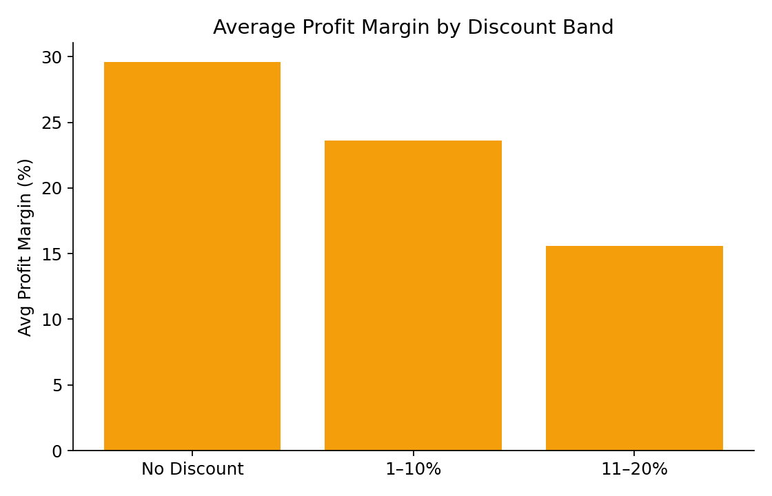
Figure 7: Average profit margin by discount band

10. Order Fulfilment
Of the 1,000 orders, 922 were successfully delivered (92.2%), 50 were cancelled (5.0%), and 28 were returned (2.8%). This gives an overall delivery rate that is healthy but leaves room to reduce cancellations and returns further.
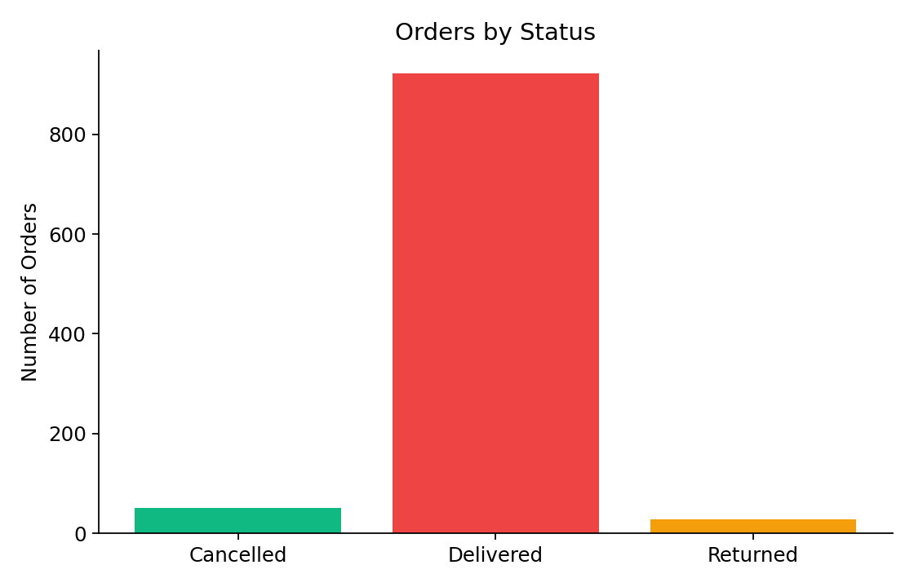
Figure 8: Orders by status

11. Business Insights
- Top Category: Electronics leads with Rs 86,12,558 in sales (21.7% margin).
- Low-Margin Category: Electronics also has the lowest profit margin among categories (21.7%) despite being the top seller — pricing and cost structure are worth reviewing.
- Top City: Bangalore generates Rs 22,41,955 in revenue, making it a key market to prioritise.
- Best Customer Segment: New customers account for Rs 70,84,123 in sales — the largest segment, and a strong target for retention efforts.
- Best-Selling Product: Bluetooth Speaker, with Rs 21,55,203 in sales across 114 units sold.
- Overall Profit Margin: 22.07% — a healthy margin that supports sustaining current pricing.

12. Risk, Opportunity & Action
Following a Risk -> Opportunity -> Action framework, the key findings translate into the following management view:
RISK — What could hurt the business?
Electronics drives the most revenue but has the lowest profit margin of all categories, and cancellations/returns together affect about 7.8% of orders — both put pressure on overall profitability.

OPPORTUNITY — Where could the business grow?
New customers already generate the largest share of sales, showing strong top-of-funnel acquisition that could be converted into repeat, higher-value Returning and Premium customers.

ACTION — What should management do?
Review Electronics pricing/costs to protect margin, launch a structured retention programme (offers, loyalty perks) targeted at New customers to convert them into Returning/Premium, and tighten discounting above 20% where it is eroding margin without a clear sales lift.

13. Interactive Dashboard
All analysis above is also available as a live, filterable Streamlit dashboard (see the Code File and README in this submission) with 8 tabs: Overview, Products & Categories, Locations, Customers, Time Trends, Payments & Discounts, Data Quality, and Insights. The dashboard lets a user filter by category, city, customer type, order status, and date range, and every chart updates accordingly.
[Optional: add 1-2 screenshots of your running dashboard here for extra credit — e.g. the Overview tab and the Insights tab.]

14. Conclusion
The analysis shows a healthy e-commerce business with a 22.07% overall profit margin and a 92.2% delivery rate. Electronics and the New customer segment are the biggest revenue drivers, while margin pressure in Electronics and a combined 7.8% cancellation/return rate are the main areas for improvement. Acting on the retention opportunity for New customers and tightening discount strategy are the two highest-leverage next steps for the business.

15. Technology Stack
- Python 3.10+
- pandas, NumPy — data cleaning and analysis
- Streamlit — interactive dashboard
- Plotly — charts and visualisations

