LA28 Mobility Study –
Transit Accessibility Analysis
StoryMap: https://storymaps.arcgis.com/stories/6e690c5e505e457e94f92770d6d8a03b

1. Project Motivation and Research Question
Los Angeles will host the 2028 Olympic and Paralympic Games. LA Metro and the LA28 organizing committee have framed the event as a "transit-first Olympics," tying it to the Twenty-Eight by '28 program: a package of 28 major transit projects—rail extensions, bus rapid transit, and connectivity hubs—targeted for completion before the Games. These investments include the D Line (Purple) subway extension to Westwood, the A Line Foothill extension toward Pomona, a new LAX transit center, and numerous bus and first-/last-mile improvements.
Despite this activity, a central question remains:
How much and where do these projects actually improve access to transit across Los Angeles County, particularly around 2028 Olympic venues?
The goal of this project is to provide a spatial, before-and-after assessment of transit accessibility using Geographic Information Systems (GIS), focusing on the change between the existing 2024/2025 network and the planned 2028 network.

2. Data and Symbology
The analysis uses GIS data from LA City GeoHub (census tracts, current Metro lines) and LA Metro developer resources for proposed 2028 projects – an already present GIS experience to toggle into new lines over a spatial interface via their website, supplemented by a point layer of LA28 Olympic venues, as planned in August 2025.
Two key visualizations drive the story:
Kernel Density (KD) accessibility improvement
- 2028 scenario – 2025 scenario. The ArcGIS project has all used maps, and datasets.
- Color ramp: dark blue = high accessibility changes, fading to white = no accessibility changes.
- These rasters show transit "reach" around the network’s new additions and upgrades.
Census tract improvement map
- Tracts classified by mean change in KD value (delta 2028, 2025).
- Color ramp: dark blue = high improvement, light blue = none.
Context layers are consistent across maps:
- Magenta lines — 2025 Metro network.
- Pink lines — 2028 improvement projects (rail, bus, last-mile).
- Purple squares — Olympic venues planned for 2028.
This consistent symbology makes it easy for readers to track how new pink lines translate into dark-blue accessibility gains and where those gains overlap Olympic venues.

3. Methods: How the Analysis Was Done
The workflow follows standard raster GIS practice, adapted from the ArcGIS Pro tutorial's Kernel Density examples.

Scenario definition
- Built a 2025 baseline polyline layer from existing Metro and bus routes.
- Built a 2028 improvements layer by merging baseline lines with all planned extensions and priority corridors.

Kernel Density Estimation (KDE)
- Converted both line networks to points (one point per line feature) to approximate stop locations.
- Ran Kernel Density twice (2025 and 2028) with a search radius of 800 meters, representing a 10–15-minute walk to transit.
- Output rasters share a 100-ft cell size and common extent/mask (LA City census tracts), ensuring comparability.

Delta (change) raster
- Used Raster Calculator to compute: ```KD_delta``` = ```KD_2028``` − ```KD_2025```
- Positive values indicate improved access; zero indicates no change.

Tract-level summarization
- Ran Zonal Statistics as Table with census tracts as zones and KD_delta as the value raster.
- Joined mean delta values back to the tract layer and classified tracts into None, Low, Low-Medium, Medium, High improvement.

Metrics
- Counted total tracts in the study area = 1273
- Counted tracts with mean delta > 0 (any improvement) = 68
- Counted tracts in each improvement class (especially Medium and High); Medium Improvement = 12, High Improvement = 10
- Calculated the corresponding percentages of all tracts
- These numbers are reported as: 1273 tracts, 68 tracts (≈ 0.05% of all tracts), 22 significantly improved tracts post 2028 project completion (≈ 32% of improved tracts).
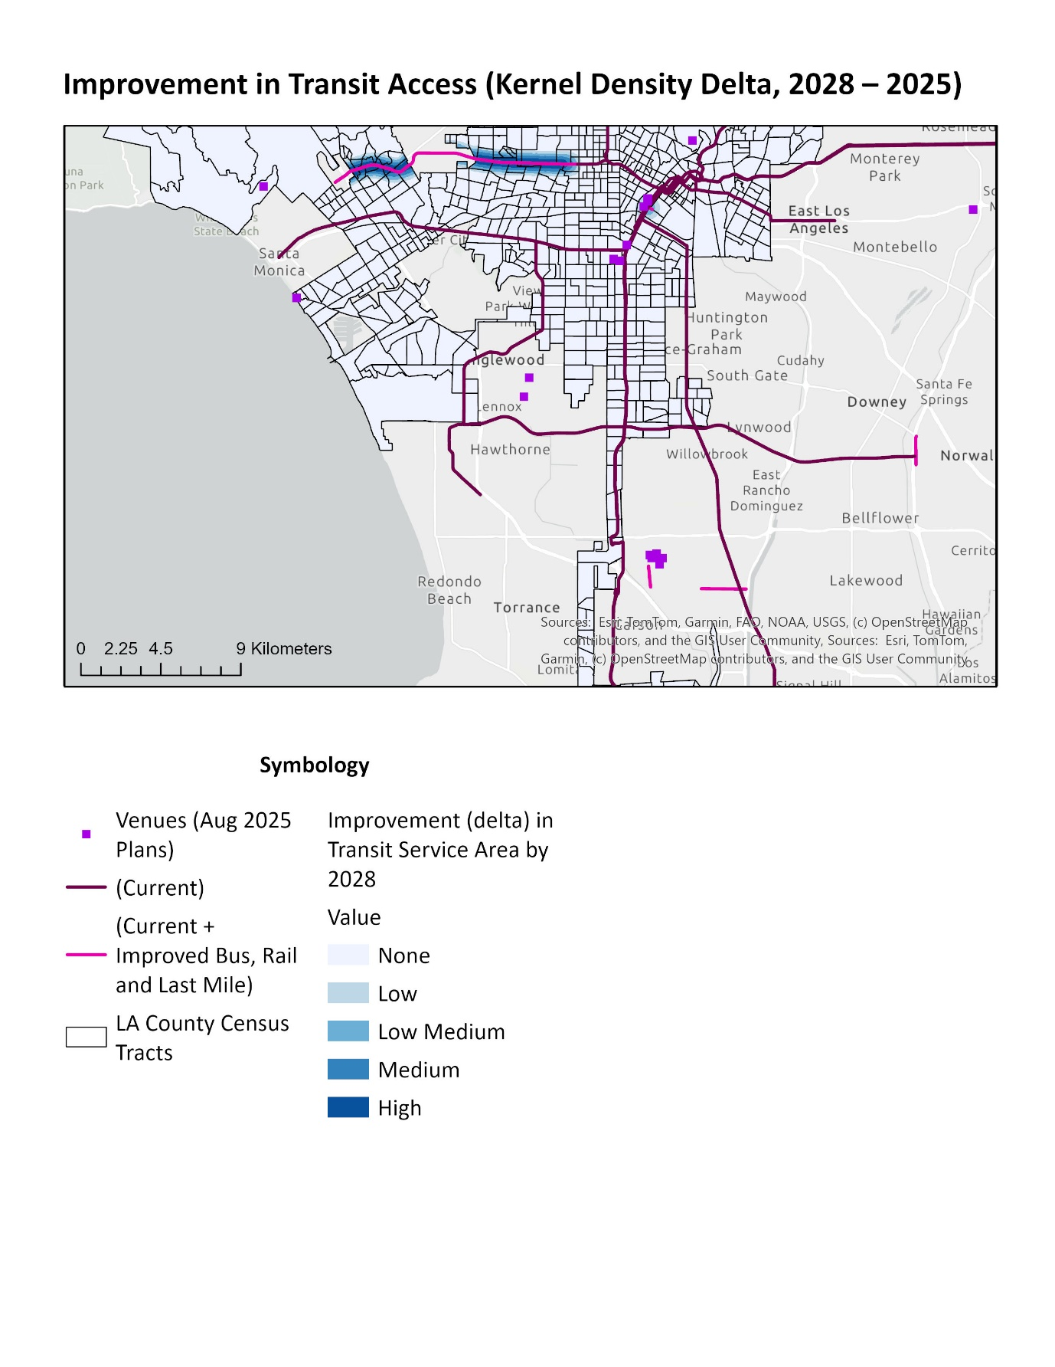

4. Why This Matters
From a planning and policy perspective, this analysis supports three key questions:
Are Olympic-driven projects aligned with long-term equity goals?
Many 2028 investments have been marketed as legacy projects that improve mobility for residents in underserved neighborhoods, not just visitors. Mapping accessibility change helps verify whether benefits align with those claims.
Where should complementary investments go?
KD delta highlights corridors where new rail or BRT creates large access gains, but also reveals holes—areas that remain white even after 2028. These become candidates for additional bus routes, first-/last-mile connections, and future transit lines.
How do venues fit into the network?
Because Olympic venues are explicit in the map (purple squares), planners and the public can see which are well served by magenta and pink lines and which still depend heavily on driving or specialized shuttle services.
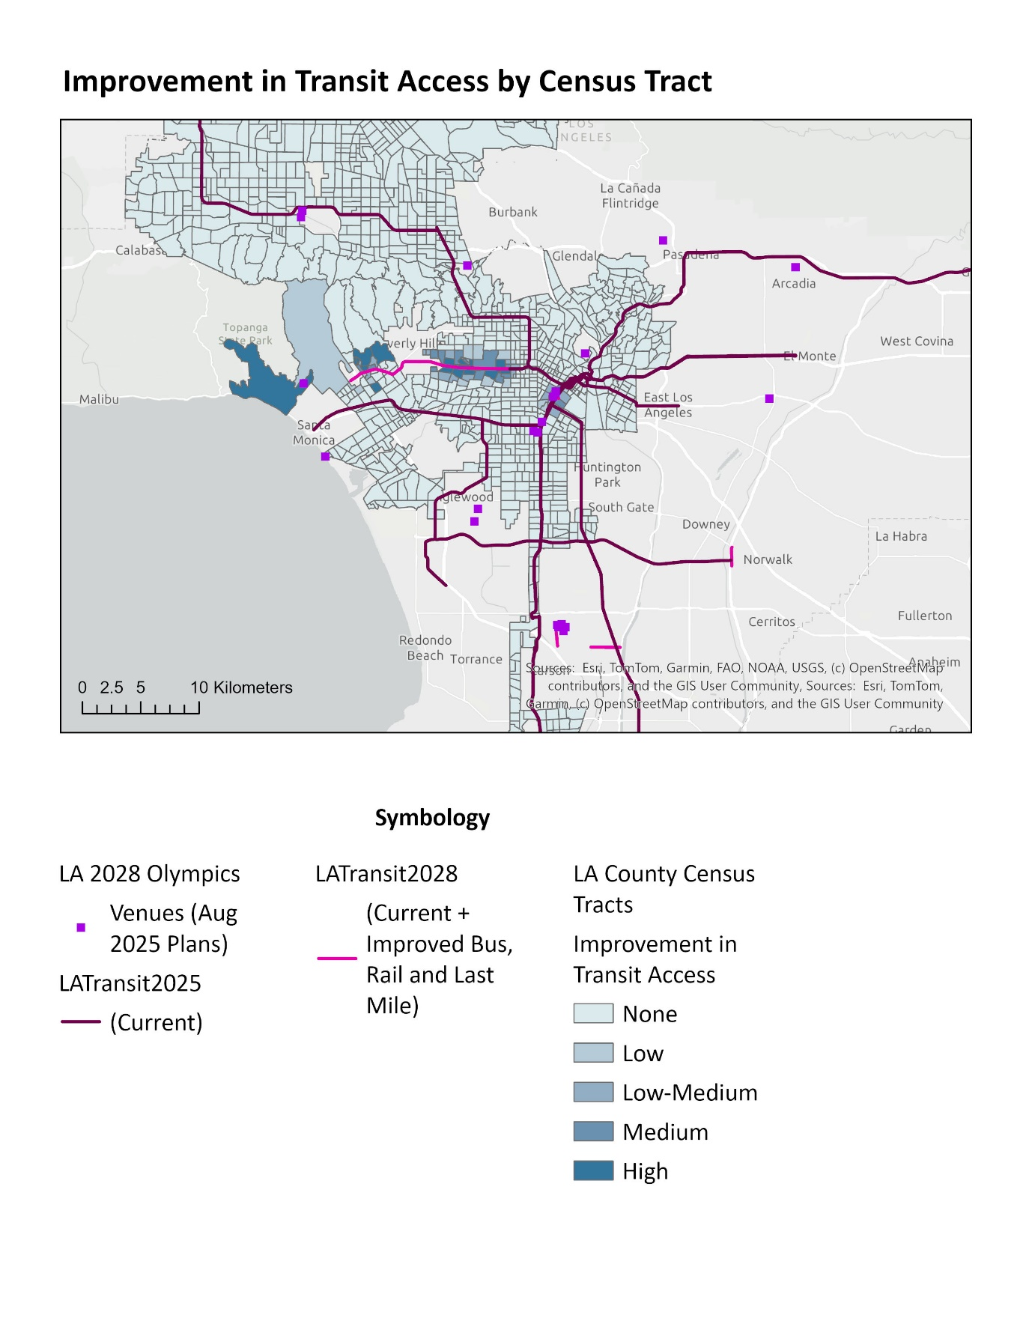

5. Key Findings
Strongest gains follow new rail corridors.
Dark-blue KD improvements cluster along the D Line subway extension toward Westwood. This matches Metro's stated priorities.
Many improved tracts are in previously underserved areas.
Medium and high-improvement tracts concentrate around the newer lines being built. This supports the argument that 2028 investments have an system-upgrade, not white-elephant dimension, even though the analysis here does not yet weight by population.
Olympic venues benefit unevenly.
Venues in Westwood, Downtown, and Inglewood sit within or adjacent to dark-blue improvement corridors, indicating strong new transit options. Others, especially more peripheral or coastal sites, remain on the network's fringe and will still require shuttles, water taxis, or significant bus augmentation to be truly "transit-first."
Large areas still see little change.
Even with an ambitious build-out, wide swaths of the region—particularly low-density suburbs and southern neighborhoods—remain white or light blue. This reinforces the reality that one Olympic investment cycle cannot fully overcome LA's auto-oriented urban form.

6. Limitations
The study has several important caveats:
Proximity, not performance.
Kernel Density encodes distance to transit, not frequency, speed, or reliability. A tract classified as "high improvement" may still have infrequent or overcrowded service.
Tracts, not people.
Due to data and time constraints, the project reports tract-based metrics, not population-weighted counts. A tract of 50,000 residents is treated the same as one with 5,000. Future work should multiply mean delta by population to estimate how many people benefit.
Scenario uncertainty.
The 2028 network is based on current plans and public timelines; real-world delays, budget constraints, or scope changes could shift actual accessibility outcomes after 2028.

7. Conclusion
This project demonstrates that GIS-based Kernel Density analysis can turn complex transit plans into an intuitive, before-and-after accessibility story:
- Dark-blue KD surfaces reveal where transit access is strongest.
- Dark-blue census tracts show who benefits most from new lines.
- Purple venues and pink/magenta lines tie the maps directly to LA28 and Metro's Twenty-Eight by '28 program.
The results suggest that 2028 investments substantially expand transit access along key corridors and appear to prioritize many previously underserved neighborhoods, while still leaving notable gaps. As LA approaches the Games, analyses like this can help ensure that costly Olympic-driven projects deliver on their promise of a lasting, equitable mobility legacy rather than a one-time spectacle.

References
4 biggest L.A. transit projects being built for the 2028 Olympics. Secret Los Angeles. (2025, May 12).4 biggest L.A. transit projects being built for the 2028. https://secretlosangeles.com/la-transit-projects-olympics/
Basics: The Spacing of Stops and Stations. Human Transit. https://humantransit.org/2010/11/san-francisco-a-rational-stop-spacing-plan.html
California Transportation Commission. (2025, August 13). Metro 2028 Games mobility concept plan [PDF]. https://catc.ca.gov/-/media/ctc-media/documents/ctc-meetings/2025/2025-08/pinks-and-presentations/tab-21-4-22-pres-a11y.pdf
Census tracts, Los Angeles County. LA City GeoHub. (2025). https://geohub.lacity.org/datasets/lacity::census-tracts-2020/about
Cronkite News. (2024, October 3). LA Metro upgrades will support 'transit-first' 2028 Olympics. Arizona PBS. https://cronkitenews.azpbs.org/2024/10/03/la-metro-upgrades-sustainable-2028-olympics-los-angeles/
Developer resources & Experience. Los Angeles County Metropolitan Transportation Authority. (2025). https://thesource.metro.net/new-metro-gis-map-to-show-mobility-preparations-for-olympics-and-paralympics/
Fullerton Observer. (2025, October 16). 1,000 days to go, LA Metro powers ahead toward America's Games. https://fullertonobserver.com/2025/10/17/1000-days-to-go-la-metro-powers-ahead-toward-americas-games/
LA28 transportation updates. LA28 Organizing Committee. (2025). https://www.metro.net/2028games/
Metro Network, Los Angeles data. LA City GeoHub. (2025). https://geohub.lacity.org/datasets/lacounty::mta-metro-lines-1/about

