ASTQ — Advanced Software Testing and Quality Assurance Platform
Project Report for Evaluation (Version 1.0)
Nimish Vashishtha — B.Tech CSE (Third Year) | Add: co-authors, roll numbers, guide, institution
19 October 2026

Abstract
Students usually run unit tests, API checks, browser tests and load tests with different tools in different terminals, so results are scattered and hard to demonstrate. ASTQ is a Flask web application that gives these activities one home. A user opens a dashboard, chooses an approved test suite, and launches it; ASTQ runs it in a separate, time-limited process, stores the lifecycle and normalised pass/fail/error/skipped counts in SQLite, keeps logs and reports, and shows history and details. A REST API exposes the same operations. The platform ships with a controlled demo e-commerce application as the system under test, 79 automated tests for ASTQ itself (93 % line coverage), a Selenium page-object suite, a JMeter baseline, and a GitHub Actions pipeline.

1. Introduction

1.1 Problem statement
Tests are launched with different commands, results vanish in terminal output, and a demonstration shows execution but not a persistent record (PRD §4). A small, understandable platform is needed that makes automated testing easy to run, understand and demonstrate.

1.2 Objectives (PRD §2)
- One place to discover and launch registered test suites.
- Persist run history and make outcomes easy to inspect.
- Integrate UI, API, unit/regression and basic performance testing tools.
- Demonstrate modular design, REST APIs, automated tests, version control and CI.
- Keep the first release small enough for a third-year project.

1.3 Scope
In scope: Flask dashboard, SQLite persistence, suite catalogue, controlled subprocess execution, Pytest + JUnit parsing, history/detail pages, log/report links, REST endpoints, unit/API tests, CI, Selenium page objects, optional JMeter baseline. Out of scope: multi-tenant SaaS, distributed grid, arbitrary user-supplied test code, testing of external targets, roles/enterprise features, production deployment.

2. Requirement analysis

2.1 Users
Student developer (primary), project teammate (secondary), evaluator/mentor (reviews evidence).

2.2 Functional requirements (FR-01 … FR-14)
Implemented as specified in the PRD; the mapping to code and tests is in Chapter 7 and in docs/evaluation-guide.md.

2.3 Non-functional requirements
Usability, performance (non-blocking runs), reliability (runner failure cannot crash the app), security (allow-list, validation, CSRF, no secrets in git, restricted targets), maintainability (modular monolith), portability, accessibility (semantic HTML, skip link, focus outlines, labelled controls, status text + colour).

3. System design

3.1 Architecture
A modular monolith with five layers (SDD §5):
Layer | Package | Responsibility
Presentation | app/templates, app/static, app/routes | pages and API; routes stay thin
Application | app/services | validate, create runs, dispatch, finalise status, safe artifact access
Execution | app/execution | command registry (allow-list), subprocess runner, demo-app launcher
Parsing / reporting | app/parsers, app/reporting | JUnit & JMeter normalisation, dashboard metrics
Persistence | app/models, SQLite | TestSuite, TestRun
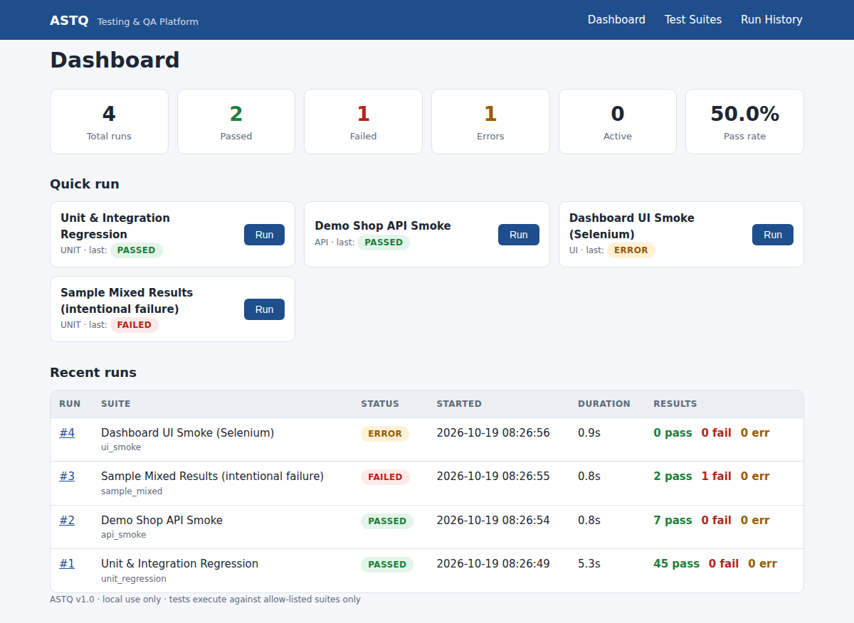
Dashboard

3.2 Data model
TestSuite: id, suite_key (unique), name, description, suite_type (UI/API/PERFORMANCE/UNIT), enabled, created_at, updated_at.
TestRun: id, suite_id (FK), status, requested_by, created_at, started_at, finished_at, duration_seconds, return_code, passed/failed/error/skipped counts, summary, error_kind, log_path, report_path. One suite has many runs. Artifact paths are stored relative to the artifact root; the browser only receives URLs, never filesystem paths.

3.3 Execution workflow (SDD §9)
- User/API requests a suite_key.
- The route validates the request and calls run_service.
- A QUEUED row is committed before anything runs.
- A worker thread marks it RUNNING.
- The runner executes the allow-listed argument list with a timeout; stdout/stderr go to files in artifacts/runs/<id>/.
- The parser normalises the counts.
- The status rules below are applied and the terminal state is committed (guarded by a last-resort exception handler).
- The page auto-refreshes and shows the result.
Status rules (documented as required by SDD §12)
Situation | Status / error_kind
spawn failure, timeout, missing/malformed result file, target not authorised | ERROR — SPAWN_ERROR, TIMEOUT, PARSE_ERROR, TARGET_NOT_AUTHORIZED
any failed or errored test | FAILED
non-zero exit without a failing test (e.g. nothing collected) | ERROR — NONZERO_EXIT
tests collected but all skipped | ERROR — NO_TESTS_EXECUTED
otherwise | PASSED
application restarted mid-run | ERROR — INTERRUPTED
The all-skipped → ERROR rule was added after the live run showed the Selenium suite reporting a pass while no browser was available; a green result that verified nothing is misleading (PRD §12 “report integrity”).

3.4 API
Six endpoints (/api/health, /api/suites, /api/suites/<key>, POST /api/runs → 202, /api/runs, /api/runs/<id>) with uniform JSON errors — see docs/api-specification.md.

4. Security design
Threat | Control | Evidence
Command injection | Browser sends only suite_key, validated by regex ^[a-z0-9_]{1,64}$; commands are server-side tuples; shell=False | test_create_run_rejects_invalid_keys, test_registry_commands_are_argument_tuples_not_shell_strings
Testing unauthorised targets | DEMO_BASE_URL must be loopback unless ALLOW_REMOTE_TARGETS=true | test_loopback_targets_authorised_remote_not, test_unauthorised_target_blocks_run
Path traversal / symlink escape | allow-listed artifact names + resolve() + relative_to(root) | test_safe_join_blocks_traversal, test_resolve_artifact_rejects_symlink_escape, test_artifact_route_blocks_traversal_and_unknown
CSRF on browser forms | per-session token required on all non-API POSTs | test_form_post_without_csrf_rejected
Malicious generated report | served with Content-Security-Policy: sandbox allow-scripts, nosniff | app/routes/runs.py
Runaway process | timeout + process-group kill; concurrency cap | test_timeout_is_error_and_app_survives
Secret leakage | .env git-ignored, .env.example placeholders only | .gitignore
Internal detail leakage | suite API excludes command config | test_list_suites_exposes_safe_metadata_only

5. Implementation

5.1 Technology
Python 3.12, Flask 3, Flask-SQLAlchemy/SQLAlchemy 2, Flask-Migrate (ready for schema changes), python-dotenv, Pytest + pytest-html + pytest-cov, Requests, Selenium 4, Apache JMeter (external), Ruff, GitHub Actions. About 2,100 lines of Python across app/, tests/, demo_app/, scripts/.

5.2 Repository layout
Follows the agreed structure (app/, tests/{unit,integration,api,ui}, demo_app/, performance/, scripts/, docs/, artifacts/, .github/workflows/). Additions: app/execution/demo_launcher.py, app/templates/_macros.html, error.html, tests/fixtures, tests/samples, docs/evidence, docs/screenshots, scripts/set_suite_enabled.py.

5.3 Notable design decisions
- Thread pool instead of Celery/RQ – a pool sized by MAX_CONCURRENT_RUNS is enough for a local MVP and keeps setup trivial; the service boundary (dispatch) isolates the change to a durable queue.
- Queued/Running rows are closed on restart instead of left forever “running”.
- Demo app auto-start – suites that need a target start the bundled app on demand and stop it afterwards.
- Report integrity – the UI shows “counts not available” rather than zeros when parsing fails.
- Sample failing suite – lets evaluators see failure evidence on demand without breaking CI (excluded from default testpaths).

6. Testing summary
Full details in docs/test-plan-and-report.md. Headline results (19 Oct 2026, Python 3.12, Linux):
Level | Tests | Result
Unit | 38 | all passed
Integration (real subprocess runs) | 7 | all passed
API (ASTQ endpoints 27 + demo shop smoke 7) | 34 | all passed
Core total | 79 | 79 passed, 0 failed, 93 % line coverage
Selenium UI | 3 | skipped — no chromedriver in build environment
JMeter baseline | — | not executed — JMeter not installed in build environment
Live dashboard run (4 suites) | — | unit 45/45 ✔, API 7/7 ✔, sample 2✔ 1✘ 1⏭ (expected), UI → ERROR NO_TESTS_EXECUTED (expected without driver)
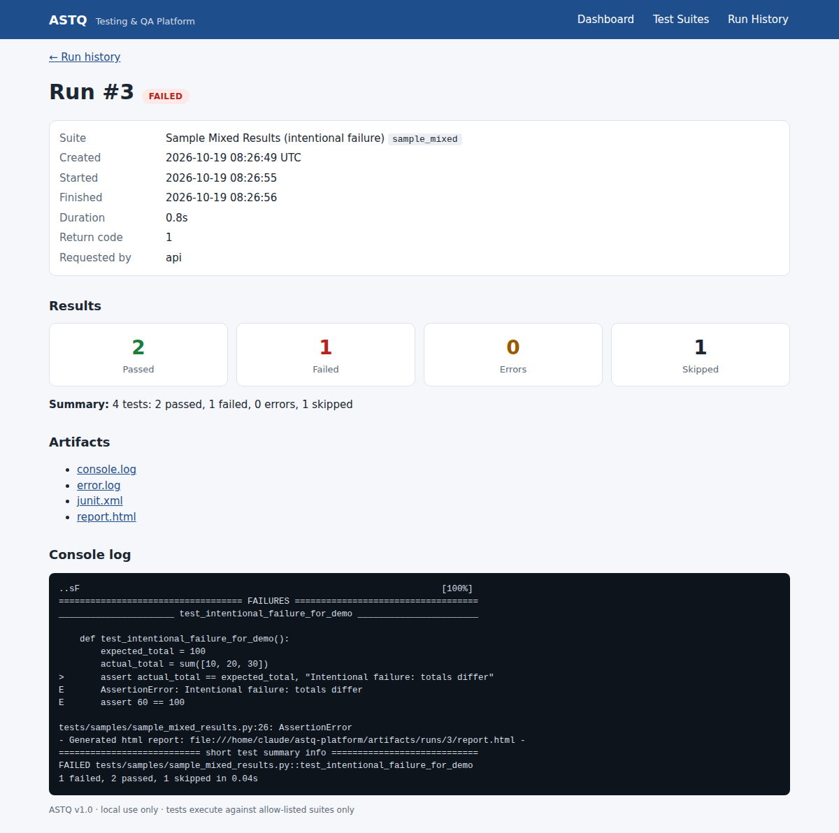
Failed run with evidence

7. Requirements traceability
Req. | Implementation | Verified by
FR-01 Dashboard | routes/dashboard.py, reporting/summary_builder.py | test_pages_render, UI test_dashboard_loads_with_heading
FR-02 Suite catalogue | services/suite_service.py, suites.html | test_list_suites_…, UI test_suite_catalogue_…
FR-03 Start run | routes/suites.py, services/run_service.start_run | test_post_run_returns_202…, test_form_post_with_csrf…
FR-04 Safe execution | execution/command_registry.py, runner.py | registry tests, invalid-key tests
FR-05 Lifecycle | run_service.execute_run | test_passing_suite_end_to_end, test_background_thread_dispatch…
FR-06 Summary counts | parsers/* | parser tests, e2e tests
FR-07 History + filters | list_runs, run_history.html | test_run_history_filters_and_pagination
FR-08 Run detail | run_detail.html | test_failing_suite_is_failed_not_error…
FR-09 Artifacts | report_service.py, artifact route | path-safety tests
FR-10 REST API | routes/api.py | 27 API tests
FR-11 Error handling | determine_status, error_kind | 8 status tests, timeout / parse / spawn e2e tests
FR-12 Automated tests | tests/ | 79 tests
FR-13 CI | .github/workflows/tests.yml | workflow (runs on push/PR once pushed to GitHub)
FR-14 Documentation | README.md, docs/ | this report

8. Limitations and risks (honest assessment)
- Selenium UI suite not executed here – the page objects and tests are written and skip cleanly, but the build environment had Chromium and no matching chromedriver. Run on a machine with Chrome/driver (or in GitHub Actions) before presenting.
- JMeter baseline not executed here – JMX is well-formed and the parser is unit-tested on a fixture; run once locally.
- GitHub Actions workflow not executed – it mirrors the commands that pass locally.
- Single-user, no authentication – acceptable for local MVP; add auth/CSRF-hardening before exposing it.
- In-process workers – queued runs do not survive a restart (they are closed as INTERRUPTED).
- Coverage gaps (93 % overall): demo-app launcher branches, a few error paths in the route layer.

9. Future enhancements
Authentication/roles; scheduled and repeated runs with comparison; coverage visualisation; notifications; PostgreSQL; RQ/Celery; Docker Compose; more adapters (e.g. Playwright, k6); report export; screenshot serving for UI failures.

10. Conclusion
All MVP items in the PRD’s Definition of Done are met and demonstrable: clean checkout starts, SQLite initialises, five suites are registered (four enabled), runs execute outside the request thread, status/results persist, logs and reports are reachable, core tests pass, and the README explains setup, architecture, API, limitations and demo steps. The remaining verification items (Selenium, JMeter, GitHub Actions) are clearly identified above.

Appendix A — Definition of Done checklist (PRD §18)
Item | Status
Clean checkout can start the app | ✔
SQLite initialises | ✔
≥ 2 suites appear | ✔ (5)
User can start a suite | ✔
Execution outside request thread | ✔ (tested)
Status and results persist | ✔
Logs/reports accessible | ✔
Unit/API tests run in CI | ✔ workflow provided; ⚠ not yet run on GitHub
README (setup, architecture, endpoints, limitations, demo steps) | ✔

Appendix B — Test Plan and Test Report
Version: 1.0 · Executed: 19 Oct 2026 · Environment: Linux, Python 3.12.3, Flask 3.1, pytest 9.1, SQLite

1. Test strategy (SDD §14)
Level | Purpose | Location | Tooling
Unit | validation, status rules, parsers, path safety, registry safety | tests/unit | pytest
Integration | route → service → runner → parser → DB with real subprocesses and a temp DB | tests/integration | pytest, Flask test client
API | ASTQ endpoints, error format, CSRF, pages; plus demo-shop smoke with Requests | tests/api | Flask client, Requests
UI | dashboard journeys via page objects | tests/ui | Selenium 4 (headless Chrome)
Performance | small authorised baseline | performance/baseline.jmx | JMeter
Entry: clean checkout, dependencies installed. Exit: all core tests pass; no open High defects. Isolation: every test uses a temp SQLite file and temp artifact dir; ports are chosen dynamically.

2. Results — core suite (evidence: docs/evidence/)
Level | File | Tests | Passed | Failed
Unit | test_junit_parser.py | 10 | 10 | 0
Unit | test_run_service.py | 28 | 28 | 0
Integration | test_run_flow.py | 7 | 7 | 0
API | test_api_endpoints.py | 27 | 27 | 0
API (demo shop) | test_demo_api.py | 7 | 7 | 0
Total |  | 79 | 79 | 0
Duration ≈ 7 s. Lint: ruff check . → All checks passed.

Coverage (pytest-cov, app/)
93 % overall (679 statements, 50 missed). 100 %: config, registry, models, summary builder, API/dashboard routes. Lowest: demo_launcher.py 50 % (auto-start branches, exercised only in live runs), suites.py 80 %, jmeter_parser.py / suite_service.py 90 %.

3. Test case catalogue (selected)
ID | Case | Expected | Result
TC-01 | GET /api/health | 200 {"status":"ok"} | Pass
TC-02 | List suites | only safe metadata, no command | Pass
TC-03 | POST /api/runs valid key | 202 + run id, status QUEUED | Pass
TC-04 | POST /api/runs with bad key; rm -rf / | 400 INVALID_SUITE_KEY | Pass
TC-05 | POST unknown suite / disabled suite | 404 / 409 | Pass
TC-06 | Run passing pytest suite end-to-end | PASSED, counts 2/0/0/0, rc 0, artifacts | Pass
TC-07 | Run failing suite | FAILED (not ERROR), logs show assert 1 == 2 | Pass
TC-08 | Command exceeds timeout | ERROR/TIMEOUT, process killed, app still healthy | Pass
TC-09 | Tool produced no JUnit XML | ERROR/PARSE_ERROR, counts null | Pass
TC-10 | Command binary missing | ERROR/SPAWN_ERROR | Pass
TC-11 | Remote DEMO_BASE_URL | ERROR/TARGET_NOT_AUTHORIZED | Pass
TC-12 | POST returns while run still active | < 1.5 s, status QUEUED/RUNNING then terminal | Pass
TC-13 | All tests skipped | ERROR/NO_TESTS_EXECUTED | Pass
TC-14 | Artifact route with ..%2F..%2Fconfig.py, unknown name, symlink escape | 404 / None | Pass
TC-15 | Form POST without CSRF token | 400 | Pass
TC-16 | History filters + pagination + invalid status | correct totals; 400 | Pass
TC-17 | Restart with QUEUED run | ERROR/INTERRUPTED | Pass
TC-18 | JUnit/JTL parsers: valid, empty, malformed, inconsistent | counts / ParseError | Pass

4. Live system test (through the real server, python run.py)
Runs were started via the REST API and inspected via API and browser.
Run | Suite | Status | Counts (pass/fail/err/skip) | Notes
1 | unit_regression | PASSED | 45 / 0 / 0 / 0 | ~5 s
2 | api_smoke | PASSED | 7 / 0 / 0 / 0 | demo app auto-started and stopped
3 | sample_mixed | FAILED | 2 / 1 / 0 / 1 | expected: intentional failure, assertion visible in log + HTML report
4 | ui_smoke | ERROR (NO_TESTS_EXECUTED) | 0 / 0 / 0 / 3 | expected: no chromedriver here
– | performance_baseline | rejected 409 SUITE_DISABLED | – | expected: opt-in
Screenshots: docs/screenshots/ (dashboard, suites, history, passed and failed run detail).

5. Defects found and fixed during testing
# | Finding | Fix
D-1 | Selenium suite showed PASSED with 0 passed / 3 skipped (misleading green) | new rule NO_TESTS_EXECUTED → ERROR, test TC-13
D-2 | Skip count glyph did not render in the results column | replaced symbols with text labels (pass/fail/err/skip)
D-3 | Stale RUNNING rows after restart would stay forever | recover_interrupted_runs() + test TC-17

6. Not executed in the build environment (must be verified before evaluation)
Item | Why | How to verify
Selenium UI tests (3) | Chromium present but no chromedriver; tests skip cleanly | install Chrome + matching driver, or set CHROME_BIN / CHROMEDRIVER_PATH, then pytest tests/ui -v or press Run on ui_smoke — expect 3 passed
JMeter baseline | JMeter not installed | install JMeter 5.6.x, python scripts/set_suite_enabled.py performance_baseline on, run from dashboard — expect 100 samples, 0 failed
GitHub Actions | repository not pushed | push; workflow runs automatically

7. Conclusion
The core platform meets its acceptance criteria: 79/79 automated tests pass at 93 % coverage and a live end-to-end run demonstrates launch → persisted status → counts → logs/report for passing, failing and errored suites.

Appendix C — Evaluation Guide

1. 10-minute demo script
Min | Action | What the evaluator sees
0–1 | pip install -r requirements.txt -r requirements-dev.txt → python run.py → open http://127.0.0.1:5000 | app starts from a clean checkout, DB auto-created
1–2 | Dashboard | totals, pass-rate, quick-run buttons, recent runs
2–3 | Test Suites | 5 suites, types, enabled state; performance suite disabled
3–4 | Run Unit & Integration Regression | status QUEUED → RUNNING → PASSED (page auto-refreshes), ≈45 tests
4–5 | Run Demo Shop API Smoke | demo app auto-starts; 7/7 pass
5–7 | Run Sample Mixed Results | FAILED: 2 pass / 1 fail / 1 skip; open console log (assertion text) and report.html (use case B)
7–8 | Run History with filters (status=FAILED, suite) | persisted history (use case C)
8–9 | Terminal: curl -X POST localhost:5000/api/runs -H 'Content-Type: application/json' -d '{"suite_key":"api_smoke"}' then curl localhost:5000/api/runs/<id> | 202 + JSON; error cases 400/404/409
9–10 | pytest tests/unit tests/integration tests/api --cov=app -q | 79 passed, 93 %
Security talking points to show live: send {"suite_key":"x; rm -rf /"} → 400; browse /runs/1/artifacts/..%2F..%2Fapp%2Fconfig.py → 404; POST a form without CSRF → 400.

2. Requirement → evidence checklist
Req. | Where to look
FR-01 – FR-03 | dashboard, suites page, Run button
FR-04 | app/execution/command_registry.py (tuples, no shell)
FR-05 – FR-06 | run detail page; run_service.py
FR-07 – FR-08 | /runs filters, /runs/<id>
FR-09 | artifacts/runs/<id>/
FR-10 | docs/api-specification.md; tests/api
FR-11 | status table in project report §3.3; try RUN_TIMEOUT_SECONDS=1
FR-12 | tests/; docs/evidence/report-core.html
FR-13 | .github/workflows/tests.yml
FR-14 | README.md, docs/
MVP DoD (PRD §18) | project report Appendix A
Success metrics 1–6 (PRD §15) | M1 README steps · M2 ≥2 suites persisted · M3 accurate counts · M4 failed run keeps logs, app survives · M5 CI workflow · M6 this script

3. Honest status (say this before being asked)
Verified here: all core tests (79/79), live runs, screenshots. Not verified here: Selenium (no chromedriver), JMeter (not installed), GitHub Actions (not pushed). Procedures are in the test report §6.

4. Likely viva questions
- Why a subprocess rather than calling pytest in-process? Isolation: a crashing/hanging suite cannot take down Flask; timeouts can kill the process group; stdout/stderr are captured per run.
- How do you prevent command injection? Browser sends only a validated key; commands live server-side as argument tuples; shell=False; tests assert it.
- What happens if the app restarts mid-run? Rows left QUEUED/RUNNING are closed as ERROR/INTERRUPTED at start-up.
- FAILED vs ERROR? FAILED = tests ran and some failed. ERROR = the run could not be trusted (timeout, parse failure, spawn failure, nothing executed).
- Why SQLite and threads? Local MVP scope; dispatch() and SQLAlchemy URL isolate the move to a queue (RQ/Celery) and PostgreSQL.
- How do you stop testing other people’s sites? Loopback-only targets unless ALLOW_REMOTE_TARGETS=true; performance suite disabled by default.
- How are reports protected? Fixed artifact allow-list, resolved path must stay under the root, HTML reports sandboxed with CSP.
- What would you add next? Authentication, scheduling, run comparison, Docker Compose, durable queue.
- How do you know the tests are good? 93 % coverage plus negative/edge tests (timeouts, malformed XML, traversal, CSRF) and a defect log (D-1…D-3) from real findings.

