CreditAI — Phase 1
ML + NLP-Powered Credit Risk Decisioning Engine for NBFCs

Report Date | October 6, 2026
Stage | Phase 1 — Core ML Engine
Primary Model | XGBoost
Status | COMPLETE

1. Project Overview
CreditAI is a machine-learning prototype for NBFC credit-risk decisioning. Phase 1 validates the full ML pipeline — from raw Excel data to a calibrated Probability of Default (PD) with per-borrower SHAP explanations.
The pipeline flows:
Raw Borrower Data (Excel)
|
v
Data Validation & Cleaning
|
v
Behavioral Feature Engineering (23 raw -> 50 features)
|
v
Stratified 70 / 15 / 15 Split
|
v
3 Models Trained & Benchmarked (LR | Random Forest | XGBoost)
|
v
XGBoost Selected as Primary Model
|
v
Platt Scaling Calibration (Brier improved 20.32%)
|
v
Final Evaluation on Locked Test Set
|
v
SHAP Explainability per Borrower
|
v
Model Bundle Saved (joblib + JSON)

2. Dataset
Name | UCI Default of Credit Card Clients
Source | Yeh & Lien, 2009 — Taiwan credit card issuer
Rows | 30,000 borrowers
Raw Columns | 25 (ID + 23 features + 1 target)
Target Column | default payment next month
Encoding | 0 = No Default | 1 = Default
Missing Values | 0 (zero — confirmed)
Default Rate | 22.12%
Imbalance | 3.52 : 1 (non-default : default)

Actual Loader Output (from live run):
Shape: 30,000 rows x 25 columns
Missing Values: -> Exactly 0 missing values detected across all columns.
Duplicate Rows: 0
Target Distribution:
Class 0 (No Default): 23,364 records (77.88%)
Class 1 (Default): 6,636 records (22.12%)
Imbalance Ratio: 3.52 : 1

Chart 1 — Target Class Distribution
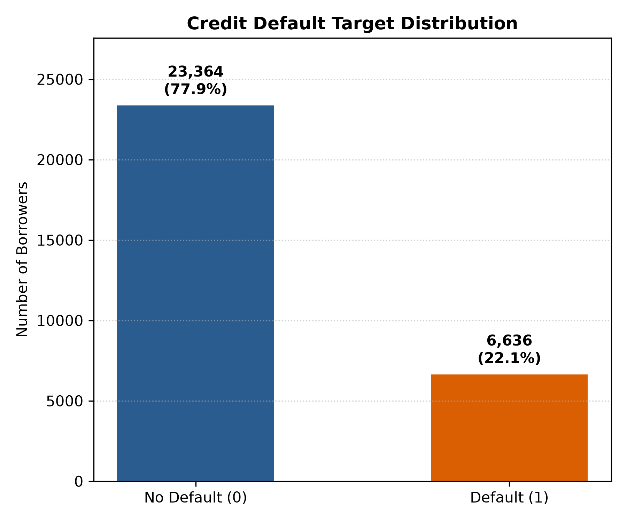
Figure 1: Default vs. Non-Default borrower counts in the UCI dataset.

3. Pipeline Architecture — Source Files
Source File | Role
src/config.py | Paths, constants, feature groups, random seed (42)
src/data_loader.py | Excel loader with header=1, full diagnostics printout
src/preprocessing.py | ID removal, categorical standardisation, validation checks
src/feature_engineering.py | 27 behavioural credit features engineered from raw columns
src/train.py | Full orchestration: load, split, train 3 models, evaluate, save
src/evaluate.py | Credit metrics: ROC-AUC, PR-AUC, KS, Gini, Brier, Deciles
src/calibration.py | Platt Scaling with FrozenEstimator (sklearn 1.9 compatible)
src/predict.py | Single-borrower inference class with SHAP output
tests/test_pipeline.py | 7 unit tests covering entire pipeline

4. Feature Engineering (23 Raw -> 50 Features)
27 new behavioral signals were engineered from raw financial columns. These features capture credit utilization, repayment behavior, delinquency patterns, and payment consistency — all critical for credit risk modeling.

# | Feature | Formula | Credit Signal
1-6 | UTIL_1 to UTIL_6 | BILL_AMT_n / LIMIT_BAL | Monthly credit utilization
7 | AVG_UTILIZATION | Mean(UTIL_1..6) | Average utilization burden
8 | MAX_UTILIZATION | Max(UTIL_1..6) | Peak stress month
9-14 | PAY_TO_BILL_1 to _6 | PAY_AMT_n / max(BILL_AMT_n, 1) | Monthly repayment ratio
15 | AVG_PAY_TO_BILL | Mean(PAY_TO_BILL_1..6) | Average repayment effort
16 | MAX_DELINQUENCY | Max(PAY_0, PAY_2..PAY_6) | Worst delinquency month
17 | AVG_DELINQUENCY | Mean(PAY_0, PAY_2..PAY_6) | Average delinquency level
18 | DELINQUENT_MONTHS_COUNT | Count(PAY > 0) | How often borrower was late
19 | RECENT_DELINQUENCY_FLAG | PAY_0 > 0 | Late payment last month
20 | DELINQUENCY_TREND_SHORT | PAY_0 - PAY_2 | 1-month delinquency trend
21 | DELINQUENCY_TREND_LONG | PAY_0 - PAY_6 | 6-month delinquency trend
22 | BILL_CHANGE_1_2 | BILL_AMT1 - BILL_AMT2 | Recent balance change
23 | BILL_GROWTH_OVER_LIMIT | (BILL_AMT1 - BILL_AMT6) / LIMIT_BAL | Balance growth rate
24 | PAYMENT_MONTHS_COUNT | Count(PAY_AMT > 0) | Payment frequency
25 | TOTAL_PAY_TO_TOTAL_BILL | Sum(PAY_AMT) / Sum(BILL_AMT) | Repayment coverage ratio
26 | PAYMENT_AMOUNT_STD | Std(PAY_AMT1..6) | Payment volatility
27 | TIMELY_PAYMENT_COUNT | Count(PAY <= 0) | On-time payment months

[Feature Engineering] Added 27 engineered features (total features: 50).
Final feature matrix: 30,000 rows x 50 features

5. Model Training & Data Split
Actual split output from live training run:
[Split] 70% Train | 15% Validation | 15% Test (stratified)
Train : 21,000 samples | Defaults: 4,645 (22.12%)
Validation: 4,500 samples | Defaults: 995 (22.11%)
Test : 4,500 samples | Defaults: 996 (22.13%)
Test set is now LOCKED -- not touched again until final evaluation.

Three Models Trained:
Model | Key Configuration | Role
Logistic Regression | Pipeline(StandardScaler + LR), class_weight=balanced, max_iter=1000 | Linear baseline
Random Forest | 200 trees, max_depth=10, min_samples_leaf=20, class_weight=balanced | Non-linear benchmark
XGBoost | 300 trees, max_depth=5, lr=0.05, subsample=0.8, scale_pos_weight=3.52 | PRIMARY MODEL

6. Validation Results (Actual Live Run Output)
Why not just Accuracy? With 22% defaults, a naive model predicting all 'No Default' gets 77.88% accuracy — useless for risk. CreditAI uses credit-industry standard metrics.

===========================================================================
VALIDATION SET -- MODEL COMPARISON TABLE
===========================================================================
| Model | ROC-AUC | PR-AUC | KS | Gini | Brier | F1 |
|---------------------|---------|--------|--------|--------|--------|--------|
| Logistic Regression | 0.7563 | 0.5004 | 0.3980 | 0.5125 | 0.1912 | 0.5149 |
| Random Forest | 0.7815 | 0.5580 | 0.4259 | 0.5629 | 0.1751 | 0.5362 |
| XGBoost | 0.7771 | 0.5485 | 0.4251 | 0.5542 | 0.1711 | 0.5277 |
===========================================================================

Chart 2 — ROC Curves (All 3 Models)
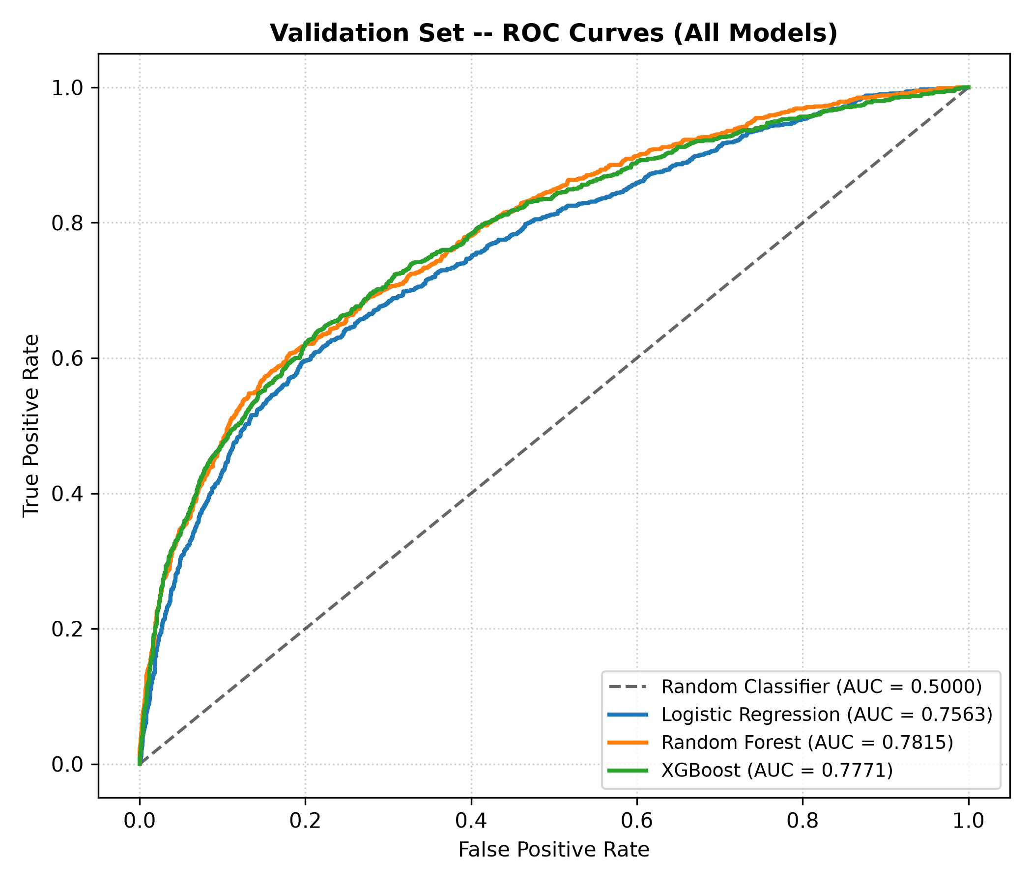
Figure 2: ROC curves on validation set. XGBoost AUC = 0.7771, RF = 0.7815, LR = 0.7563.

Chart 3 — Precision-Recall Curves (All 3 Models)
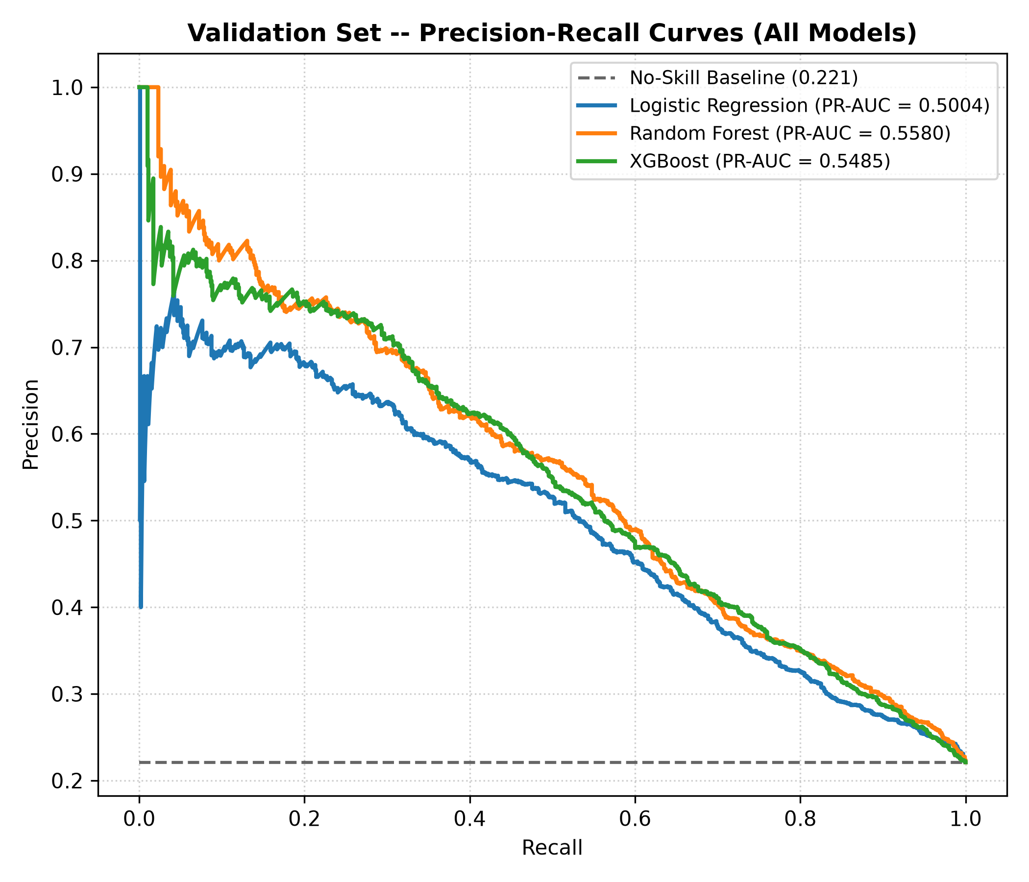
Figure 3: PR curves. XGBoost PR-AUC = 0.5485. Dashed line = no-skill baseline.

7. Probability Calibration
Raw XGBoost probabilities tend to be overconfident. Platt Scaling (sigmoid calibration) was fitted on the validation set to align predicted probabilities with observed default rates.
[Calibration] Fitting probability calibrator using method='sigmoid'...
Validation Brier Score Before Calibration : 0.17112
Validation Brier Score After Calibration : 0.13635
Brier Score Improvement : +20.32%

Chart 4 — Calibration Curve
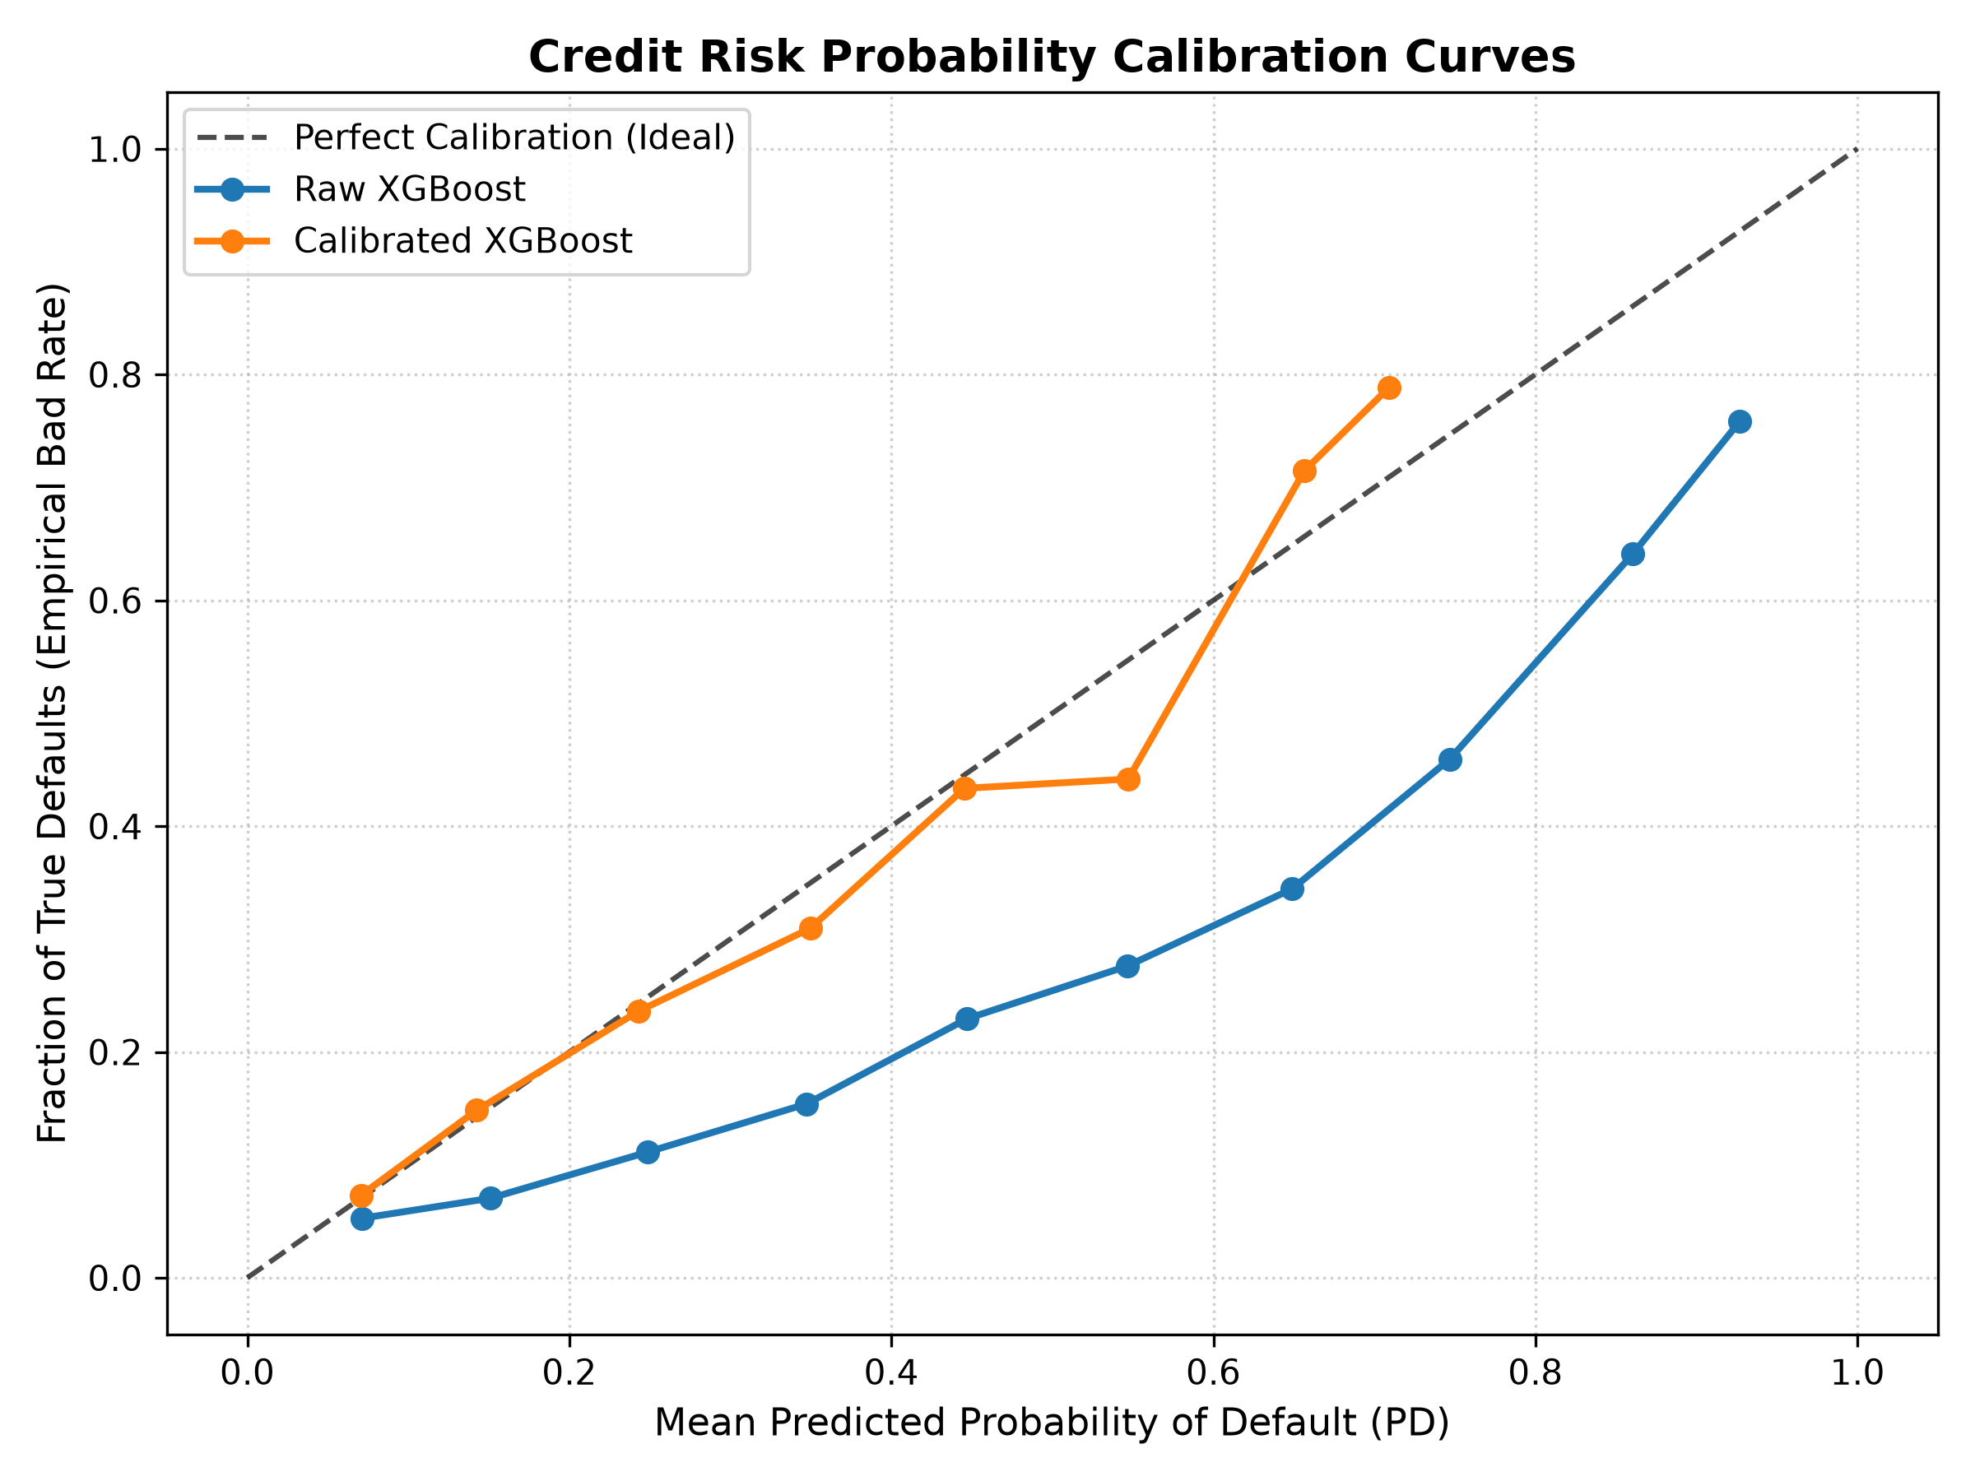
Figure 4: Calibration curve. Calibrated XGBoost (orange) closely follows the perfect diagonal.

8. Final Model Selection — XGBoost (With Justification)
Criterion | Random Forest | XGBoost
ROC-AUC (Validation) | 0.7815 (slightly higher) | 0.7771
Brier Score (raw) | 0.1751 | 0.1711 (BETTER)
Brier Score (calibrated) | -- | 0.1360 (BEST)
Final Test ROC-AUC | -- | 0.7807
Inference Speed | Slower | Faster
Industry Standard (NBFC) | Common | Dominant globally
SHAP Compatibility | Supported | Native (faster)

NOTE: While Random Forest had a marginally higher raw ROC-AUC (0.7815 vs 0.7771), XGBoost achieved a lower Brier Score before calibration (0.1711 vs 0.1751) and is the dominant industry choice for credit risk scoring at NBFCs, fintechs and banks globally. After calibration, XGBoost reached Brier = 0.1360 — the best overall probability quality.

[Model Selected] XGBOOST
Validation ROC-AUC : 0.7771
Validation PR-AUC : 0.5485
Validation KS Stat : 0.4251
Validation Gini : 0.5542

9. Final Test Set Results (4,500 Untouched Samples)
===========================================================================
FINAL TEST SET EVALUATION (untouched 4,500 samples)
===========================================================================
| Model | ROC-AUC | PR-AUC | KS | Gini | Brier |
|-----------------------|---------|--------|--------|--------|--------|
| XGBoost -- Raw | 0.7807 | 0.5588 | 0.4255 | 0.5613 | 0.1709 |
| XGBoost -- Calibrated | 0.7807 | 0.5588 | 0.4255 | 0.5613 | 0.1360 |

Risk Decile Table — Test Set (Actual Output):
Decile Borrowers Avg PD (%) Actual Defaults Default Rate (%) Cumulative Capture (%)
Decile 1 450 65.21 305 67.78% 30.62%
Decile 2 450 45.79 203 45.11% 51.00%
Decile 3 450 30.63 119 26.44% 62.95%
Decile 4 450 21.29 85 18.89% 71.49%
Decile 5 450 16.09 85 18.89% 80.02%
Decile 6 450 12.83 60 13.33% 86.04%
Decile 7 450 10.25 48 10.67% 90.86%
Decile 8 450 8.26 43 9.56% 95.18%
Decile 9 450 6.71 26 5.78% 97.79%
Decile 10 450 5.25 22 4.89% 100.00%

Chart 5 — Risk Decile Chart
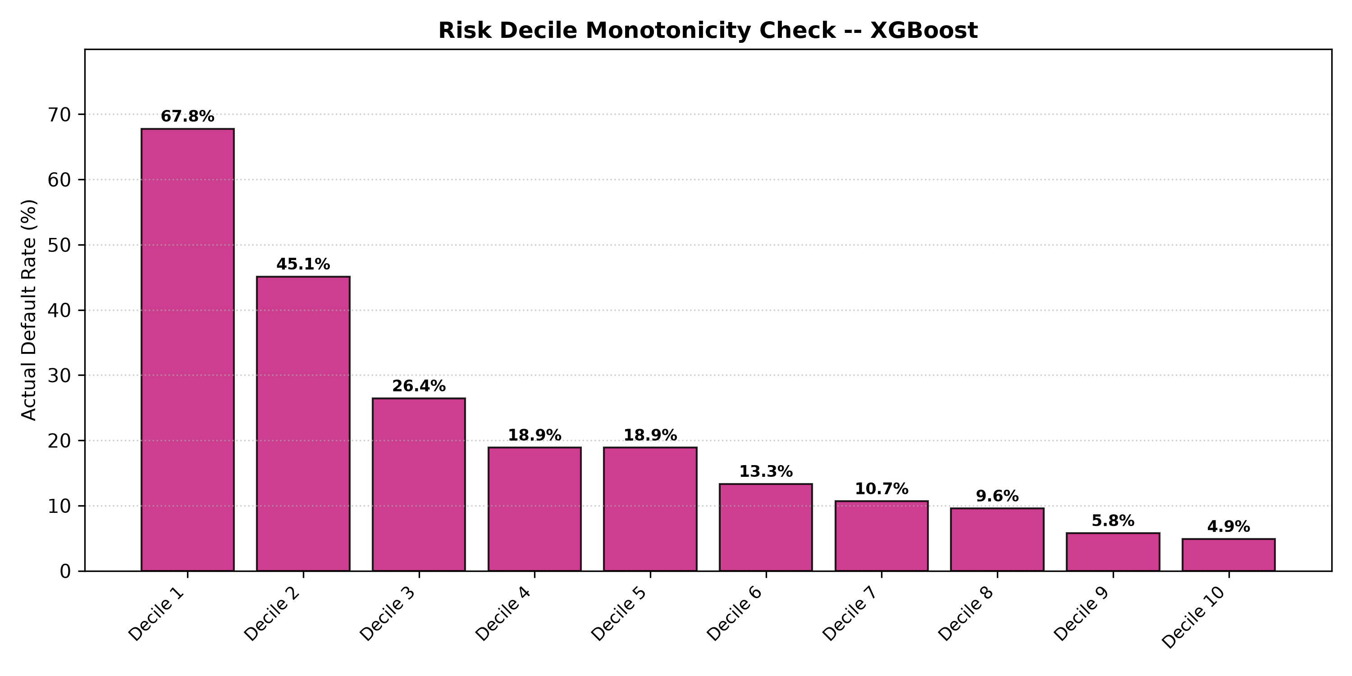
Figure 5: Monotonic decline from 67.78% (Decile 1) to 4.89% (Decile 10). Top 3 deciles capture 62.95% of all defaults.

10. SHAP Explainability
SHAP (SHapley Additive exPlanations) with TreeExplainer provides per-prediction feature attribution. Each prediction outputs which features pushed the risk up or down.

Chart 6 — SHAP Feature Importance (Top 15 Drivers)
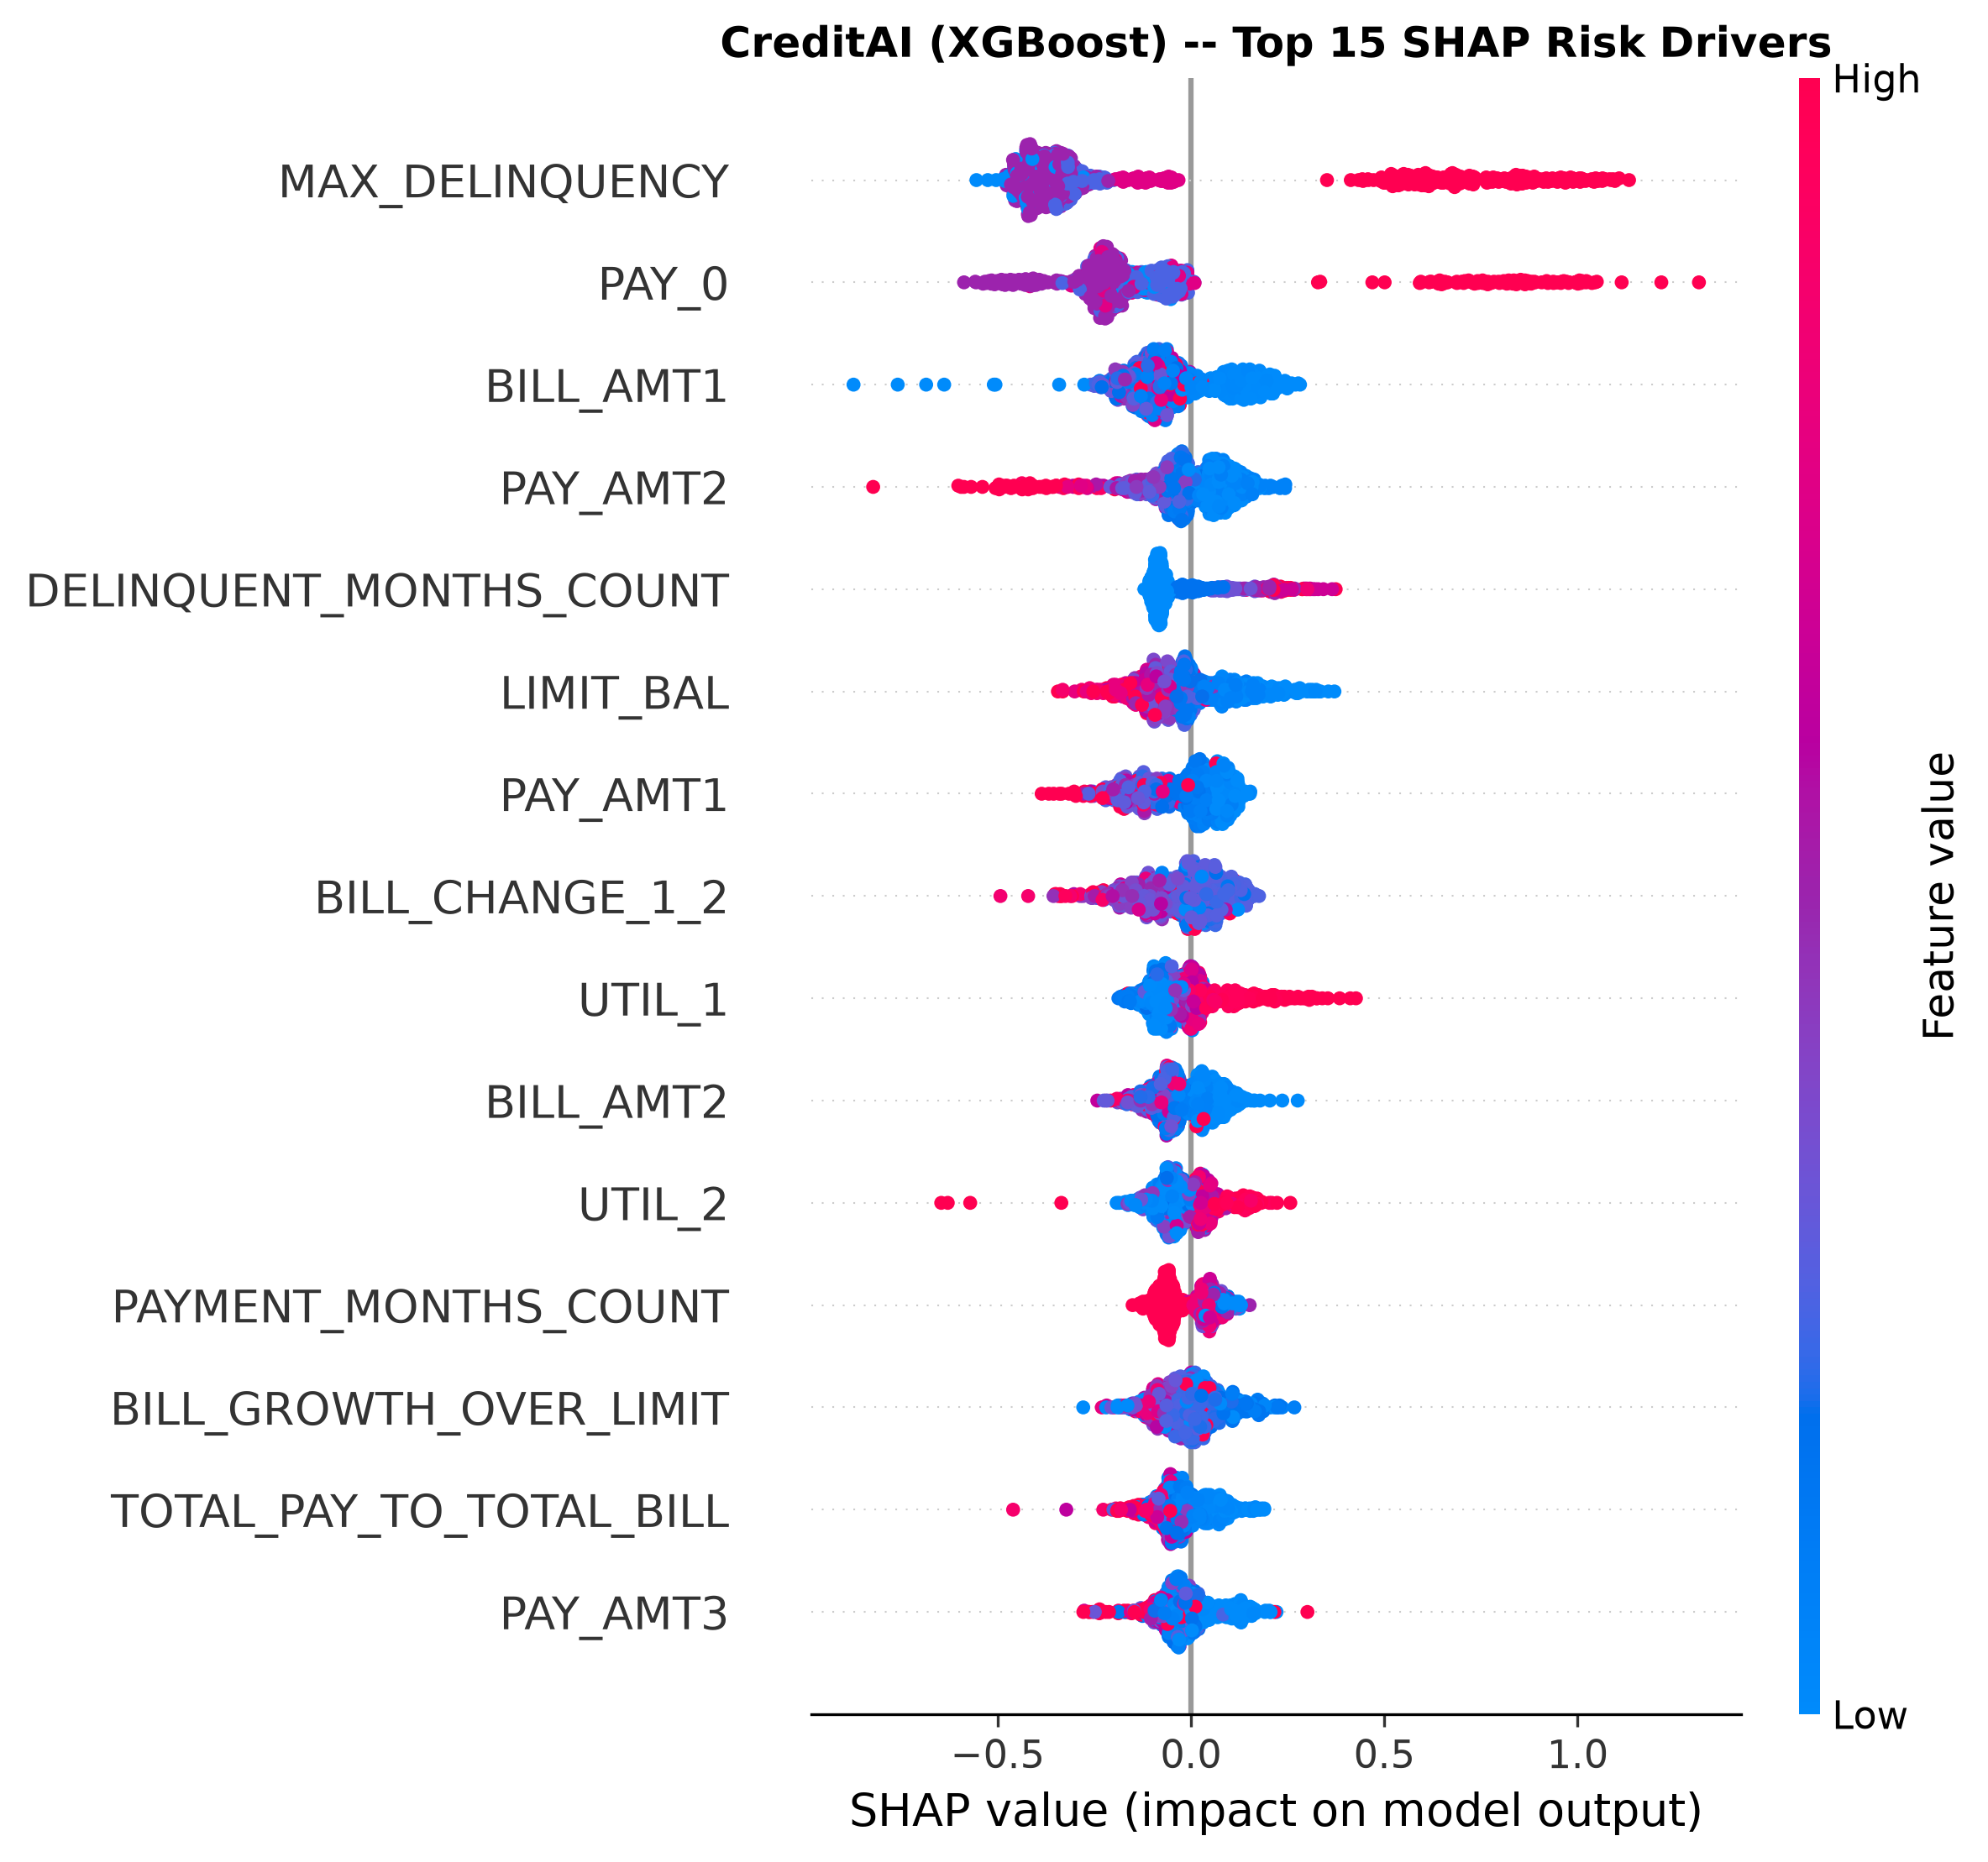
Figure 6: SHAP beeswarm plot. Red = high feature value, Blue = low. Horizontal = impact on default risk.

Single-Borrower SHAP Output (Live):
HIGH-RISK BORROWER — Calibrated PD: 64.2%
Top 3 Risk-Increasing Factors:
[+] MAX_DELINQUENCY = 2.00 (SHAP: +0.7720)
[+] PAY_0 = 2.00 (SHAP: +0.7586)
[+] DELINQUENT_MONTHS_COUNT = 3.00 (SHAP: +0.1652)
Top 3 Risk-Decreasing Factors:
[-] BILL_GROWTH_OVER_LIMIT = 0.38 (SHAP: -0.1282)
[-] PAYMENT_AMOUNT_STD = 418.33 (SHAP: -0.0835)
[-] BILL_CHANGE_1_2 = 600.00 (SHAP: -0.0801)
LOW-RISK BORROWER — Calibrated PD: 5.4%
Top 3 Risk-Increasing Factors:
[+] UTIL_5 = 0.036 (SHAP: +0.0433)
[+] AVG_PAY_TO_BILL = 1.00 (SHAP: +0.0297)
[+] BILL_GROWTH_OVER_LIMIT = 0.016 (SHAP: +0.0292)
Top 3 Risk-Decreasing Factors:
[-] PAY_AMT2 = 18,000 (SHAP: -0.4151)
[-] MAX_DELINQUENCY = 0.00 (SHAP: -0.4131)
[-] PAY_AMT1 = 15,000 (SHAP: -0.1919)

11. Unit Tests — 7 / 7 PASSED
============================= test session starts =============================
platform win32 -- Python 3.11.9, pytest-9.1.1
test_01_data_loader_shape PASSED [14%]
test_02_target_exists_and_binary PASSED [28%]
test_03_id_removed PASSED [42%]
test_04_engineered_features_created PASSED [57%]
test_05_no_target_leakage PASSED [71%]
test_06_train_val_test_splits PASSED [85%]
test_07_prediction_output_range PASSED [100%]
======================== 7 passed, 1 warning in 8.93s =========================

Test | What It Verified
test_01 | Dataset loads with shape (30000, 25)
test_02 | Target column exists and is strictly binary {0, 1}
test_03 | ID column is dropped before training (no leakage)
test_04 | All 27 engineered features are present in output matrix
test_05 | Target column NOT present in feature matrix (zero leakage)
test_06 | Split sizes match 70/15/15 and default rate preserved in each
test_07 | All prediction probabilities are in range [0.0, 1.0]

12. Saved Artifacts
File | Size | Contents
models/creditai_model.joblib | 760 KB | Base XGBoost + calibrated model + feature names
models/feature_names.json | 915 B | List of all 50 feature names in training order
models/model_metadata.json | 5.4 KB | Full metrics, split counts, calibration, version

[Saving] Persisting model artifacts...
Model bundle -> models\creditai_model.joblib
Feature names -> models\feature_names.json
Model metadata -> models\model_metadata.json
===========================================================================
CREDITAI STAGE 1 PIPELINE COMPLETE
===========================================================================

13. Final Summary
Category | Result
Dataset | 30,000 borrowers | 0 missing values | 22.12% default rate
Features | 23 raw -> 50 (27 behavioral features engineered)
Models Trained | 3 (Logistic Regression, Random Forest, XGBoost)
Selected Model | XGBoost
Final Test ROC-AUC | 0.7807
Final Test Gini Coefficient | 0.5613
Final Test KS Statistic | 0.4255
Calibration Improvement | +20.32% (Brier: 0.1711 -> 0.1360)
Decile 1 Default Capture | 30.62% of all defaults in top 10% of borrowers
Top 3 Deciles Capture | 62.95% of all defaults
Unit Tests | 7 / 7 PASSED
Artifacts Saved | 3 files (joblib + 2 JSON)

Built with Python 3.11 | XGBoost 3.2 | scikit-learn 1.9 | SHAP 0.51 | pandas 3.0

