Challenge: Near Earth Objects Machine Learning
For this challenge, we invite you to become "virtual contributors" to the Asteroid Grand Challenge and develop a hypothetical method, concept note or simple prototype that demonstrates how Machine Learning could be used to help us avoid the same fate as the dinosaurs.
Required: people with machine learning & BigData skills, mathematical and astronomy skills, presentation making skills.

Detection of occultations by asteroids with array of telescopes.

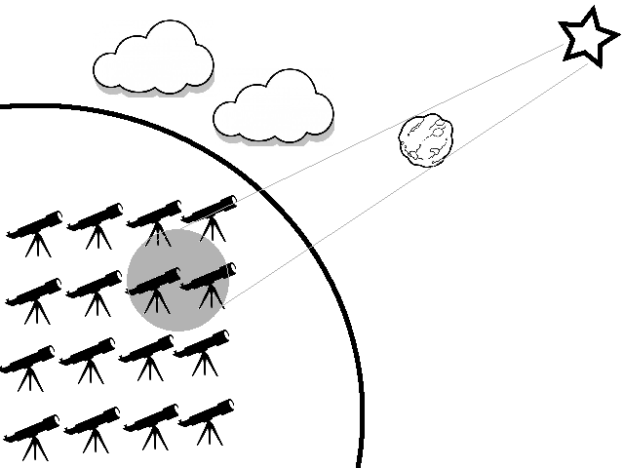
Description:
We already keep track of the most of big near-Earth asteroids. But when it comes to small sized ones – we are basically ignorant of them. For example, we estimate that there is at least 1 million of 40 m near Earth asteroids, and we discovered at most 1% of them.

In order to detect an asteroid we need a telescope. All ongoing asteroid detection projects(NEAT, LONEOS, CINEOS, etc.) use big and very expensive telescopes. But even with big telescope it is hard to detect 40 meter rock tens of millions kilometres away.

We propose change of paradigm – by using thousands of low cost telescope we will watch out for asteroid occultations. Star shadow of asteroid moving across Earth surface will create a pattern of occultation detections in our telescope array and by using machine learning technics we will produce current asteroid celestial coordinates.

The good news are that we can get a lot of telescopes for free – there are thousands of amateur owned computer controlled, digital camera compatible telescopes! All we need to do is to help amateurs to connect them to Internet!

Work to do:
- Detailed estimation of feasibility of proposed method.
- Create program that would simulate data feed from telescope array. Occultations, CCD noise and defects, clouds, meteorite events, etc.
- Implement method for extraction of data from data feed despite high level of false positives(CCD noise) – asteroid celestial coordinates and shape.
- If sky is covered by clouds – we need a method for finding out what observation sky point is clear for most telescope in array.
- If meteorite event is detected then we can estimate height of meteorite flight.

This project is brainchild of Ivan Bondar, ivan.e.bondar@gmail.com, skype: vashu1, p.: 0468 818 969

