WEEK 1 TASK
Data Acquisition, Cleaning, and Exploratory Data Analysis
Virtual Data Science with Python Apprentice Intern
Dataset: Titanic Passenger Dataset
Prepared by: Vasundhara Chandra
Week 1 Internship Assignment

1. Introduction
This project was completed as part of Week 1 of the Virtual Data Science with Python Apprentice Intern program. The task focuses on the initial stages of a data science workflow: acquiring a publicly available dataset, inspecting its structure, cleaning the data, performing exploratory data analysis (EDA), creating visualizations, and drawing meaningful insights from the results.

2. Task Objective
The main objective was to simulate a practical data preparation and exploratory analysis process using Python. The analysis was performed on the Titanic passenger dataset using Pandas, NumPy, Matplotlib, and Seaborn.
- Acquire and inspect a publicly available dataset.
- Identify missing values and handle them appropriately.
- Check for duplicate records.
- Inspect and verify data types.
- Perform descriptive statistical analysis.
- Create relevant visualizations to identify patterns and relationships.
- Summarize the main findings from exploratory analysis.

3. Dataset Description
The Titanic dataset contains information about passengers who travelled on the RMS Titanic. The original training dataset contains 891 passenger records and 12 columns. The variables include passenger identification, survival status, passenger class, name, sex, age, family-related information, ticket, fare, and port of embarkation.
- PassengerId – Unique passenger identifier.
- Survived – Survival status, where 0 indicates did not survive and 1 indicates survived.
- Pclass – Passenger class (1, 2, or 3).
- Name – Passenger name.
- Sex – Passenger gender.
- Age – Passenger age.
- SibSp – Number of siblings or spouses aboard.
- Parch – Number of parents or children aboard.
- Ticket – Ticket number.
- Fare – Passenger fare.
- Cabin – Cabin information.
- Embarked – Port of embarkation.

4. Tools and Technologies
- Python
- Pandas – data loading, cleaning, manipulation, and analysis.
- NumPy – numerical operations.
- Matplotlib – data visualization.
- Seaborn – statistical visualization.
- Google Colab / Jupyter Notebook – development and analysis environment.

5. Data Acquisition
A publicly available Titanic passenger dataset was used for the project. The dataset was downloaded and loaded into a Pandas DataFrame using the read_csv() function. The original file was retained as train.csv and a cleaned version was saved as titanic_cleaned.csv.
Code used to load the dataset:
import pandas as pd
import numpy as np
import matplotlib.pyplot as plt
import seaborn as sns
df = pd.read_csv('/content/train.csv')
df.head()

6. Initial Data Inspection
Before performing cleaning operations, the dataset was inspected to understand its structure, dimensions, column names, data types, summary statistics, missing values, and duplicate records.
- Original dataset size: 891 rows and 12 columns.
- The dataset contained numerical and categorical variables.
- Missing values were identified in Cabin, Age, and Embarked.
- No duplicate rows were found.
- Descriptive statistics were generated using df.describe().

7. Data Cleaning

7.1 Missing Value Analysis
Missing values were quantified by calculating both the number and percentage of missing observations in each column.
Column | Missing Values | Percentage | Treatment
Cabin | 687 | 77.10% | Column removed
Age | 177 | 19.87% | Median imputation
Embarked | 2 | 0.22% | Mode imputation
Other columns | 0 | 0% | No action required

7.2 Treatment of Missing Values
The Cabin column had approximately 77.10% missing values. Because the proportion of missing information was very high, the column was removed rather than introducing a large amount of artificial information through imputation.
The Age column had 177 missing values, representing approximately 19.87% of the dataset. These observations were retained and missing ages were replaced with the median age. Median imputation was selected because it is less affected by extreme values.
Only two Embarked values were missing, representing approximately 0.22% of the dataset. Since Embarked is a categorical variable, the missing values were replaced with the most frequent category (mode).
df = df.drop(columns=['Cabin'])
df['Age'] = df['Age'].fillna(df['Age'].median())
df['Embarked'] = df['Embarked'].fillna(df['Embarked'].mode()[0])

7.3 Duplicate Records
The dataset was checked for duplicate rows using Pandas. The duplicate count was 0, so no records were removed.
df.duplicated().sum() # 0

7.4 Data Type Verification
After cleaning, the dataset contained 891 rows and 11 columns. All columns had complete non-null values. The numerical variables were stored as integer or floating-point types, while Name, Sex, Ticket, and Embarked were stored as object types.
- 5 integer columns: PassengerId, Survived, Pclass, SibSp, and Parch.
- 2 floating-point columns: Age and Fare.
- 4 categorical/text columns: Name, Sex, Ticket, and Embarked.

8. Exploratory Data Analysis
After cleaning, descriptive statistics and visualizations were used to explore the dataset. The analysis focused on survival distribution, gender and survival, passenger age, correlations among numerical variables, and fare distribution.

8.1 Descriptive Statistics
The cleaned dataset contains 891 passenger records. The mean passenger age was approximately 29.36 years and the median age was 28 years. The mean survival value was approximately 0.384, corresponding to an overall survival rate of about 38.4%. The average fare was approximately 32.20, while the median fare was approximately 14.45. The maximum recorded fare was 512.33, indicating a wide spread in fare values.

8.2 Visualization 1 – Passenger Survival Distribution
The survival distribution visualization compares passengers who did not survive (0) with those who survived (1). It shows that the number of passengers who did not survive was higher than the number who survived. The overall survival rate was approximately 38.4%.
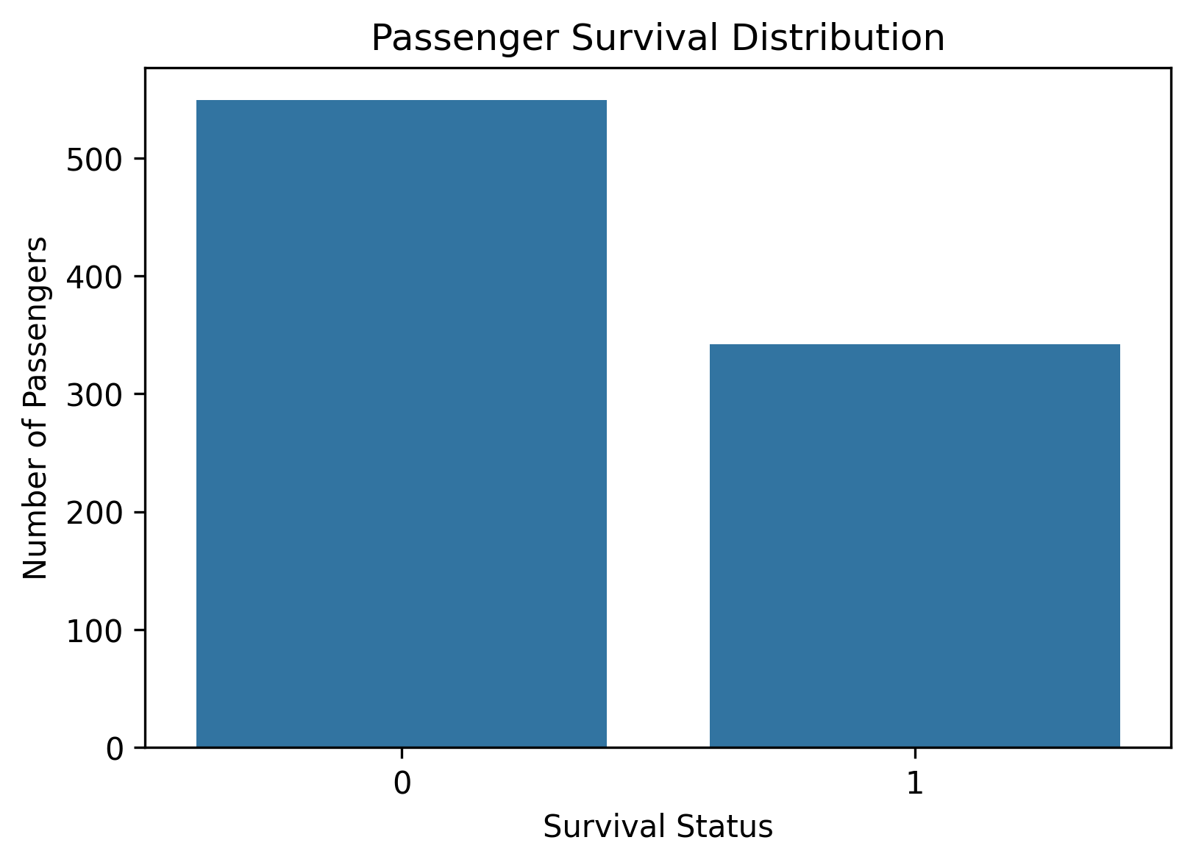
Visualization 1 – Passenger Survival Distribution

8.3 Visualization 2 – Survival Distribution by Gender
The gender-based survival visualization shows a substantial difference between male and female survival outcomes. Female passengers had a considerably higher survival rate than male passengers. This indicates a strong association between gender and survival in this dataset.
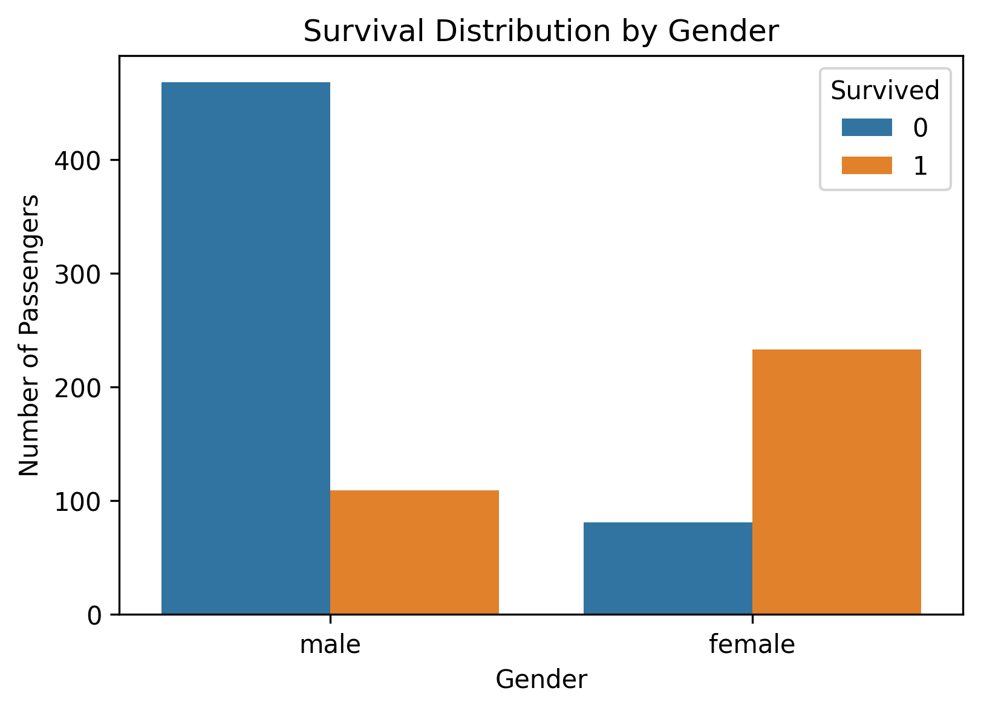
Visualization 2 – Survival Distribution by Gender

8.4 Visualization 3 – Age Distribution
The age histogram shows that passenger ages covered a broad range, from children to elderly passengers. Most observations were concentrated around young and middle adulthood. The distribution was examined after filling missing age values with the median.
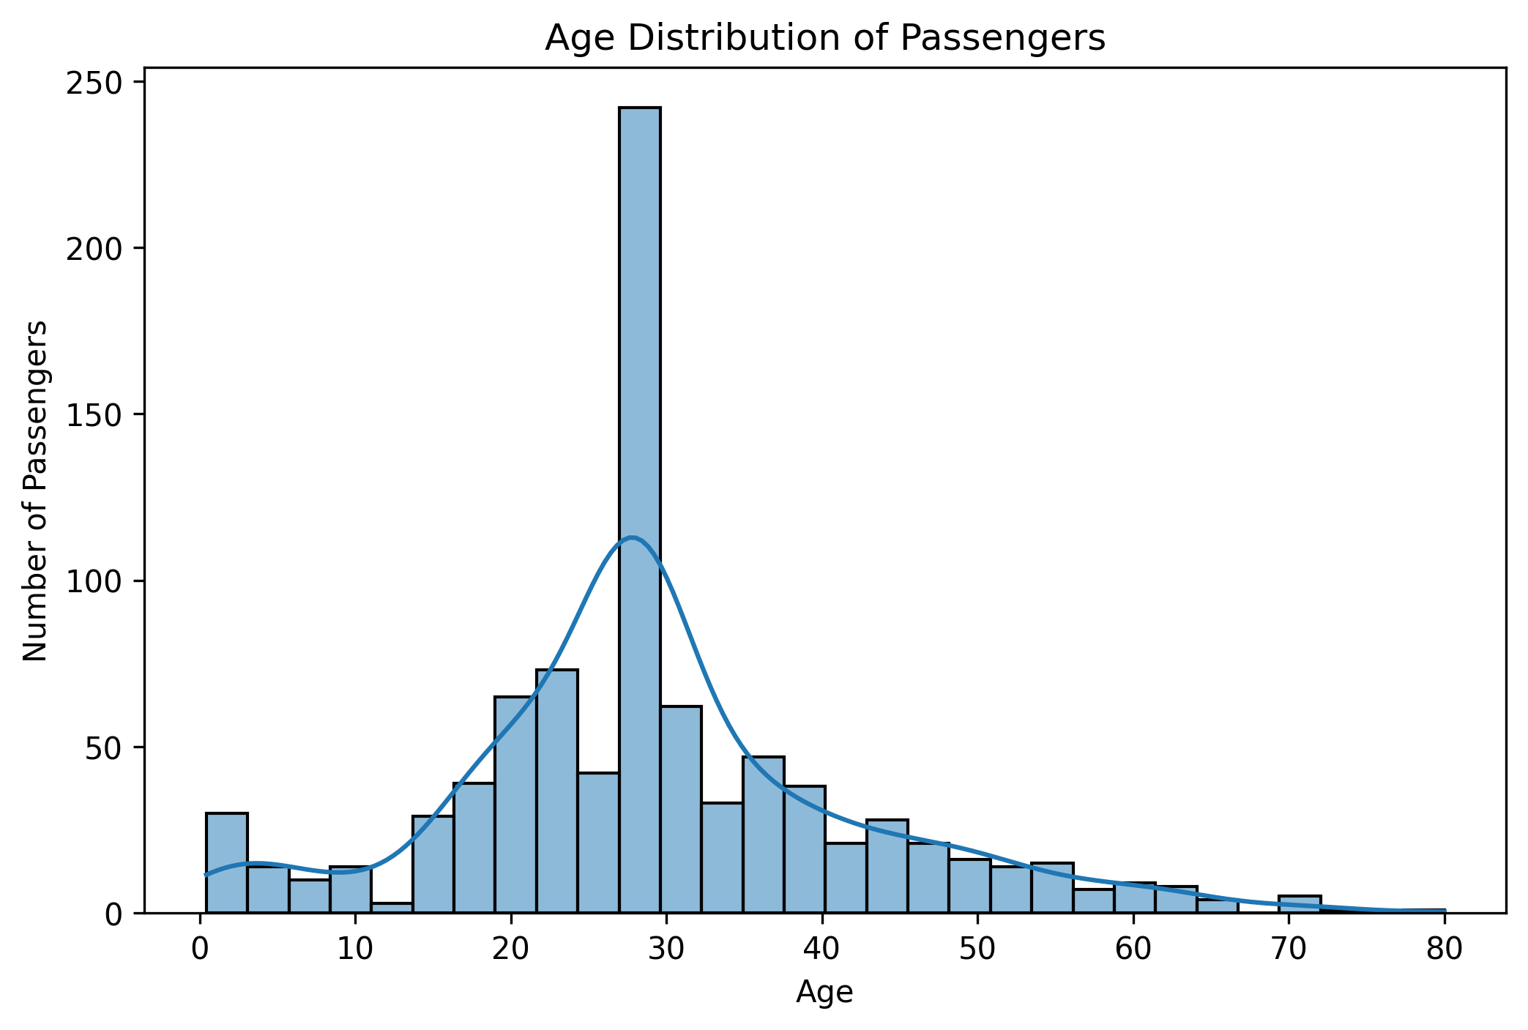

Visualization 3 – Age Distribution

8.5 Visualization 4 – Correlation Heatmap
The correlation heatmap was used to examine linear relationships among numerical variables. Passenger class showed a noticeable relationship with survival, while variables such as Age, SibSp, and Parch showed comparatively weaker relationships. These values represent associations and should not be interpreted as proof of causation.
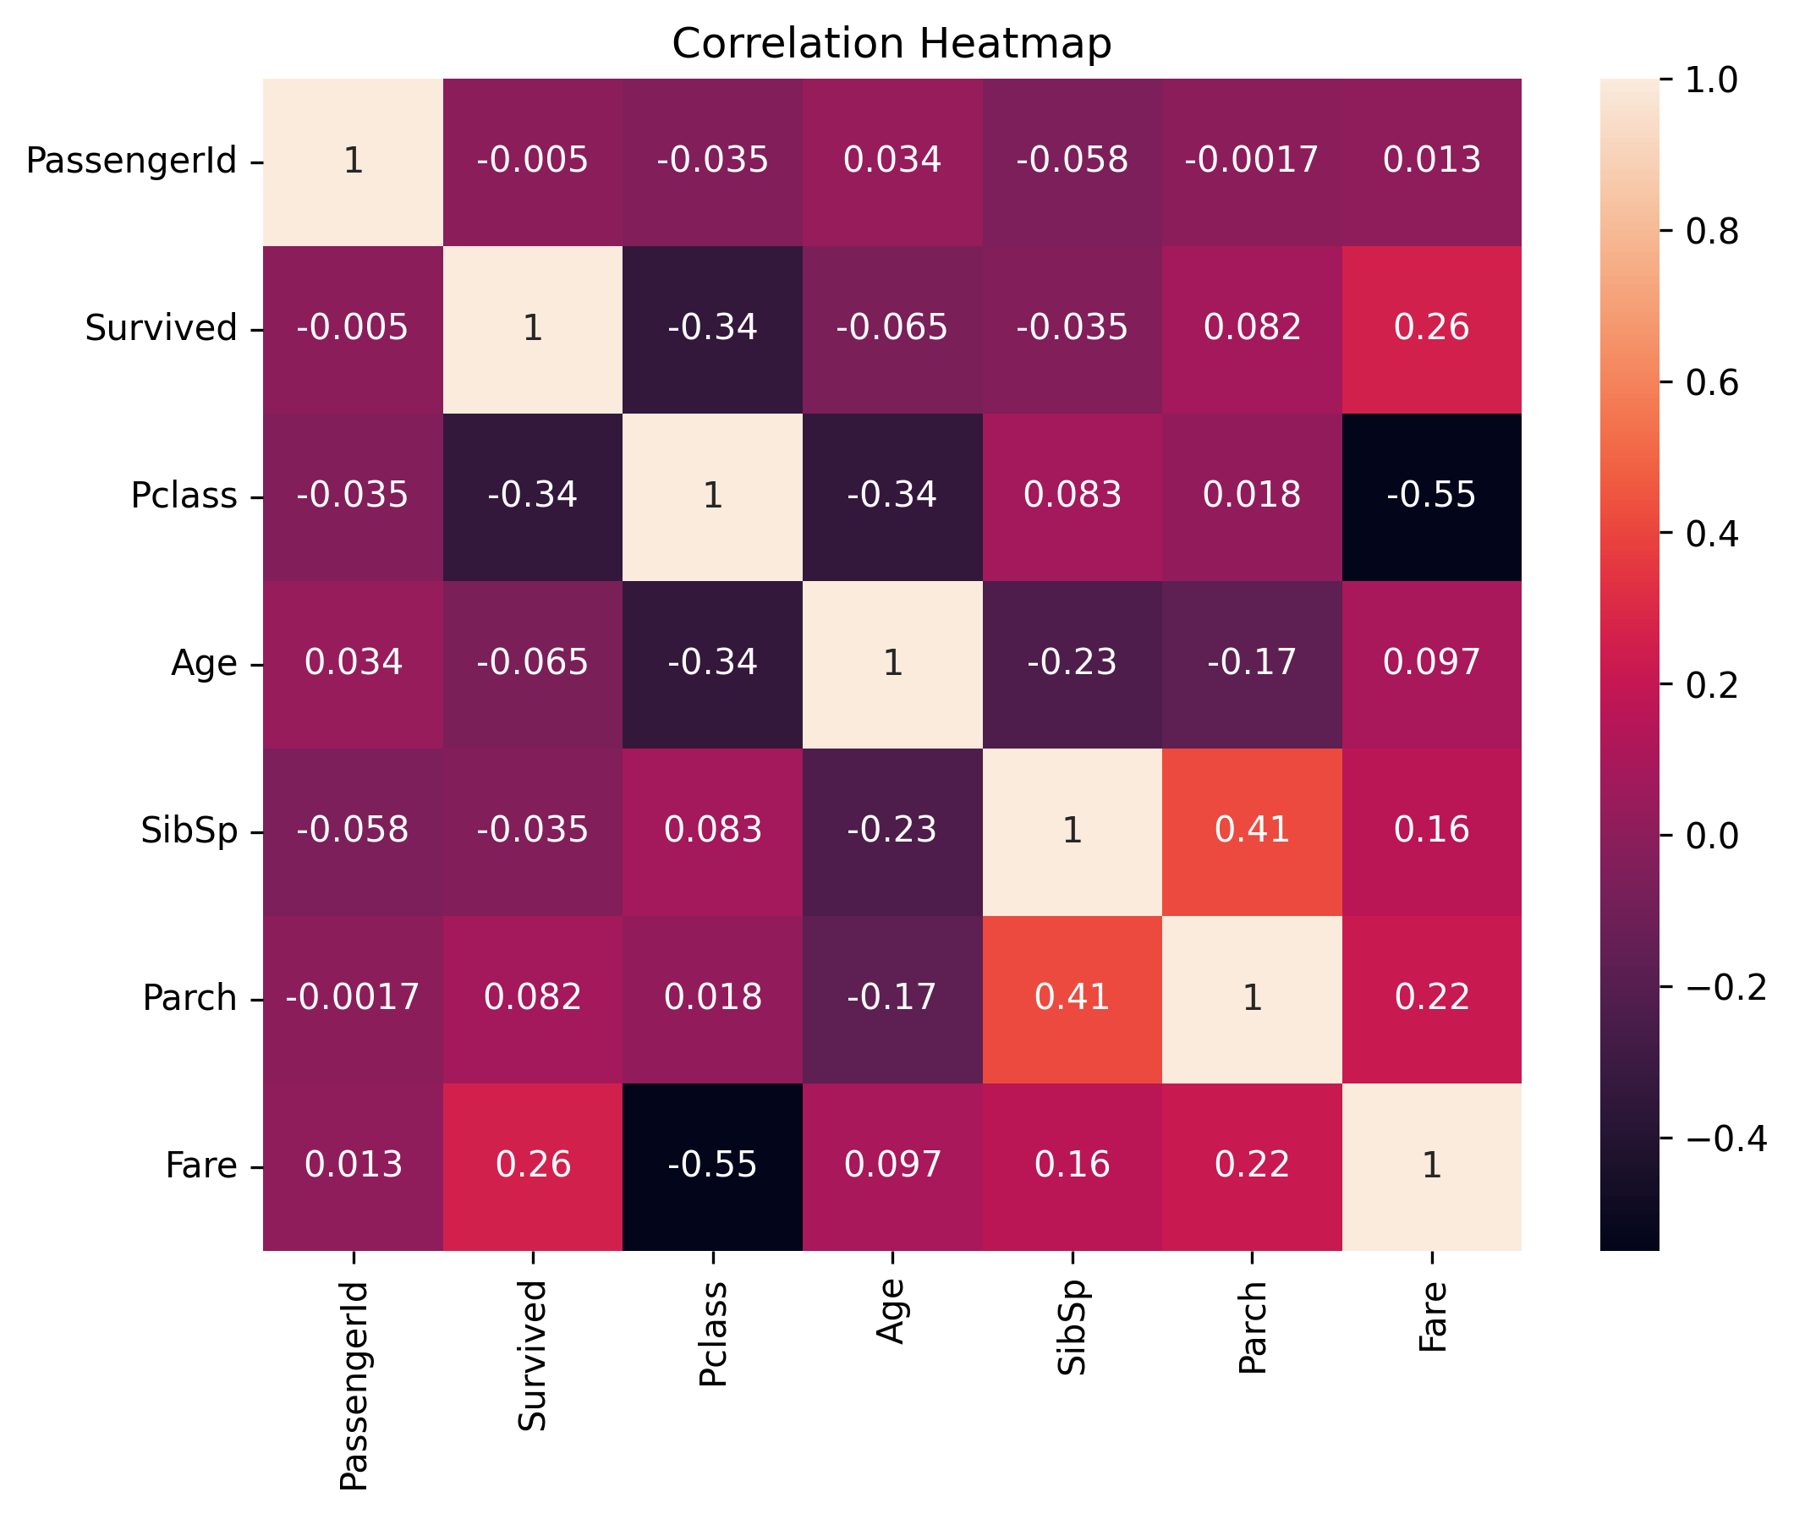
Visualization 4 – Correlation Heatmap

8.6 Visualization 5 – Fare Distribution and Outliers
The fare box plot shows a wide range of ticket prices and several high-value observations. The maximum fare of 512.33 is substantially higher than the median fare of approximately 14.45. These observations were not automatically removed because high fares can represent legitimate passenger records rather than data-entry errors.

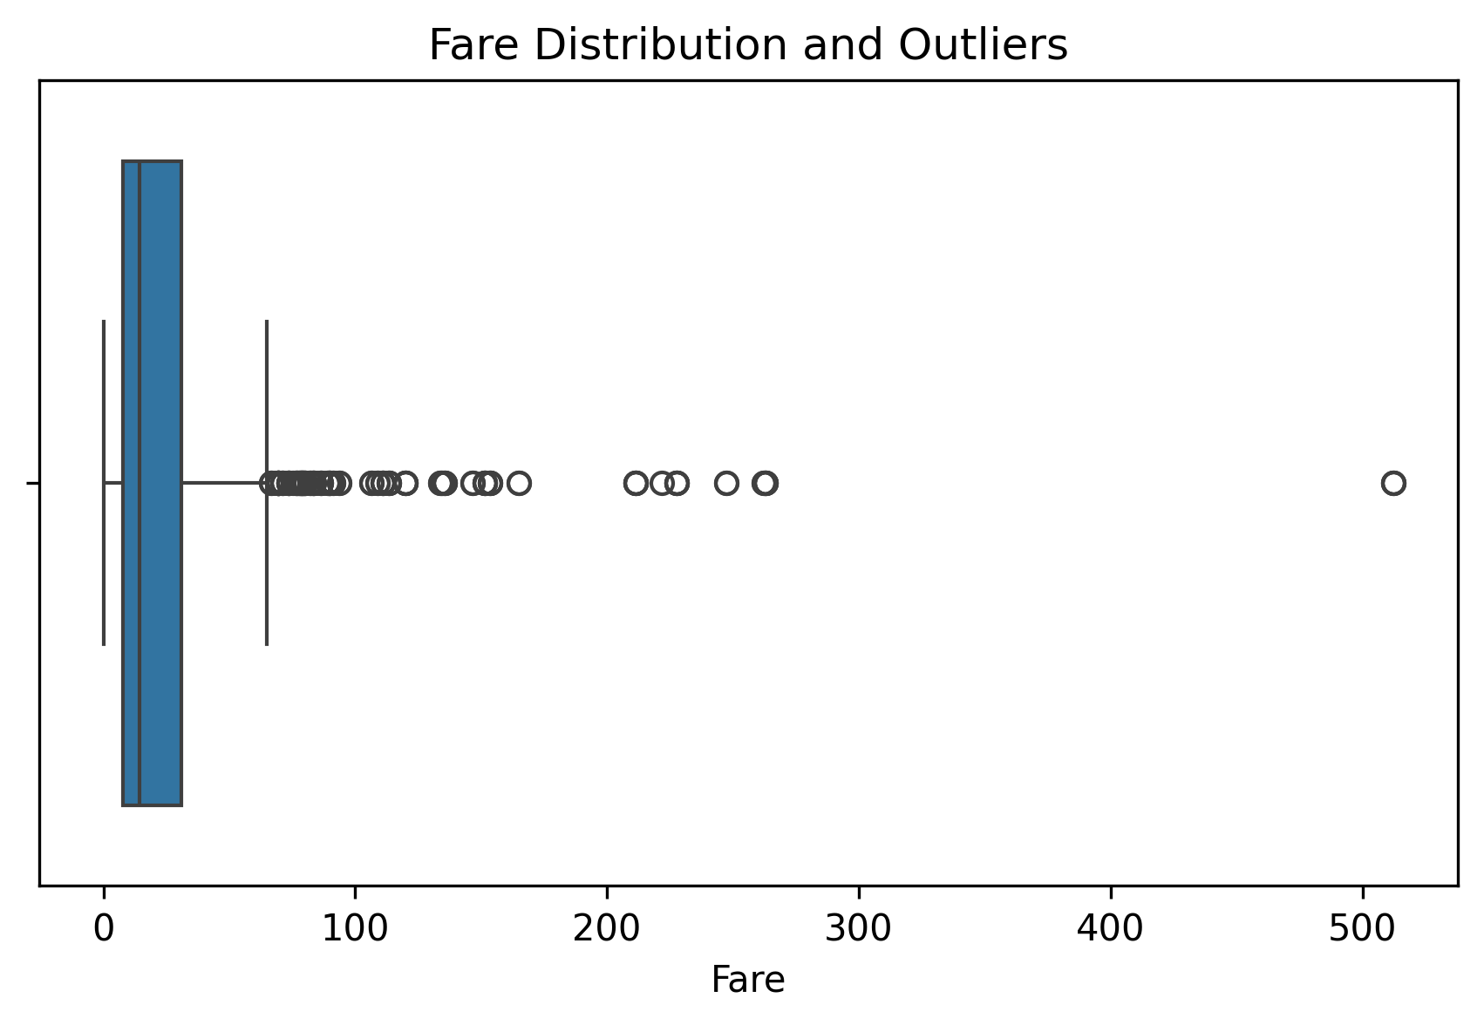
Visualization 5 – Fare Distribution and Outliers

9. Key Insights
- The dataset contained 891 passenger records after cleaning.
- The overall survival rate was approximately 38.4%, meaning most passengers in the dataset did not survive.
- Female passengers had a substantially higher survival rate than male passengers.
- Passenger class was associated with survival, with first-class passengers generally showing higher survival rates than lower classes.
- Passenger ages covered a wide range, with many observations concentrated around young and middle adulthood.
- Fare values showed substantial variation and high-value observations that appeared as potential outliers.
- The correlation analysis identified differences in the strength of numerical relationships with survival.

10. Final Data Quality Check
A final validation was performed after cleaning. The final dataset contained 891 rows and 11 columns, with zero missing values and zero duplicate rows.
print(df.shape) # (891, 11)
print(df.isnull().sum().sum()) # 0
print(df.duplicated().sum()) # 0

11. Conclusion
This project demonstrated a complete introductory data science workflow using the Titanic passenger dataset. The process included dataset acquisition, initial inspection, missing-value analysis, duplicate checking, data-type verification, cleaning, descriptive statistics, visualization, and interpretation of findings. The cleaned dataset provides a suitable foundation for further statistical analysis or predictive modeling.

12. GitHub Project
The complete project files, including the notebook, original dataset, cleaned dataset, visualizations, requirements file, and README, are available in the following public GitHub repository:
https://github.com/vashuchandra08-tech/week-1-titanic-eda

13. Project Deliverables
- Word report documenting data acquisition, cleaning, EDA, visualizations, and insights.
- Titanic_EDA_Week1.ipynb containing the complete analysis code.
- train.csv containing the original dataset.
- titanic_cleaned.csv containing the cleaned dataset.
- Five visualization image files.
- requirements.txt containing the Python dependencies.
- Public GitHub repository containing the project.

