Week 3 – Statistical Analysis and Hypothesis Testing in Python
Statistical Analysis and Hypothesis Testing of the Relationship Between TV Advertising and Product Sales

1. Introduction
Statistical analysis plays an important role in data science because it helps identify patterns, measure relationships, and support evidence-based decision-making. Hypothesis testing is a statistical approach used to determine whether an observed relationship or difference is statistically significant or could have occurred by chance.
This project focuses on analyzing the relationship between advertising expenditure and product sales using Python. The Advertising dataset contains information about expenditure on TV, radio, and newspaper advertising along with corresponding product sales. For this study, TV advertising expenditure and sales were selected as the primary variables for formal hypothesis testing.
The main objective is to determine whether TV advertising expenditure has a statistically significant relationship with product sales. Descriptive statistics, exploratory visualizations, Pearson correlation, and simple linear regression were used to investigate the relationship. Regression diagnostics were also performed to assess important model assumptions.
The analysis was performed using Python libraries including Pandas, NumPy, Matplotlib, Seaborn, SciPy, and Statsmodels. A significance level of 0.05 was used for hypothesis testing.

2. Problem Statement
Businesses invest money in different advertising channels to increase product sales. However, advertising expenditure does not automatically guarantee higher sales. A data-driven statistical analysis is therefore useful for determining whether advertising expenditure is meaningfully associated with sales.
This project investigates whether TV advertising expenditure is statistically related to product sales in the selected dataset. The analysis aims to provide quantitative evidence that can help understand the relationship between the two variables.

3. Research Question
Is there a statistically significant relationship between TV advertising expenditure and product sales?

4. Hypothesis
Null Hypothesis (H₀): There is no statistically significant relationship between TV advertising expenditure and product sales.
Alternative Hypothesis (H₁): There is a statistically significant relationship between TV advertising expenditure and product sales.
Significance level (α): 0.05
Decision rule: If the p-value is less than 0.05, the null hypothesis will be rejected. Otherwise, the null hypothesis will not be rejected.

5. Dataset Description
The analysis uses the Advertising dataset containing 200 observations. The original dataset contains five columns: an index column, TV, radio, newspaper, and sales. The index column, named 'Unnamed: 0', was removed because it only represented row numbers and was not useful for statistical analysis.
The final dataset used for analysis contains four variables: TV, radio, newspaper, and sales. TV, radio, and newspaper represent advertising expenditure, while sales represents product sales.

6. Tools and Libraries Used
The following Python tools and libraries were used:
• Python
• Pandas – data loading, cleaning, and statistical summaries
• NumPy – numerical operations
• Matplotlib – visualization
• Seaborn – statistical visualization
• SciPy – Pearson correlation and Shapiro-Wilk testing
• Statsmodels – ordinary least squares regression analysis
• Google Colab – development and execution environment

7. Methodology
The analysis followed a structured statistical workflow. First, the dataset was loaded into Python and inspected. Missing values and duplicate records were checked, and the unnecessary index column was removed. Descriptive statistics were then calculated to understand the distribution and central tendency of the variables.
Exploratory visualizations, including histograms, a scatter plot, a regression plot, residual plots, and a correlation heatmap, were created to understand the data visually.
Pearson correlation was used to measure the strength and direction of the linear relationship between TV advertising expenditure and sales. The p-value from the Pearson test was used to evaluate statistical significance.
Simple linear regression was then performed with TV advertising expenditure as the independent variable and sales as the dependent variable. The regression model was evaluated using R-squared, coefficient significance, confidence intervals, and the overall F-test.
Finally, regression diagnostics were performed. The Shapiro-Wilk test was used to examine residual normality, while the Durbin-Watson statistic was reviewed for evidence of residual autocorrelation.

8. Data Preparation
The dataset was loaded using Pandas. The dataset initially contained 200 rows and five columns. The 'Unnamed: 0' column was removed because it represented only an index.
The dataset was checked for missing values. No missing values were found in the variables used for analysis. Duplicate records were also checked, and no duplicate rows were identified.
After cleaning, the final dataset contained 200 observations and four variables: TV, radio, newspaper, and sales.

9. Descriptive Statistical Analysis
Descriptive statistics were calculated using the Pandas describe() function. The mean, median, standard deviation, minimum, maximum, and quartiles were examined.
TV advertising expenditure had a mean of 147.04 and a median of 149.75. Radio advertising expenditure had a mean of 23.26 and a median of 22.90. Newspaper advertising expenditure had a mean of 30.55 and a median of 25.75. Sales had a mean of 14.02 and a median of 12.90.
The descriptive statistics provided an initial understanding of the scale and distribution of the variables before formal hypothesis testing.

10. Exploratory Data Analysis
Histograms were created to examine the distributions of TV, radio, newspaper, and sales. A scatter plot of TV advertising expenditure against sales was also created.
The scatter plot showed a clear upward pattern, indicating that observations with higher TV advertising expenditure generally tended to have higher sales. This visual observation was consistent with the later Pearson correlation and regression results.
A correlation heatmap was also created to compare relationships among all variables. The correlation between TV and sales was 0.7822, which was stronger than the correlations between radio and sales (0.5762) and newspaper and sales (0.2283).
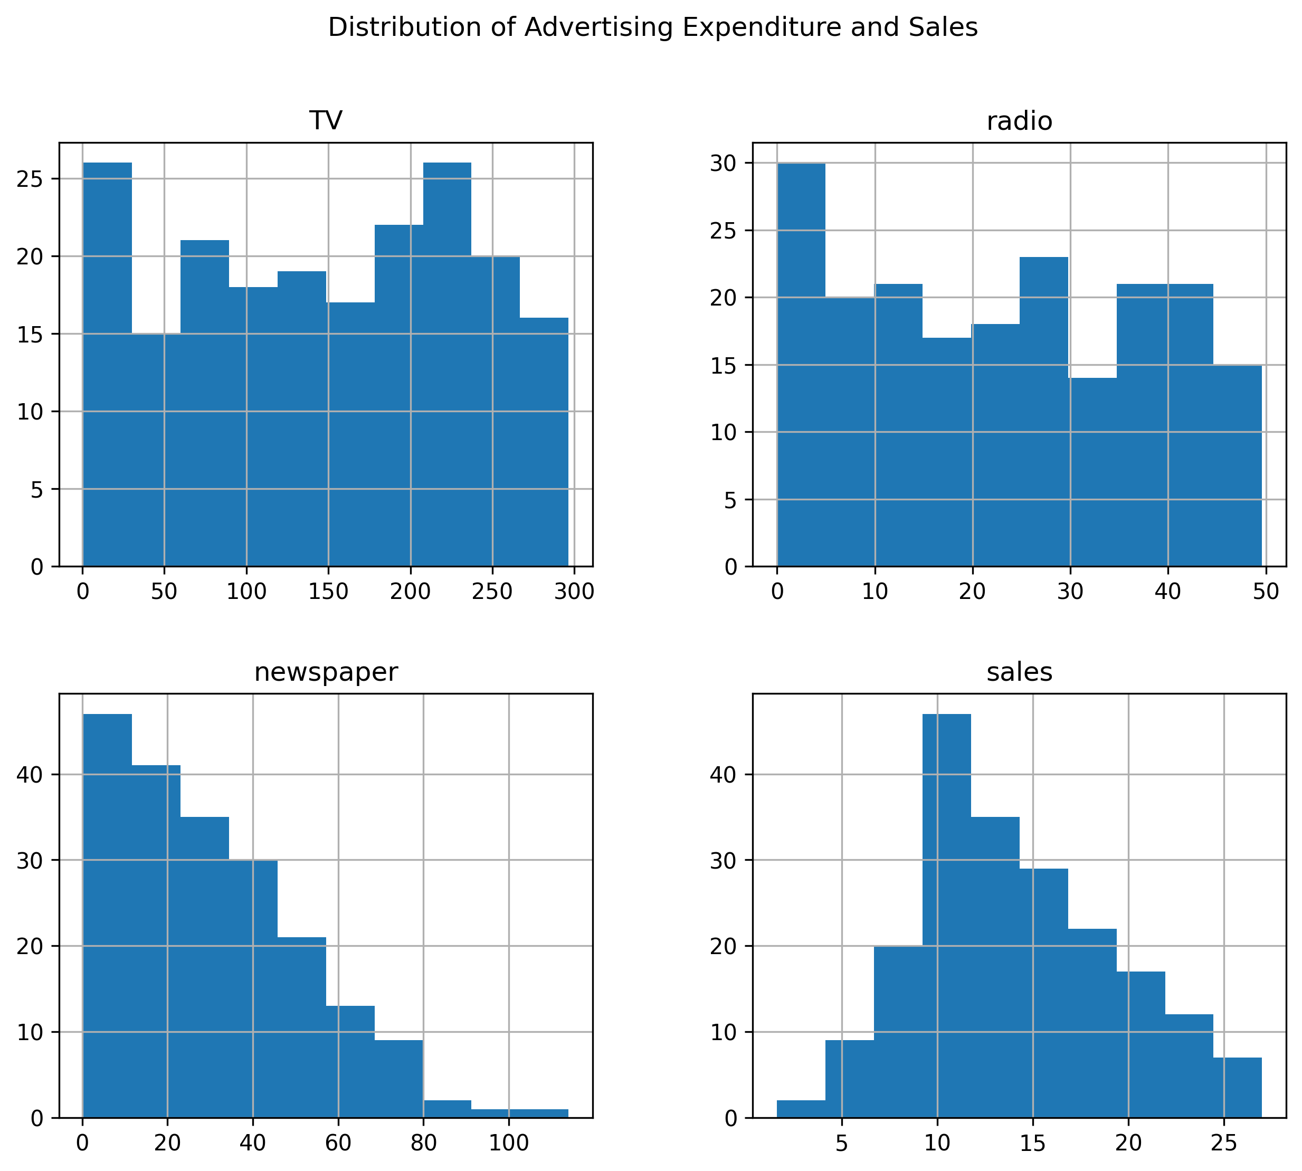
Figure 1: Distribution of Advertising Expenditure and Sales
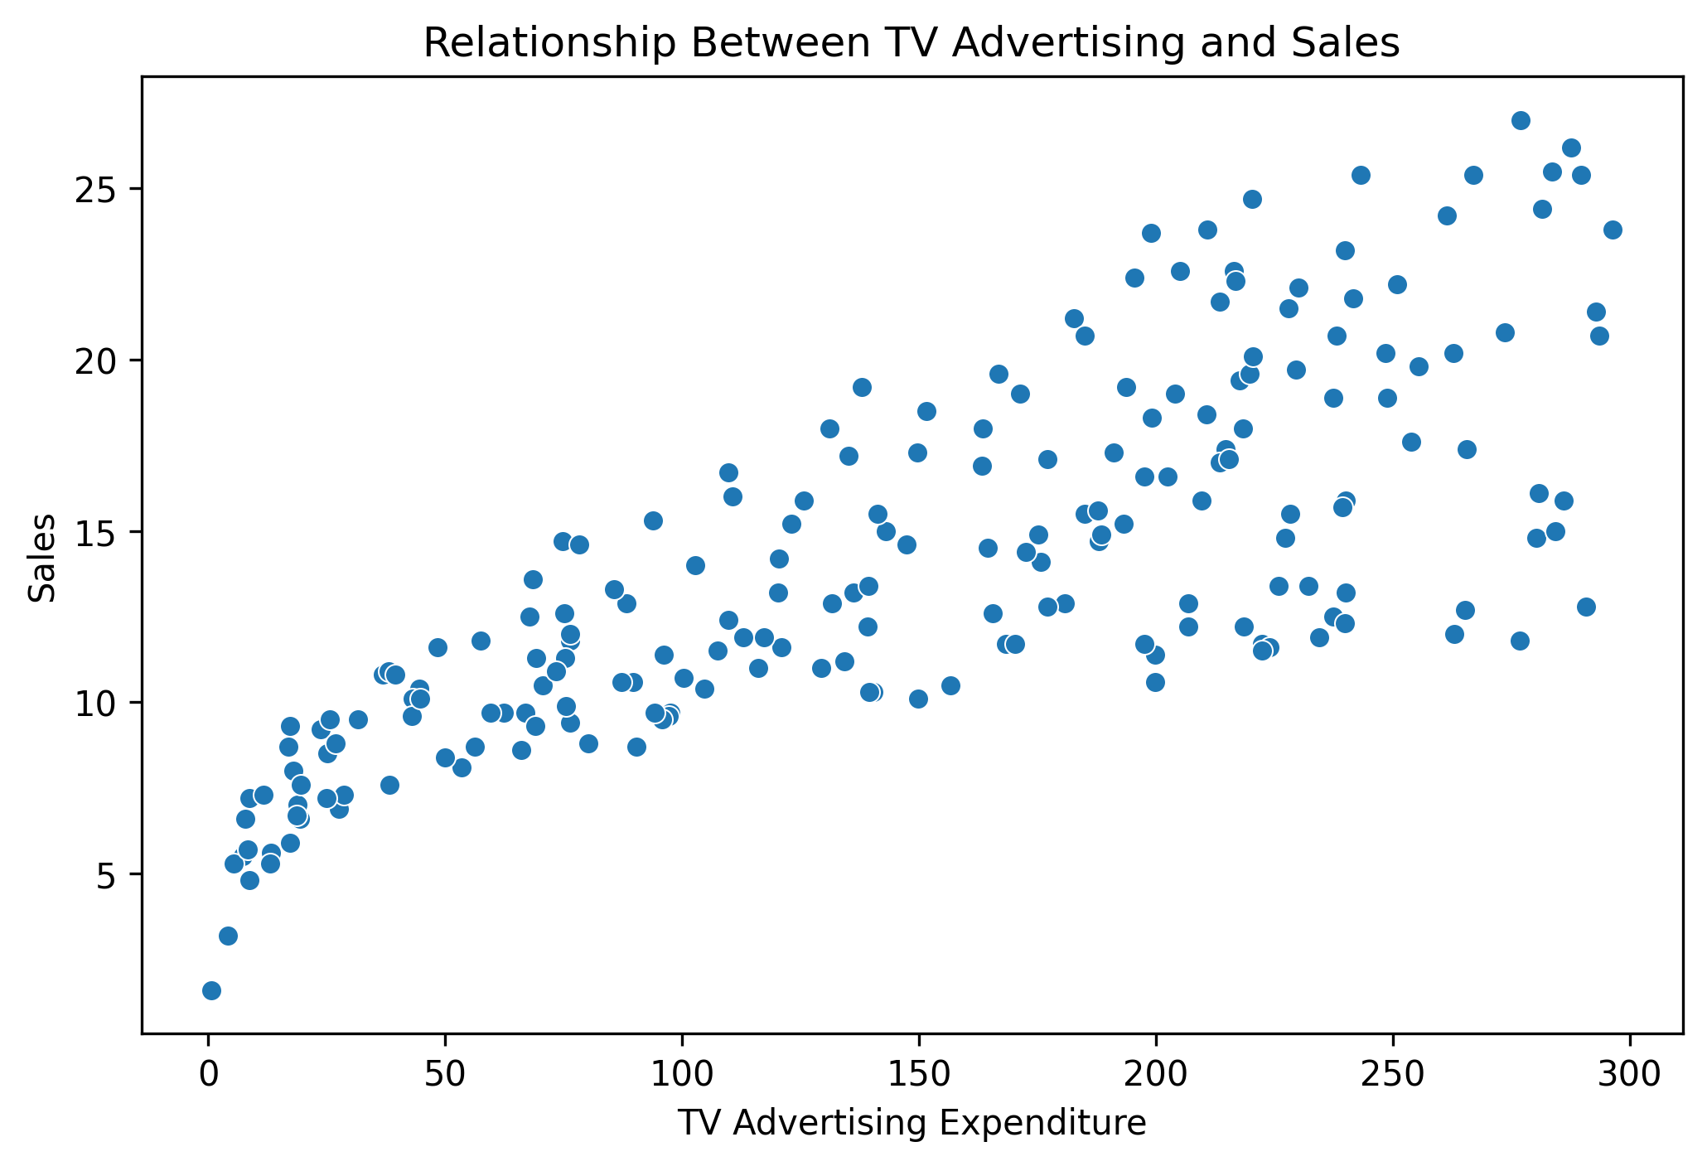
Relationship Between TV Advertising Expenditure and Sales
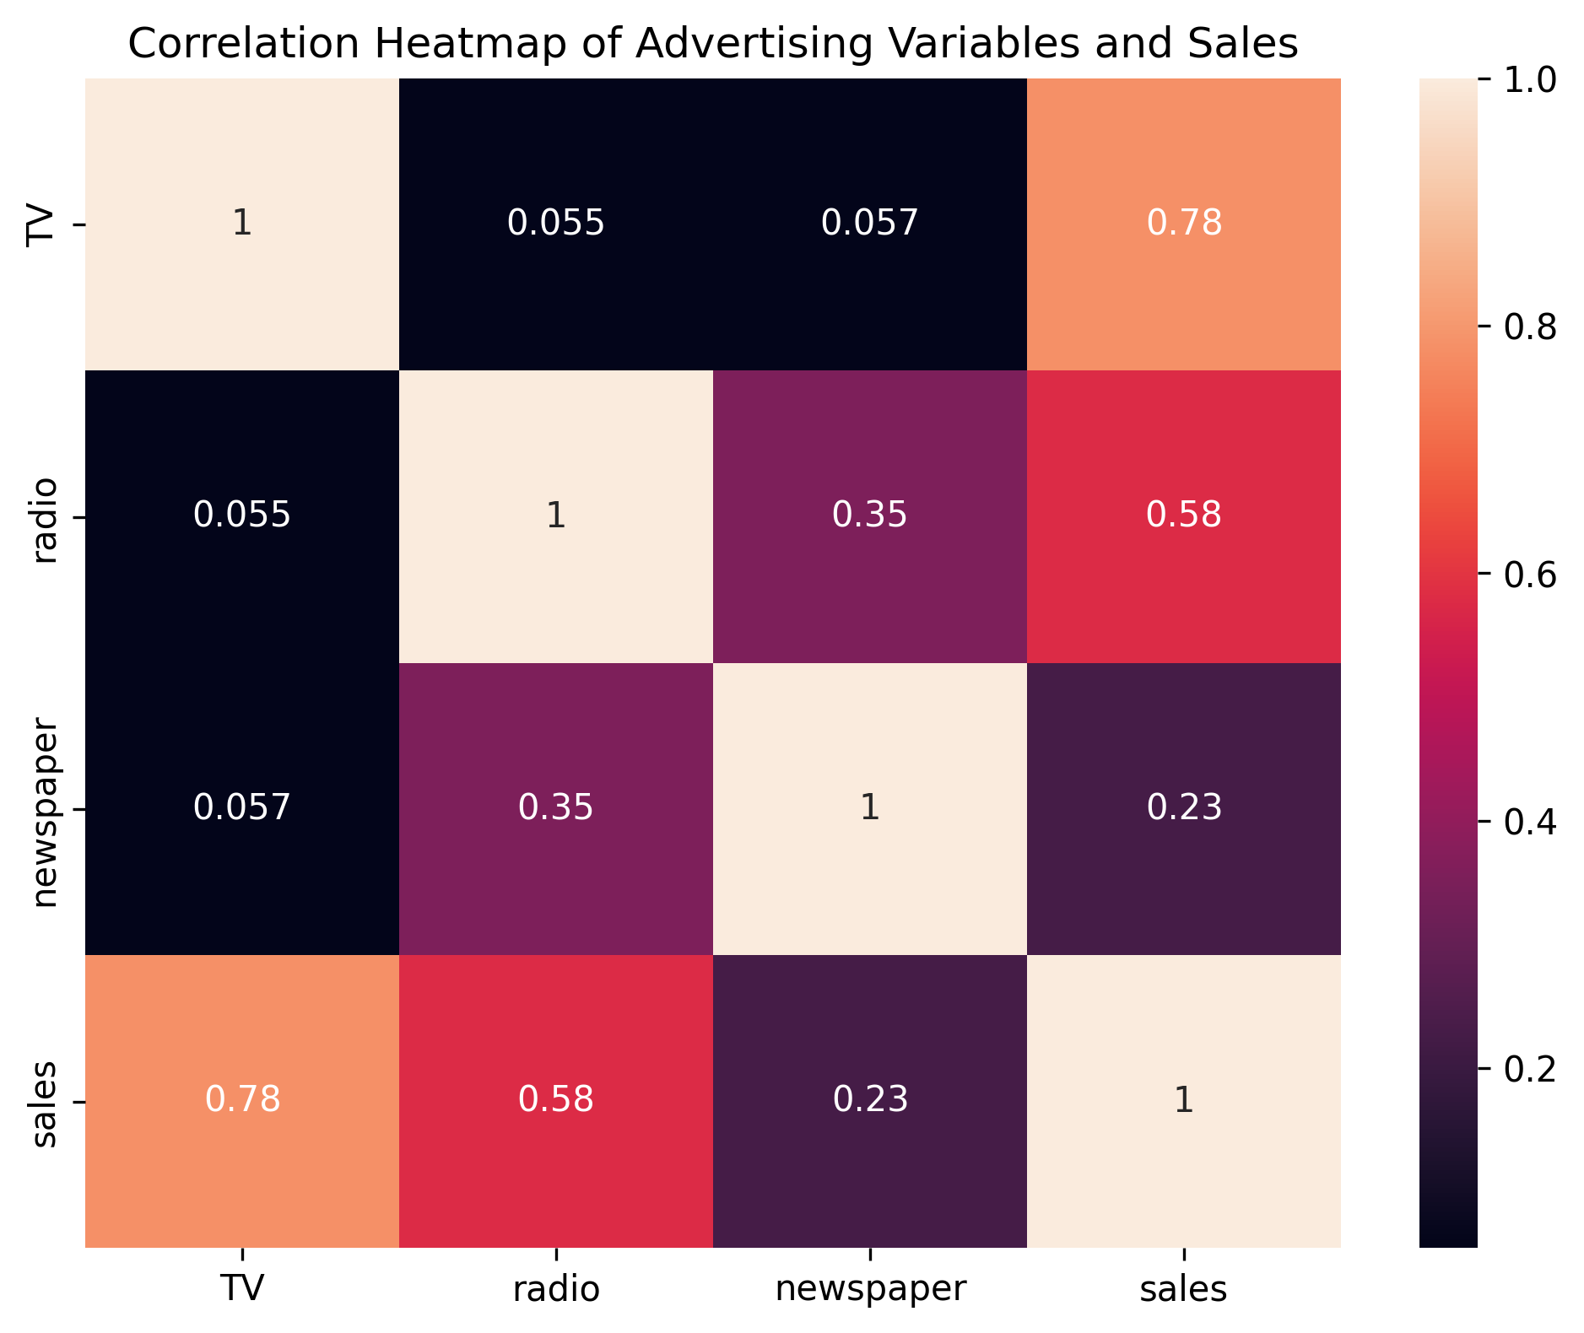
Correlation Heatmap of Advertising Variables and Sales

11. Pearson Correlation Analysis
Pearson's correlation test was performed to measure the linear relationship between TV advertising expenditure and sales.
The Pearson correlation coefficient was 0.7822244249. This indicates a strong positive linear association between TV advertising expenditure and sales.
The p-value was 1.4673897002 × 10⁻⁴². Since this value is far below the significance level of 0.05, the null hypothesis was rejected.
Therefore, the analysis provides strong statistical evidence of a significant positive relationship between TV advertising expenditure and sales.

12. Linear Regression Analysis
A simple ordinary least squares (OLS) regression model was fitted with TV advertising expenditure as the independent variable and sales as the dependent variable.
The estimated regression equation was:
Sales = 7.0326 + 0.0475 × TV
The TV coefficient was 0.0475, indicating a positive association between TV advertising expenditure and predicted sales. The coefficient was statistically significant with p < 0.001.
The model had an R-squared value of 0.612. This means that approximately 61.2% of the observed variation in sales is explained by TV advertising expenditure in this simple regression model.
The overall F-statistic was 312.1 with a model p-value of approximately 1.47 × 10⁻⁴², indicating that the regression model as a whole was statistically significant.
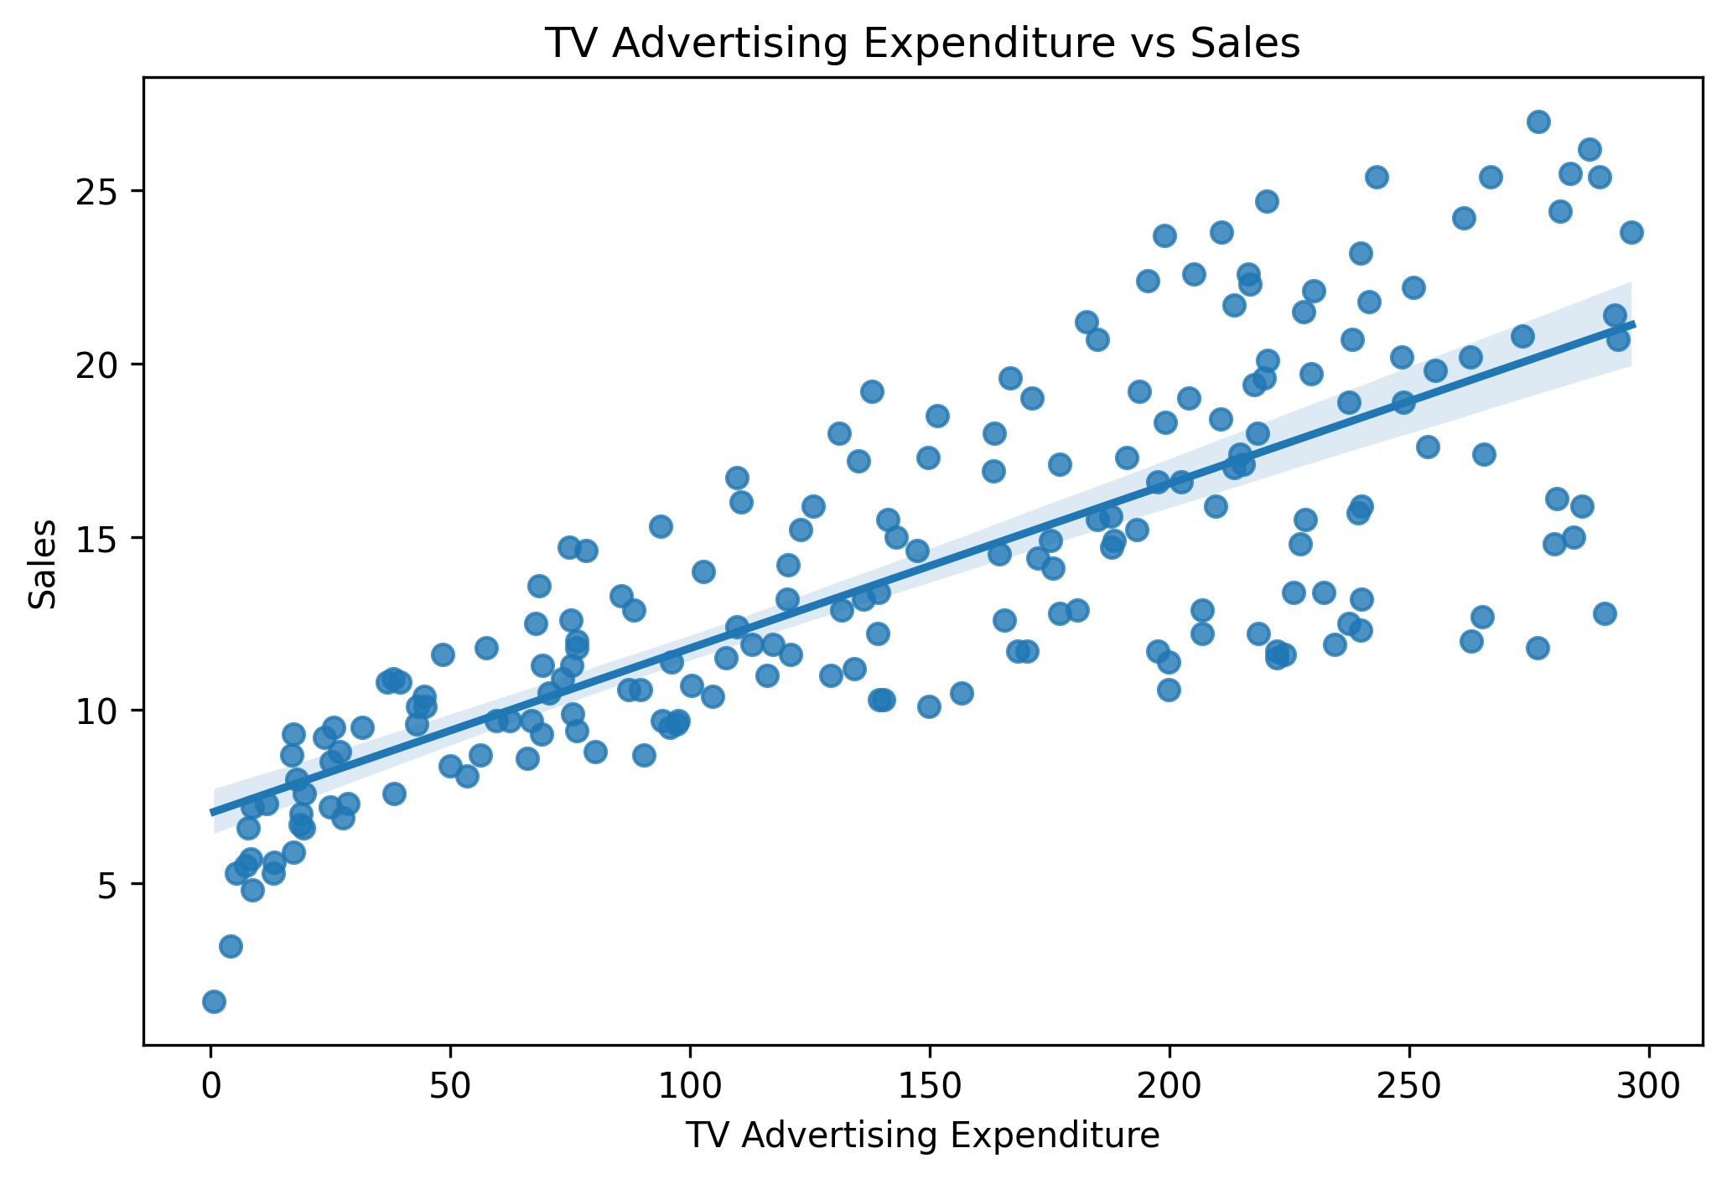
Linear Regression of TV Advertising Expenditure and Sales

13. Confidence Interval
The 95% confidence interval for the TV regression coefficient was approximately 0.042 to 0.053.
Because the entire interval is above zero, the estimated coefficient supports a positive relationship between TV advertising expenditure and sales. Under the assumptions of the model, the interval provides a plausible range for the population regression coefficient.

14. Regression Diagnostics
Regression diagnostics were performed to assess whether the model assumptions were reasonably satisfied.
The Shapiro-Wilk test produced a statistic of 0.9905 and a p-value of 0.2133. Since the p-value is greater than 0.05, the null hypothesis of normally distributed residuals was not rejected. Therefore, there was not sufficient evidence of non-normal residuals.
The Durbin-Watson statistic was 1.935. Because this value is close to 2, there was no substantial indication of autocorrelation in the residuals.
Residual histograms and residual-versus-fitted-value plots were also examined to visually assess the residual behavior.
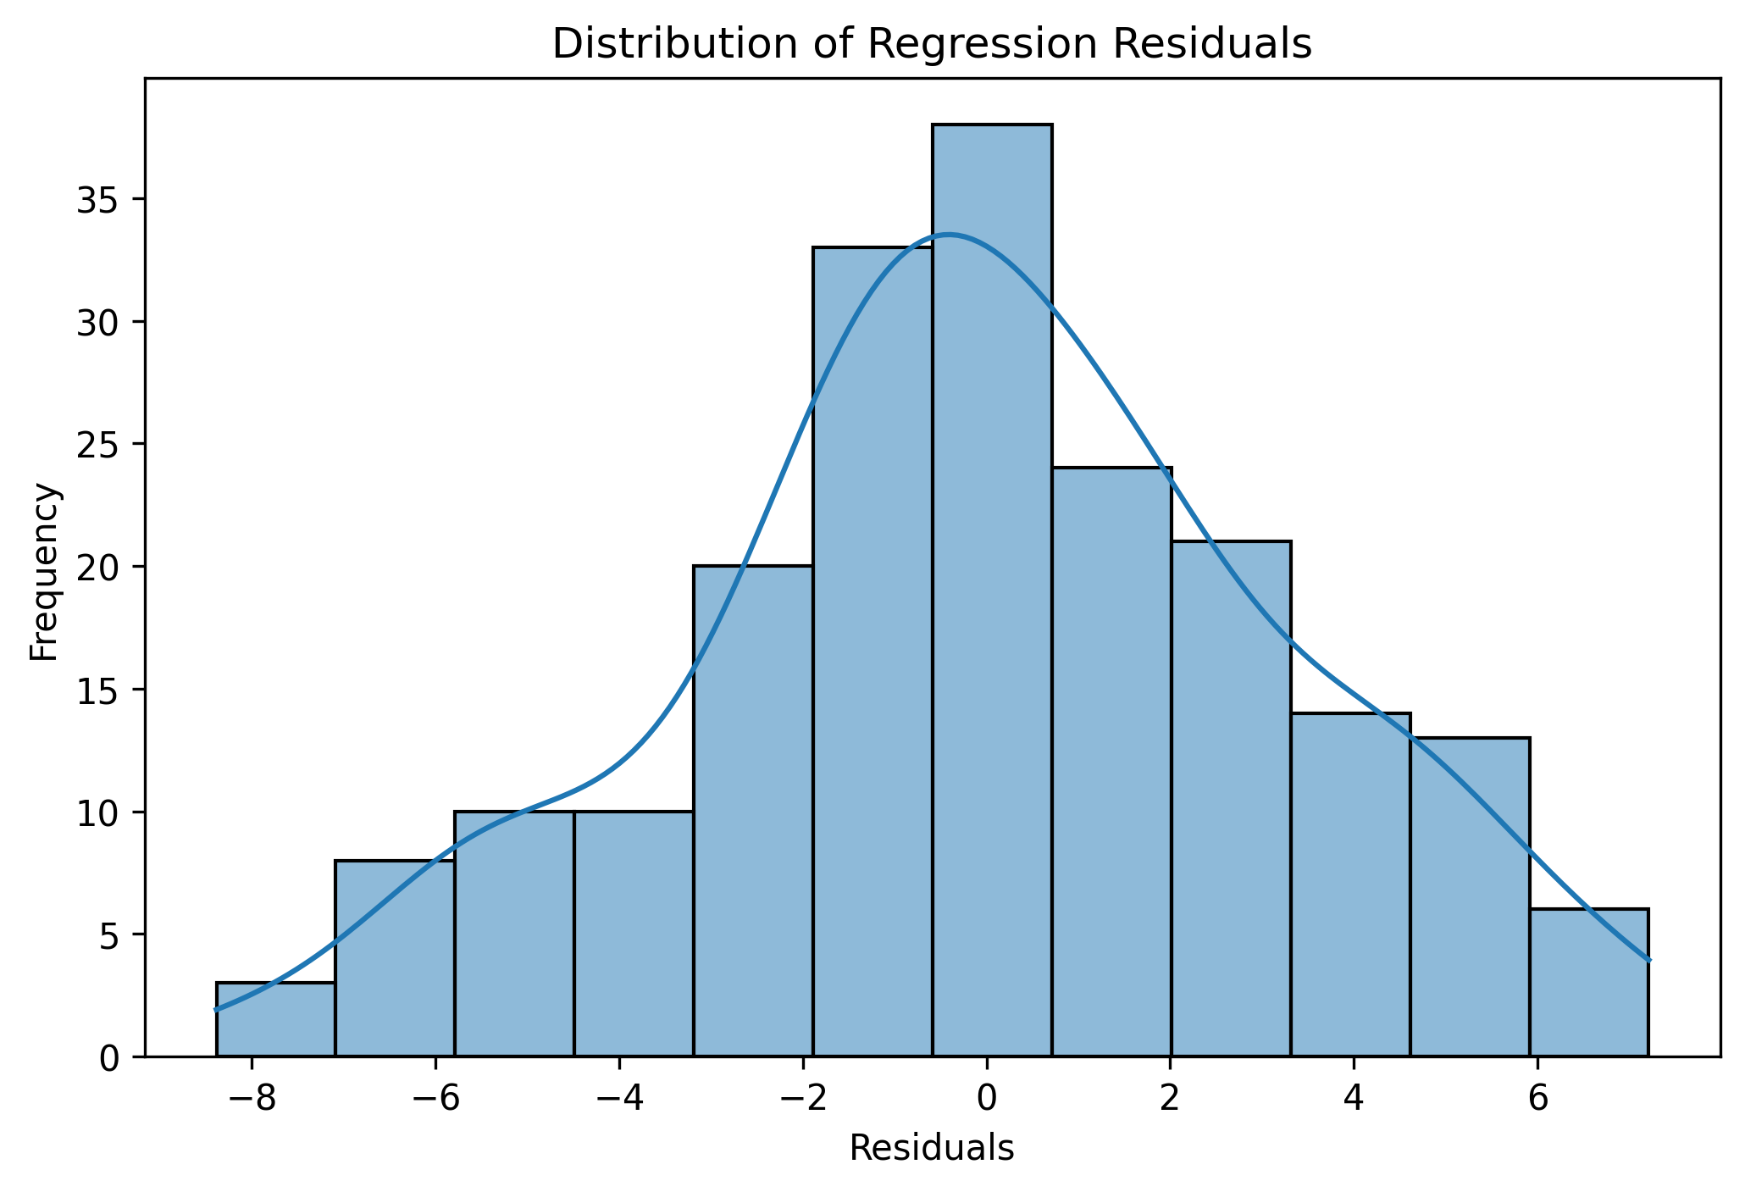
Distribution of Regression Residuals

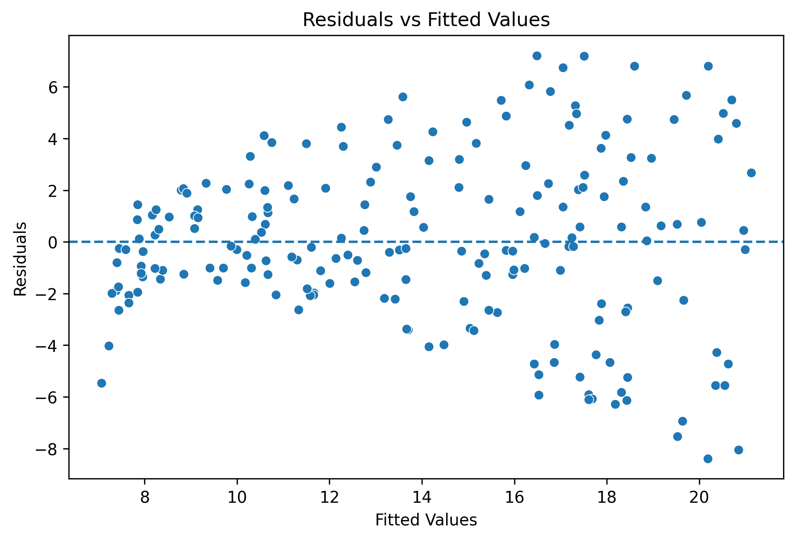
Residuals vs Fitted Values

15. Summary of Statistical Results
Key results from the analysis are summarized below:
• Number of observations: 200
• Missing values: 0
• Duplicate rows: 0
• Pearson correlation between TV and sales: 0.7822
• Pearson correlation p-value: 1.467 × 10⁻⁴²
• Regression R-squared: 0.612
• TV regression coefficient: 0.0475
• TV coefficient p-value: < 0.001
• 95% confidence interval for TV coefficient: 0.042–0.053
• F-statistic: 312.1
• Regression model p-value: 1.47 × 10⁻⁴²
• Shapiro-Wilk p-value: 0.2133
• Durbin-Watson statistic: 1.935

16. Hypothesis Decision
The Pearson correlation test produced a p-value far below 0.05. The TV coefficient in the regression model was also statistically significant.
Therefore, the null hypothesis is rejected and the alternative hypothesis is supported.
The analysis indicates that TV advertising expenditure has a statistically significant positive association with product sales in the analyzed dataset.

17. Interpretation and Business Implications
The findings suggest that TV advertising expenditure is strongly associated with sales in the dataset. The correlation coefficient of 0.7822 indicates a strong positive linear relationship, while the regression results show that TV is a statistically significant predictor of sales.
The R-squared value of 0.612 indicates that TV advertising expenditure alone explains a substantial portion of the variation in sales. However, approximately 38.8% of the variation is not explained by this simple model and may be related to other factors such as radio advertising, newspaper advertising, pricing, product characteristics, market conditions, seasonality, competition, or other variables not included in the model.
From a business perspective, the results suggest that TV advertising may be an important factor to consider when analyzing sales performance. However, decisions about increasing advertising expenditure should not be based on this analysis alone.

18. Limitations
This study has several limitations. First, the analysis focuses primarily on the relationship between TV advertising expenditure and sales and does not include all possible factors affecting sales.
Second, correlation and regression in this dataset demonstrate statistical association but do not by themselves establish causation. Therefore, the results should not be interpreted as proof that increasing TV advertising will directly cause a specific increase in sales.
Third, the model is a simple linear regression model. A multiple regression model including TV, radio, newspaper, and other relevant variables could provide a more comprehensive explanation of sales variation.
Finally, the findings are based on the selected dataset and may not automatically generalize to every business, industry, or market.

19. Future Scope
Future analysis could extend this work by building a multiple linear regression model using all advertising channels. Additional statistical tests could be used to compare the effectiveness of different advertising channels.
Machine learning models could also be developed to predict sales and compare predictive performance. Additional variables such as price, season, region, customer demographics, and market conditions could improve the analysis.
The project could further be extended with cross-validation, feature selection, residual diagnostics, and model comparison to develop a more robust predictive framework.

20. Conclusion
This project demonstrated the application of statistical analysis and hypothesis testing using Python. The Advertising dataset was cleaned and explored using descriptive statistics and visualizations. Pearson correlation and simple linear regression were then used to formally investigate the relationship between TV advertising expenditure and product sales.
The Pearson correlation coefficient of 0.7822 showed a strong positive association, and the extremely small p-value provided strong evidence that the relationship was statistically significant. The regression model had an R-squared value of 0.612, indicating that approximately 61.2% of the variation in sales was explained by TV advertising expenditure in the simple model. The regression coefficient was positive and statistically significant, with a 95% confidence interval from 0.042 to 0.053.
Regression diagnostics did not provide strong evidence of non-normal residuals, and the Durbin-Watson statistic was close to 2. Overall, the findings support rejection of the null hypothesis and indicate a statistically significant positive association between TV advertising expenditure and sales.
The project also demonstrates the importance of combining statistical tests with visualization and careful interpretation. While the results indicate a strong association, they should not be interpreted as proof of causation. Further analysis using multiple variables and more advanced modeling techniques would provide a deeper understanding of sales performance.

21. Python Code Used
# Import libraries
import pandas as pd
import numpy as np
import matplotlib.pyplot as plt
import seaborn as sns
from scipy import stats
import statsmodels.api as sm
# Load dataset
url = "https://raw.githubusercontent.com/selva86/datasets/master/Advertising.csv"
df = pd.read_csv(url)
# Remove unnecessary index column
df = df.drop(columns=['Unnamed: 0'])
# Basic checks
print(df.shape)
print(df.info())
print(df.isnull().sum())
print(df.duplicated().sum())
# Descriptive statistics
print(df.describe())
print(df.median())
# Correlation matrix
print(df.corr())
# Histograms
df.hist(figsize=(10, 8))
plt.suptitle("Distribution of Advertising Expenditure and Sales")
plt.show()
# Scatter plot
plt.figure(figsize=(8, 5))
sns.scatterplot(data=df, x='TV', y='sales')
plt.title("Relationship Between TV Advertising and Sales")
plt.xlabel("TV Advertising Expenditure")
plt.ylabel("Sales")
plt.show()
# Pearson correlation test
correlation, p_value = stats.pearsonr(df['TV'], df['sales'])
print("Pearson Correlation:", correlation)
print("P-value:", p_value)
# Linear regression
X = df[['TV']]
y = df['sales']
X = sm.add_constant(X)
model = sm.OLS(y, X).fit()
print(model.summary())
# Regression plot
plt.figure(figsize=(8, 5))
sns.regplot(data=df, x='TV', y='sales')
plt.title("TV Advertising Expenditure vs Sales")
plt.xlabel("TV Advertising Expenditure")
plt.ylabel("Sales")
plt.show()
# Residuals
residuals = model.resid
# Residual histogram
plt.figure(figsize=(8, 5))
sns.histplot(residuals, kde=True)
plt.title("Distribution of Regression Residuals")
plt.xlabel("Residuals")
plt.ylabel("Frequency")
plt.show()
# Residuals vs fitted values
plt.figure(figsize=(8, 5))
sns.scatterplot(x=model.fittedvalues, y=residuals)
plt.axhline(y=0, linestyle='--')
plt.title("Residuals vs Fitted Values")
plt.xlabel("Fitted Values")
plt.ylabel("Residuals")
plt.show()
# Shapiro-Wilk test
shapiro_stat, shapiro_p = stats.shapiro(residuals)
print("Shapiro-Wilk Statistic:", shapiro_stat)
print("Shapiro-Wilk P-value:", shapiro_p)
# Confidence intervals
print(model.conf_int())
# Correlation heatmap
plt.figure(figsize=(8, 6))
sns.heatmap(df.corr(), annot=True, cmap='coolwarm', fmt='.2f')
plt.title("Correlation Heatmap of Advertising Variables and Sales")
plt.show()

22. References
1. Python documentation and standard scientific Python libraries used for data analysis.
2. Pandas documentation for data manipulation and descriptive statistics.
3. SciPy documentation for statistical testing.
4. Statsmodels documentation for ordinary least squares regression.
5. Advertising dataset used for educational statistical analysis.

23. Key Results Table
Analysis | Result | Interpretation
Pearson correlation | 0.7822 | Strong positive association
Pearson p-value | 1.467 × 10⁻⁴² | Statistically significant
R-squared | 0.612 | 61.2% variation explained
TV coefficient | 0.0475 | Positive association
TV p-value | < 0.001 | Statistically significant
95% CI | 0.042–0.053 | Positive coefficient range
Shapiro-Wilk p-value | 0.2133 | No evidence of non-normal residuals
Durbin-Watson | 1.935 | Close to 2; little evidence of autocorrelation

