Week 4 Task: Machine Learning Model Development and Evaluation

1. Introduction
This project focuses on developing and evaluating machine learning models using Python. The Advertising dataset was used to predict product sales based on advertising expenditure on TV, radio, and newspaper. The complete process includes data cleaning, exploratory data analysis, model training, evaluation, visualization, and error analysis.

2. Objective
The main objectives of this project are:
- To prepare and clean the dataset.
- To perform exploratory data analysis.
- To develop and evaluate machine learning models.
- To compare model performance using suitable metrics.
- To analyze prediction errors and possible improvements.

3. Dataset Description
The Advertising dataset contains 200 observations and the following variables:
Variable | Description
TV | TV advertising expenditure
Radio | Radio advertising expenditure
Newspaper | Newspaper advertising expenditure
Sales | Product sales (target variable)
The Unnamed: 0 column was removed because it was only an index column.

4. Tools and Libraries
The project was implemented using Python and the following libraries:
- Pandas
- NumPy
- Matplotlib
- Seaborn
- Scikit-learn

5. Data Preparation
The dataset was loaded using Pandas and inspected for data types, missing values, duplicate records, and statistical information.
There were no missing values and no duplicate rows. The unnecessary Unnamed: 0 column was removed.
The features were:
TV, radio, newspaper
The target variable was:
sales
The dataset was divided into 80% training data and 20% testing data.

6. Exploratory Data Analysis
EDA was performed using histograms, scatter plots, and a correlation matrix to understand the dataset and relationships between advertising expenditure and sales.
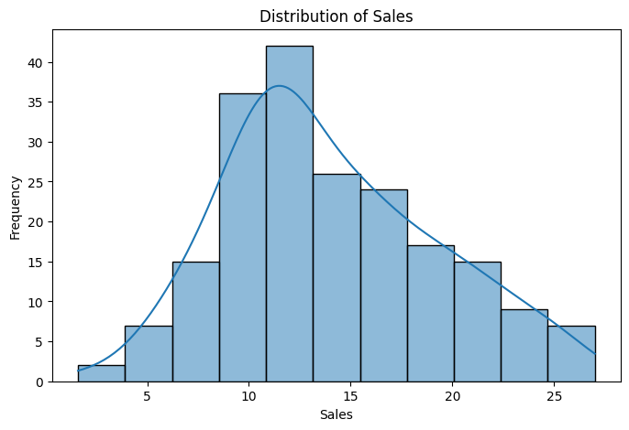
Distribution of Sales
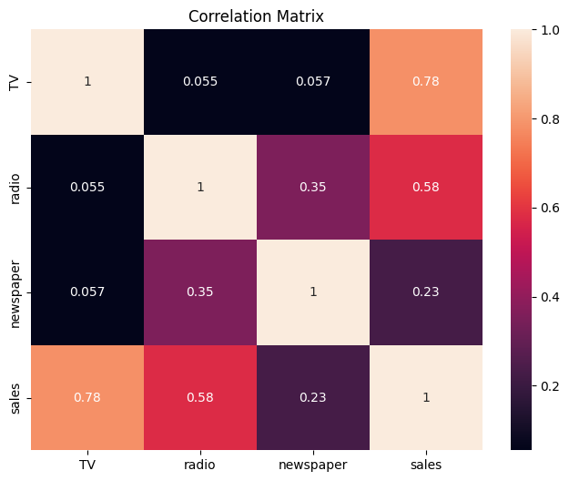
Correlation Matrix
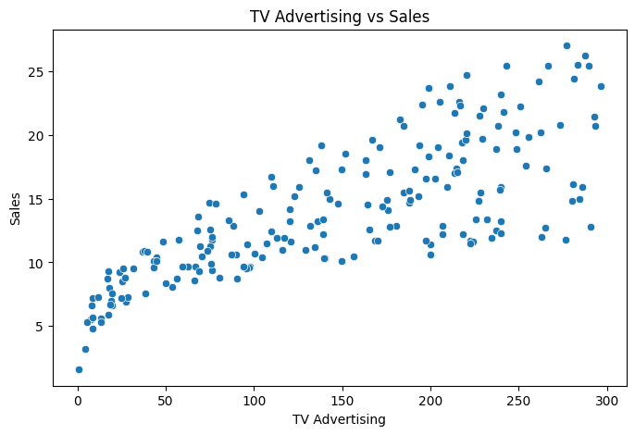
TV vs Sales Scatter Plot
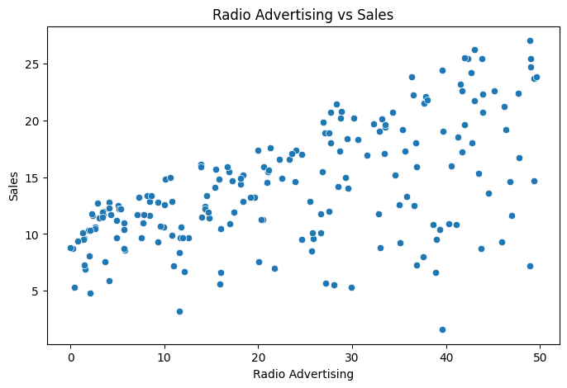
Radio vs Sales Scatter Plot
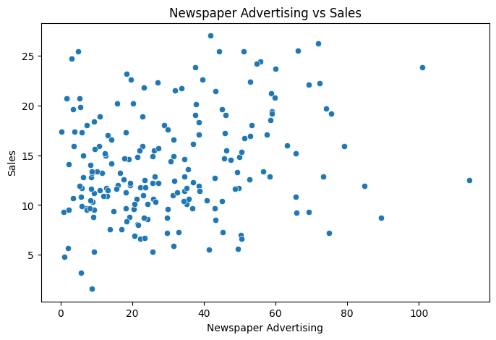
Newspaper vs Sales Scatter Plot
The analysis showed that TV and radio had stronger relationships with sales compared with newspaper advertising.

7. Model Development
Two regression models were developed.

7.1 Linear Regression
Linear Regression was used as the baseline model because it is simple and suitable for predicting a continuous variable such as sales.

7.2 Decision Tree Regression
A Decision Tree Regressor was used as a second model. The maximum depth was set to 5 to control model complexity and reduce overfitting.

8. Model Evaluation
The models were evaluated using MAE, MSE, RMSE, and R² Score.
Model | MAE | MSE | RMSE | R² Score
Linear Regression | 1.461 | 3.174 | 1.782 | 89.94%
Decision Tree | 1.194 | 2.697 | 1.642 | 91.45%
The Decision Tree performed better than Linear Regression because it had lower error values and a higher R² score.
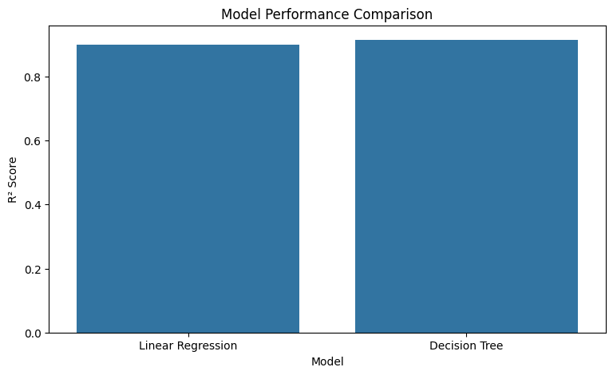
Model Performance Comparison

9. Model Performance Visualization
The following visualizations were used to understand the performance of the final Decision Tree model.

9.1 Actual vs Predicted Sales
[Insert Image: Decision Tree Actual vs Predicted Sales]
The points being close to the diagonal line indicate that the predicted values are reasonably close to the actual sales values.

9.2 Residual Plot

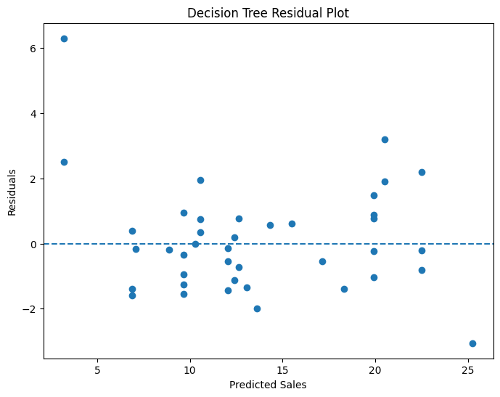Decision Tree Residual Plot
The residuals are distributed around zero, indicating that the model makes both overpredictions and underpredictions without a strong systematic pattern.

10. Error and Overfitting Analysis
The Decision Tree achieved an R² score of 98.51% on training data and 91.45% on testing data.
The difference indicates some overfitting. However, the testing score is still strong, showing that the model performs well on unseen data.
Some prediction errors may occur because the dataset contains only three advertising variables and does not include other factors that can affect sales.

11. Feature Importance
The Decision Tree feature importance values were:
- TV: 61.12%
- Radio: 37.76%
- Newspaper: 1.12%
TV was the most influential feature, followed by radio, while newspaper had a much smaller contribution.
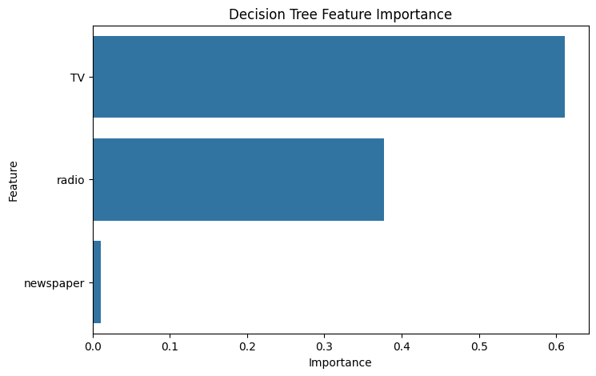Decision Tree Feature Importance

12. Suggestions for Improvement
The model can be improved by:
- Using cross-validation.
- Tuning Decision Tree parameters.
- Testing other models such as Random Forest.
- Using a larger dataset.
- Adding more relevant features.
- Performing feature engineering.

13. Conclusion
This project successfully demonstrated a complete machine learning workflow using the Advertising dataset. Data was cleaned and analyzed before training Linear Regression and Decision Tree models.
The Decision Tree Regressor performed better, achieving an R² score of 91.45%, MAE of 1.194, MSE of 2.697, and RMSE of 1.642 on the test data.
The project provided practical understanding of data preprocessing, model development, evaluation metrics, visualization, error analysis, and model improvement.

