CREATING A REPOSITORY

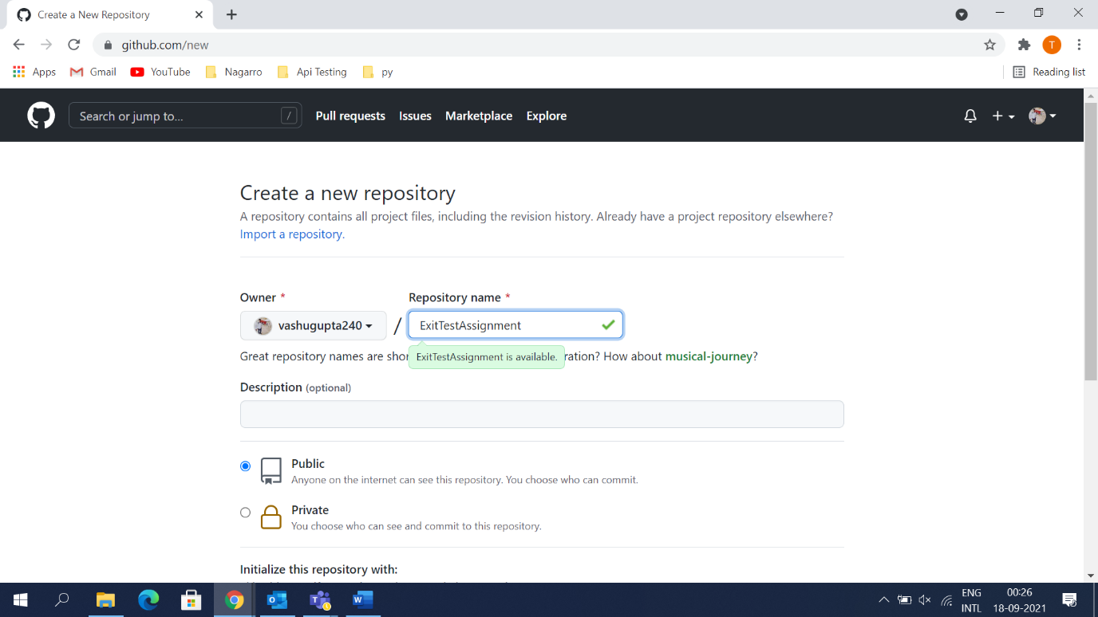

REPOSITORY CREATED

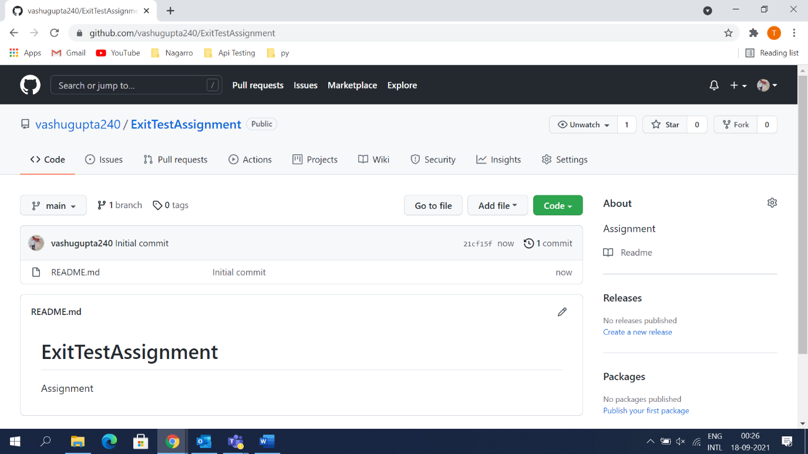

UPLOADIING FILES BY USING GIT BASH

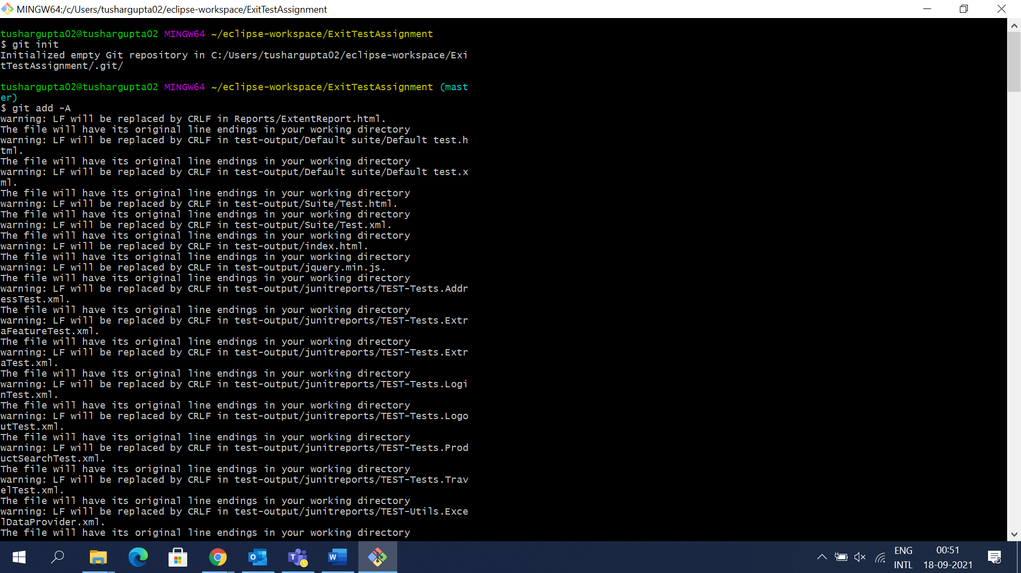

FILE UPLOADED

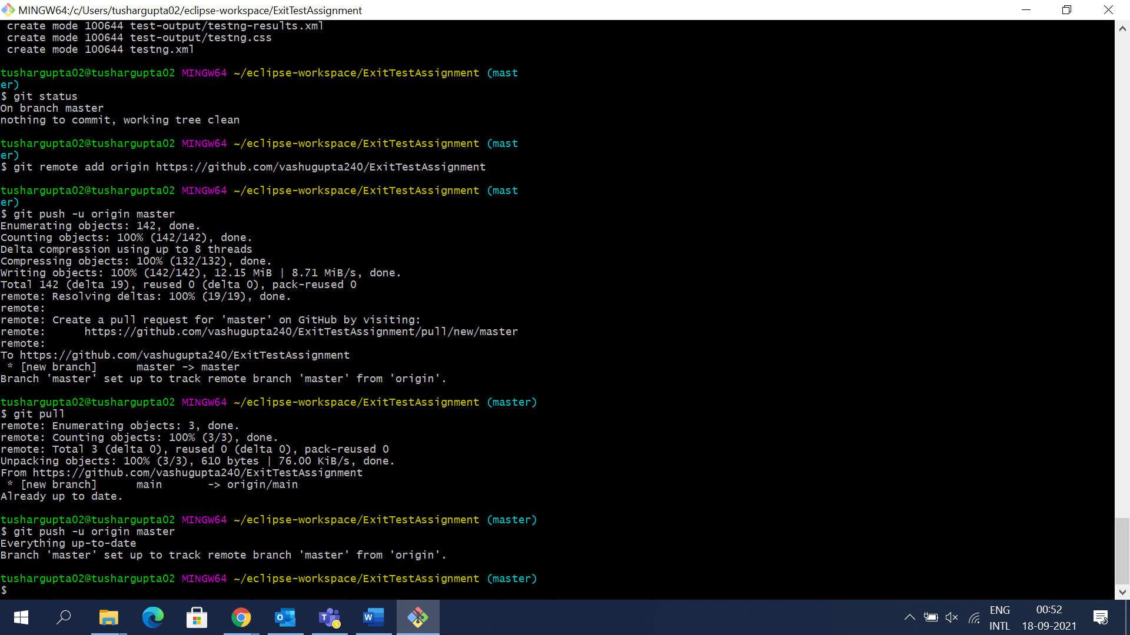

FILES IN GITHUB

CREATING JENKINS PROJECT

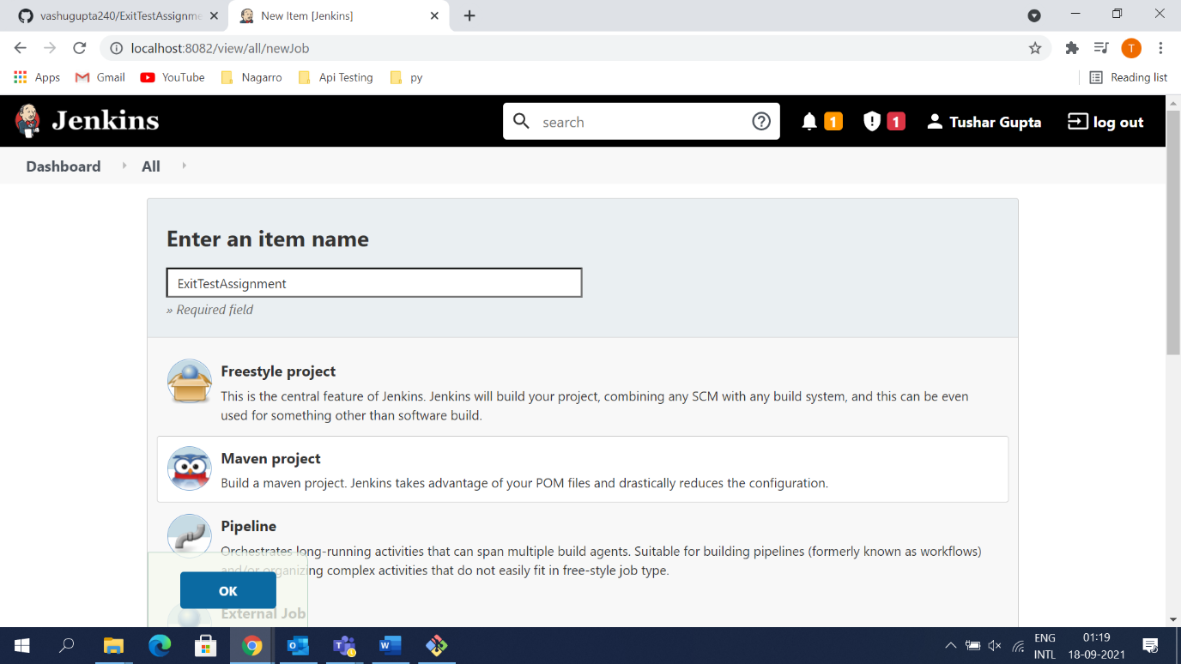

PROVIDING DETAILS

