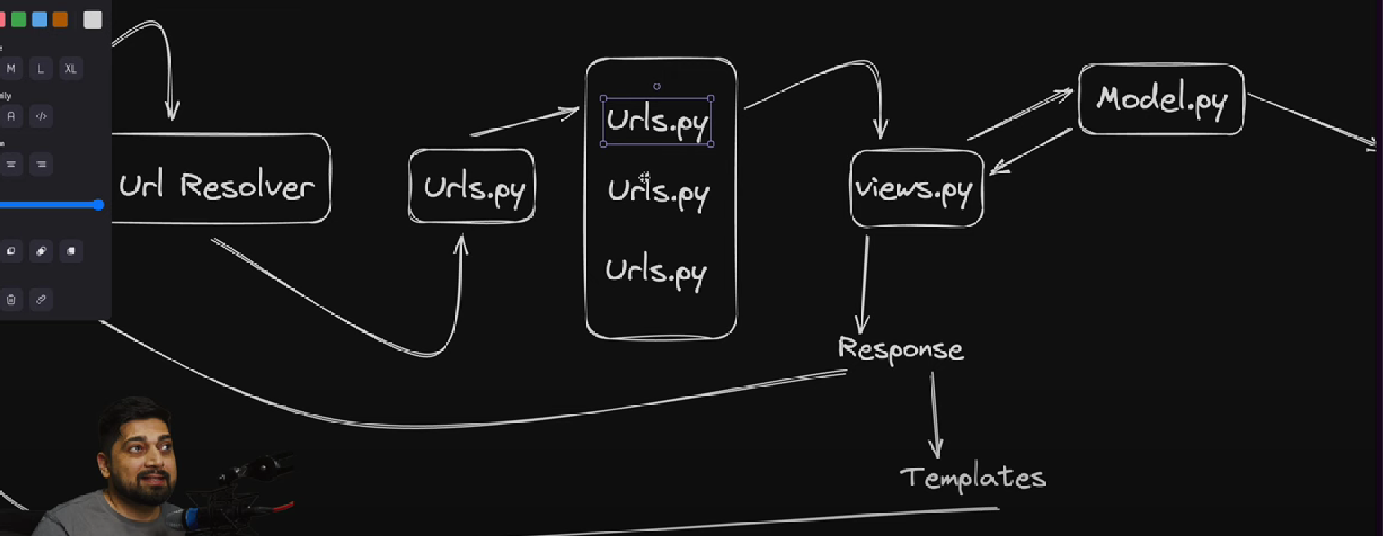

template engine -

kahi bhi inject kr skte ho apna programativly code {% %}

{% static style.css%}

{% load static%}

AFTER MAKING NEW APPS USING PYTHON MANAGE.PY STARTAPP MAKE MAIN PROJECT AWARE NEW APPS ARE ADDED

ADMIN MAI REGISTER KRO MODEL