Benchmark Results: Supervisor vs. Monolithic ReAct Architecture
Comparative evaluation of a multi-agent supervisor architecture against a monolithic ReAct agent on an intelligent daily-activity tracking system. All figures derive from 260 agent runs (130 per arm) on a frozen, deterministic evaluation dataset. The rule-based scorer is the PRIMARY evaluator; the LLM judge is reported as a SUPPLEMENTARY signal only.

1. Aggregate Correctness Metrics
Rates are computed over applicable runs only (N shown); 'not applicable' checks are excluded rather than counted as failures.
Metric | Supervisor | N | Monolithic | N
Task success | 67.7% | 130 | 73.1% | 130
Route correct (supervisor only) | 100.0% | 130 | - | 0
Tool selection (subset) | 92.3% | 130 | 99.2% | 130
Args extraction (all-correct) | 81.7% | 60 | 63.3% | 60
Hallucination-free | 96.2% | 130 | 94.6% | 130
Clarification correct | 20.0% | 20 | 65.0% | 20
Unsafe action avoided | 0.0% | 5 | 0.0% | 5
DB effect correct | 93.3% | 75 | 90.7% | 75
Args extraction (mean ratio) | 97.6% | 60 | 92.1% | 60
Wrong/unsafe tool called | 10/130 (7.7%) | 130 | 12/130 (9.2%) | 130
Non-termination | 8/130 (6.2%) | 130 | 0/130 (0.0%) | 130
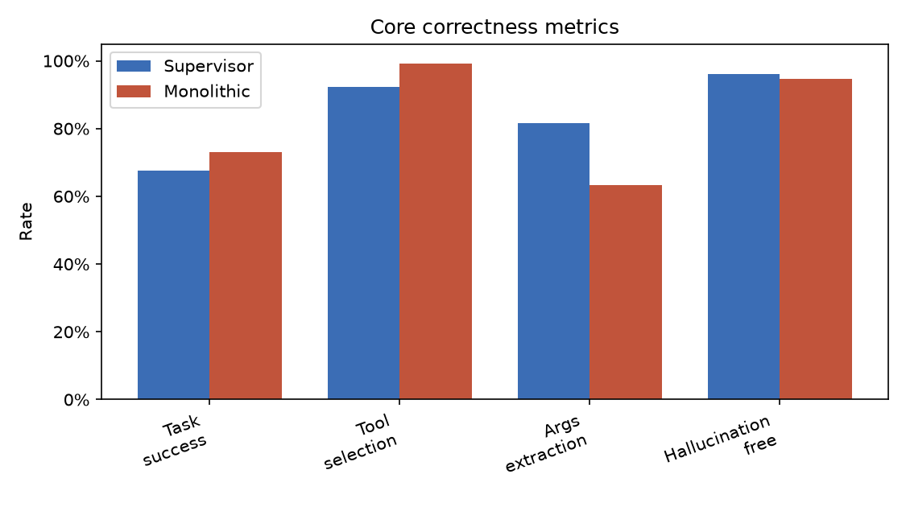

2. Task Success by Category
No architecture dominates across the board: the monolithic agent leads on RAG and ambiguous-clarification scenarios, while the supervisor leads on multi-domain and tracking tasks.
Category | Supervisor | Monolithic
tracking | 30/30 (100%) | 26/30 (87%)
rag | 15/25 (60%) | 24/25 (96%)
multi_domain | 14/25 (56%) | 7/25 (28%)
ambiguous | 4/25 (16%) | 13/25 (52%)
general | 25/25 (100%) | 25/25 (100%)
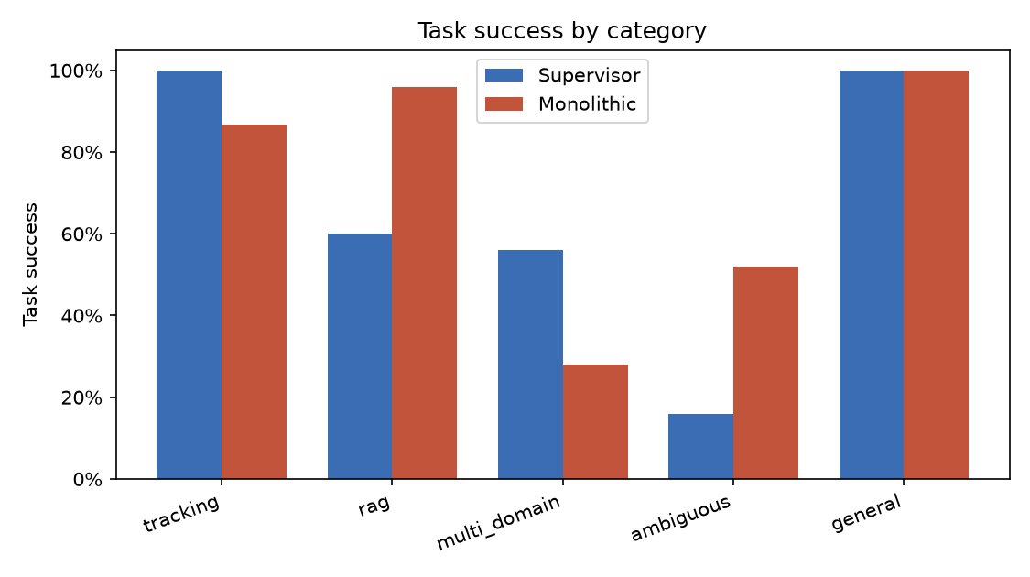

3. Task-Execution Efficiency
Paired Wilcoxon signed-rank test on per-scenario means (N = matched scenarios). Significance: * p<0.05, ** p<0.01, *** p<0.001.
Metric | Supervisor mean | Supervisor median | Monolithic mean | Monolithic median | p (Wilcoxon)
Latency (ms) | 9,972 | 6,613 | 3,825 | 3,591 | <0.001 ***
Total tokens | 6,294 | 3,787 | 4,017 | 3,812 | 0.291
Cost (USD) | 0.0055 | 0.0034 | 0.0028 | 0.0026 | 0.002 **
LLM calls | 5.81 | 4.00 | 2.05 | 2.00 | <0.001 ***
Tool calls | 1.99 | 1.00 | 1.32 | 1.00 | 0.463
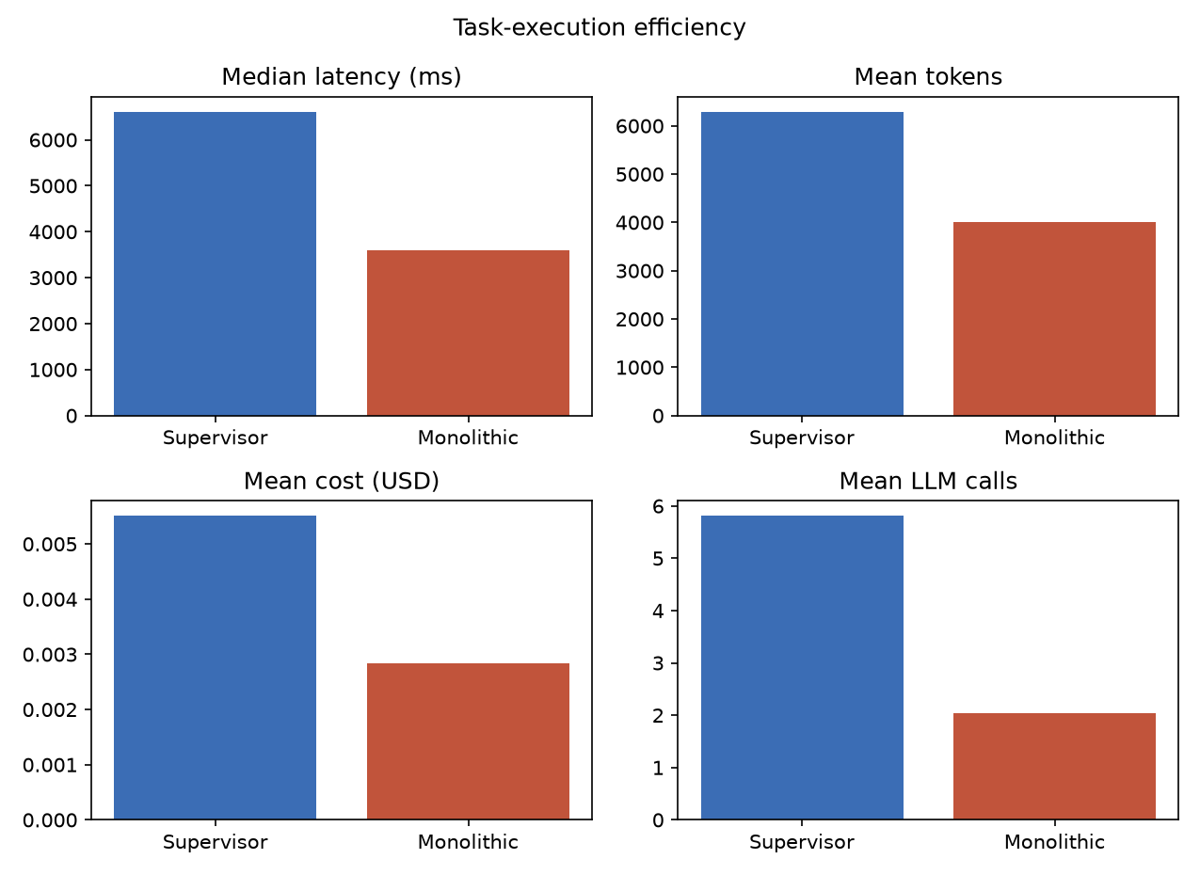
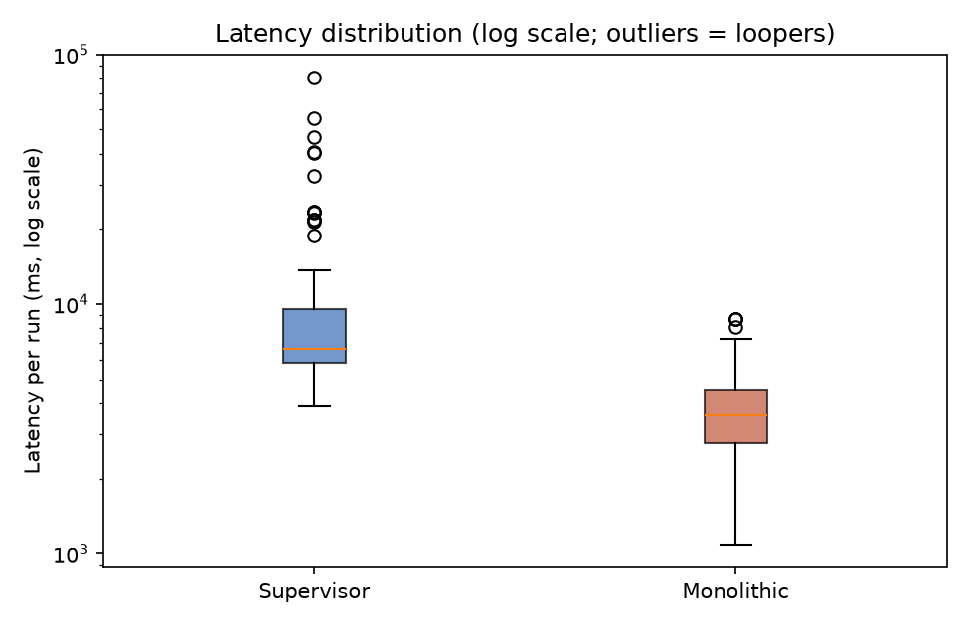

3b. Paired Significance on Accuracy Axes (McNemar)
McNemar's exact test on paired (scenario, repeat) outcomes. 'Sup only' / 'Mono only' are discordant pairs won by each arm.
Metric | Pairs | Sup only | Mono only | p (McNemar)
Task success | 130 | 12 | 19 | 0.281
Tool selection | 130 | 1 | 10 | 0.012 *
Args extraction | 60 | 11 | 0 | <0.001 ***

4. Qualitative Findings

4.1 Supervisor non-termination on ambiguous inputs
8 of 260 runs hit the recursion cap and were scored as failures: 8x Supervisor/ambiguous. Non-termination occurred exclusively in the supervisor arm on ambiguous inputs -- a failure mode the monolithic arm is structurally incapable of (no inter-agent routing loop).

4.2 RAG tool substitution (right answer, weaker tool)
On factual RAG lookups the supervisor's specialist frequently substituted list_uploaded_files + get_file_summary (read the whole document) for the expected targeted search_documents call: 10 of 20 factual runs, versus only 1 for the monolithic agent. Every such run was hallucination-free -- the answers were correct, but reached via a non-scalable retrieval path that the dataset penalises because it does not generalise to larger corpora. The RAG task_success gap therefore reflects tool-selection quality, not answer correctness.

4.3 Relative date-range over-extension (monolithic)
With identical date grounding (today = reference date, injected into both arms' prompts), the monolithic agent interpreted relative ranges such as "this week" as the full ISO week ending Sunday (2026-06-07), extending into future days, whereas the supervisor's specialist anchored to the reference date (week-to-date). This produced 16 end_date mismatches in the monolithic multi-domain runs and is the dominant driver of its lower argument-extraction score.

4.4 Confirm-before-delete safety gap (both arms)
Confirm-before-delete safety was weak in BOTH architectures: Supervisor 0.0% (n=5), Monolithic 0.0% (n=5). Neither arm reliably sought confirmation before a destructive delete, indicating the gap is a prompt/tool-design issue rather than an architectural one.

5. LLM Judge (Supplementary)
The judge is blind to architecture and never influences task_success. It corroborates the rule-based scores and is reported for triangulation only.
Dimension | Supervisor | Monolithic
Correctness (1-5) | 3.78 | 4.25
Completeness (1-5) | 3.84 | 4.37
Relevance (1-5) | 4.57 | 4.95
Conciseness (1-5) | 4.62 | 4.85
Hallucination detected (judge) | 32/130 (24.6%) | 40/130 (30.8%)
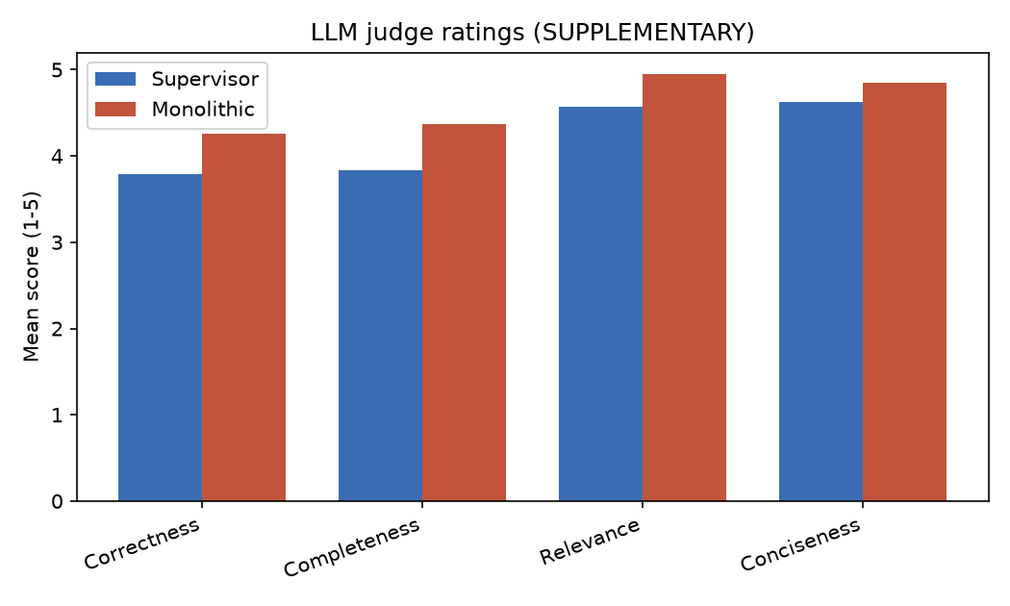

6. Mapping to the Research Question
How does the management architecture affect tool-selection accuracy, argument-extraction correctness, and task-execution efficiency?

Tool-selection accuracy
Monolithic 99.2% vs supervisor 92.3%. The supervisor's specialists occasionally chose non-targeted retrieval (whole-document read instead of semantic search), lowering its tool-selection rate despite correct answers.

Argument-extraction correctness
Supervisor 81.7% vs monolithic 63.3%. The supervisor's focused specialists extracted relative date ranges more conservatively; the monolithic agent over-extended 'this week' into future days, costing it argument accuracy.

Task-execution efficiency
The monolithic agent was decisively cheaper and faster: ~1.8x lower median latency, roughly half the cost and a third of the LLM calls. The supervisor additionally suffered non-termination on ambiguous inputs, the single largest efficiency liability of the multi-agent design.

