HIGH EFFICIENCY METHODS FOR MICROPROPAGATION AND REGENERATION OF NEPENTHES HYBRIDS
RUANGWIT PORRUAN AND SOMBOON ANUNTALABHOCHAI*
Department of Biology, Faculty of Science, Chiang Mai University, Chiang Mai 50200, Thailand.
*Fax: +66-53- 892259, *E-mail: soanu.1@gmail.com
Abstract
Nodal segments of Nepenthes hybrids were cut from seedlings and cultured on CPM (Carnivorous Plant Basal Mixture + Nitsch vitamins + 25g l⁻¹ sucrose) containing 0.5-2.0 mg l⁻¹ of 6-benzylaminopurine (BAP) to produce 2-3 mm axillary shoots in each node after 5 weeks of culture. These axillary shoots were then excised and subcultured in CPM using different concentrations and/or combinations of auxins (Indole-3-Butyric acid ;IBA-0.5 -2 mg l⁻¹, Naphthaleneacetic acid; NAA- 0.5 -2 mg l⁻¹, 2, 4-Dichlorophenoxyacetic acid; 2, 4-D at 0.5-2 mg l ⁻¹) and cytokinins (BAP at 0.5-2 mgl⁻¹). CPM with 1-2 mg l⁻¹ of 6-benzylaminopurine gave superior results in producing multiple shoots at the shoot base. Single shoots were then excised and transferred to CPM containing 0.5-4 mg l⁻¹ of NAA or 0.5-4 mg l⁻¹ of IBA as a rooting medium. CPM containing 2 mg l⁻¹ IBA gave the best results for root induction. Surprisingly, Nepenthes seedlings cultured on CPM containing 0.5-2 mg l⁻¹ of NAA produced larger pitchers at the leaf tips than that with IBA containing hormone-free medium.
Key words: Micropropagation, Regeneration, Nepenthes, Pitcher, Carnivorous plant, two step regeneration system, auxin, cytokinin

Introduction
Nepenthes is a genus of tropical plants containing 129 species (McPherson, 2010) and many hybrid cultivars which are widespread throughout Southeast Asia, Australia, India and Madagascar (Clarke, 1997). Nepenthes are more commonly known as pitcher plants because they have modified leaves which look like a cup with a specialized function. As Nepenthes often grow in nutrient-poor soil, to supplement nutrient deficiencies, they use the pitcher to capture insects and less frequently small animals. Since these are carnivorous plants (Clarke 1997, Ellison et al. 2003), they produce an acidic fluid which is secreted at the bottom of the pitchers (Higashi et al. 1993, An et al. 2001). This fluid contains several hydrolytic enzymes including protease and phosphatase (Heslop-Harrison 1975).
Because of the beauty and novelty of the pitchers, many species and hybrids of Nepenthes plants have been developed as ornamental pot plants. In particular, due to their high commercial value, many hybrid cultivars have been produced with a diversity of pitcher characters, shapes and colors, but there are some limitations when producing such hybrids. Since Nepenthes are dioecious plants, natural reproduction or cross hybridization is only possible when a male plant and a female plant flower at the same time (Clarke 2002). As with other similar plants, to produce genetically stable hybrids, Nepenthes hybrids need to be able to self breed and be cultured for at least three generations. Other asexual propagation methods including stem cutting and division are very time consuming and have a low multiplicity rate. Because of the economic value of Nepenthes as an ornamental pot plant, mass production using a tissue culture method would be highly beneficial. In addition to large scale production of Nepenthes for pot plants, Nepenthes bottle plantlets also have potential commercial value as gifts or decoration like other ornamental plants including roses and orchids. The highlight of the miniature Nepenthes is not the beauty of their flower but the unique character of their pitcher.
At present there are only 2 published reports about the micropropagation of the Nepenthes plant, specifically, the species N. khasiana is an endangered medicinal Nepenthes species of India (Latha and Seeni 1994, Bahadur et al. 2008). In this research, the Woody Plant Medium was supplemented with various auxin (Indole-3-acetic acid;IAA, NAA) and Cytokinin (BAP, Kinetin) substances to help micropropagation with resulting low regeneration efficiencies.
In this study, we have improved the method for micropropagation of Nepenthes plants by using a two step shoot induction with BAP which leads to a marked higher regeneration efficiency. The basal medium used in this study was first described by R. de Fossard in 2009 to propagate Nepenthes diatas (unpublished).

Materials and Methods
Plant material: Nepenthes hybrid (N. viking x N. mirabilis) seed pods from approximately 60 greenhouse-grown plants were collected. Fresh seeds were sterilized after opening each of the 10 pods for 15 min with a 10% solution of Chlorox (0.8% NaClO) commercial bleach and a drop of tween-20. After rinsing 3 times with sterile distilled water, the seeds were then transferred to half strength Murashige and Skoog (1962) medium for germination.
Culture medium: Carnivorous Plant Medium (CPM) was used in this experiment as the basal medium for all experiments. Briefly the basal medium contained the Carnivorous Plant Basal Mixture (Phytotechnology laboratories,USA), as first described by R. de Fossard in 2009, supplemented with 1x Nitsch vitamin (Phytotechnology laboratories,USA) and 2.5% (w/v) sucrose. The pH of the media was adjusted to 5.8 with 0.1 N NaOH or 0.1 N HCl prior to adding agar 0.7% (w/v). Routinely, 30 ml of molten medium were dispensed into the culture vessel (6 × 10 cm). Media were steam-sterilized at 121ºC and 1.05 Kg cm⁻² for 15 min. The cultures were incubated for a 16 h photoperiod in cool white fluorescent light (55 µmol m⁻²s⁻¹) (Phillips, Thailand) and maintained at a constant temperature of 25 ± 2ºC.
Axillary shoot induction: Sterile Nepenthes hybrid seedlings aged 3 months from seed culture were used in this experiment. The apical shoot, leaves and root were cut off. Stem segments with 2-3 nodes (4-6 axillary buds) were cultured in CPM with either 0.0 to 2.0 mg l⁻¹ BAP. After 5 weeks of culture, axillary shoots sized 2-3 millimeters were generated from the axillary bud. In the BAP-free medium, the axillary shoots were generated only on the upper most node of one or two shoots per stem segment. Nodal explants from sterile seedlings of a Nepenthes hybrid with 3-5 nodes (each node having 2 buds) were excised and placed on CPM supplemented with different concentrations of BA (0.0, 0.5, 1.0, 2.0 mg l⁻¹) to produce axillary shoots.
% Axillary shoot formation = x 100
Shoot proliferation from the excised axillary shoot: Axillary shoots sized 2-3 mm were excised from each node and placed on CPM containing 2, 4-D (0.0, 0.5, 1.0 mg l⁻¹), BAP (0.0, 0.5, 1.0 mg l⁻¹) or a combination of 2, 4-D (0.0, 0.5, 1.0 mg l⁻¹) and BAP (0.0, 0.5, 1.0 mg l⁻¹)
Average No. of shoots/explant =
Root Induction: Elongated shoots (1–2 cm long) were excised from the culture and transferred to CPM supplemented with different concentrations of IBA or NAA (0.0, 0.5, 1, 2 and 4 mg l⁻¹) for root initiation. One excised shoot was then cultured in each culture vessel (6 × 10 cm) with 30 ml of the medium. All the cultures were incubated at 25 ± 2ºC under a 16h photoperiod with a cool white fluorescent lamp. After 4 weeks, the percentage of shoot forming roots was assessed. Rooted plants were thoroughly washed to remove the adhering gel on the 6th week and root length and root number for each shoot were scored. Then plantlets were planted in pots and kept in the greenhouse. The survival rate was recorded 1 month after being transferred to individual pots.
Statistical analysis: The mean of the axillary shoots, per total axillary bud, were calculated after 5 weeks of stem culture. Then the numbers of shoots for the explants were recorded on the 6th week after subculture of the excised shoot. The percentages of rooting plants were calculated on the 3rd week after transferring plantlets to the rooting medium. The root length and root number per shoot were scored on the 6th week after being grown on rooting medium. The data were analyzed statistically using the Duncan’s multiple range test (Harter 1960) to determine the least significant difference required for means to be significantly different. Means followed by the same letter within columns were not significantly different at P < 0.05.
Results and Discussions
Axillary shoot induction: This is quite different from the stem segments grown on BAP-containing medium. From this it is clear that the axillary shoot can generate the most buds and the shoot formation rate is higher when BAP concentrations are higher. The best concentration of BAP in CPM for axillary shoot induction was found to be 2 mg l⁻¹, but this result was not statistically different from CPM plus 1 mg l⁻¹ BAP (Table 1). BAP has been shown to be a suitable plant growth regulator for axillary bud induction in Nepenthes hybrids as reported in N. khasiana (Latha and Seeni 1994, Bahadur et al. 2008). There were 10 samples used for each treatment.
Shoot proliferation from excised axillary shoots: Axillary shoots were excised and sub-cultured in CPM containing auxin (IBA, NAA, 2,4-D) or cytokinin (BAP). In the CPM with IBA or NAA, Nepenthes plantlets continued to show growth, but no multiple shoot plants were found. All roots were generated from the cut end within 3 weeks. In contrast to the 2,4-D treatment, some explants showed a death zone or browning effect. Most of the generated plants had a callus at the cut end with a big shoot (Fig. 1 A). Although shoot proliferation was generated at the callus in some explants, most callus were found to be very compact.
For the BAP treatment, shoot proliferation occurred in all treatments and multiple shoots were generated at the base of the explant. The average shoot per explant was higher with higher BAP concentrations (Table 2). The highest average shoot number at 19.26 shoot per explant was found in CPM included 2.0 mg l⁻¹ BAP (Fig. 1 B) but this result was not statistically different from the 1.0 mg l⁻¹ BAP (Table 2).
In a previous tissue culture study of N. khasiana (Latha and Seeni 1994), primary stem segments were induced with 0.5 mg l⁻¹ BAP to produce axillary buds. These same primary stem segments were then subcultured in the same BAP containing medium to produce axillary branchings of 6-12 shoots per stem segment (Latha and Seeni 1994). In our study, we used a modified 2 step shoot induction. In the first step, axillary shoots were induced from stem segments using BAP. Then after 5 weeks, the second step was performed. The axillary shoots were excised from the stem segment and used as explants for multiple shoot induction.
We found that the proliferation rate of this method was much higher than the old one step method, if we used CPM with 2 mg l⁻¹ BAP in both steps. One primary stem segment (6 bud per stem segment) produced an estimated 90% or 5.40 axillary shoots in the first step. These 5.40 axillary shoots were then used in the second step. The axillary shoots from first step then gained an average of 19.26 shoots (Table 2). Thus, after a 2 step induction, we produced an average of 5.40 x 19.26 = 104.00 shoots starting from one primary stem segment.
From the data shown on Table 2, we hypothesized that if we added combinations of BAP and 2, 4-D, the proliferation rate might be increased. But on the other hand, this combination might also increase the explant death rate and in fact a decrease in the survival rate was observed (Table 3). This combination led to tissue disorders including the generation of a death zone, red to brown pigmentation in the callus, abnormal shoots and leaves with a pale sickly green color (Fig. 1 C). The reasons for this effect are still unclear. In conclusion, BAP alone is the most effective PGR for shoot proliferation and 2, 4-D alone is effective for shoot multiplication and callus induction from excised shoots.
Table 1. Effects of BAP on the axillary shoot formation from axillary node of Nepenthes hybrid after 5 weeks of culture.
BAP concentration (mg l⁻¹) | % Auxillary shoot formation
0.0 | 28.33a
0.5 | 63.33b
1.0 | 87.50c
2.0 | 90.00c
Data are given as the mean of ten replicates. Means followed by the same letter are not significantly different at the 5% level, as determined using the least significant difference test.

Table 2. Effects of various growth regulators on shoot differentiation from excised axillary shoots of Nepenthes hybrids.
PGR Group | Treatments | Concentration  (mg l⁻¹) | Average No. of shoots/explant | Morphology observed.
Control | none | 0 | 1a | Shoot with root
Auxin | 2,4-D | 0.5 | 2.80ab | One/multiple shoot  with callus
Auxin | 2,4-D | 1 | 5.13bc | One/multiple shoot  with callus
Auxin | 2,4-D | 2 | 7.93c | One/multiple shoot  with callus
Auxin | IBA | 0.5 | 1a
Auxin | IBA | 1 | 1a | Shoot with root
Auxin | IBA | 2 | 1a
Auxin | NAA | 0.5 | 1a
Auxin | NAA | 1 | 1a | Shoot with root
Auxin | NAA | 2 | 1a
 | BAP | 0.5 | 9.46c
Cytokinin | BAP | 1 | 17.26d | Multiple shoot
 | BAP | 2 | 19.26d
Data are given as the mean of 15 replicates. Means followed by the same letter within a column are not significantly different from each other at the 5% level, as determined using the least significant difference test.

Table 3. Effects of BAP and 2,4-D combination on shoot differentiation from excised axillary shoots of Nepenthes hybrids.
Treatments (mg l⁻¹) |  | Average No. of shoots/explant | % survival | General color of survived explants
BAP | 2, 4-D | Average No. of shoots/explant | % survival | General color of survived explants
0 | 0 | 1.00ab | 100 | Green plant with root
0.5 | 0.5 | 1.27b | 73.33 | Pale green leaves with black root nodule
0.5 | 1 | 3.07c | 86.67 | Pale green leaves
0.5 | 2 | 2.67c | 100.00 | Pale green leaves
1 | 0.5 | 2.80c | 80.00 | Pale green leaves
1 | 1 | 0.87ab | 40.00 | Pale green leaves + dead zone
1 | 2 | 0.40ab | 26.67 | Pale green leaves + dead zone
2 | 0.5 | 1.47b | 86.67 | Pale green leaves + dead zone
2 | 1 | 1.07ab | 80.00 | Pale green leaves + dead zone
2 | 2 | 0.13a | 13.33 | Pale green leaves + dead zone
Data are given as the mean of 15 replicates. Means followed by the same letter within a column are not significantly different from each other at the 5% level, as determined using the least significant difference test.

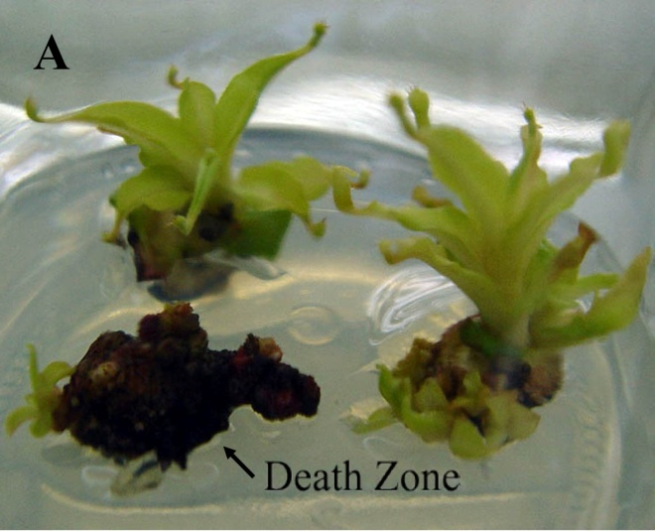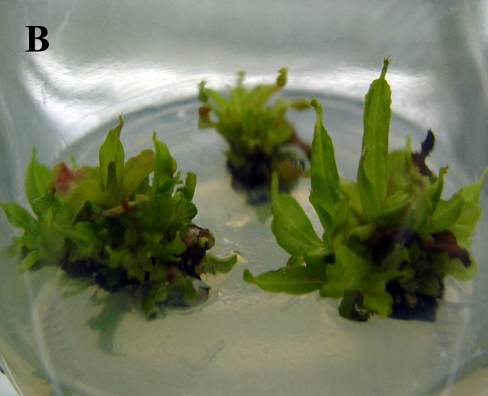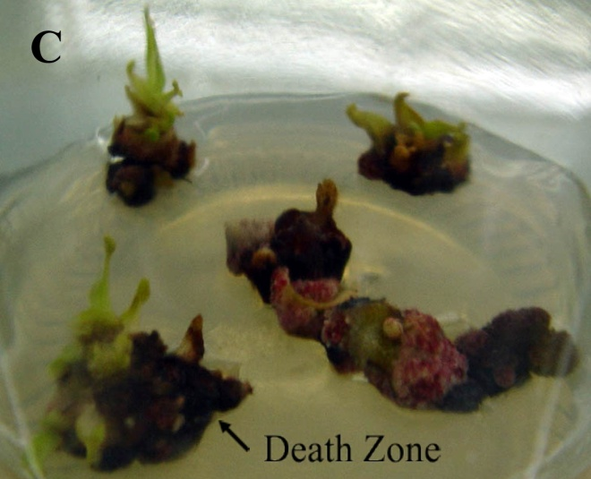

Fig. 1. Effects of 2,4-D and BAP in combination and alone on shoot differentiation from excised axillary shoots. A) 2 mg l⁻¹ 2,4-D.
B) 2 mg l⁻¹ BAP
C) 1 mg l⁻¹ BAP+ 1 mg l⁻¹ 2,4-D.

Root Induction: After 6 weeks of culture in BAP containing medium, single shoots were excised and transferred to CPM with and without auxin (IBA/NAA) for root induction. Without the addition of auxin, root initiation of the plantlets did occur but shorter root lengths and a slower initiation rate was found in comparison to plantlets grown on medium with auxin. For Auxin, IBA was better than NAA for the production of plantlets with long root lengths. But to generate a higher root number, NAA was better than IBA (Figs. 2 A, B).
Interestingly, Nepenthes plantlets grown on hormone free media (Fig 2 C) showed very few and small pitchers compared to plantlets grown on NAA containing medium which produced larger pitchers at the leaf ends (Fig. 2 D) compared to the pitchers from plantlets generated on IBA (Fig. 2 E). The degree of pitcher increase is dependent on NAA concentration. The size of the pitchers increased with increasing NAA concentration between 0.5 to 2 mg l⁻¹(Fig. 2 A). However, high concentrations of NAA made Nepenthes plants become sickly and the larger pitcher plantlets came with reddish yellows leaves (Fig. 2 D). The increased number of senescent leaves on Nepenthes plants growing on higher NAA concentrations ultimately led to death on 4 mg l⁻¹ NAA containing medium within 3 weeks.
We hypothesize that these symptoms may be caused from an insufficient amount of nitrogen to support their metabolism. Srivastava et al. 2003 reported that the presence of NAA in callus culture medium of Cuscuta reflexa, an angiosperm holoparasitic plant, increased the activity of enzymes in the nitrogen assimilation pathway throughout the culture period without altering their developmental profiles. These enzymes included nitrate reductase (NR), glutamine synthetase (GS), glutamate synthase (GOGAT) and glutamate dehydrogenase (GDH). Because the pitcher plant produces supplementary nitrogen from insects, if the Nepenthes plant requires more nitrogen, it is possible that they could produce a larger pitcher to eat more insects. However, the role of NAA as a potential effector of nitrogen assimilating enzymes has not yet been investigated in higher plants. In addition to nitrogen, there is a report that N. insignis used a C2-portion of the carbon skeleton of l-alanine to build up the allelochemical plumage in (Rischer et al. 2002).
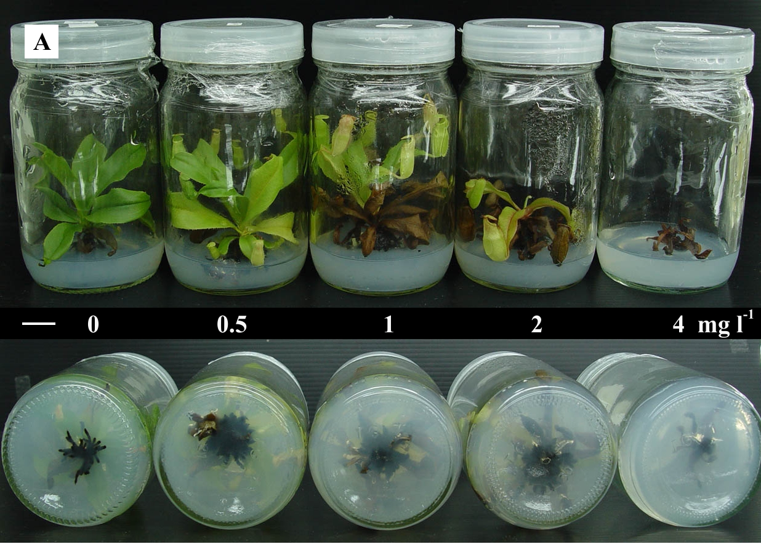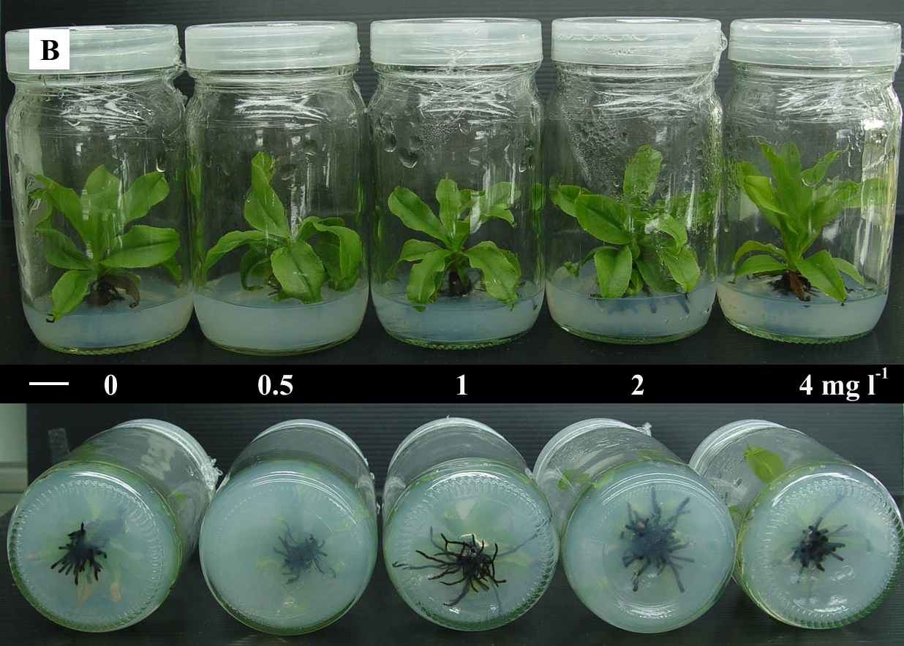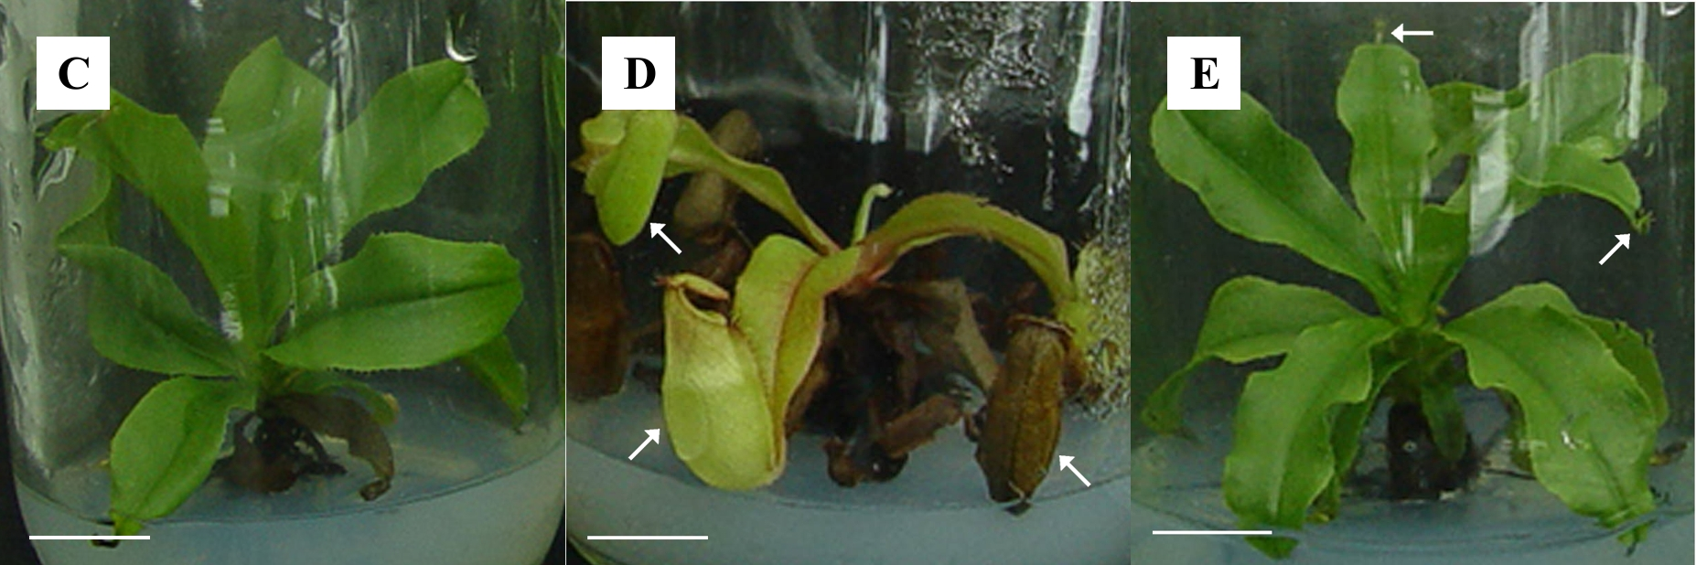
Fig. 2. Effects of NAA and IBA on pitcher and root size of in vitro culture of Nepenthes hybrid at 6 weeks after sub-culture. A) Nepenthes hybrids growing on 0-4 mg l⁻¹ NAA. B) Nepenthes hybrids growing on 0-4 mg l⁻¹ IBA. C) Enlargement of Nepenthes plantlet growing on hormone free media. D) Enlargement of Nepenthes plantlet growing on 2 mg l⁻¹ NAA. E) Enlargement of Nepenthes plantlets growing on 1 mg l⁻¹ IBA. The white arrows show pitchers at the leaf tip. The white scale bars indicate 1 centimeter.
The increased pitcher size character of the miniature Nepenthes may increase the commercial value of these glass bottle plants as a gift or decoration. One of the key advantages of bottle plants are their compact size which lets them grow almost anywhere with a minimal need for water and fertilizer and a minimal need for pest or disease control.
The pitcher plant is a unique and wonderful plant, of interest to many researchers. Numerous reports about the gene expression in the pitcher plants have been including studies on ammonium, amino acid and peptide transporter genes (Schulze et al. 1999), aspartic proteinase genes (An et al. 2002), and chitinase genes (Eilenberg et al. 2006). Moreover, the proteins in the pitcher fluid have been shown to have differentially expressed protein at different developmental stages (Pinthong et al. 2009) and plasma-membrane H⁺-ATPase anomalies (Chung et al. 2001) have also been investigated.
This study of the tissue culture of Nepenthes is useful for genetic transformation of Nepenthes species via Agrobacterium. Besides being useful in education, this research may also be valuable for the genetic improvement of Nepenthes plants for trade and to produce new varieties of Nepenthes with new pitcher shapes and colors.

Acknowledgements: We gratefully acknowledge the Royal Golden Jubilee (The Thailand Research Fund) for financial supporting of this research.

References
An, CI., E. Fukusaki and A. Kobayashi. (2001). Plasma-membrane H+-ATPases are expressed in pitchers of the carnivorous plant Nepenthes alata Blanco. Planta, 212: 547–555.
An, CI., E. Fukusaki and A. Kobayashi. (2002). Aspartic proteinases are expressed in pitchers of the carnivorous plant Nepenthes alata Blanco. Planta, 214: 661–667.
Bahadur, V., K.S. Kirad, A. Mathew and D.B. Singh. (2008). Tissue culture studies in Nepenthes khasiana. Acta Horticulturae (ISHS), 786: 287–293.
Chawla, H.S. (2002). Introduction to plant biotechnology, 2nd edn. Science Publishers, Enfield
Chaveerach, A., A. Tanomtong, R. Sudmoon and T. Tanee. (2006). Genetic diversity among geographically separated populations of Nepenthes mirabilis. Biologia Bratislava. 61: 295-298.
Clarke, C. (2002). A Guide to the Pitcher Plants of Peninsular Malaysia. Natural History Publications (Borneo), Kota Kinabalu.
Clarke, C. (1997). Nepenthes of Borneo (Kota Kinabalu, Sabah, Malaysia: Natural History Publications [Borneo]), 207pp.
de Fossard, R. Posted on the Plant TC Listserv, Sept. (2009). Subject: Nepenthes diatas. (http://lists.umn.edu/cgi-bin/wa?A2=ind0901&L=PLANT-TC&T=0&F=&S=&X=1050D3258E48269160&P=2728). Also posted on: http://www.labflytrap.com/forum/viewtopic.php?f=7&t=209&start=0.
Eilenberg, H., S. Pnini-Cohen, S. Schuster, A. Movtchan and A. Zilberstein. (2006). Isolation and characterization of chitinase genes from pitchers of the carnivorous plant Nepenthes khasiana. Journal of Experimental Botany. 57(11): 2775–2784.
Ellison, A.M., N. J. Gotelli, J. S. Brewer, D. L. Cochran-Stafira, J. M. Kneitel, T. E. Miller, A. C. Worley and R. Zamora. (2003). The evolutionary ecology of carnivorous plants; Adv. Ecol. Res. 33: 1–74.
Harter, H. L. (1960). Critical values for Duncan's new multiple range test. Biometrics. 16: 671-85.
Heslop-Harrison Y. (1975). Enzyme release in carnivorous plants. Front Biol. 43:525–578.
Higashi, S., A. Nakashima, H. Ozaki, M. Abe and T. Uchiumi. (1993). Analysis of feeding mechanism in a pitcher of Nepenthes hybrida. J Plant Res. 106:47–54.
Latha, P.G. and S. Seeni. (1994). Multiplication of endangered Indian pitcher plant (Nepenthes khasiana) through enhanced axillary branching in vitro. Plant Cell, Tissue and Organ Culture. 38: 69-71.
McPherson, S.R. (2010). Carnivorous Plants and their Habitats. 2 volumes. Redfern Natural History Productions, Poole, 1296-1305.
Mokkamul, P., A. Chaveerach, R. Sudmoon and T. Tanee. (2007). Species identification and sex determination of the genus Nepenthes (Nepenthaceae). Pak. J. Biol. Sci., 10: 561-567.
Murashige, T. and Skoog, F. (1962) A revised medium for rapid growth and bioassays with tobacco tissue cultures. Physiol Plant 15(3): 473-497.
Pinthong, K., C. Arunrat, T. Tawatchai, S. Runglawan and M. Piya. 2009. Differential expressed protein in developing stages of Nepenthes gracilis Korth. Pitcher. Pak. J. Biol. Sci., 12: 526-529.
Rischer H., A. Hamm and G., Bringmann. (2002). Nepenthes insignis uses a C2-portion of the carbon skeleton of l-alanine acquired via its carnivorous organs, to build up the allelochemical plumbagin. Phytochemistry. 59: 603–609.
Schulze, W., W.B. Frommer and J.M. Ward. (1999). Transporters for ammonium, amino acids and peptides are expressed in pitchers of the carnivorous plant Nepenthes. Plant J., 17: 637-646.
Srivastava S. and U.N. Dwivedi. (2003). Modulation of key nitrogen assimilating enzymes by NAA and in vitro culture in Cuscuta reflexa. Plant Physiology and Biochemistry. 41: 65–71.

*

