IN VITRO propagatIon of AmsonIa orIentalIs from NODAL SEGMENTs of Adult Plants
Arda Acemi, Fazıl Özen, Ruhiye Kıran
Corresponding author: Arda Acemi
Adress: Department of Biology, Faculty of Sciences and Arts, Kocaeli University, 41380, Kocaeli, Turkey
E-mail: arda.acemi@kocaeli.edu.tr
Fax: +90 262 303 20 03
Co-author 1: Fazıl Özen
Adress: Department of Biology, Faculty of Sciences and Arts, Kocaeli University, 41380, Kocaeli, Turkey
E-mail: fazil.ozen@kocaeli.edu.tr
Fax: +90 262 303 20 03
Co-author 2: Ruhiye Kıran
Adress: Department of Biology, Faculty of Sciences and Arts, Kocaeli University, 41380, Kocaeli, Turkey
E-mail: ruhiyekiran@gmail.com
Fax: +90 262 303 20 03

Abstract
Amsonia orientalis Decne. (syn. Rhazya orientalis (Decne.)) is an ornamental and medicinal plant which has restricted distribution only in the northwest of Turkey and the northeast of Greece. Nodal explants excised from adult plants were cultured in MS media supplemented with 6-benzyl-aminopurine (BAP) concentrations (0.5, 1.0, 2.0, 4.0 mg l⁻¹) for shoot multiplication. Media containing 1.0 mg l⁻¹ BAP suggested regeneration of the highest number of shoots (9.20 ± 0.2 shoots per explant at 91.1 ± 2.3% frequency). Nodes obtained from multiplied shoots were excised and cultured in MS media supplemented with combinations of BAP, kinetin (Kn), indole-3-acetic acid (IAA) and 2,4-dichlorophenoxyacetic acid (2,4-D). Maximum mean shoot length of 4.4 ± 0.7 cm was noted from the media supplemented with 0.5 mg l⁻¹ indole-3-acetic acid (IAA) + 1.5 mg l⁻¹ BAP and 0.5 mg l⁻¹ IAA + 0.5 mg l⁻¹ Kinetin (Kn) individually. Rooting experiments were also conducted in half- and full-strength MS media supplemented with IAA or indole-3-butyric acid (IBA). All shoots could be induced to root on full-strength MS medium supplemented with 0.5 mg l⁻¹ IAA within 30 days with a fairly good length and number of roots per shoot (7.9 ± 0.3 roots per shoot at 2.8 ± 0.2 cm mean length). Plantlets went through a hardening phase in a controlled plant growth chamber prior to ex vitrum transfer. Through this study, a reliable in vitro propagation protocol for A. orientalis was developed by using nodal explants taken from field-grown adult plants.
Key words: Amsonia orientalis, Apocynaceae, blue star, axillary bud break, in vitro rooting
Running title: In vitro propagation of Amsonia orientalis

Introduction
The plants belonging to Apocynaceae (dogbane) family are widely known for their ornamental and pharmacological properties. In vitro propagation studies were conducted on various species of this family in order to increase the number of individuals available for several purposes (Kumar et al. 2005, Nishita et al. 2006, Ozden-Tokatli et al. 2008). As a member of Apocynaceae family, genus Amsonia Walter contains species that have horticultural merit or potential. Amsonia species are commonly known as “blue stars” because they have pale blue colored and star shaped flowers. All blue stars produce masses of rich green leaves that remain neat and attractive throughout the growing season, generally free from any insect pests. Their milky sap is not known to be harmful to humans, but does seem to discourage deer and other mammals from feeding, which is an attractive trait to many gardeners. Amsonia orientalis is an ornamental and medicinally important plant which has restricted natural distribution only observed in northwest Turkey and northeast Greece (Tutin et al. 1972). Field studies have indicated that plant is now very rare and near extinction (Özen 2006). In the “Red Data Book of Turkish Plants” A. orientalis is listed in the category of “critically endangered” (CR) (Ekim et al. 2000). Moreover, in the Bern Convention, The European Council placed the plant on the list of the plant species that must be conserved on European scale. A few years ago, propagation of A. orientalis was carried out through in vitro germination of seeds by Öz et al. (2008). Although they succeed in in vitro propagation of blue star, they achieved to germinate only 15% of the seeds. This low germination ratio limits the number of explant sources which can be used for mass propagation studies. Their method offers only a single combination of indole-3-butyric acid (IBA; 1.0 mg l⁻¹) and kinetin (Kn; 0.5 mg l⁻¹) for both shoot regeneration and root induction. Medium optimization by testing the concentrations and combinations of plant growth regulators is an important point for developing reliable and efficient protocols in in vitro propagation studies. We thought that culturing mature explants should be more reliable and effective for micropropagation of this plant than trying to germinate its recalcitrant seeds for such purposes.
In vitro propagation of rare and threatened plants is generally undertaken to enhance the biomass and conserve the germplasm, especially when population numbers are low in the wild (Sarasan et al. 2006). The application of plant tissue culture has long been recognized for in ex situ conservation of rare and endangered plant taxa including medicinal and economically important plants (Latha and Seeni 1994, Balaraju et al. 2009, Ishii et al. 2011). Because of risk of extinction and also ornamental and medicinal properties of A. orientalis, it is necessary to develop reliable regeneration, propagation and conservation strategies. In the present study we intended to describe a reliable in vitro propagation protocol of A. orientalis using nodal explants excised from field-grown adult individuals, followed by successful ex vitrum establishment of regenerated plants.
Materials and Methods
Plant material and disinfection
Well-developed shoots, 20–25 cm in length, were collected from four field-grown wild type specimens of Amsonia orientalis before flowering in May 2011. For easy handling the shoots were cut into shorter segments about 10 cm long and washed under tap water for 15 minutes. All leaves were cut off before washing step. These shoots were cut into 1-2 cm long segments that had at least one node and were disinfected by dipping in 70% ethyl alcohol (EtOH) for 2 minutes and 1% sodium hypochlorite (NaOCl) for 10-12 minutes respectively. Traces of NaOCl were removed by two or three rinses with distilled sterile water.

Culture media and conditions
All media were supplemented with 30 g l⁻¹ sucrose (Duchefa) and 7 g l⁻¹ of Plant agar (Duchefa). The pH of all media was adjusted to 5.7 with 1 N NaOH or 1 N HCl prior to autoclaving at 121˚C under pressure of 118 kPa for 20 min. Disinfection treatments and inoculations were carried out aseptically in a laminar air flow cabinet.
Cultures were maintained at 23 ± 1°C and a relative humidity of 65% (only at the first stage of acclimatization) in a plant growth chamber with a 16/8 h light/dark photoperiod under an illumination of 80 μmol m⁻² s⁻¹ photosynthetic photon flux intensity provided by cool-white fluorescent lights.
Shoot multiplication and effect of plant growth regulators
Disinfected single node explants were inoculated vertically in culture vessels containing 40 ml of Murashige and Skoog’s (1962) medium (MS) with vitamins. MS medium at 4 different concentrations of 6-benzyl-aminopurine (BAP; 0.5, 1.0, 2.0, 4.0 mg l⁻¹) tested the effects on axillary shoot multiplication. After the culture period of 4 weeks, numbers and lengths of shoots were noted. Multiplied shoots were cut into small segments of 1 cm length with at least one node. Shoot multiplication was continued on the fresh media of the same composition by subculturing axillary shoot segments with 2-3 nodes every four weeks under the same conditions. For investigating the effects of plant growth regulators (PGRs) on axillary shoot initiation and elongation, single nodes obtained from multiplication phase were cultured on MS supplemented with three different combinations of 2,4-dichlorophenoxyacetic acid (2,4-D), BAP, indole-3-acetic acid (IAA) and kinetin (Kn) at various concentrations.

Rooting and acclimatization
Effects of half- and full-strength MS media with various auxin concentrations were tested for effective rooting. Proliferated shoots, not less than 3 cm but approximately at same length, were excised with a scalpel blade then these shootlets were inoculated into culture vessels. A period of 4-weeks was chosen for the rooting phase with 0.5-5 mg l⁻¹ IAA or 0.5-5 mg l⁻¹ indole-3-butyric acid on the solid half- or full-strength MS medium. After 4 weeks, lids of culture vessels were half opened during the next 3 days as the first stage of acclimatization. Roots of the plantlets with fully expanded leaflets were washed under tap water to remove all adhering culture medium. Rooted plantlets, not less than 3 cm long, were transferred into pots containing a mixture of peat and compost (1:1). As the second stage of acclimatization, the pots were made covered with transparent plastic bags to maintain high humidity for 3-4 days. After this period, small holes were made in plastic bags for air circulation. By this way, relative humidity was reduced gradually. After one week, plastic bags were removed and well acclimatized in vitro-raised plants were maintained at room temperature under natural light conditions. After 15-20 days they were transferred to gardens at the Umuttepe Campus of Kocaeli University.
Data collection and statistical analysis
Each treatment for culture establishment and shoot multiplication contained 15 nodes. In rooting experiments, 15 in vitro-raised shoots were used for each treatment. All treatments were repeated thrice and measurements were done at the end of the incubation periods. At the shoot multiplication and root induction phases, mean shoot and root numbers and lengths were compared using Duncan’s multiple range test at P<0.05 significance level. The data were given in the tables. Additionally, linear regression model was used to determine optimal concentrations and effects of the PGRs on in vitro-raised shoots. In the regression adjusted R-square levels of PGRs were compared. The data were represented as line graphs or box plot data with mean bars. The software IBM SPSS Statistics 19 was used for statistical analysis.
Results
Establishment of in vitro cultures and shoot multiplication
Multiple shoots emerged directly from axillary buds of the cultured explants after 4 weeks in all media. Axillary buds started breaking 5-7 days after inoculation. The highest percentage of bud break (97.8 ± 0.6%) was observed in medium enriched with 0.5 mg l⁻¹ BAP (Figure 1A). The frequency of shoot initiation declined when the concentration of BAP was increased to 4.0 mg l⁻¹. The number of multiplied shoots was greatly influenced by the growth regulator concentration. Among the five different media tested (control and supplemented with increasing levels of BAP), medium supplemented with 1.0 mg l⁻¹ BAP was the most effective for in vitro shoot multiplication of nodal explants while the control medium did not support the proliferation of multiple shoots (Table 1). Over 90% of explants showed an average shoot number of 9.20 ± 0.2 per each one within 30 days of culture (Figure 1B). In addition, MS with 1.0 mg l⁻¹ BAP increased the mean length of multiplied shoots (4.87 ± 0.1 cm). Except little callus clumps about 2-3 mm in diameter, no remarkable callus formation was observed in cultures. Explants cultured on medium containing BAP alone started shedding leaves 40-45 days after culture.
Effects of PGRs on axillary bud break and shoot growth
Axillary buds started breaking after 7-10 days of culture. Of the three combinations tested, IAA plus Kn was found to be superior for bud break and also more effective for shoot elongation. In the present study, combined IAA (2.0 mg l⁻¹) plus Kn (1.0 mg l⁻¹) and 2,4-D (0.5 mg l⁻¹) plus BAP (1.5 mg l⁻¹) in the culture medium promoted the bud break frequency (95.6 ± 0.6%) whereas the combination of 2,4-D (2.0 mg l⁻¹) plus BAP (1.5 or 2.0 mg l⁻¹) induced it at a lower frequency (40 - 44.4%). In the media supplemented with 2,4-D and BAP concentrations the higher bud break percentages were observed only when 2,4-D concentrations were at their lowest concentration (Figure 2). Especially, increasing 2,4-D concentrations caused a reduction on bud break frequency when BAP was at 1.5 mg l⁻¹. Conversely, when explants were cultured in MS supplemented with IAA and Kn concentrations bud break was not remarkably reduced although concentration of IAA was increased (Figure 3). On the other hand, lower bud break percentages were noted from MS with IAA and BAP than MS with IAA and Kn (Figure 4). Abnormalities such as falciform and crinkly leaves were observed in a few media containing 2,4-D at 2.0 mg l⁻¹. Explants cultured on medium containing 1.5 or 2.0 mg l⁻¹ 2,4-D in combination with 1.5 or 2.0 mg l⁻¹ BAP resulted in stunted growth of single shoots, which could not further elongate. All concentrations of 2,4-D in combination with BAP induced calli at basal cut ends of explants. Callus formation was found to be weaker in the media enriched with other combinations of PGRs. Shoot lengths were negatively influenced by increased 2,4-D levels (Figure 5). According to results, 1.5 mg l⁻¹ BAP is the most explanatory factor for explaining the negative effect of 2,4-D on the mean length of the shoots with R-square value of 84.7% (R²=0.847). However, BAP at 0.5 mg l⁻¹ is the least explanatory for the regression (R²=0.040). Internodes of regenerated shoots from axillary buds of nodal explants cultured on the media with 2,4-D and BAP were relatively short, but more nodes were obtained (data not shown). In contrast, shoots induced by IAA and Kn had fewer nodes but longer internodes (data not shown). Maximum shoot length of 4.4 ± 0.7 cm was observed on media supplemented with the combination of IAA and Kn (both at 0.5 mg l⁻¹) and the combination of IAA and BAP at the concentration of 0.5 mg l⁻¹ and 1.5 mg l⁻¹ respectively (Figure 6). Similar to 2,4-D, 1.5 mg l⁻¹ BAP is optimal for explaining the effect of IAA on growth according to regression results (R²=0.600). In addition, concentration of 0.5 mg l⁻¹ BAP is also optimal for explaining the effects of IAA levels (R²=0.581). There is only 1.9% difference between the effects of 0.5 mg l⁻¹ and 1.5 mg l⁻¹ BAP. We noted the maximum shoot lengths from media enriched with higher cytokinin and lower auxin concentrations. MS supplemented with lower Kn combined with reduced auxin levels caused stimulation of shoot growth (Figure 1C). For explaining the effect of the Kn, optimal concentration of IAA is found to be 0.5 mg l⁻¹ (Figure 7). However, its explanatory level is very low (R²=0.394). At the concentration of 1.0 mg l⁻¹ IAA, effect of Kn is insignificant at significance level of P<0.05 (P=0.066). It may be stated that increasing IAA levels combined with Kn had no strong effect on mean shoot lengths. In general, of the three combinations tested, IAA and BAP gave better results for shoot elongation.
Effects of Auxins on root induction
In our study, full-strength medium with lower auxin level (0.5 mg l⁻¹) and half-strength medium without auxin stimulated root induction (Table 2). Full-strength MS with IBA gave better rhizogenic response (97.8 - 100%) while the response given to half-strength MS with IBA was relatively poor (57.8 - 84.4%). Similar results were also observed from media with IAA. In other words, medium strength played an important role on rooting frequency. According to our findings, the effect of IAA on the number of roots was relatively weaker than the effect of IBA. The highest number of roots per shoot (13.4 ± 0.5, 14.5 ± 0.5 and 17.7 ± 0.4) were observed from the full-strength MS with IBA. Root inductions in all IAA-containing media were observed earlier than in all media supplemented with IBA. Although in terms of root initiation plantlets responded to IBA late, it was observed that higher levels of IBA showed a strong positive effect on the number of roots (Figure 1D). Among tested concentrations of auxins, IBA at 5.0 mg l⁻¹ induced the highest number of roots (17.7 ± 0.4) compared with IAA. On the other hand, in our study, IAA at 2.0 mg l⁻¹ and IBA at 5.0 mg l⁻¹ increased mean number of roots per shoot while root lengths were negatively affected by them. The root length of 2.6 ± 0.2 cm was observed on half-strength control medium while media containing increasing levels of (1.0, 3.0 or 5.0 mg l⁻¹) IAA or IBA reduced the root lengths. Especially, the half-strength media supplemented with 5.0 mg l⁻¹ IBA drastically reduced the mean root length to 0.5 ± 0.0 cm. Full-strength MS media supplemented with 0.5 and 1.0 mg l⁻¹ of auxin showed increased the length of roots over time (Figure 1E). Maximum mean root length of 2.8 ± 0.2 cm was observed on full-strength MS medium supplemented with 0.5 mg l⁻¹ IAA. Callus formation appeared before rhizogenesis. Although all media induced the callus formation in two weeks, only the control medium and the medium supplemented with 0.5 mg l⁻¹ IAA induced minimal callus formation at the ends of basal parts. During rhizogenesis shoot elongations were observed. IBA at the concentration of 0.5 mg l⁻¹ successfully supported these shoot elongations. Higher IBA concentrations (3.0 and 5.0 mg l⁻¹) showed an inhibitory effect on shoot elongation.
Acclimatization of plantlets
For acclimatization of plantlets to outdoor conditions a two-stage protocol was developed. In the first stage of acclimatization, plants were acclimatized to 65% relative humidity (RH) and all of them survived (Figure 1F). Normally, some bacterial contaminations were observed during the first stage. In the second stage, fungal contaminations were observed when the pots were kept covered with transparent plastic bags without holes more than 3-4 days. Plants grown in the potted soil did not show any morphological abnormality at the room temperature with natural light conditions. After the second stage more than 80% of transferred plants survived and were acclimatized to successfully (Figure 1G).
Discussion
In the present study, we found that MS supplemented with 1.0 mg l⁻¹ 6-benzyl-aminopurine (BAP) is the optimal medium for shoot multiplication with a high bud break ratio from mature explants. Recently, Adel et al. (2012) studied the effects of media supplemented with BAP alone or in combination with kinetin (Kn) on initiation, proliferation and elongation of shoots from nodal explants of Rhazya stricta. They have found that MS medium with 2.0 mg l⁻¹ BAP and 1.0 mg l⁻¹ Kn promoted the highest number of shoots (15.0 ± 0.29 per nodal explant) while MS with 1.0, 2.0 or 3.0 mg l⁻¹ BAP alone provided less number of shoots (6.0 ± 0.15, 7.0 ± 0.17 and 9.0 ± 0.09 per nodal explant). Their results are suggesting the potential for improvement of Amsonia orientalis micropropagation by testing a few cytokinins together. The stimulatory effect of BAP on bud break and multiple shoot formation has been reported earlier for several ornamental and medicinal plant species including Holarrhena antidysenterica (Raha and Roy, 2001), Hibiscus rosa-sinensis (Christensen et al. 2008) and Adenium obesum (Kanchanapoom et al. 2010). Reduction in the number of shoots generated from each node at BAP concentrations higher than the optimum level was also reported for several plants (Kaur et al. 1998, Purkayastha et al. 2008, Sujana and Naidu 2011). In our experiments when we test effects of combined PGRs on bud break and shoot growth, we found that in the presence of 2,4-D and BAP or IAA and BAP at respectively balanced levels, bud break was decreased, nevertheless, IAA and Kn showed positive synergistic effect on bud break when applied in combination. Therefore, there is a complexity in the interaction of these PGRs. When applied in combinations, similar synergistic effects of BAP, IAA and NAA were found on axillary bud induction of Coleus blumei. Rani et al. (2006) stated that MS containing 2.0 mg l⁻¹ BAP in combination with 0.2 mg l⁻¹ IAA promoted bud break (100%) whereas medium containing BAP alone gave lower bud break ratios (41 - 64%). In terms of shoot elongation, our findings are in line with Echeverrigaray et al. (2005) and Balaraju et al. (2008) who found better results using BAP combined auxins. Formation of shorter internodes but more nodes from medium supplemented with 2,4-D and BAP combination appears to be an advantage for generating in vitro explant sources that can be used for multiplying shoots in future subcultures. Although we did not observe direct shoot regeneration, Öz et al. (2008) reported that the combination of IBA (1.0 mg l⁻¹) and Kn (0.5 mg l⁻¹) induced direct shoot regeneration from shoot explants in 4 weeks. Furthermore, they observed root formation after 8 weeks of culture in same medium. When the rooting performance and culture period are taken into account, our results offer a more effective protocol for the rooting phase. The earlier rooting response on IAA and the later response given to IBA could be attributed to their different mobility. In accordance with our study, in the micropropagation of Chonemorpha grandiflora, IBA was more effective than IAA and α-naphtaleneacetic acid (NAA) (Nishitha et al. 2006). Nordström et al. (1991) attributed the greater ability of IBA to promote adventitious root formation compared with IAA to the higher stability of IBA versus IAA both in solution and plant tissue. Additionally, Machakova et al. (2008) stated that not only physical effects such as temperature and light but also oxidative degradation of IAA can lead to lose its effects in time. Similar results dealing with the superiority of IBA on in vitro rooting of plants can be found in several reports (Nissen and Sutter 1990, Iliev et al. 2001, Ahmad et al. 2010). Shoot elongation in the presence of IBA alone in MS medium were also observed in Swietenia macrophylla and various Vitis vinifera cultivars (Roubelakis-Angelakis and Zivanovitc 1991, Nakamura and Soda 2002). For the first stage of acclimatization, Sherwood (1994) stated that the contamination of a medium does not cause any problem unless the culture vessels are kept open more than one week. It can be thought that the first stage is a preparatory to main acclimatization process (second stage). Rohr et al. (2003) described two major strategies that may be applied in vitro at the preparatory stage for acclimatization of micropropagated trees. The first involves encouraging micropropagated plantlets to become autotrophic and the second reducing water stress by changing culture environment. Our study showed that these strategies, especially second one can also be applied to herbaceous ornamental garden plants such as blue stars.

Conclusion
The seeds of A. orientalis are known for their slow and uneven germination (Öz et al. 2008). Low seed viability and germination rate further curtail the propagation of A. orientalis through seeds. Conventional propagation of such plants by seeds is not suitable for the demands of both ornamental and pharmaceutical industries. In this study, a regeneration protocol for A. orientalis was developed for the first time by using explants taken from field-grown plants. The protocol reported here could be used for conservation and large-scale propagation of this important ornamental and medicinal plant, which is threatened with extinction.
Acknowledgments
The study was supported by Scientific Research Projects Commission of Kocaeli University (Grant No. BAP 2009/50).
References
Adel E., Mohamed E.A., Attia A.O., El Dessoky D.S. (2012). In vitro multiplication of the important medicinal plant, harmal (Rhazya stricta Decne). Journal of Medicinal Plants Research, 6(19): 3586-3590.
Ahmad N., Faisal M., Anis M., Aref I.M. (2010). In vitro callus induction and plant regeneration from leaf explants of Ruta graveolens L. South African Journal of Botany, 76: 597-600.
Balaraju K., Agastian P., Preetamraj J.P., Arokiyaraj S., Ignacimuthu S. (2008). Micropropagation of Vitex agnus-castus, (Verbenaceae)—a valuable medicinal plant. In vitro Cellular and Developmental Biology-Plant, 44: 436-441.
Balaraju K., Agastian P., Ignacimuthu S. (2009). Micropropagation of Swertia chirata Buch.-Hams. ex Wall.: a critically endangered medicinal herb. Acta Physiologiae Plantarum, 31: 487-494.
Christensen B., Sriskandarajah S., Serek M., Müller R. (2008). In vitro culture of Hibiscus rosa-sinensis L.: Influence of iron, calcium and BAP on establishment and multiplication. Plant Cell, Tissue and Organ Culture, 93:151-161.
Echeverrigaray S., Basso R., Andrade L.B. (2005). Micropropagation of Lavandula dentata from axillary buds of field-grown adult plants. Biologia Plantarum, 49(3): 439-442.
Ekim T., Koyuncu M., Vural M., Duman H., Aytaç Z., Adıgüzel N. (2000). Türkiye bitkileri kırmızı kitabı. Türkiye Tabiatını Koruma Derneği ve Van Yüzüncü Yıl Üniversitesi Yayını, Barışcan Ofset, Ankara, 178 pp.
Iliev I., Kitin P., Funada R. (2001). Morphological and anatomical study of in vitro root formation of Silver birch (Betula pendula Roth.). Propagation of Ornamental Plants, 1(1): 10-19.
Ishii K., Hosoi Y., Maruyama E., Kanetani S. (2011). Preservarion of an in vitro propagated endangered species Pinus armandii var. amamiana (KOIDZ.) HATSUSHIMA. Propagation of Ornamental Plants, 11(4): 210-212.
Kanchanapoom K., Sunheem S., Kanchanapoom K. (2010). In vitro Propagation of Adenium obesum (Forssk.) Roem. and Schult.. Notulae Botanicae Horti Agrobotanici Cluj-Napoca, 38(3): 209-213.
Kaur K., Verma B., Kant U. (1998). Plants obtained from the Khair tree (Acacia catechu Willd.) using mature nodal segments. Plant Cell Reports, 17: 427-429.
Kumar R., Sharma K., Agrawal V. (2005). In vitro clonal propagation of Holarrhena antidysenterica (L.) WALL. through nodal explants from mature trees. In vitro Cellular and Developmental Biology-Plant, 41: 137-144.
Latha, P.G., Seeni, S. (1994). Multiplication of the endangered Indian pitcher plant (Nepenthes khasiana) through enhanced axillary branching in vitro. Plant Cell, Tissue and Organ Culture, 38: 69-71.
Machakova I., Zazimalova E., George E.F. (2008). Plant growth regulators I: Introduction; auxins, their analogues and inhibitors In: George, E.F., Hall, M.A., De Klerk, G. (Eds.) Plant Propagation by Tissue Culture 3rd Edition: The Background, vol. 1, Springer: 175-204.
Murashige T., Skoog F. (1962). A revised medium for rapid growth and bioassays with tobacco tissue culture. Physiologia Plantarum, 15: 473-497.
Nakamura K., Soda R. (2002). Method of large-scale propagation of trees of genus Swietenia. United States Patent, Patent No.: US 6,481,154 B1, Nov. 19.
Nishitha K., Martin K.P., Ligimol, Shahanaz Beegum A., Madhusoodanan P.V. (2006). Microporopagation and encapsulation of medicinally important Chonemorpha grandiflora. In vitro Cellular and Developmental Biology-Plant, 42: 385-388.
Nissen S.J., Sutter E.G. (1990). Stability of IAA and IBA in nutrient medium to several tissue culture procedures. American Society for Horticultural Science, 25(7): 800-802.
Nordström A-C, Jacobs FA, Eliasson L. (1991). Effect of exogenous indole-3-acetic acid and indole-3-butyric acid on internal levels of the respective auxins and their conjugation with aspartic acid during adventitious root formation in pea cuttings. Plant Physiology, 96: 856-861.
Özen F. (2006). Türkiye’de tükenme tehlikesinde olan bir türün otekolojisi: Amsonia orientalis Decne. (Apocynaceae). BAÜ Fen Bilimleri Enstitüsü Dergisi, 8(1): 4-9.
Öz G.C., Yüzbaşıoğlu E., Erol O., Üzen E. (2008). In vitro propagation of Amsonia orientalis Decne (Apocynaceae). African Journal of Biotechnology, 7(20): 3638-3641.
Ozden-Tokatli Y., De Carlo A., Gumusel F., Pignattelli S., Lambardi M. (2008). Development of encapsulation techniques for the production and conservation of synthetic seeds in ornamental plants. Propagation of Ornamental Plants, 8(1): 17-22.
Purkayastha J., Sugla T., Paul A., Solleti S., Sahoo L. (2008). Rapid in vitro multiplication and plant regeneration from nodal explants of Andrographis paniculata: a valuable medicinal plant. In vitro Cellular and Developmental Biology-Plant, 44: 442-447.
Raha S., Roy S.C. (2001). In vitro plant regeneration in Hollerrhena antidysenterica Wall., through high frequency axillary shoot proliferation. In Vitro Cellular and Developmental Biology-Plant, 37: 232-236.
Rani D., Talwar D., Nagpal A., Virk G.S. (2006). Micropropagation of Coleus blumei from nodal segments and shoot tips. Biologia Plantarum, 50(4): 496-500.
Rohr R., Iliev I, Scaltsoyiannes A., Tsouloha P. (2003). Acclimatization of micropropagated forest trees. Acta Horticulturae, 616: 59-69.
Roubelakis-Angelakis K.A., Zivanovitc S.B. (1991). A new culture medium for in vitro rhizogenesis of grapevine (Vitis spp.) genotypes. Horticultural Science, 26(12): 1551-1553.
Sarasan V., Cripps R., Ramsay M.M., Atherton C., McMichen M., Prendergast G., Rowntree J.K. (2006). Conservation in vitro of threatened plants-Progress in the past decade. In Vitro Cellular and Developmental Biology-Plant, 42: 206-214.
Sherwood J.L. (1994). Applied aspects of plant regeneration (Virus-free plants). In: Dixon R.A., Gonzales R.A. (Eds), Plant Cell Culture – A Practical Approach, Oxford Uni. Press: 135-138.
Sujana P., Naidu C.V. (2011). High frequency rapid plant regeneration from shoot tip and nodal explants of Mentha piperita (L.) – An important multipurpose medicinal plant. Journal of Phytology, 3(5): 09-13.
Tutin T.G., Heywood V.H., Burges N.A., Moore D.M., Valentine D.H., Walters S.M., Webb D.A. (1972). Flora Europaea. Cambridge University Press, Cambridge, Vol. 3, 69 pp.

Table headings and figure legends
Table 1. Influence of BAP on shoot proliferation of field-grown Amsonia orientalis on MS medium
Table 2. Effects of medium strength and auxin concentration on root formation in regenerated shoots
Figure 1. In vitro propagation through nodal explants excised from adult, field-grown Amsonia orientalis plants. A, Shoot induction from nodal segments on MS medium containing 0.5 mg l⁻¹ BAP. B, Shoot multiplication on MS medium with 1.0 mg l⁻¹ BAP at the end of first culture cycle. C, Shoots developed from nodal microcuttings of in vitro regenerants on MS medium supplemented with 0.5 mg l⁻¹ IAA and 1.5 mg l⁻¹ BAP in combination. D, Rooting of in vitro derived shoots in full-strength MS medium with 3.0 mg l⁻¹ IBA at the end of 4th week of culture. E, Elongated roots in full-strength MS medium with 0.5 mg l⁻¹ IAA at the end of 6th week of culture. F, A rooted plant is ready to transfer into pots after the first stage of acclimatization. G, Acclimatized plant.
Figure 2. Mean shoot initiation frequency change depending on different 2,4-D and BAP concentrations
Figure 3. Mean shoot initiation frequency change depending on different IAA and Kn concentrations
Figure 4. Mean shoot initiation frequency change depending on different IAA and BAP concentrations
Figure 5. Mean shoot length change depending on different 2,4-D and BAP concentrations
Figure 6. Mean shoot length change depending on different IAA and BAP concentrations
Figure 7. Mean shoot length change depending on different IAA and Kn concentrations

Tables
Table 1.
Concentrations of  BAP (mg l⁻¹) | Shoot initiation (%) | Mean shoot length (cm) | No. of shoots / explant
Control | 82.2 ± 1.5 | 1.92 ± 0.2e | 1.53 ± 0.1d
0.5 | 97.8 ± 0.6 | 4.28 ± 0.2b | 4.24 ± 0.1c
1.0 | 91.1 ± 2.3 | 4.87 ± 0.1a | 9.20 ± 0.2a
2.0 | 86.7 ± 2.6 | 3.85 ± 0.1c | 7.07 ± 0.2b
4.0 | 80.0 ± 1.7 | 2.34 ± 0.2d | 4.64 ± 0.2c
Data represent means ± SE of three replicates, each with 15 explants. Means having the same letter in a column were not significantly different by Duncan’s multiple-range test (P<0.05).
Table 2.
PGR and medium strength | Concentrations (mg l⁻¹) | Rooting (%) | Mean root length (cm) | Mean No. of roots
IAA - MS | 0 | 100 ± 0.0 | 2.1 ± 0.2ab | 4.5 ± 0.1i
IAA - MS | 0.5 | 100 ± 0.0 | 2.8 ± 0.2a | 7.9 ± 0.3f
IAA - MS | 1.0 | 100 ± 0.0 | 2.7 ± 0.3a | 7.7 ± 0.2f
IAA - MS | 2.0 | 100 ± 0.0 | 1.7 ± 0.1bc | 9.8 ± 0.2d
IAA - MS | 3.0 | 73.3 ± 2.6 | 1.4 ± 0.2bc | 6.7 ± 0.3g
IAA - MS | 5.0 | 86.7 ± 3.5 | 1.2 ± 0.2c | 8.9 ± 0.2e
IAA - ½MS | 0 | 91.1 ± 2.3 | 2.6 ± 0.2a | 4.2 ± 0.2i
IAA - ½MS | 1.0 | 91.1 ± 1.2 | 2.1 ± 0.3ab | 6.0 ± 0.2h
IAA - ½MS | 3.0 | 71.1 ± 2.9 | 1.5 ± 0.2bc | 4.4 ± 0.3i
IAA - ½MS | 5.0 | 91.1 ± 2.3 | 1.5 ± 0.1bc | 5.5 ± 0.2h
IBA - MS | 0 | 100 ± 0.0 | 2.1 ± 0.2abc | 4.5 ± 0.1i
IBA - MS | 0.5 | 100 ± 0.0 | 2.3 ± 0.2ab | 8.0 ± 0.2f
IBA - MS | 1.0 | 100 ± 0.0 | 1.8 ± 0.1bc | 9.5 ± 0.3d
IBA - MS | 2.0 | 97.8 ± 0.6 | 1.5 ± 0.3cd | 13.4 ± 0.5c
IBA - MS | 3.0 | 100 ± 0.0 | 0.7 ± 0.1e | 14.5 ± 0.5b
IBA - MS | 5.0 | 100 ± 0.0 | 0.9 ± 0.0e | 17.7 ± 0.4a
IBA - ½MS | 0 | 91.1 ± 1.5 | 2.6 ± 0.2a | 4.2 ± 0.2i
IBA - ½MS | 1.0 | 84.4 ± 0.6 | 1.6 ± 0.1cd | 5.6 ± 0.3h
IBA - ½MS | 3.0 | 80.0 ± 0.0 | 1.1 ± 0.1de | 8.2 ± 0.4f
IBA - ½MS | 5.0 | 57.8 ± 3.1 | 0.5 ± 0.0e | 4.7 ± 0.3i
Data represent means ± SE of three replicates, each with 15 explants. Means having the same letter in a column were not significantly different by Duncan’s multiple-range test (P<0.05).

Figure
Figure 1.
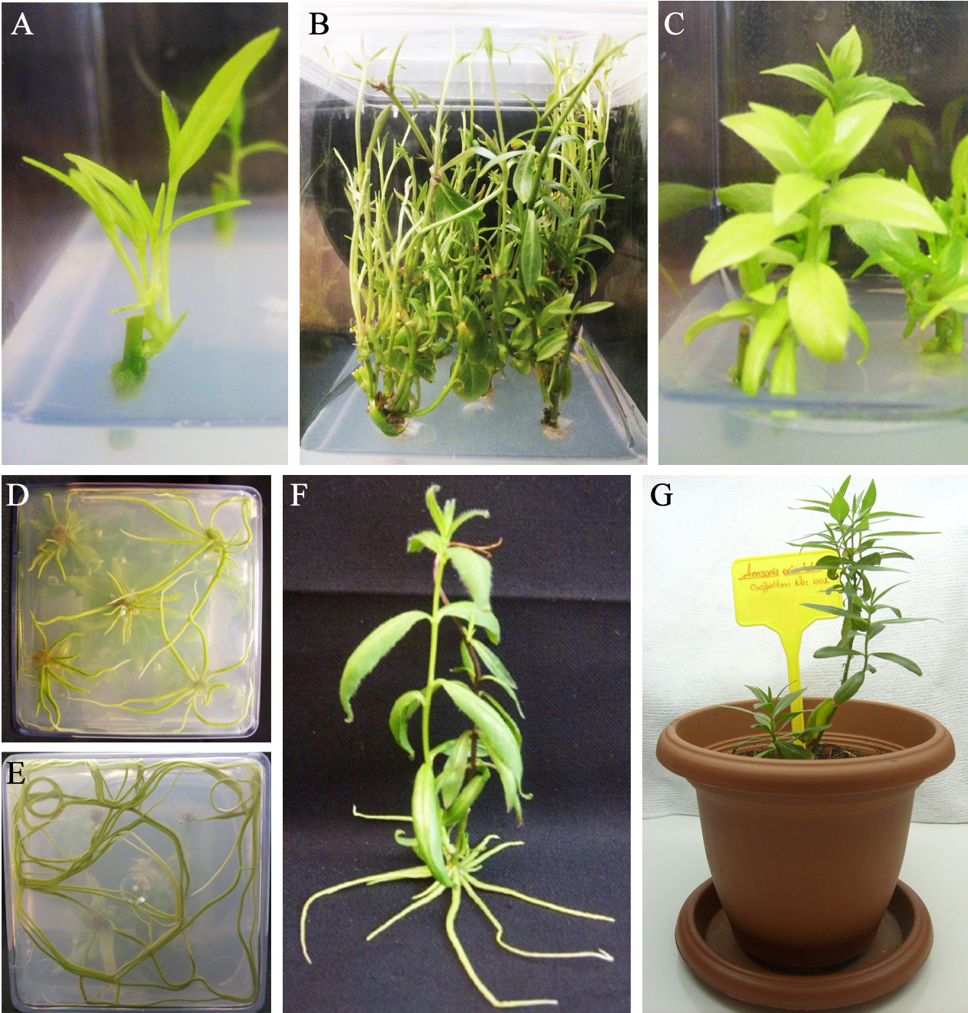

Figure 2.
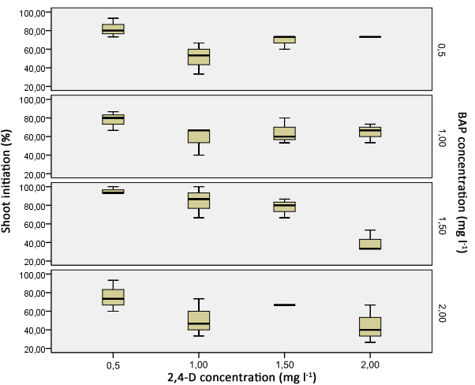
Figure 3.
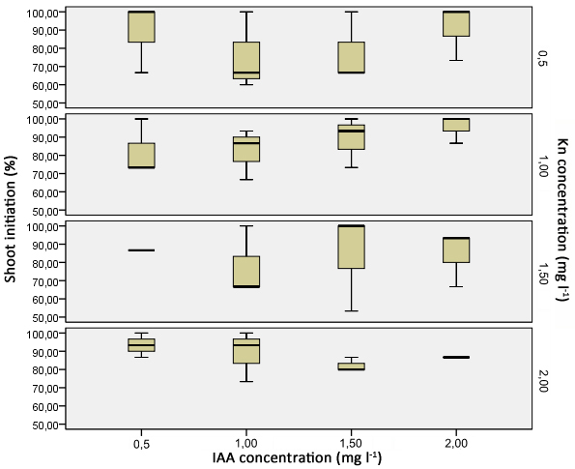
Figure 4.
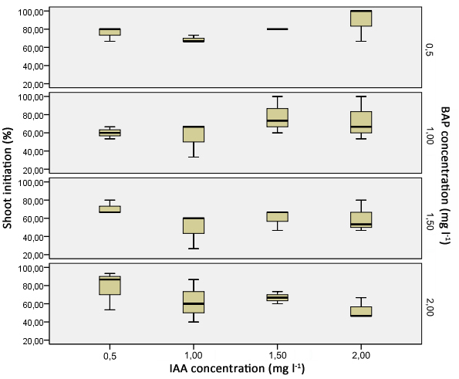
Figure 5.
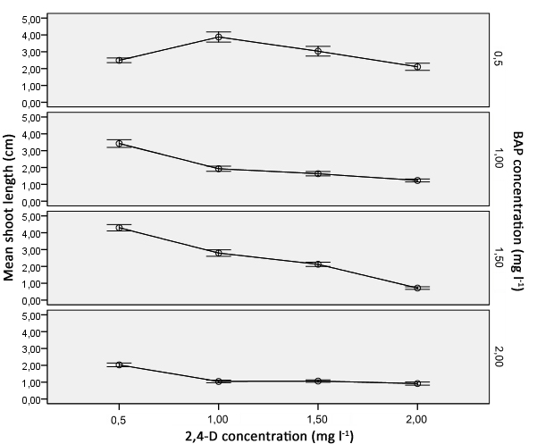
Figure 6.
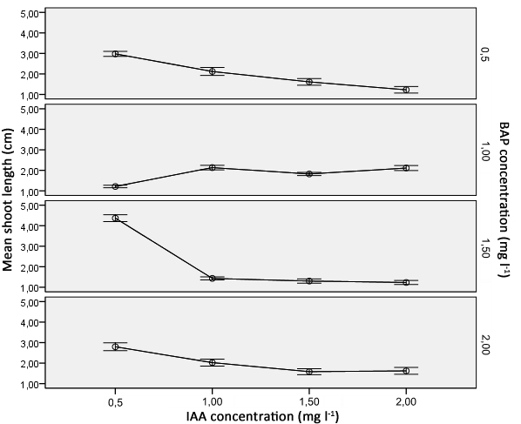
Figure 7.
