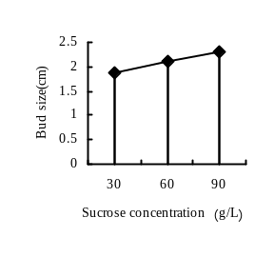
Fig. 1 The influence of different treatment time of carbendazim on the contamination rate of ‘Eyeliner’ scales

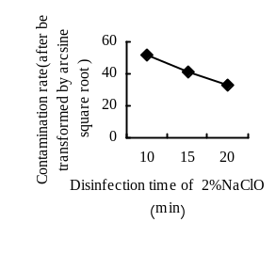
Fig. 2 The influence of the disinfection time of 2%NaClO on the contamination rate of ‘Eyeliner’ scales
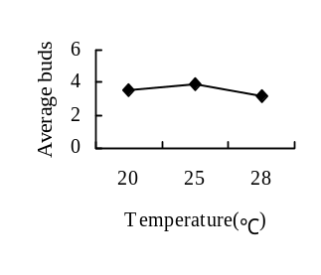
Fig. 3 The influence of The disinfection time of 2%NaClO on the Induction rate of ‘Eyeliner’ scales.

Note: All values ​​in the figures are the mean (the same of the following figures)
Figure 1, Figure 2 , Figure 3 showed that the optimum treatment and disinfection methods of ‘Eyeliner’ bulb scales is being soaked in 1:500 carbendazim solution for 30 min, disinfected in 75% alcohol for 10 s-60 s, disinfected in 2% NaClO solution for 15 min

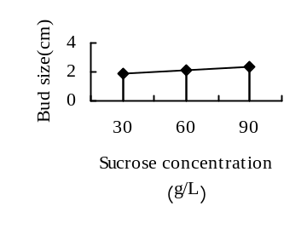Fig.4 The influence of different sucrose concentration on the size of ‘Eyeliner’buds
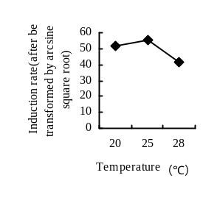
Fig. 5 The influence of different culture temperature on induction rate of ‘Eyeliner’
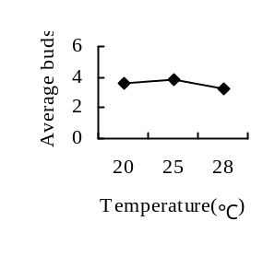
Fig. 6 The influence of different culture temperature on the average number of ‘Eyeliner’ induced buds

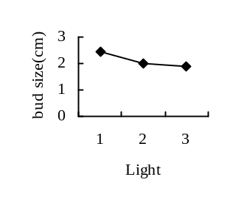 Fig. 7 The influence of different culture temperature on the size of ‘Eyeliner’buds
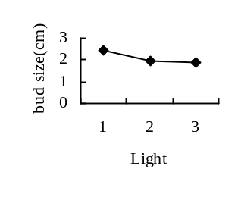
Fig. 8 The influence of different illumination on the average number of ‘Eyeliner’ induced buds
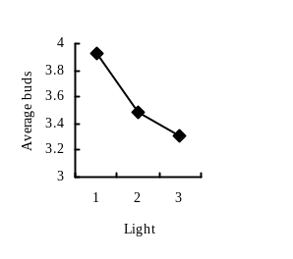
Fig.9 The influence of different illumination on the size of ‘Eyeliner’buds

Note: 1.2.3.in abscissa mean dark, 10 h light +14 h dark, 14 h light +10 h dark（the same of
following figures）

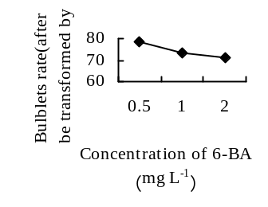Fig. 10 The influence of different 6-BA concentration on the bulb formation rate of ‘Eyeliner’
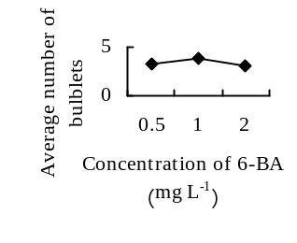
Fig.11 The influence of different 6-BA concentration on the average number of bulblets of ‘Eyeliner’
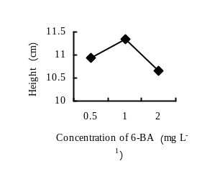
Fig. 12 The influence of different 6-BA concentration on the height of ‘Eyeliner’

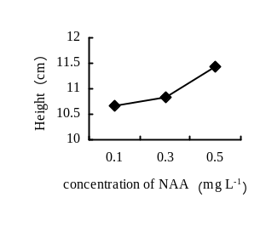
Fig.13 The influence of different NAA concentration on the height of ‘Eyeliner’
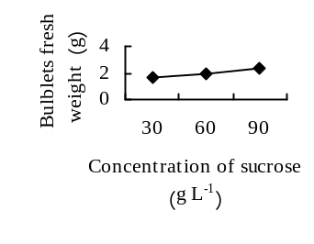 Fig.14 The influence of different sucrose concentration on the bulblets fresh weight of ‘Eyeliner’
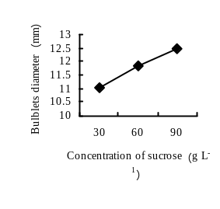Fig. 15 The influence of different sucrose concentration on the bulblets diameter of ‘Eyeliner’

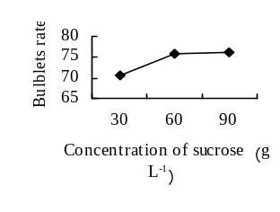 Fig. 16 The influence of different sucrose concentration on the bulb formation rate of ‘Eyeliner’
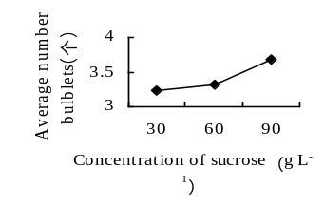 Fig. 17 The influence of different sucrose concentration on the average number of bulblets of ‘Eyeliner’
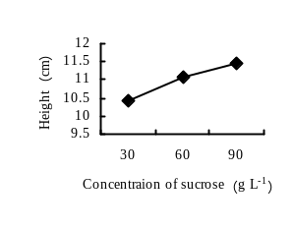
Fig. 18 The influence of different sucrose concentration on the height of ‘Eyeliner’

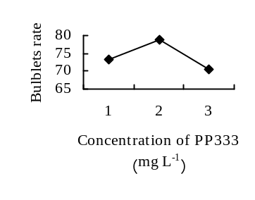 Fig. 19 The influence of different macroelement concentration on the bulb formation rate of ‘Eyeliner’

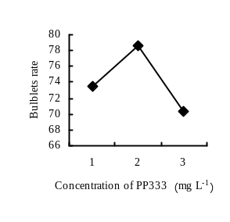
Fig. 20 The influence of different macroelement concentration on the average number of bulblets of ‘Eyeliner’
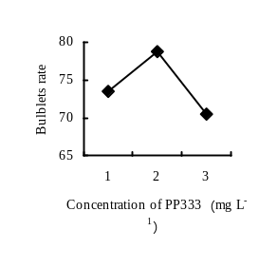
Fig. 21 The influence of different macroelement concentration on the height of ‘Eyeliner’

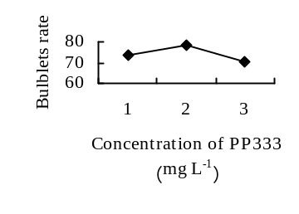 Fig. 22 The influence of different PP333 concentration on the bulb formation rate of ‘Eyeliner
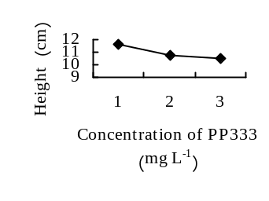Fig. 23 The influence of different PP333 concentration on the height of ‘Eyeliner’
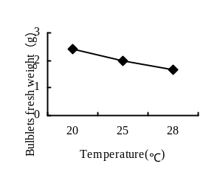 Fig. 24 The influence of different culture temperature on the bulblets fresh weight of ‘Eyeliner’

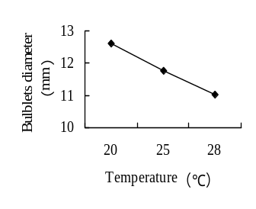 Fig. 25 The influence of different culture temperature on the bulblets diameter of ‘Eyeliner’
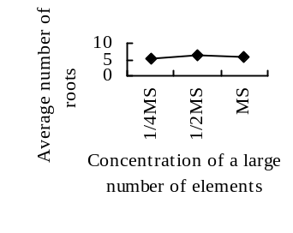 Fig. 26 The influence of different culture temperature on the bulb formation rate of ‘Eyeliner’
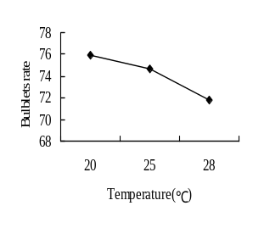 Fig. 27 The influence of different culture temperature on the average number of bulblets of ‘Eyeliner’

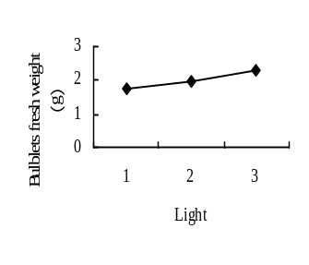 Fig. 28 The influence of different lighting conditions on the bulblets fresh weight of ‘Eyeliner’ 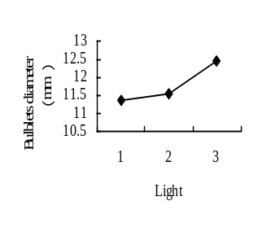
Fig. 29 The influence of different lighting conditions on the bulblets diameter of ‘Eyeliner’ 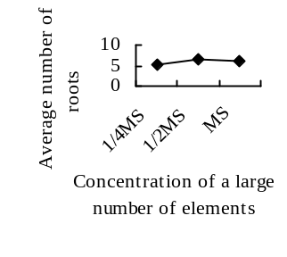 Fig. 30The influence of different macroelement concentration on the average number of roots of ‘Eyeliner’

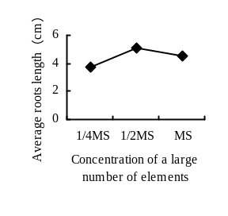
Fig. 31 The influence of different macroelement concentration on the average length of roots of ‘Eyeliner’
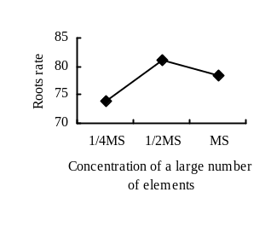
Fig.32 The influence of different macroelement concentration on the rooting rate of ‘Eyeliner’
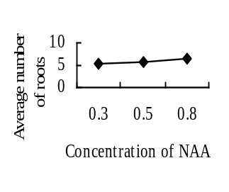 Fig. 33 The influence of different NAA concentration on the average number of roots of ‘Eyeliner’

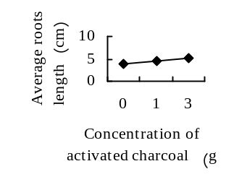 Fig. 34 The influence of different NAA concentration on the average length of roots of ‘Eyeliner’
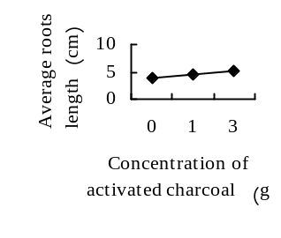
Fig. 35 The influence of different NAA concentration on the rooting rate of ‘Eyeliner’
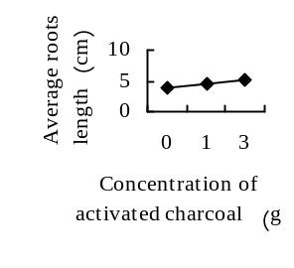 Fig. 36 The influence of different Activated Charcoal concentration on the average length of roots of ‘Eyeliner’

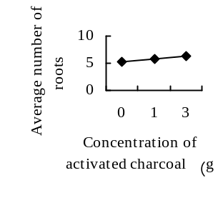 Fig. 37 The influence of different Activated Charcoal concentration on the average number of roots of ‘Eyeliner’
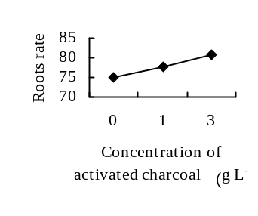 Fig. 38 The influence of different activated charcoal concentration on the rooting rate of ‘Eyeliner’
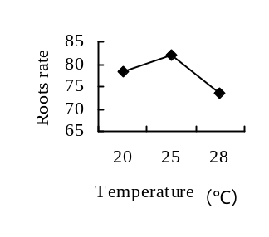 Fig. 39 The influence of different culture temperature on the average number of roots of ‘Eyeliner’

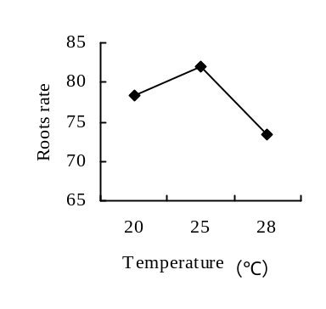
Fig. 40 The influence of different culture temperature on the rooting rate of ‘Eyeliner’
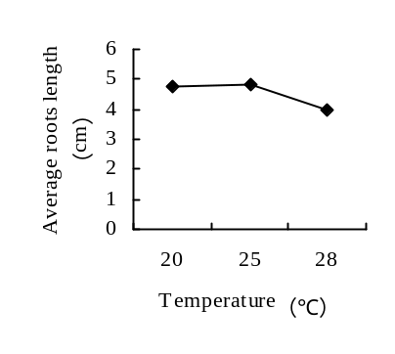
Fig. 41 The influence of different culture temperature on the average length of roots of ‘Eyeliner’

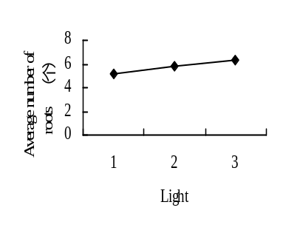
Fig. 42 The influence of different lighting conditions on the average number of roots of ‘Eyeliner’
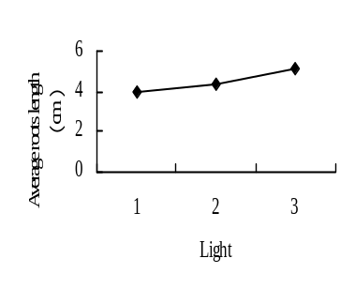
Fig. 43 The influence of different lighting conditions on the average length of roots of ‘Eyeline

