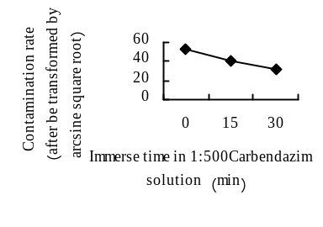
Fig.1 The influence of different treatment time of carbendazim on the contamination rate of ‘Eyeliner’ scales
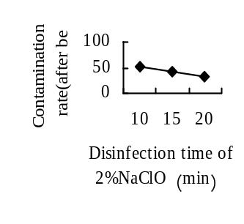
Fig.2 The influence of the disinfection time of 2%NaClO on the contamination rate of ‘Eyeliner’ scales
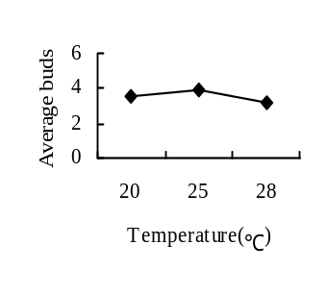
Fig.3 The influence of The disinfection time of 2%NaClO on the Induction rate of ‘Eyeliner’ scales.

Note: All values ​​in the figures are the mean (the same of the following figures)
Figure1, Figure2 , Figure 3 showed that the optimum treatment and disinfection methods of ‘Eyeliner’ bulb scales is being soaked in 1:500 carbendazim solution for 30 min, disinfected in 75% alcohol for 10 -60 s, disinfected in 2% NaClO solution for 15 min.

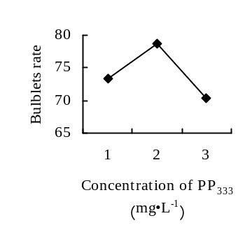
Fig.22 The influence of different PP₃₃₃ concentration on the bulb formation rate of ‘Eyeliner’
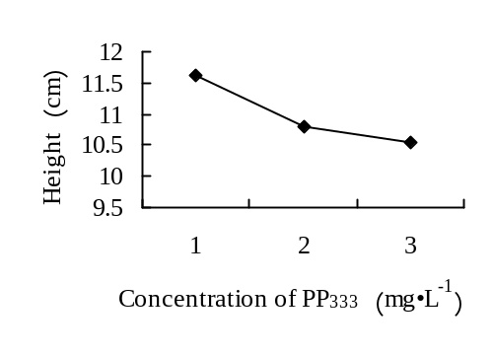
Fig.23 The influence of different PP₃₃₃ concentration on the height of ‘Eyeliner’

