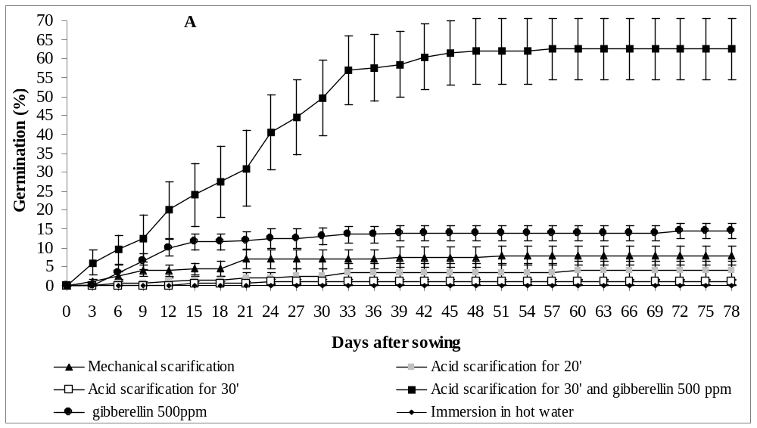

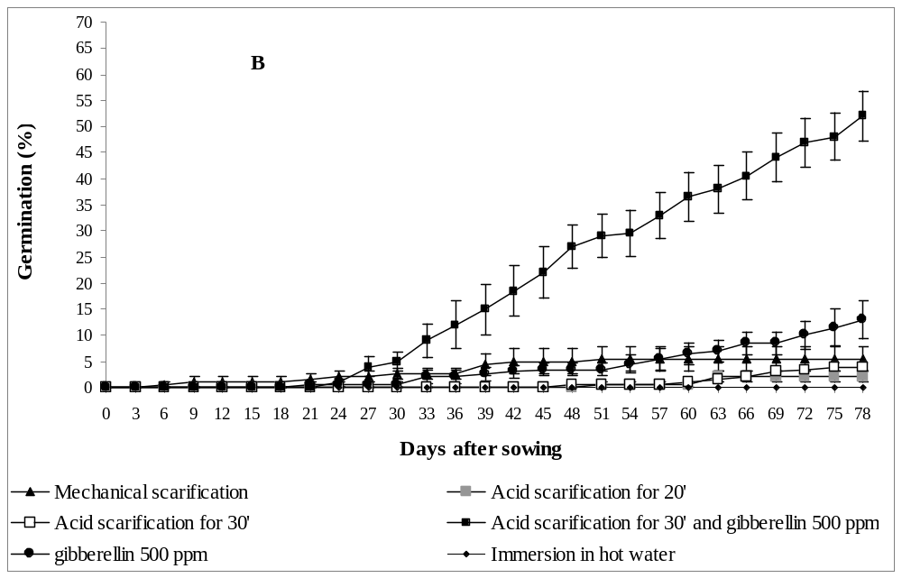
Fig. 1. Germination distribution (%) of Cercis siliquastrum seeds originated from a natural habitat (A) and from an urban environment (B) subjected to various breaking dormancy treatments.

