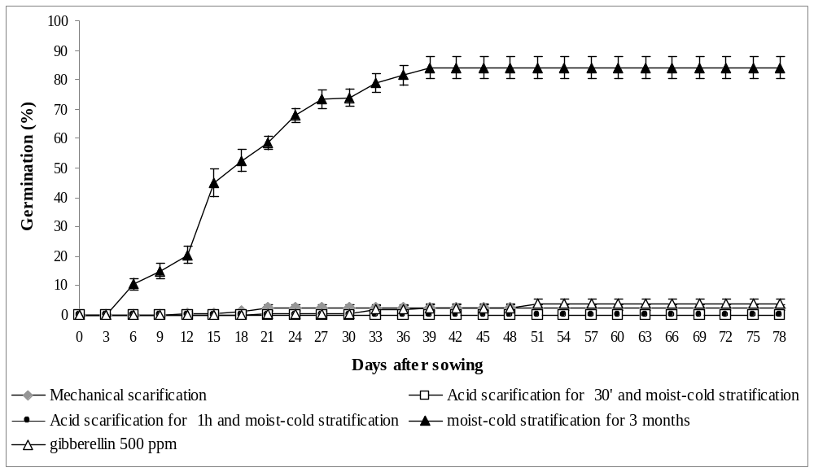
Fig. 2. Germination distribution (%) of Carpinus orientalis seeds subjected to various breaking dormancy treatments.

