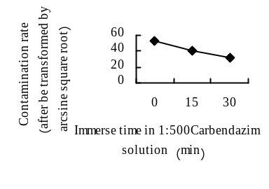 Fig. 1 The influence of different treatment time of carbendazim on the contamination rate of ‘Eyeliner’ scales
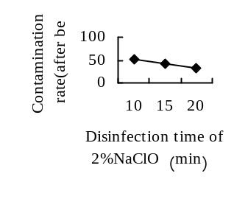
Fig. 2 The influence of the disinfection time of 2%NaClO on the contamination rate of ‘Eyeliner’ scales
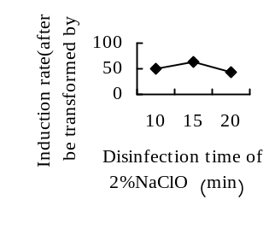
Fig. 3 The influence of The disinfection time of 2%NaClO on the induction rate of ‘Eyeliner’ scales.

Note: All values ​​in the figures are the mean (the same of the following figures)
Figure 1, Figure 2 , Figure 3 showed that the optimum treatment and disinfection methods of ‘Eyeliner’ bulb scales is being soaked in 1:500 carbendazim solution for 30 min, disinfected in 75% alcohol for 10 s-60 s, disinfected in 2% NaClO solution for 15 min

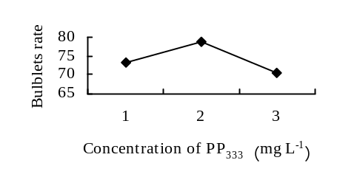
Fig. 4 The influence of different PP₃₃₃ concentration on the bulb formation rate of ‘Eyeliner
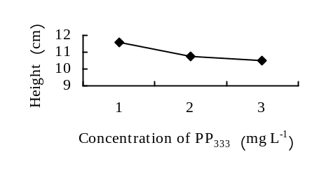
Fig. 5 The influence of different PP₃₃₃ concentration on the height of ‘Eyeliner’

