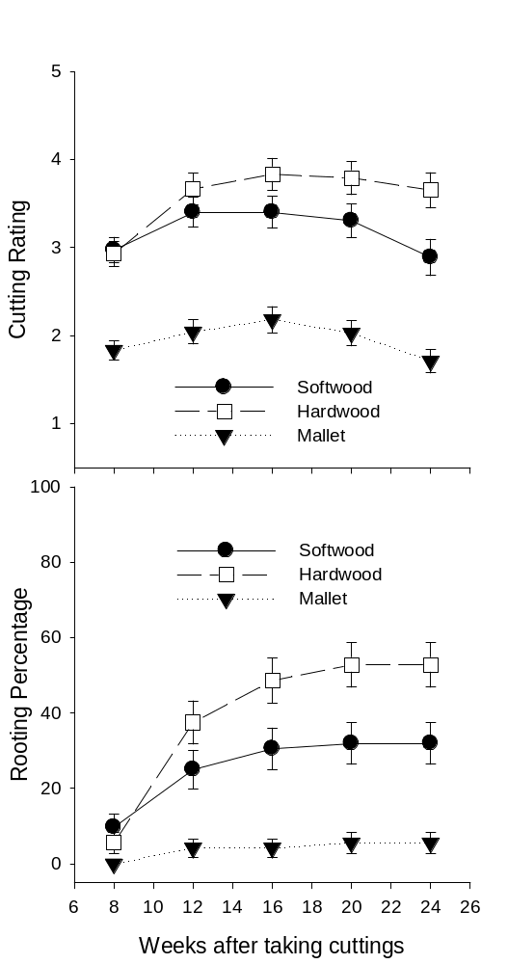

Figure 1. Effect of cutting type of Cupressus cashmeriana on cutting rating [1=dead; 2=alive, no callus; 3=mild to moderate callus; 4=heavy callus; and 5=visible root(s)] and rooting percentage every 4 weeks for 24 weeks averaged over K-IBA treatments for experiment 1. Error bars represent standard error.

