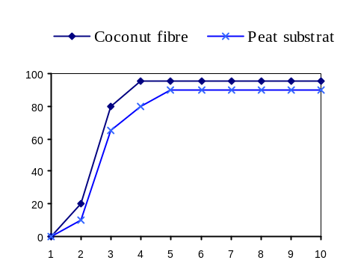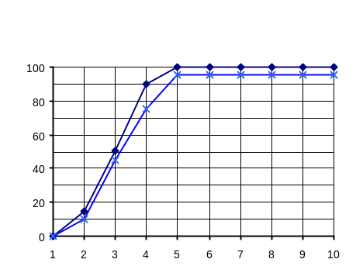
%
%
Elite Salmon
daysssyd
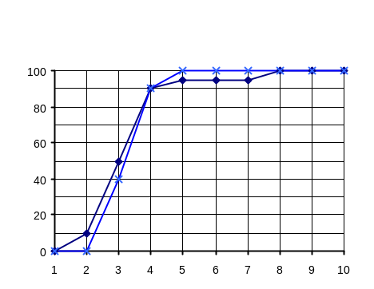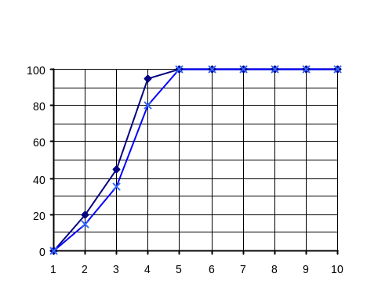
%
%
Elite Pink
days
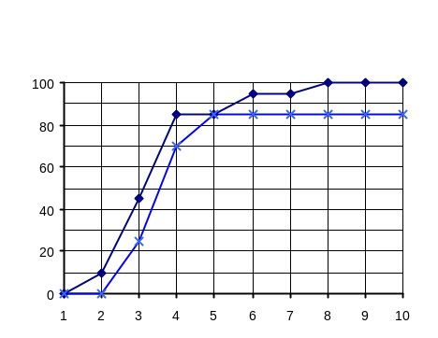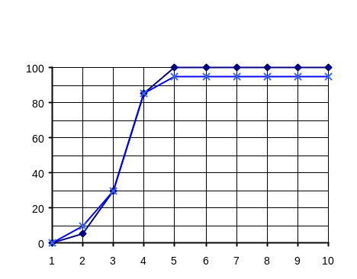
%
%
Maverick Pink
Orbit Coral
days
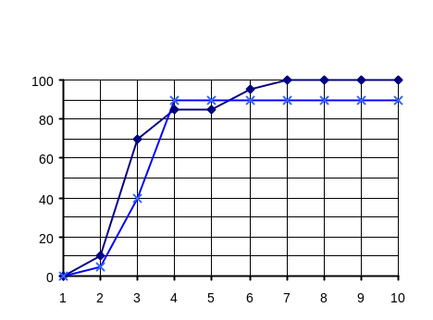
%
Orbit Appleblossom
Orbit Light Salmon
Multibloom Lavender
days
Fig. 1. Dynamics of seeds germination of Pelargonium × hortorum F₁ cultivars grown in two organic media. Means of the years 2004-2005

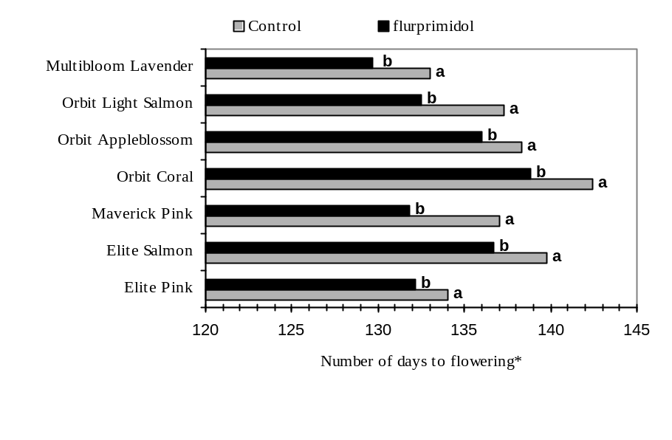
*a,b – means marked with the same letter do not differ significantly;

Fig. 2. Effect of flurprimidol on number of days to flowering of Pelargonium × hortorum
F₁ cultivars grown in coconut fibre

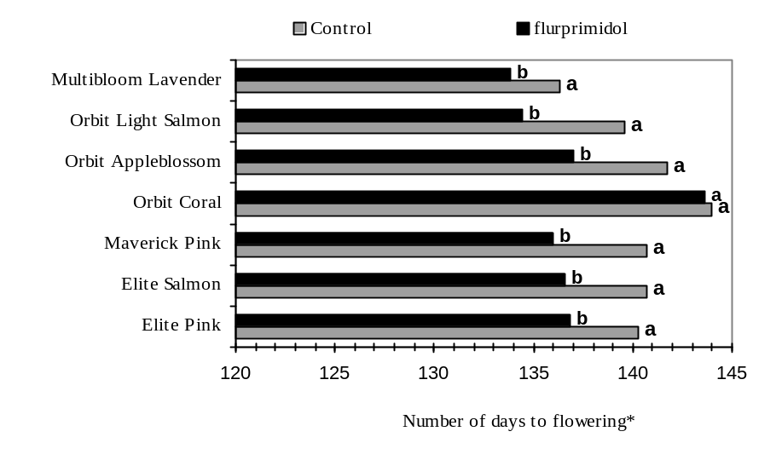

*a,b – means marked with the same letter do not differ significantly;

Fig. 3. Effect of flurprimidol on number of days to flowering of Pelargonium × hortorum
cultivars grown in peat substrate

