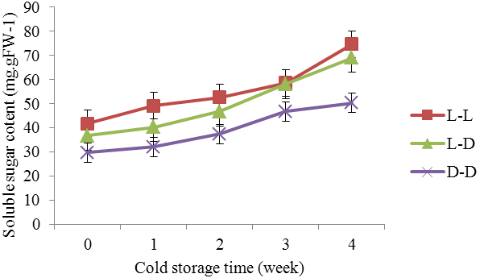
a
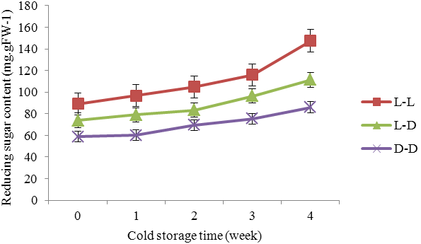
b
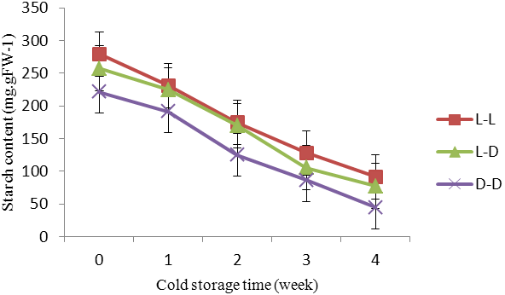
c
Fig.3 Carbohydrate content change trends of bulblet cultured under various light conditions during cold storage
(a): Various trends of soluble sugar content; (b): Various trends of reducing sugar content; (c): Various trends of starch content.

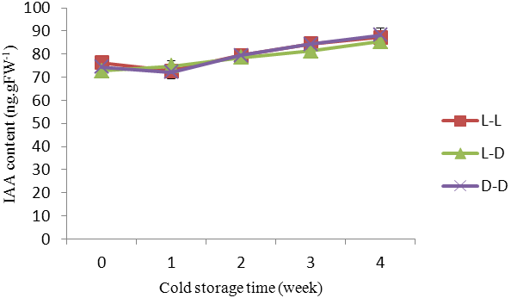
a
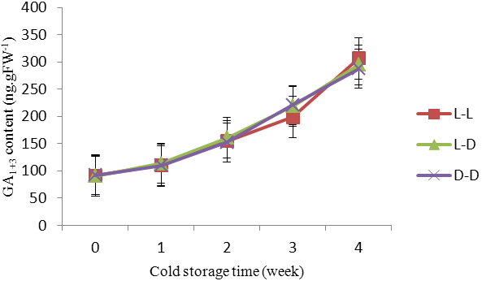
b

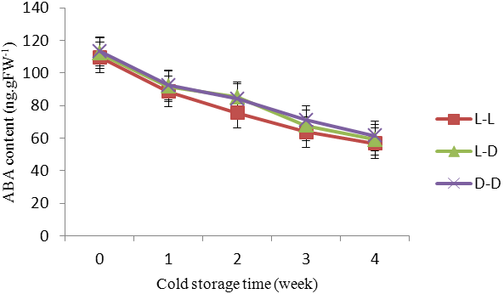
c

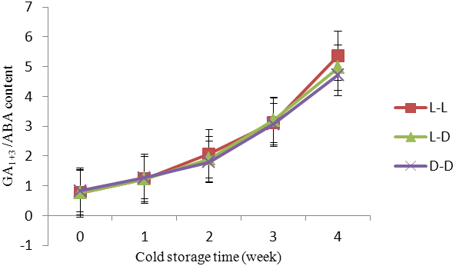
d
Fig.4 Different endogenous hormone content change trends of bulblet cultured under various light conditions during cold storage
(a): Various trends of IAA content; (b): Various trends of GA₁₊₃ content; (c): Various trends of ABA content; (d) Various trends of GA₁₊₃ / ABA content.

