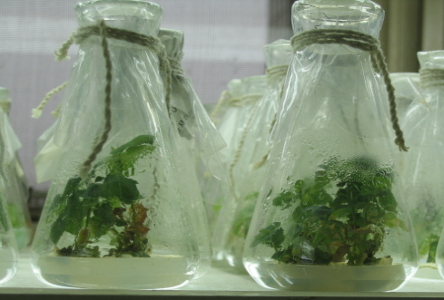
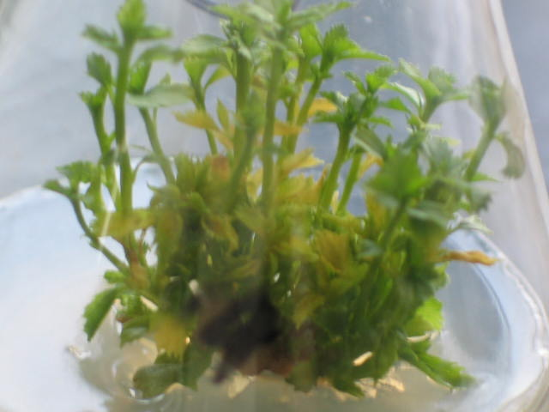
A
B

Fig.1.A) Three-time-subcultured seedlings used as explants. B) Proliferation of explants cultured in MS supplied with 0.1 mg l ⁻¹ IBA and 4.0mg l⁻¹ BA.

