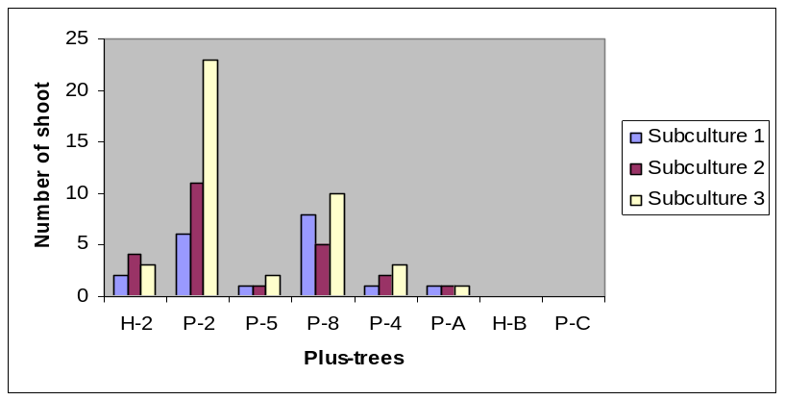

Fig. 2. Effects of Castanea sativa mature plus-tree genotypes on the number of shoots produced in tissue culture.

