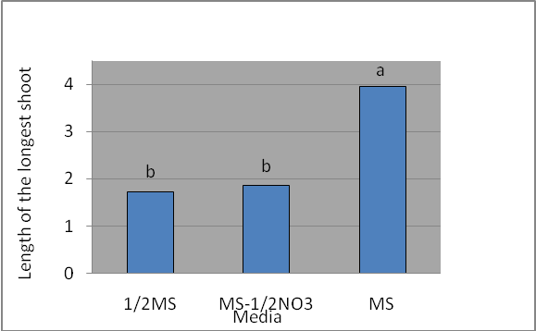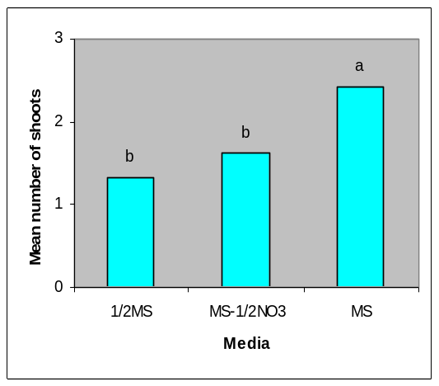
(a) (b)

Fig. 3. Effect of media on length (a) and number of shoots (b) of Castanea sativa mature plus-tree genotypes.

