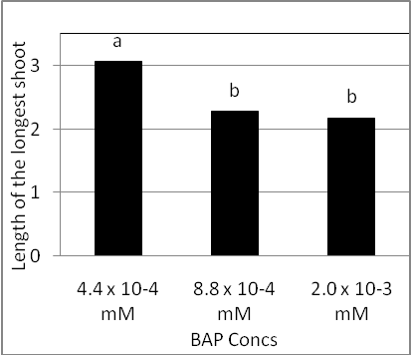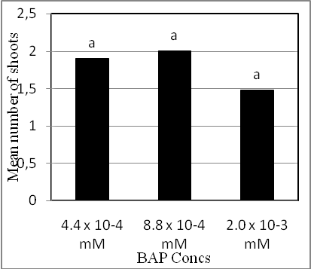
(a) (b)

Fig. 5. Effect of BAP concentration on shoot length (a) and shoot number (b) of Castanea sativa mature plus-tree genotypes.

