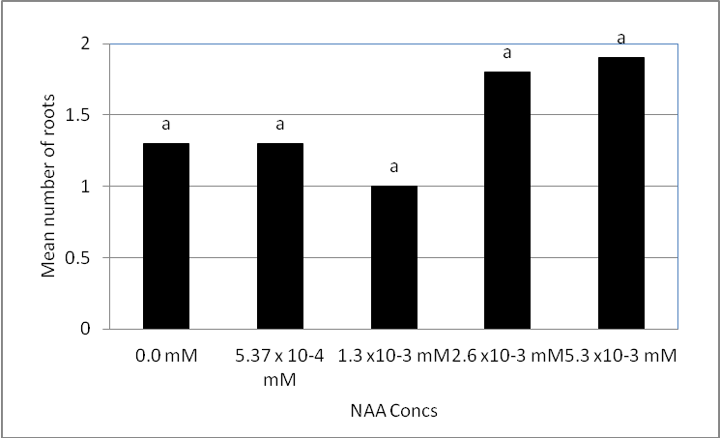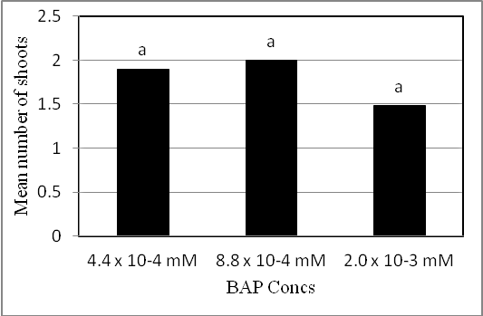

(a) (b)

Fig. 6. Effect of NAA concentration on length of roots (a) and number of roots (b) of Castanea sativa mature plus-tree genotypes.

