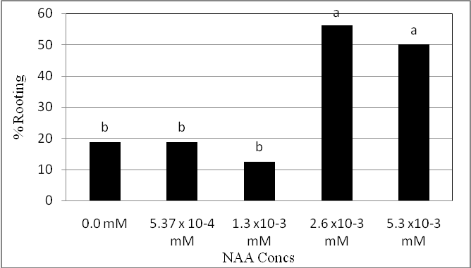

Fig. 7. Effect of NAA concentrations on rooting percentage of Castanea sativa mature plus-tree genotypes.

